ADULT, COMMUNITY AND FURTHER EDUCATION BOARD
2021 PRE-ACCREDITED TRAINING DELIVERY GUIDELINES

CONTENTS
PRE-ACCREDITED TRAINING DELIVERY GRANT FUNDING PROCESS 3
ADULT, COMMUNITY AND FURTHER EDUCATION (ACFE) BOARD PRE-ACCREDITED TRAINING DELIVERY GRANT FUND 5
PURPOSE OF THESE GUIDELINES 5
PURPOSE OF GOVERNMENT SUBSIDISED PRE-ACCREDITED TRAINING 5
PRIORITIES FOR 2021 PRE-ACCREDITED TRAINING 5
THE PRE-ACCREDITED QUALITY FRAMEWORK 6
ROLE OF THE ACFE BOARD 6
ROLE OF THE ACFE REGIONAL COUNCILS 7
LOCATION OF REGIONAL COUNCIL AREAS 7
ROLE OF PROVIDERS 7
ROLE OF DEPARTMENT OF EDUCATION AND TRAINING 8
ELIGIBILITY CRITERIA 9
LEARNER ELIGIBILITY CRITERIA 9
ASYLUM SEEKER ELIGIBILITY CRITERIA 9
PRIVACY NOTICE FOR STUDENT ENROLMENT 9
PROVIDER ELIGIBILITY CRITERIA 10
HOW TO APPLY FOR PRE-ACCREDITED FUNDING 11
WEBINARS AND REGIONAL FORUM INFORMATION 11
COMPLETING AND SUBMITTING THE DELIVERY PLAN 11
DELIVERY PLAN AND A-FRAME ASSESSMENT 14
NOTIFICATIONS OF OUTCOMES 14
PAYMENT AND REPORTING DATES 15
TRAINING DELIVERY SUPPORT GRANT (TDSG) 15
REGIONAL LOADING 15
FEE CONCESSION ARRANGEMENTS FOR PRE-ACCREDITED DELIVERY 16
COURSE FEES 16
SAMS2— SERVICE AGREEMENT 17
RECORDKEEPING 17
SERVICE PLAN 17
SERVICE PLAN VARIATIONS 17
SUBCONTRACTING 17
WORK EXPERIENCE 17
INSURANCE 18
COMPLIANCE 19
SERVICE AGREEMENT COMPLIANCE CERTIFICATE (SACC) 19
HOW TO COMPLETE THE SACC FORM? 19
COMMUNICATION WITH LEARN LOCAL PROVIDERS 20
WHO DO I CONTACT IF I NEED ASSISTANCE 20
BRANDING REQUIREMENTS 21
LEARN LOCAL BRAND GUIDELINES 21
PUBLICITY AND ACKNOWLEDGEMENT GUIDELINES 21
THIS ACKNOWLEDGEMENT MUST BE MADE IN: 21
USEFUL LINKS 21

PRE-ACCREDITED TRAINING DELIVERY TIMELINE
Action |  | Date
2021 Expression of Interest (EOI) open. For more information, see Department of Education and Training (DET) website. | Open 14 September 2020  Close 14 October 2020
Download the 2021 Pre-accredited Training Delivery Guidelines and the 2021 Delivery Plan template. | From 14 September 2020
Attend an online information session: register here. | 17 & 23 September 2020
Ensure Business and Governance Status (BGS) is completed, signed and uploaded to the compliance tab in SAMS2. | 30 September 2020, extended to 27 November 2020 at latest
Attend a regional forum in your area. Your regional office will send you an invitation closer to the date. | September- October 2020
Prepare Delivery Plan and A-frames and submit your Delivery Plan and A-frames, along with any LEAP and/or Skills for Work and Study applications, in one email to: training.participation@education.vic.gov.au | By 14 October 2020
Department staff review EOIs. | October-November 2020
Department advises providers of EOI outcomes. | End November 2020
A Service Plan will be created in SAMS2 once all prerequisites are met, including BGS. | December 2020
Once contract requirements are finalised, first payment released. | Commences late January 2021
Contact your regional office for more information. | Anytime

PE-ACCREDITED TRAINING DELIVERY GRANT FUNDING PROCESS

ADULT, COMMUNITY AND FURTHER EDUCATION (ACFE) BOARD PRE-ACCREDITED TRAINING DELIVERY

Purpose of These GUIDELINES
The information provided in these guidelines has been developed to assist Learn Local providers, AMES Australia and CAE in planning and implementing their delivery of pre-accredited training in 2021.

Purpose of government subsidised pre-accredited training
The primary purpose of pre-accredited education and training is to provide opportunities for adult learners in Victoria to gain the educational capacity and core skills they need for study, work and life.
Pre-accredited education and training addresses the needs of adults who have experienced barriers to education in the past and find it difficult to undertake accredited courses as their first step into vocational training, particularly those learners who have not achieved Year 12 or an equivalent qualification.
Pre-accredited training programs focus on creating pathways for learners to further education and training and to employment.
Pre-accredited training programs are short modular courses which are unique and separate from accredited training programs, with their own A-frames (Course and Session Plans) and objectives.
Programs are designed to be flexible, meet learners’ needs and support them to return to study, improve their literacy and numeracy skills, qualification pathways and broaden their employment options.

Priorities for 2021 pre-accredited training
The Adult, Community and Further Education (ACFE) Board’s priorities for the allocation of pre-accredited training funds are based on demographic data and the Board’s strategic objectives.
The ACFE Board has identified people who have experienced educational disadvantage as a priority in the design and delivery of pre-accredited programs.
It is expected that pre-accredited programs will reflect the Board’s strategic priorities outlined in the ACFE Board Strategy 2020-2025, and Ministerial Statement on the Future of Adult Community Education in Victoria 2020-25.
The ACFE Board recognises the significant impact of COVID-19 on Learn Local providers and the efforts providers made to continue delivering pre-accredited training wherever possible throughout 2020.
In recognition of the impact of COVID-19 on pre-accredited training delivery, the ACFE Board has approved a 2021 pre-accredited allocation for each provider which is the same as their 2020 regional allocation. Providers may request to reduce this allocation but should not request hours greater than the allocation.
Should hours be returned, these will be redistributed via a separate process, according to priorities and criteria set by the ACFE Board.
In 2021, opportunities for additional training delivery are available through the Skills for Work and Study pilot programs. The Skills for Work and Study pilot program allocation process will be managed in coordination with the pre-accredited training allocation process.
Contracted providers are expected to deliver pre-accredited programs aligned to one or more of the four roles outlined in the ACFE Board Strategy 2020-25:
- Engage and participate in further education and training - Building confidence and skills for participation in education and training
- Achieve success in further education and training - Supporting successful attainment in accredited training
- Engage and participate in work - Building confidence and skills for participation in work
- Achieve success in work - Upskilling and reskilling vulnerable workers.

THE PRE-ACCREDITED QUALITY FRAMEWORK
All pre-accredited programs must satisfy and be designed in line with the Pre-accredited Quality Framework (PQF) using the required tools and principles, to be eligible for funding.
The PQF is a system of interrelated processes that ensure quality and continuous improvement in the cycle of planning, developing, implementing and reviewing pre-accredited courses.
The PQF provides assurance to all stakeholders (including learners, the community, employers and the ACFE Board) that pre-accredited programs provide quality learning experiences.
As a quality improvement mechanism, the PQF aims to improve outcomes for learners not ready to undertake an accredited course, but wishing to improve their skills to secure employment, access further study, and to build their capacity to engage and remain a part of a complex and fast-changing society.
The PQF supports teachers and managers to plan, develop, teach and review pre-accredited courses. It is comprised of a number of components (described below), which can also be accessed through the DET website.

A-frame
The central component of the PQF is the A-frame. The A-frame provides for the development of adult-centered learning, for planning, delivering and documenting educational practices, and includes practical templates (the Course Plan and the Session Plan) for planning pre-accredited courses.
Providers contracted by the ACFE Board to deliver pre-accredited programs must use the A-frame to design and develop these programs. Copies of Course Plans and Session Plans for any pre-accredited program subsidised by the ACFE Board must be provided for new and substantially amended programs.
Program Evaluation / Moderation
Through the ACFE Board’s quality framework, pre-accredited providers are required to undertake ongoing evaluation/moderation of their pre-accredited programs. This evaluation/moderation is a collaborative peer appraisal process that promotes a shared understanding of what constitutes quality course design, delivery and outcomes for learners. Evaluated/moderated courses have documented evidence to provide an assurance to the ACFE Board that the courses they subsidise are of high quality. All pre-accredited courses must be evaluated/moderated annually by providers.
It is expected that feedback on the quality of courses and the quality of delivery will be sought from participants in pre-accredited programs, through the pre-accredited learner satisfaction survey. Other protocols for measuring quality may be implemented over the course of the year as directed by the ACFE Board.

role of the ACFE Board
The ACFE Board is a statutory authority under the Education and Training Reform Act 2006. Its role is to plan and promote adult learning, allocate resources, develop policies, and advise the Minister for Training and Skills on matters related to adult education in Victoria.
Through the ACFE Board, the Victorian Government provides funding to Learn Local providers, AMES Australia and the CAE, to deliver education and training programs to a broad range of Victorians over compulsory school leaving age, with a special focus on people who have had limited prior access to education.
The ACFE Board Strategy 2020-25 is a primary means to implement the Ministerial Statement on the Future of Adult Community Education in Victoria 2020-25.
The ACFE Board Strategy 2020-25 responds to trends and challenges in the Learn Local sector, including changes in learner needs, changing modes of skills acquisition, changes in place-based models, changes in industry and the nature of work, policy and regulatory changes at the State and Commonwealth Government levels, and changes in society more generally. Above all, it reflects the right of people to access core education and training.
Allocation of resources
Within the context of a fixed budget, the ACFE Board aims to equitably distribute Government funds across the state to each of the eight Regional Council areas (Barwon South West, Eastern Metropolitan, Gippsland, Grampians, Hume, Loddon Mallee, North West Metropolitan, and Southern Metropolitan).
This distribution of resources is determined by a demographically driven formula based on the 2016 Census data, moderated by demonstrated demand and provider capacity to deliver.
This formula includes weightings for the Regional Council area’s share of the Victorian working age population (people aged 15–69 who are not attending school) and the proportion of the Regional Council area population experiencing educational disadvantage.

ROLE OF THE ACFE REGIONAL COUNCILS
The eight ACFE Regional Councils are established in line with the Education and Training Reform Act 2006. Using their different expertise and local knowledge about adult education, Regional Councils advise the ACFE Board on the needs of adult education across their region. They also contribute to state-wide planning and policy development.

LOCATION OF REGIONAL COUNCIL AREAS
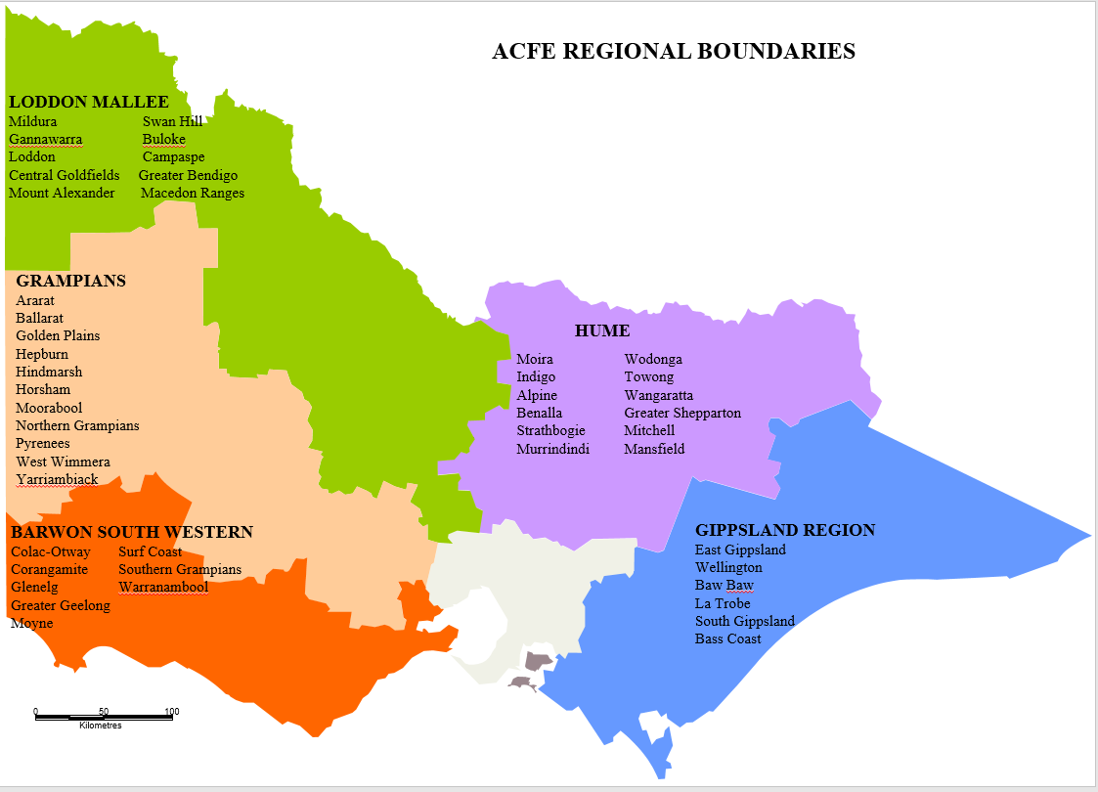
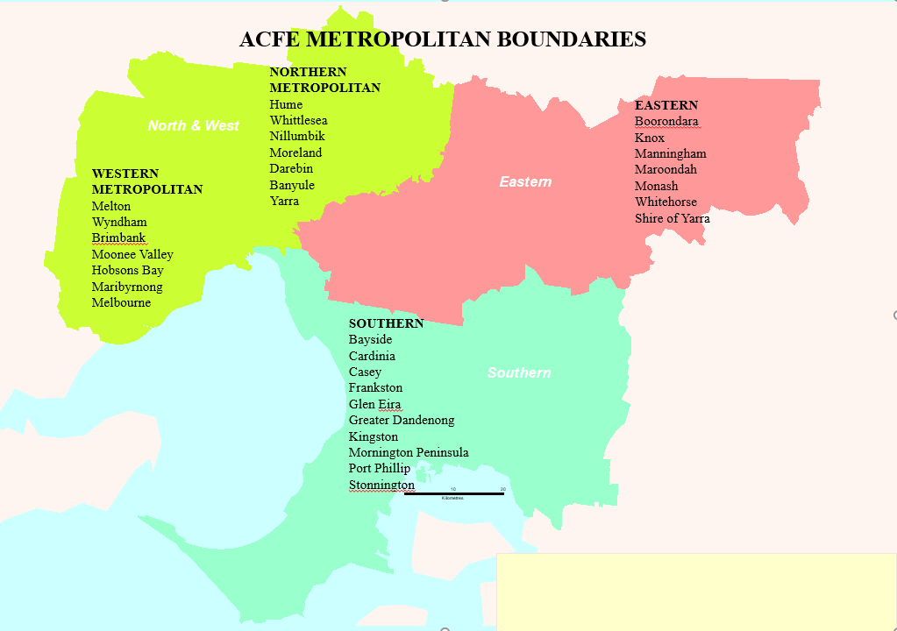

ROLE OF PROVIDERS
Learn Local providers are among Victoria’s most valuable community assets, improving the lives and prospects of many Victorians, and playing a positive role in strengthening local economies and communities.
The Learn Local sector is an essential part of Victoria’s post-compulsory education system. It plays four crucial roles in supporting learners to enter and succeed in further study and employment, as outlined in the ACFE Board Strategy 2020-25.

Role of DEPARTMENT of Education and Training
The role of the Department of Education and Training (‘the Department’) is to manage the procurement of student contact hours, within the parameters set by the ACFE Board, execute and monitor contracts with contracted providers within the delegations set by the ACFE Board, and make regular reports to the ACFE Board on progress towards the targets set in contracts and in meeting broader strategic priorities.
The Department manages the procurement process to determine training delivery at the Local Government Area (LGA) through a formal Expression of Interest (EOI) process, following the ACFE Board’s allocation of resources to Regional Council areas. The Expression of Interest process is outlined in detail on page 11 of these guidelines.

Eligibility Criteria

LEARNER Eligibility Criteria
To be eligible to enrol in government subsidised pre-accredited training, learners must meet the following criteria:
 |  | ELIGIBILE | NOT ELIGIBLE
LEARNER eligibility CRITERIA | Australian Citizen | 
 | Holder of an Australian permanent visa | 
 | New Zealand citizen | 
 | Principle place of residence NOT in Victoria
 | A prisoner held at a prison, within the meaning of the Corrections Act 1986.
 | Detained under the Mental Health Act 1986; or the Crimes (Mental Impairment and Unfitness to be Tried) Act 1997 or the Sentencing Act 1991 at the Thomas Embling Hospital.
 | Detained (other than on weekend detention) under the Children, Youth and Families Act 2005 or the Sentencing Act 1991 or who is held on remand in the Malmsbury Juvenile Justice Centre or Parkville Youth Residential Centre.
 | Enrolled at school

ASYLUM SEEKER ELIGIBILITY CRITERIA
ASYLUM SEEKERS | Asylum seekers in specified visa categories, referred by Jobs Victoria Employment Network providers to pre-accredited pre-employment programs. | 
Citizenship requirements apply for accessing all other ACFE Board pre-accredited training programs.
There is currently no exemption for asylum seekers to participate in ACFE Board subsidised programs, other than Jobs Victoria Employment Network referred clients (above). Asylum seekers in specified visa categories are separately eligible for specific Department-funded asylum seeker VET programs.

PRIVACY NOTICE FOR STUDENT ENROLMENT
When enrolling learners in government subsidised pre-accredited training, providers are required to use the student enrolment privacy notice set out in the latest version of the Victorian VET Student Statistical Collection Guidelines.
The Student Enrolment Privacy Notice is located on page 193, Appendix 1 of the Victorian VET Student Statistic Guidelines.
The privacy notice must be used in all enrolment forms for all students who are commencing or re-enrolling. Providers may need to add further information to cover their training provider’s use of student data.
Where electronic enrolment forms are provided, appropriate electronic confirmation procedures should be implemented for the student to confirm that the details provided are correct and that the student has accepted the privacy notice. Please ensure that you are using the latest version of these Victorian VET Student Statistical Collection Guidelines at all times.

PROVIDER Eligibility Criteria
To be eligible to receive government subsidised pre-accredited training delivery grant funding, providers must meet the following criteria:
 |  | DESCRIPTION | LEARN LOCAL | AMES & CAE | LEARN LOCAL RTO
PROVIDER ELIGIBILITY CRITERIA | ACFE REGISTRATION | - Providers must be registered with the ACFE Board or be covered under the Education and Training Reform Act 2006.  - Registration does not guarantee funding.  - For information on registration with the ACFE Board, see: Become a registered Learn Local provider on the Department website. |  | Education and Training Reform Act 2006 | 
 | ACFE BOARD BUSINESS AND GOVERNANCE STATUS ASSESSMENT (BGS) | Providers must have a current BGS that has passed the assessment criteria to be eligible for funding. Note: The financial report upon which the BGS assessment is completed must also be submitted with the BGS Assessment. Contracting will not proceed until this requirement is met.  The following organisation categories are exempted from the BGS submission requirements:  - Registered Training Organisations (RTO) with Skills First Contracts.  - Providers operating under the auspices of Local Government.  For more information about the BGS assessment process, see: Business and governance status assessment on the Department website. |  | Education and Training Reform Act 2006 | Must have a current Skills First contract
 | STUDENT MANAGEMENT SYSTEM AND ADMINISTRATION | - Contracted providers must have an Australian Vocational Education and Training Management Information Statistical Standard (AVETMISS) compliant, up-to-date student management system, and meet the requirements in the Victorian VET Student Statistical Data Collection Guidelines.  - Must have appropriate and sufficient personnel trained in the use of their Student Management System and the Skills Victoria Training System (SVTS), to ensure integrity, accuracy and currency of data and reporting. |  |  | 
 | DELIVERY PLAN | - Must submit a Delivery Plan that reflects ACFE Board and relevant regional priorities, accompanied by course plans for all proposed programs (and session plans for new programs).  - To be eligible to receive funding, a pre-accredited course must be a minimum of 20 hours duration and part of total program delivery of at least 500 student contact hours (SCH) for the calendar year. |  |  | 
 | SAMS2 REGISTRATION | - Once ACFE Board registration and BGS has been approved, commence SAMS2 registration process for contracting by contacting your regional office. |  |  | 
 | If you wish to deliver pre-accredited training in 2021, but have not delivered in 2020, please contact your regional office as soon as possible. See: COMMUNICATION WITH PROVIDERS on page 21

HOW TO APPLY FOR PRE-ACCREDITED FUNDING

INFORMATION SESSIONS and regional forums
The Department in partnership with the VET Development Centre (VDC), is facilitating two online information sessions in September 2020.
The online information sessions will focus on priorities for 2021 pre-accredited training delivery, the Learner Engagement A-frame Program (LEAP) and the Skills for Work and Study pilot program, as indicated in the respective guidelines. This will include information on the timelines associated with the EOI process.
All Learn Local providers are encouraged to participate in an information session and attend a regional forum.
Information session | Date | Time
Information session 1 | Thursday, 17 September 2020 | 12.30pm – 1.30pm
Information session 2 | Wednesday, 23 September 2020 | 12.30pm – 1.30pm
Information session presentation | From Wednesday, 30 September 2020 | DET website
Regional forums | Throughout September-October 2020 | TBA by Regional Office

Information session registration
Please register for one of the general information sessions here.
Once registration is complete, you will be emailed a confirmation booking. Your session participation link will be emailed to you prior to the information session and again on the day of the session.
In order to participate effectively in the information session, please check that you have:
- your booking confirmation and participation link
- a strong internet connection
- headphones to hear the presentation
- Google Chrome, installed and ready for use as your web browser (Safari for MAC users) to view the information session.
If you are unable to participate in an information session, the presentation will be available on the DET website and the Learn Local Facebook page from Wednesday, 30 September 2020.

Regional forums
Regional forums will be scheduled throughout September-October 2020 to discuss the development of Delivery Plans. Invitations will be sent out by regional offices.

Completing and submitting the delivery plan
The EOI process is conducted through the submission of a Delivery Plan. The Delivery Plan forms the basis for the Department to negotiate and approve the allocation of subsidised pre-accredited training to providers, by LGA and course across the state.
Learn Local providers will notice some changes to the 2021 Delivery Plan. This includes changes to the pre-accredited program categories, the mode of delivery, and delivery site and partnerships.
There are separate Delivery Plan templates for Pre-accredited Training Delivery, LEAP and Skills for Work and Study. Each Delivery Plan template includes instructions.
If you are also applying for the LEAP program, see instructions for completing the LEAP Delivery Plan and guidelines around maximum available hours in the LEAP Guidelines.
If you are also applying for the Skills for Work and Study pilot programs, see instructions for completing the Skills for Work and Study Delivery Plan in the Skills for Work and Study Guidelines.
Action 1: How to complete the pre-accredited Delivery Plan
- Select the pre-accredited training delivery template
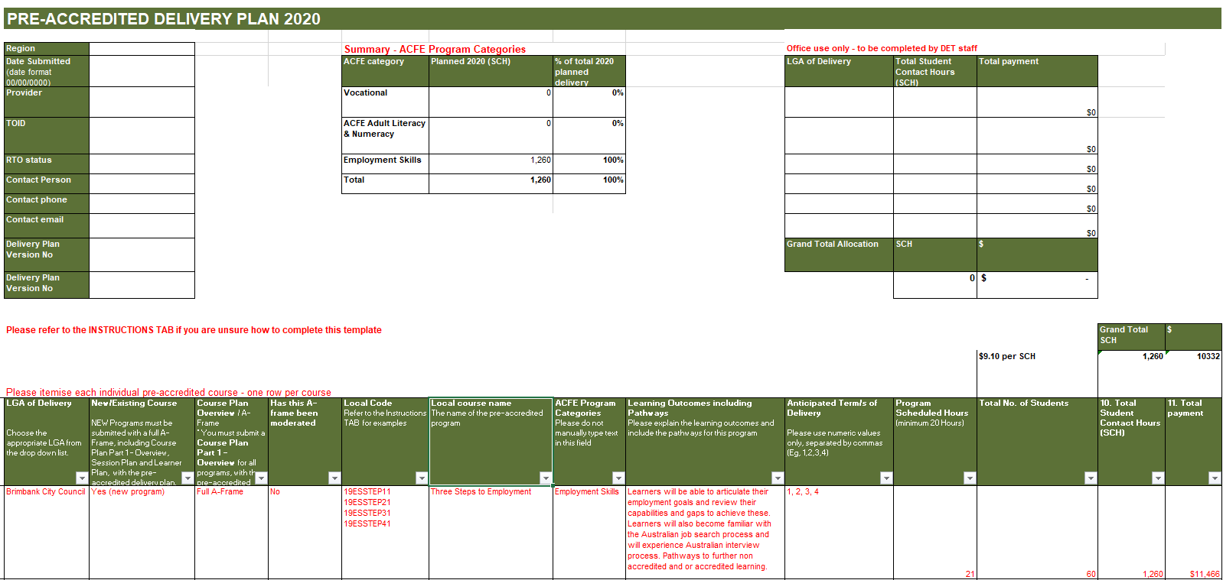
- Prepare Delivery Plan by Local Government Area (LGA) and list course modules in order of your priority, up to a maximum of your 2020 student contact hour allocation.
- Local Course Codes must be developed for all pre-accredited programs to facilitate effective reporting.
- Use local course codes for Delivery Plans and reporting.
- Do not use a national or state recognised course for Delivery Plans or reporting.
- Codes should be alphanumeric and up to 12 characters in length with no spaces.
- Delivery Plan codes must match SVTS data codes, eg: 21EMP3STEPS = [year] 2021 – [ACFE Category] EMPLOYABILITY – [Local Name] 3 STEPS TO EMPLOYMENT
- In 2021, Program Categories for pre-accredited programs have been adjusted for greater clarity, and are as follows:
Category | Description
Language  Literacy and Numeracy | includes programs focused on speaking, reading and writing English for learners who speak English as an additional language  includes programs focused on reading and writing everyday texts, including digital texts and/or using maths in everyday life
Employability  Vocational  Digital Literacy | includes programs focused on assisting learners to develop and improve the core and transferable skills to engage in the workplace  includes programs focused on assisting learners to develop their understanding and/or skills in a specific industry or employment sector  includes programs focused on assisting learners to develop the skills they need to live, learn, and work in a society where communication and access to information is increasingly through digital technologies such as internet platforms, social media, and mobile and other digital devices

- Modes of delivery
All proposed courses in 2021 must be delivered using one of the following modes of delivery:
- Face to Face
- Online classes
- Blended
Blended delivery is a mix of face to face and structured online classes, facilitated by a trainer.
Structured independent learning is permissible but should not exceed 10% of total course hours and must be detailed in the Course Plan.
For online delivery providers will need to ensure that:
    - they have suitable technologies for this mode of delivery
    - tutors and students have access to the resources they need to engage in learning online, including equipment and software access
    - the students are capable and confident in undertaking online learning and are provided ongoing support
    - staff have sufficient skills to teach online
    - classes are directed or facilitated by a tutor
    - the provider ensures learners are regularly logging in, and participating in learning at scheduled times, in order to progress through the course
    - learners are aware of OH&S requirements.
- Courses are short and modular in nature and in general are under 100 SCH. Course Plans over 100 SCH will be reviewed in detail by the Department regarding the educational necessity and justification for the course duration.
- A-frames
  - To be eligible for pre-accredited funding:
    - a pre-accredited course must be a minimum of 20 hours duration
    - the provider must deliver a total of at least 500 student contact hours (SCH) for the calendar year.
    - Course Plans must be submitted for all modules along with your Delivery Plan. Your Course Plan must clearly outline the structure and delivery mode for all course hours.
    - All sections of the A-frame (including Course and Session Plans) should be completed and submitted if you are proposing to deliver a new or substantially amended course in 2021.
    - The latest evaluated/moderated version of Course and Session Plans should be submitted. Evaluated/moderated courses should include evidence of quality improvement. All pre-accredited courses must be evaluated/moderated annually by providers.
    - A-frame templates, including Course and Session Plans, are available on the DET website at Pre-accredited Quality Framework.
Action 2: Submit your EoI
Submit your Delivery Plan and Course Plans (for existing courses) and/or full A-frame (for new or substantially amended courses) by COB 14 October 2020 to training.participation@education.vic.gov.au. Submit in one email along with any LEAP and/or Skills for Work and Study applications.
Note: It is essential that your EOIs are submitted to the training participation inbox, so that you receive a confirmation of your submission. If you do not receive confirmation within one week, please contact DET. You must submit ONE email including EOIs for Pre-accredited Training and if applicable, LEAP and Skills for Work and Study.

Notifications of Outcomes
Providers will be notified via email regarding their approved Delivery Plan and associated A-frames. A Service Plan will be sent to your organisation’s signatory via SAMS2 once all steps have been completed for execution in December 2020. Check and ensure that your organisation’s contact details and signatories are up to date in SAMS2. You will not receive a Service Plan until all contract pre-requisites are completed including the BGS.
Note: Your signatory will have a five day window to review and accept the Service Plan, after which SAMS2 will automatically accept on behalf of your signatory. Your first milestone payment will be processed once all steps are complete.

DELIVERY PLAN AND A-FRAME Assessment
All Delivery Plans and A–frames will be subject to the following assessment criteria:
- alignment to the ACFE Board Strategy 2020-25
- quality of Course Plans and Session Plans
- clear evidence that the proposed course aims to lead to further education, training or employment
- evidence that the proposed course is aligned to one or more of the roles specified in the ACFE Board Strategy 2020-25
- the course is targeted at the needs of educationally disadvantaged adults
- evidence of course evaluation/moderation
- relevance of the proposed course to the Local Government Area (LGA) including local community needs and regional area priorities
- the provider’s history of delivery to contract
- capacity of the provider to meet delivery and reporting standards.

PAYMENT AND REPORTING DATES
Consistent with 2020, the subsidy per Student Contact Hours (SCH) will remain at $9.10 in 2021.
Providers contracted for 2021 Pre-accredited Training Delivery will have their payment released upon successful completion of the associated milestone in the 2021 pre-accredited training Service Plan.
Once processed by SAMS2, payments will appear in the organisation’s bank account. Please note this takes at least five working days and may be more, depending on payment processing dates.
Payments may be delayed where any issue has ‘locked’ the agreement or a Service Plan for changes (e.g. signatories, bank account changes, Service Plan and name changes).
It is expected that 100% of contracted student contact hours will be delivered.
2021 Payment & Reporting Schedule
No. | Payment  Processing date | Payment percentage (%) | Cumulative payment percentage (%) | Requirement for release of payment
1 | January/February | 35% | 35% | Contract execution
2 | April | 25% | 60% | 25% enrolments reported by 30 March
3 | August | 20% | 80% | 55% enrolments reported by 31 July
4 | October | 20% | 100% | 75% enrolments reported by 30 September

REPORTING GUIDELINES
Reporting Guidelines are now in a separate document for all ACFE Board training delivery programs.

Training Delivery Support Grant (TDSG)
The Training Delivery Support Grant (TDSG) provides funds to eligible providers to purchase resources or equipment that will support delivery of quality programs and services to learners facing barriers to participation and attainment in education and training.
A grant of $5,500.00 (excluding GST) will be paid to contracted providers that have a current contract with the ACFE Board to deliver government subsidised pre-accredited training in 2021.
For more information, see: Training Delivery Support Guidelines.

Regional Loading
In 2018, a 20 per cent loading on regional delivery was introduced. This measure is intended to increase regional participation in the context of the persistent challenge of achieving viable class sizes in regional areas.
Payments are based upon reported data for delivery that occurs in the identified postcode areas. The regional loading is currently $1.82 per hour which is 20 per cent of the student contact hour rate of $9.10.
- The first payment of the pre-accredited regional loading will be processed in May 2021 and will be based upon 2021 contracted delivery.
- The payment will be calculated by multiplying the loading rate by 50 percent of the total 2021 contracted delivery hours.
- Subsequent payments will be processed based on a reconciliation of 2021 reported eligible delivery early in 2022.

Fee concession arrangements for pre-accredited delivery
Some learners in pre-accredited programs are eligible for fee concessions. Providers will be reimbursed for a proportion of the revenue foregone by granting fee concessions to learners in government subsidised pre-accredited programs. Final SVTS data reports will be the source for calculating these payments. Ensure concessions are flagged appropriately when uploading your statistical data to SVTS in order to be considered for a reimbursement.

Course Fees
Fees and charges for training and further education are set by the provider. A government subsidised course attracts the level of contribution set by the Minister for Training and Skills and is subject to other conditions set by the Minister.
For further information see: Course fees on the DET Website.

RECONCILIATION OF PRE-ACCREDITED FUNDING
Contracted providers are required to deliver to their SCH targets as outlined in their SAMS2 contract and approved Delivery Plan for 2021. The ACFE Board may give notice to the contracted provider to repay unacquitted funds as part of its pre-accredited reported data analysis against the agreed Service Plan and approved Delivery Plan.
Providers should monitor the delivery and reporting of pre-accredited training regularly and put strategies in place to ensure that contract requirements are met. Where providers identify a possible under-delivery against their contract, they should contact their regional office immediately to discuss a mitigation strategy.
The Department may contact contacted providers where any issues are identified.

SAMS2— SERVICE AGREEMENT
The current ACFE Board Service Agreement cycle is aligned to the Department of Education and Training’s cycle which commenced 1 January 2020 and ends 30 June 2024.
Providers offered pre-accredited training delivery subsidies enter into an agreement with the ACFE Board. This agreement between the provider and the ACFE Board will be made via a Service Agreement in the SAMS2 system.
The Service Agreement:
- Outlines the general terms and conditions on which it is made. For more information, see: Terms and Conditions of the Service Agreement.
- Establishes the principles guiding the relationship between the ACFE Board and the provider.
- Obtains the provider’s commitment to support government policies that have a bearing on the provision of adult, community and further education to Victorians.
More information about the Service Agreement is available on the DHHS SAMS2 Funded Agency Channel (FAC).

recordkeeping
Section 6 of the Service Agreement details the requirements for Organisations to keep full and accurate records for all services delivered under the Agreement.

Service Plan
Service Plans listed in Schedule 1–3 of the Service Agreement group together like service activities specific to a program area and identify the Department/region/division/group providing funding and as negotiated annually on behalf of the ACFE Board.
Where a variation to a provider’s Delivery Plan is approved, should the variation include a change in total student contact hours, or to the distribution of hours by LGA, a Variation Agreement with a revised Service Plan will be issued through SAMS2.

Service Plan Variations
Providers proposing to vary their contracted Delivery Plans must obtain prior approval by the Department before making any changes and commencing delivery.
A variation to the Delivery Plan that includes changes to LGA targets or payments, can only be requested during a formal variation window. Advice on variation windows will be provided during the year.
Please ensure that the Chairperson (or approved delegate) of your organisation approves any variation prior to submitting a request. An email to the regional office from your approved delegate is sufficient.

Subcontracting
Providers wishing to enter into a subcontracting arrangement for delivery of pre-accredited training must advise the Department prior to entering any such arrangement and comply with the terms and conditions listed in Clause 10— Assignment and Subcontracting of the Service Agreement.

Work Experience
All government subsidised pre-accredited programs delivered must comply with the policy outlined in the Pre-accredited Work Experience Guidelines. These guidelines are based on current best practice in the sector. They support work experience, which is safe, easily administered, and valuable for learners, providers and industry and provides advice on legal and insurance coverage to safeguard learners, providers and host employers. The Pre-accredited Work Experience Guidelines and a FAQ document are all available on the Department website.

Insurance
Under the Terms and Conditions of the Service Agreement contracted providers who deliver pre-accredited training must ensure they have appropriate insurance coverage for its operation and business risks with one or more of the following:
- the Victorian Managed Insurance Authority or, if the Organisation is a Council, Liability Mutual Insurance
- an insurer authorised under the Insurance Act 1973 (Commonwealth)
- An insurer approved in writing by the Authority.
Contracted providers must:
- Provide the Authority with proof of the Organisation's insurance cover on request.
- Maintain appropriate insurance coverage for the Term, and, if those policies are underwritten on a 'claims made' basis, for no less than six years after the completion of the Services.
- Undertake periodic reviews to make sure the Organisation's operational and business risks are adequately insured, particularly in regard to public and products liability and professional indemnity risks.

COMPLIANCE

Service Agreement Compliance Certificate (SACC)
Providers funded by the ACFE Board are required to complete a Service Agreement Compliance Certification (SACC).
The SACC consists of a series of questions to be completed annually by the funded organisations, which certifies compliance with Service Agreement requirements. The questions relate to:
- financial management - that the organisation has used funding as outlined in their Service Agreement, is financially viable, has prepared its financial reports and any audit reports and maintains an asset register
- risk management - that risks are managed in accordance with the Australian/New Zealand Risk Management Standard
- staff safety screening - that referee checks, police record checks and, if relevant, Working with Children Checks have been completed
- privacy - that the organisation’s practices and systems are compliant with the Privacy and Data Protection Act 2014 and the Health Records Act 2001 to protect personal and health information
- ACFE Board Business and Governance Status (BGS) - the organisation has submitted an up-to-date BGS assessment or is eligible for an exemption to the BGS requirement under the Business and governance status assessment guidelines.
By submitting a SACC form, organisations are making a commitment to the Authority that they have appropriate systems in place to comply with the relevant Service Agreement requirements.

How to complete the SACC Form
The SACC notifications will be emailed to your organisation via SAMS2 and is due 90 days after the end of your organisation's reporting period. However, if your organisation's annual general meeting (AGM) is after the due date you can insert your organisation's AGM date in SAMS2 and the SACC due date will automatically update to seven days after the AGM.
Organisations should ensure the Contacts tab in SAMS2 is updated regularly to avoid delays in this process.
- The SACC will need to be completed in My Agency, the secure area of the Funded Agency Channel (FAC) website, where organisations update records and information regarding their funded services.
- Within My Agency, registered users will enter the Service Agreement Module (SAM) and be required to complete and submit their organisation's Service Agreement Compliance Certification (SACC).
- The SACC can be saved at any time, allowing for different areas of your organisation to individually complete different sections.
- Once completed, the SACC should be submitted by an authorised person, such as the Director, Chairperson, Chief Executive Officer, President, Principal or Treasurer.
Further information about how to complete the SACC Form is available on the DHHS website.

COMMUNICATION WITH PROVIDERS
The Department, on behalf of the ACFE Board, provides regular memos, information and advice to providers. See Notifications: General Memos
In addition, provider forums and information sessions are arranged at regular intervals to give the Department and providers the opportunity to meet and discuss issues, share experiences, knowledge and expertise. These can be face-to-face or electronically via forums and webinars.
Your regional office will provide further correspondence, information and support.

who do i contact if i need assistance
All enquiries regarding the Pre-accredited Training Delivery procurement process should be directed to your regional office. Contracted providers delivering across multiple Department regions should contact the Regional Engagement Support Unit.
South Western Victoria Region (SWV) Barwon South Western, Grampians Regional Council Areas
Georgina Ryder, Manager SWV | 5215 5204 | Georgina.Ryder@education.vic.gov.au
David Harris, Senior Project Officer | 5215 5203 | David.Harris@education.vic.gov.au
Marcia Thomas, Senior Project Officer | 4113 7431 | Marcia.Thomas@education.vic.gov.au
Peter McNabb, Project Officer | 5215 5202 | Peter.Macnabb@education.vic.gov.au
South Eastern Victoria Region (SEV) Southern Metropolitan and Gippsland Regional Council Areas
Robyn Downie, Manager SEV | 8904 2580 | Robyn.Downie@education.vic.gov.au
Jeremy Brewer, Senior Project Officer | 8904 2503 | Jeremy.Brewer@education.vic.gov.au
Val Macgregor, Senior Project Officer | 8904 2401 | Valerie.Macgregor@education.vic.gov.au
Irene Desiatov, Project Officer | 8904 2433 | Irene.Desiatov@education.vic.gov.au
North Western Victoria Region (NWV) Loddon-Mallee and North Western Metropolitan Regional Council Areas
Kaye Callaghan, Manager NWV | 4433 7582 | Kaye.Callaghan@education.vic.gov.au
Larry Price, Senior Project Officer | 4433 7638 | Lawrence.Price@education.vic.gov.au
Simon Flood, Senior Project Officer | 7022 0580 | Simon.Flood@education.vic.gov.au
Ash Prasad, Project Officer | 4433 7671 | Ashwini.Prasad@education.vic.gov.au
North Eastern Victoria Region (NEV) Eastern Metropolitan and Hume Regional Council Areas
Julie Hebert, Manager NEV | 7022 1802 | Julie.Hebert@education.vic.gov.au
Iwona Jonasz, Senior Project Officer | 7022 1804 | Iwona.Jonasz@education.vic.gov.au
Sue O’Brien, Senior Project Officer | 7022 1805 | Susanne.Obrien@education.vic.gov.au
Janine Summers, Project Officer | 7022 1806 | Janine.Summers@education.vic.gov.au
Regional Engagement Support Unit
Teresa Durka, Manager | 7022 1601 | Teresa.Durka@education.vic.gov.au
Andrew Kaighin, Senior Project Officer | 7022 1598 | Andrew.Kaighin@education.vic.gov.au
Anna Oxley, Project Officer | 7022 0164 | Anna.Oxley@education.vic.gov.au

BRANDING REQUIREMENTS

Learn Local Brand guidelines
The Learn Local Brand Guidelines is the official style guide for all visual aspects of the Learn Local brand. The guidelines contain the design specifications for each aspect of the brand identity as well as explanations and examples of key principles and typical applications.

Publicity and Acknowledgement Guidelines
All providers are required to adhere to the Victorian Government Acknowledgement and Publicity Guidelines. If you have any questions in relation to these guidelines please contact your regional office.
Under clause 4.16 of the Service Agreement, providers must acknowledge the funding support provided by the Victorian Government for the services funded.

This acknowledgement must be made in:
- publications and publicity related to services funded – for example, websites, media releases, print and electronic documents and speeches/launches
- An organisation’s annual report.
No acknowledgement is required for general administrative notices or messages such as weekly newsletters relating to operational aspects of the business. These guidelines are focused on publications that directly relate to services funded by the Victorian Government.
By acknowledging this support, providers are informing the community about how public funding is spent.
For a copy of the current Acknowledgment and Publicity Guidelines for Victorian Government funding support, see: Victorian Government Acknowledgement and Publicity Guidelines.

USEFUL LINKS
Registration and Business and Governance Status Assessment (BGS)
- ACFE Board registration
- Business and Governance Status Assessment (BGS)
Data Reporting
- Australian Vocational Education and Training Management Information Statistical Standard (AVETMISS)
- Data collection
- Skills Victoria Training System (SVTS)
Learn Local Resources

- Victorian Government Acknowledgement and Publicity Guidelines
- Curriculum resources
- Fire risk management
- Learn Local toolkit
- Memos and communication
- Microsoft agreement
- Pre-accredited Quality Framework
- Victorian VET Student Statistical Collection Guidelines
- Course fees

APPENDIX A - ACFE APPROVED REGIONAL LOADING POSTCODES
Postcode
3212 | 3271 | 3330 | 3413 | 3490 | 3564 | 3631 | 3699 | 3816 | 3890
3213 | 3272 | 3331 | 3414 | 3491 | 3565 | 3633 | 3700 | 3818 | 3891
3214 | 3273 | 3332 | 3415 | 3494 | 3566 | 3634 | 3701 | 3820 | 3892
3215 | 3274 | 3333 | 3418 | 3496 | 3567 | 3635 | 3704 | 3821 | 3893
3216 | 3275 | 3334 | 3419 | 3498 | 3568 | 3636 | 3705 | 3822 | 3895
3217 | 3276 | 3340 | 3420 | 3500 | 3570 | 3637 | 3707 | 3823 | 3896
3218 | 3277 | 3342 | 3423 | 3501 | 3571 | 3638 | 3708 | 3824 | 3898
3219 | 3278 | 3345 | 3424 | 3505 | 3572 | 3639 | 3709 | 3825 | 3900
3220 | 3279 | 3350 | 3431 | 3506 | 3573 | 3640 | 3711 | 3831 | 3902
3221 | 3280 | 3351 | 3434 | 3507 | 3575 | 3641 | 3712 | 3832 | 3903
3222 | 3281 | 3352 | 3435 | 3509 | 3576 | 3643 | 3713 | 3833 | 3904
3223 | 3282 | 3355 | 3437 | 3512 | 3579 | 3644 | 3714 | 3835 | 3909
3224 | 3283 | 3356 | 3438 | 3515 | 3580 | 3646 | 3715 | 3840 | 3921
3225 | 3284 | 3357 | 3440 | 3516 | 3581 | 3649 | 3717 | 3841 | 3922
3226 | 3285 | 3360 | 3442 | 3517 | 3583 | 3658 | 3718 | 3842 | 3923
3227 | 3286 | 3361 | 3444 | 3518 | 3584 | 3659 | 3719 | 3844 | 3925
3228 | 3287 | 3363 | 3446 | 3520 | 3585 | 3660 | 3720 | 3847 | 3945
3230 | 3289 | 3364 | 3447 | 3521 | 3586 | 3662 | 3722 | 3850 | 3946
3231 | 3292 | 3370 | 3448 | 3522 | 3588 | 3663 | 3723 | 3851 | 3950
3232 | 3293 | 3371 | 3450 | 3523 | 3589 | 3664 | 3724 | 3852 | 3951
3233 | 3294 | 3373 | 3451 | 3525 | 3590 | 3665 | 3725 | 3854 | 3953
3234 | 3300 | 3374 | 3453 | 3527 | 3591 | 3666 | 3726 | 3856 | 3954
3235 | 3301 | 3375 | 3458 | 3529 | 3594 | 3669 | 3727 | 3857 | 3956
3236 | 3302 | 3377 | 3460 | 3530 | 3595 | 3670 | 3728 | 3858 | 3957
3237 | 3303 | 3378 | 3461 | 3531 | 3596 | 3671 | 3730 | 3859 | 3958
3238 | 3304 | 3379 | 3462 | 3533 | 3597 | 3672 | 3732 | 3860 | 3959
3239 | 3305 | 3380 | 3463 | 3537 | 3599 | 3673 | 3733 | 3862 | 3960
3240 | 3309 | 3381 | 3464 | 3540 | 3607 | 3675 | 3735 | 3864 | 3962
3241 | 3310 | 3384 | 3465 | 3542 | 3608 | 3676 | 3736 | 3865 | 3964
3242 | 3311 | 3385 | 3467 | 3544 | 3610 | 3677 | 3737 | 3869 | 3965
3243 | 3312 | 3387 | 3468 | 3546 | 3612 | 3678 | 3738 | 3870 | 3966
3249 | 3314 | 3388 | 3469 | 3549 | 3614 | 3682 | 3739 | 3871 | 3967
3250 | 3315 | 3390 | 3472 | 3550 | 3616 | 3683 | 3740 | 3873 | 3971
3251 | 3317 | 3391 | 3475 | 3551 | 3617 | 3685 | 3741 | 3874 | 3979
3254 | 3318 | 3392 | 3477 | 3552 | 3618 | 3687 | 3744 | 3875 | 3984
3260 | 3319 | 3393 | 3478 | 3555 | 3619 | 3688 | 3746 | 3878 | 3987
3264 | 3321 | 3395 | 3480 | 3556 | 3620 | 3689 | 3747 | 3880 | 3988
3265 | 3322 | 3396 | 3482 | 3557 | 3621 | 3690 | 3749 | 3882 | 3990
3266 | 3323 | 3400 | 3483 | 3558 | 3622 | 3691 | 3756 | 3885 | 3991
3267 | 3324 | 3401 | 3485 | 3559 | 3623 | 3694 | 3758 | 3886 | 3992
3268 | 3325 | 3407 | 3487 | 3561 | 3624 | 3695 | 3763 | 3887 | 3995
3269 | 3328 | 3409 | 3488 | 3562 | 3629 | 3697 | 3764 | 3888 | 3996
3270 | 3329 | 3412 | 3489 | 3563 | 3630 | 3698 | 3779 | 3889

