2021 Pre-Accredited Training
Data Reporting Guidelines

Accurate reporting of pre-accredited delivery is important for timely and efficient execution of contracted providers’ service agreement payments. Also, it enables efficient planning, monitoring and evaluation of ACFE Board strategies, to improve employment and social opportunities for educationally disadvantaged Victorians.

What is the purpose of these guidelines?
These guidelines provide advice on how data related to 2021 Service Agreements with the ACFE Board must be reported. It covers training under the pre-accredited, LEAP, Skills for Work and Study and SARA 2021 program streams.
It is designed to ensure providers have clear guidelines on:
- how data should be entered into their Student Management System
- when and how data must be submitted to the Department’s Skills Victoria Training System
- who to contact when issues arise or to seek clarification on reporting issues.
While this document is designed to be accessible to all stakeholders, it is primarily targeted at people responsible for data entry and reporting.

Where can I find the information I need?
- Your Service Agreement Reporting Obligations — are detailed on page 1.
- Information on how to access the Skills Victoria Training System (SVTS) is provided on page 2.
- Guidelines on how to report Pre-accredited, LEAP, Skills for Work and Study and SARA program streams data are provided on page 3.
A note on terminology
Different terminology is used in the ACFE Board Service Agreement/Delivery Plan, the Victorian VET Student Statistical Data Collection Guidelines – 2021 (Statistical Guidelines), and the Student Management System software can cause confusion. For example:
 | Statistical Guidelines | Student Management System | Service Agreement*
 | Subject  Identifier | Subject or module code | Local Course Code
 | Subject  Name | Subject or module name | Local Course Name
 | Nominal  Hours | Subject or module nominal hours | Program Scheduled Hours
* Including supporting Delivery Plans.
For clarity, this guide uses the Statistical Guidelines terminology and the corresponding ‘NAT Files’ which are referenced on the data entry screens of most compliant SMS software. The guide references the corresponding Service Agreement and Delivery Plan terminology where appropriate.

What are your Service Agreement Reporting requirements?
Providers contracted to deliver pre-accredited training with the ACFE Board must maintain an AVETMISS compliant up-to-date student management system and must upload their training activity data to the Department’s SVTS to meet the evidence requirements for payment under the agreed Service Plan and approved Delivery Plan.

AVETMISS compliant Student Management System
Providers contracted to deliver pre-accredited training must maintain an AVETMISS compliant, up-to-date Student Management System (SMS), and have staff trained in the use of this software. A Register of AVETMISS compliant SMS software is maintained by the NCVER (www.ncver.edu.au/rto-hub/avetmiss-compliant-software-register).
Providers are advised to:
- check the NCVER list to ensure their SMS software is compliant and up to date.
- ensure staff are trained in the use their SMS software.
Note that Training Delivery Support Grants provide funds to eligible providers to purchase and train staff in the use of SMS software.

Alignment with Victorian VET Student Statistical Data Collection Guidelines
AVETMISS compliant software provides for the entry and submission to the Department’s SVTS of pre-accredited training activity data that is consistent with the Victorian VET Student Statistical Data Collection Guidelines – 2021 (Statistical Guidelines).
The latest Statistics Guidelines are available on the Department’s training data collection website (www.education.vic.gov.au/training/providers/rto/Pages/datacollection.aspx).
The Statistical Guidelines are the primary reference when entering data into the SMS except where

specific exceptions are provided in the agreed Service Agreement and Delivery Plan or these guidelines.
When entering data into their Student Management Systems, providers should follow the recommendation in these guidelines and consult the Statistical Guidelines where this document is silent.

Reporting frequency
Contracted providers are encouraged to report pre-accredited training activity on a monthly or more frequent basis, but are required to report quarterly under the terms and conditions of the Service Agreement Section.
Students do not need to have fully completed a pre-accredited course before the data is reported.
In 2019, around 40 per cent of contracted providers reported data on a monthly or more frequent basis.

Reporting and Payment Schedules
All contracted providers must accurately report all ACFE training delivery in accordance with the agreed Delivery Plan and must report in SVTS according to the following payment and reporting schedule (Table 1).

Inaccurate or late report may affect payments
In accordance with the terms and conditions of the Service Agreement Section 4.9, the ACFE Board may in its discretion give notice to contracted providers to repay unacquitted funds as part of its pre accredited reported data analysis against the agreed Service Plan and approved Delivery Plan.

Table 1 2021 Payment and Reporting Schedule
This schedule applies to Pre-accredited Training, Learner Engagement A-frame Program (LEAP) and Skills for Work and Study.
 | No. | Payment  Processing date | Payment  percentage (%) | Cumulative payments  percentage (%) | Requirement for release of payment
 | 1 | January/February | 35% | 35% | Contract execution
 | 2 | April | 25% | 60% | 25% enrolments reported by 30 Mar 21
 | 3 | August | 20% | 80% | 55% enrolments reported by 31 Jul 21
 | 4 | October | 20% | 100% | 75% enrolments reported by 30 Sep 21

How do you access the Skills Victoria Training System?
Providers contracted to deliver pre-accredited training must upload data to the Department’s SVTS
and have staff trained in the use of this system to ensure integrity, accuracy and currency of reported data.
Details on how to access and use SVTS are provided on this website (www.education.vic.gov.au/svts).
The SVTS User Guide is also available at (www.education.vic.gov.au/svts/Account/SVTSUserGuide).
Note that the website and user documentation has primarily been established for providers with Skills First contracts and information regarding reporting requirements and contract management under Skills First does not apply to providers contracted to deliver pre-accredited training with the ACFE Board.

How to get help with the Skills Victoria Training System
Queries regarding registration or login-in issues should be directed to the Department’s Service Desk on 1800 641 943. Select > option 1, and then > option 4 to get through to the correct area. Or alternatively contact servicedesk@edumail.vic.gov.au. Please include your TOID and username if you are submitting an email to the Service Desk.
Queries related to SVTS data upload should be logged through the ‘Enquiries’ option within SVTS:
Log in to SVTS > Select ‘Stakeholder’ from the left menu > Select ‘Enquiries’ > Click ‘Make an Enquiry’.

How do you Report Pre-Accredited, LEAP, Skills for Work and Study and SARA delivery?
The Statistical Guidelines should be followed for all reporting except for the following four attributes:
- Subject (module/local course) details — these guidelines are based on the approved Delivery Plan that forms part of the Service Agreement and supersede the instructions provided in the Statistical Guidelines (NAT00060). See below for further details.
- Program (qualification/course) details — Subject/modules are the unit of delivery in pre-accredited training. However, as ACFE Board funded training is not delivered as part of a Program (qualification/course), all NAT00030 Program (qualification/course) details must be blank. This includes:
  - Program Identifier
  - Program Name
  - Nominal Hours
  - Program Recognition Identifier
  - Program Level of Education Identifier
  - Program Field of Education Identifier
  - ANZSCO (Occupation Type) Identifier
  - VET Flag.
- Training organisation details — providers contracted to deliver Pre-accredited training under an ACFE Board Service Agreement should identify their organisation type as ‘Code 61— Community based Adult Education Provider’. These guidelines complement the instructions provided in the Statistical Guidelines (NAT00010). All other instructions in the Statistical Guidelines should be followed.
- Funding Source Identifier — providers should report the following Funding Source State Codes for subject/module training funded under approved Delivery Plan and Service Agreement
- General pre-accredited, LEAP, Skills for Work and Study and SARA Training must be reported using the “ACE” funding source state code.
- Reconnect clients referred to pre-accredited programs must be reported using the “ACR” funding source state code.
- Asylum seekers referred by Jobs Victoria Employment Networks to pre-accredited pre-employment programs must be reported using the “ACJ” funding source state code.
For all subject (module/local course) training funded under approved Delivery Plan and Service Agreement, the Funding Source National Code should be reported as “11 - Commonwealth and State general purpose recurrent”.
These guidelines complement the instructions provided in the Statistical Guidelines (NAT00120).
- Delivery Mode Identifier — where appropriate, information reported on Delivery Mode Identifier and Predominant Delivery Mode should be consistent with the expectations detailed in the approved Delivery Plan. These guidelines complement the instructions provided in the Statistical Guidelines (NAT00120).

Completing the subject (module/local course) (NAT00060) data entry screen
While the ACFE Board contracting guidelines refer to these data items as local code/local name or program code/program name, the national standards document and SMS software will typically use the term subject or module.
The subject/module (NAT00060) data entry screen requires five items (Figure 1):
- Subject code is referred to as ‘Local Course Code’ in the Delivery Plan template.
  - Pre-accredited delivery — the Subject code must be consistent with the approved Delivery Plan and use the naming convention based on the ACFE Program Category and the contract year (Table 2).
  - LEAP delivery — the Subject code must be consistent with the approved Delivery Plan and use the following naming convention based on an ‘ACL’ prefix, a two-digit identifier referring to the contract year and an RTO specific local code (Table 3).
  - Skills for Work and Study delivery — the ‘Local Code’ must be consistent with the approved Delivery Plan and use the subject code based on the program stream (Table 4).
  - SARA delivery — the Subject code must have a prefix: ‘ACP’, followed by ‘21’, followed by ‘SARA’, i.e. ‘ACP21SARA’.
- Subject name — referred to as ‘Local course name’ in the Delivery Plan template and should reflect the content and purpose of the training.
The subject name for SARA training should have a prefix ‘SARA’.
- Subject field of education identifier — providers are free to refer to the Statistical Guidelines (p. 148) or use the default recommendation in Figure 1 which is based on the module/subject ACFE Program Category assigned in the approved Delivery Plan. Note that all Skills for Work and Study delivery relates to the Literacy and Numeracy ACFE Program Category.
- Subject VET Flag — All Pre-accredited training delivered under an ACFE Board Service Agreement should have the VET Flag set to Y.
- Subject nominal hours — referred to as ‘Program Scheduled Hours’ in the Delivery Plan template.

Figure 1 Completing the subject/module (NAT00060) data entry screen
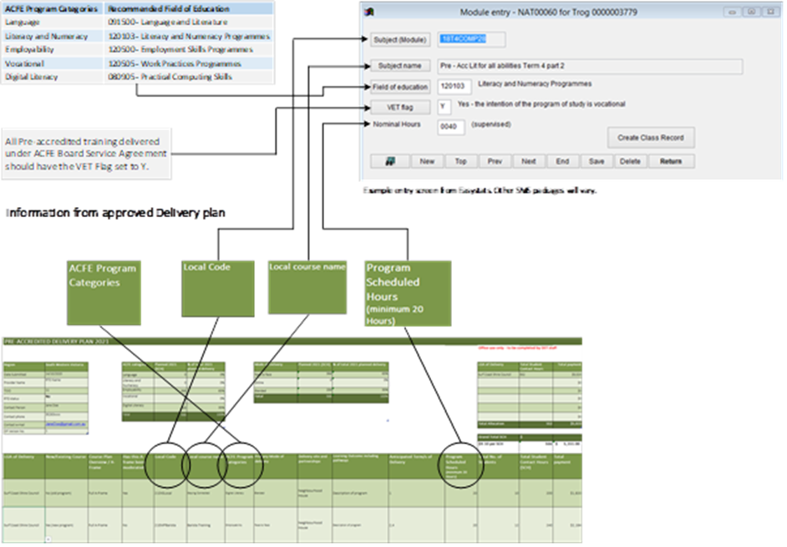

Table 2 Pre-accredited delivery Subject Code
 | ACFE Program Category | Subject code
 | Language | 21LNG[Local Code]
 | Literacy and Numeracy | 21ALN[Local Code]
 | Employability | 21EMP[Local Code]
 | Vocational | 21VOC[Local Code]
 | Digital Literacy | 21DIG[Local Code]

Table 3 LEAP delivery Subject Code
 | ACFE Program Category | Subject code
 | All Program categories | ACL21[Local Code]

Table 4 Skills for Work and Study Subject Code
 | Subject code | Program stream
 | 21SFWSCOMM | Skills for Work and Study Community Services
 | 21SFWSAGED | Skills for Work and Study Aged Care
 | 21SFWSFOODPR | Skills for Work and Study Food Processing
 | 21SFWSHEALTH | Skills for Work and Study Health Services
 | 21SFWSBUILD | Skills for Work and Study Building and Construction
 | 21SFWSCHILD | Skills for Work and Study Early Childhood Education

How can you help improve these guidelines?
The Department is committed to continually improving these guidelines to ensure they are accessible to users and have the information that encourages high-quality, timely reporting. If you have suggestions for improvement, please contact:
training.participation@education.vic.gov.au

