Student eligibility for Skills First
This fact sheet explains how you should apply Skills First eligibility rules and includes helpful example scenarios.

Eligibility requirements
To be eligible for Skills First funding, a student must be:
- an Australian citizen or permanent resident, or a New Zealand citizen
- physically present in Victoria when they’re doing training and assessment.
There are limits on how much Skills First-funded training a student can do. This aims to maximise program completions and encourage students to make informed decisions about their training and employment opportunities.
Eligibility requirements are described in the VET Funding Contract (the contract) and the Guidelines About Eligibility (the guidelines).
You must apply the eligibility requirements unless there’s an exemption in part C of schedule 1 of the contract or under any special initiatives. To grant an exemption you must follow the requirements of the relevant initiative.

Further information
Submit an enquiry via SVTS
Fact sheet: Sighting and retaining evidence of eligibility

Volume limits
To maximise program completions and encourage students to make informed decisions about training and employment opportunities, there are 3 limits on how much training a student can do:
Limit | What? | When? | Not taking into account
‘2 skill sets in a year’  The student may make a maximum of… | commencements in skill sets  (Skills First subsidised) | in a calendar year | - if a student is moving from a superseded program to the current version of the same program  - if a student is recommencing training in the same program (at either the same or a different provider)  - if a student has participated in ‘22510VIC – Course in identifying and responding to family violence risk’
‘2 AQF qualifications in a year’  The student may make a maximum of… | commencements in AQF qualifications  (Skills First subsidised) | in a calendar year | - if a student is moving from a superseded program to the current version of the same program  - if a student is recommencing training in the same program (at either the same or a different provider)  - if a student is seeking to enrol in an apprenticeship after having participated in one of the programs identified as a ‘Pre-Apprenticeship and Pathway Program’ on the Funded Programs Report
‘2 at a time’  The student may undertake a maximum of… | programs (skill sets and AQF qualifications)  (Skills First subsidised) | at any one time | - ‘22510VIC – Course in identifying and responding to family violence risk’

Example scenarios
These scenarios show examples of how to assess a student’s eligibility.

Example 1 – Mohammed wants to enrol in the Certificate II in Ecology
This calendar year, Mohammed:  - commenced and completed the Certificate II in Food Processing (Skills First subsidised)  - commenced and completed the Certificate II in Auslan (Skills First subsidised). | Is Mohammed eligible?  - NO. Mohammed has reached the ‘2 AQF qualifications in a year’ limit, so he can’t get Skills First funding for any more AQF qualifications this calendar year.  - However, he is still eligible to enrol in up to 2 Skills First funded skill sets this year.

Example 2 – Sarah wants to enrol in the Certificate III in Engineering
This calendar year, Sarah:  - continued her training in the Certificate III in Beauty Services that she started last year (Skills First subsidised)  - commenced the Certificate III in Retail this year (Skills First subsidised).  Both programs are still in progress. | Is Sarah eligible?  - NO. Sarah has reached the ‘2 at a time’ limit.  - However, she can commence the Certificate III in Engineering later in the year if she completes or withdraws from one of her current courses.  - If this happens, she will not be exceeding the ‘2 AQF qualifications in a year’ limit because she commenced the Certificate III in Beauty Services last year.

Example 3 – Stefan wants to enrol in the Certificate III in Tourism
This calendar year, Stefan:  - commenced the Certificate III in Pet Grooming (Skills First subsidised)  - commenced the Certificate III in Science (fee for service).  Both programs are still in progress. | Is Stefan eligible?  - YES. Stefan hasn’t reached the ‘2 in a year’ or the ‘two at a time’ limit, because only one of the programs he commenced this year was Skills First subsidised.

Example 4 – Nisha wants to enrol in the ‘Assist Clients with Medication Skill Set’
This calendar year, Nisha:  - commenced the Certificate II in Health Support Services (Skills First subsidised)  - commenced the Course in Supporting People with Disability to use Medications (Skills First subsidised).  Both programs are still in progress. | Is Nisha eligible?  - NO. Nisha has reached the ‘2 at a time’ limit.  - However, because Nisha hasn’t reached the ‘2 skill sets in a year’ limit, they’d be eligible for the ‘Assist Clients with Medication Skill Set’ after they either finish or withdraw from one of the other programs.

Student eligibility flowchart
This flowchart helps you understand the steps to assess eligibility. It is a guide only and doesn’t cover all individual student circumstances. Refer to the guidelines for comprehensive information on eligibility rules.

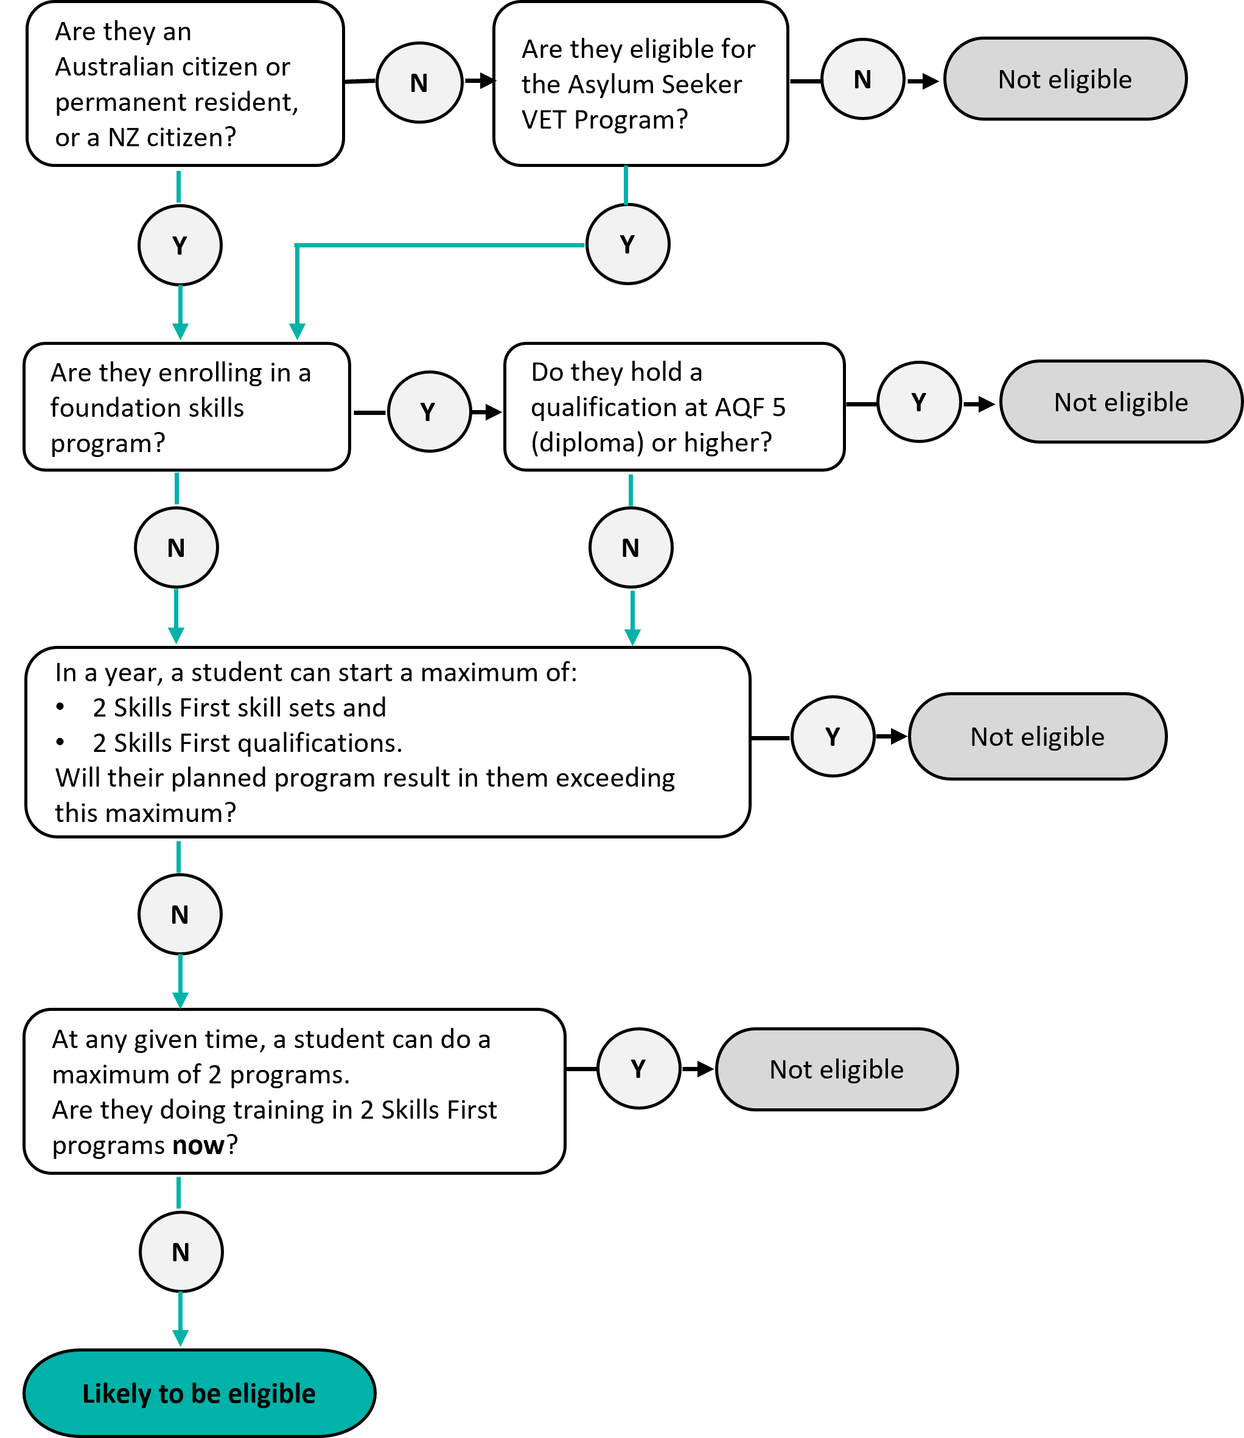

© State of Victoria (Department of Education and Training) 2022. Except where otherwise noted, material in this document is provided under a Creative Commons Attribution 4.0 International Please check the full copyright notice

