Stakeholder Kit
Teacher Recruitment Campaign
‘Teach the Future’ 2022
Contents

Teacher recruitment in Victoria 3
What can you do to help? 3
Newsletter text 3
Social Static 4
Social post sample copy 1 4
Social post sample copy 2 5
Social post sample copy 3 5
Social Carousels 5
Social carousel 1 5
Posters 6
Frequently Asked Questions (FAQs) 6
What are the English language competence requirements to become a teacher in Victoria? 6
How much will it cost me to study teaching? 6

Teacher recruitment in Victoria
The Victorian Government is looking for teachers to support and inspire the next generation.
We are encouraging people from culturally and linguistically diverse backgrounds to complete teaching courses and help inspire the next generation.
There are more than 1500 government schools in Victoria, offering different types of teaching jobs across primary and secondary schools, and specialist education.
Whether you’ve just left school or have an established career, there are pathways available to enter teaching - some post-graduate options and accelerated programs could get you teaching within 18-24 months.

What can you do to help?
You can help by:
- Sharing the materials that you can access from this stakeholder kit with your communities and organisations via your communications channels (social channels, newsletters etc).
- Directing people to the Victorian Government’s Teach the Future webpage for information: vic.gov.au/teachthefuture

Newsletter text
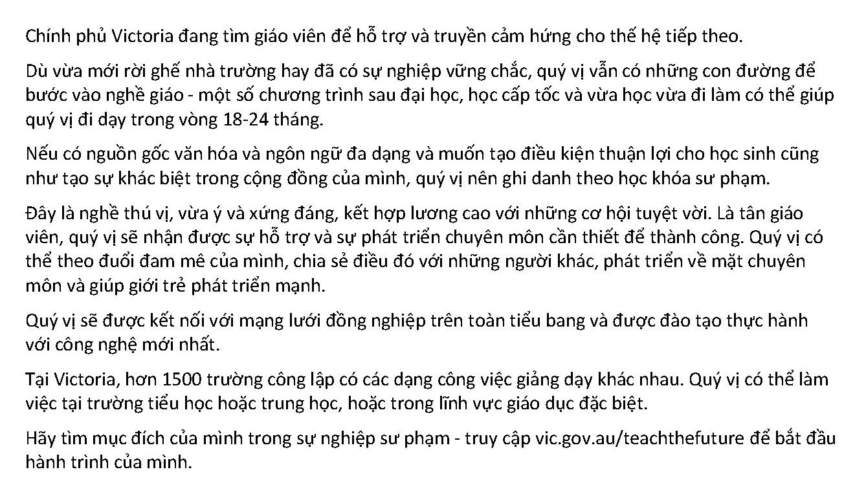

To download the newsletter article image and text, please visit:
https://www.vic.gov.au/teach-future-communication-resources

Social Static

Social post sample copy 1
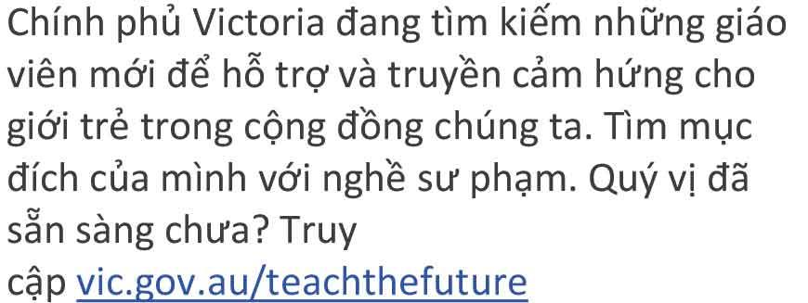

Social post sample copy 2
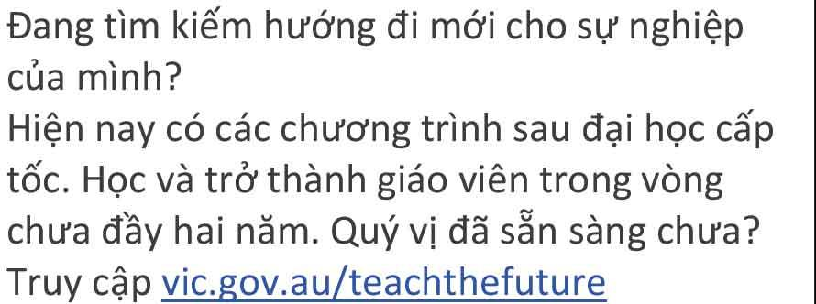

Social post sample copy 3
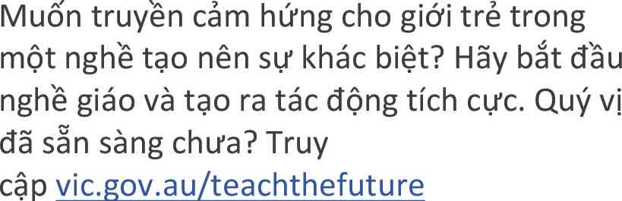

To download social media assets, please visit:
https://www.vic.gov.au/teach-future-communication-resources

Social Carousels

Social carousel
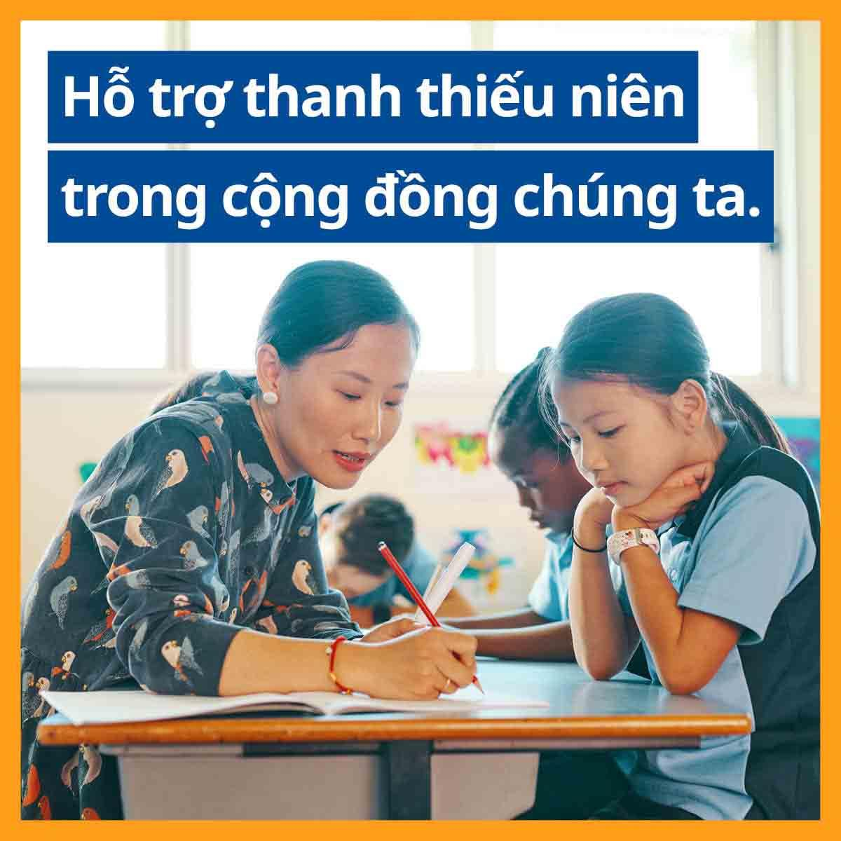
To download social media assets, please visit:
https://www.vic.gov.au/teach-future-communication-resources

Posters
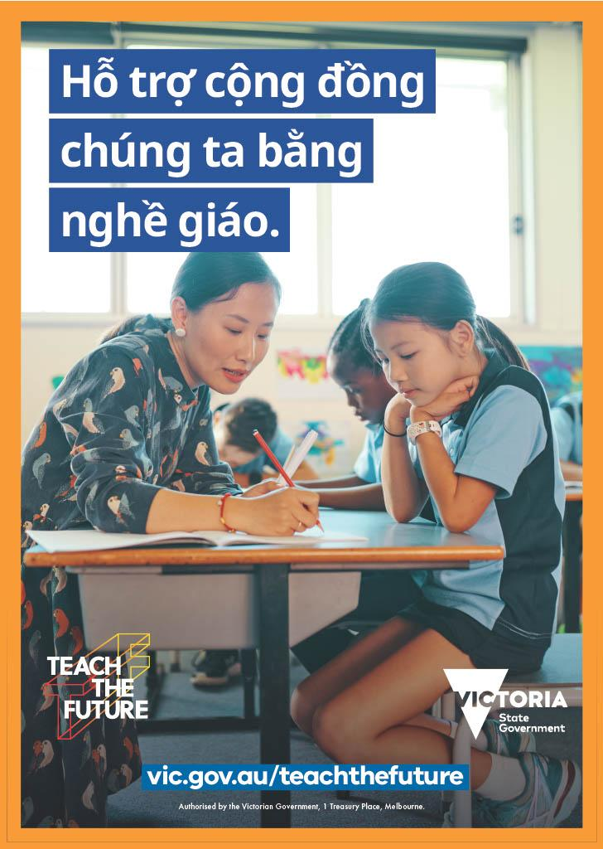 | 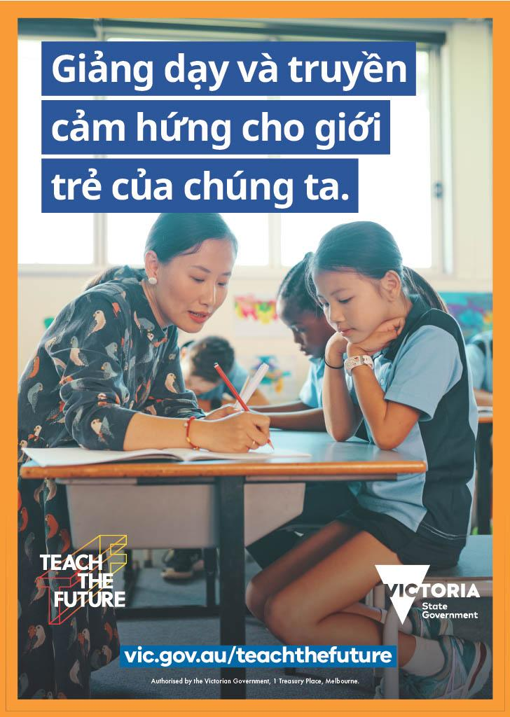
To download posters, please visit:
https://www.vic.gov.au/teach-future-communication-resources

Frequently Asked Questions (FAQs)

What are the English language competence requirements to become a teacher in Victoria?
To register as a teacher in Victoria, you need to be competent in written and spoken English. If you have completed all four years of the higher education study required for teaching registration in English at an institution in Australia, New Zealand, the United Kingdom, or the United States of America, this may be all you need.

Evidence of results from an approved English language test can also be provided for consideration or alternatively, you will need to undertake an English language test. For more information, visit Approved English Language Tests or contact the Victorian Institute of Teaching.

How much will it cost me to study teaching?
The cost of studying a teaching course is set by the individual university and can vary each year. To find out the exact cost of each teaching courses we recommend contacting the relevant university faculty of education directly.

For the full list of Victorian institutions, visit vic.gov.au/university-teaching-courses

If you enrol in a Commonwealth Supported Place studyassist.gov.au/help-loans/commonwealth-supported-places-csps, you may be eligible for HECS-HELP, to pay for your studies.

Find out more about Commonwealth Supported Places studyassist.gov.au/help-loans/commonwealth-supported-places-csps to see if you are eligible.

