Insight Assessment Platform
  - Tip sheet: Reviewing Diagnostic Assessment Tools in English (DATE) records

The Diagnostic Assessment Tools in English were developed in response to the identified need for early intervention and diagnosis in both low and high-achieving students.

Logging in
- Insight Assessment Platform: http://det.linkitau.com/
- Privacy: click I agree
- Sector: click DET

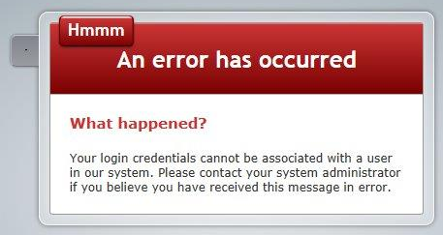
Trouble shooting
If you receive this message, check with your CASES21 operator that your User ID (T0 number) is correct in CASES21. CASES21 updates are automatically imported into Insight each night and appear in the system the following morning.
If this issue continues, escalate to your School Assessment Administrator and, if they cannot resolve the issue, contact the Service Desk:
- Service Gateway: https://servicegateway.eduweb.vic.gov.au/MSMSelfService/
- Email: servicedesk@edumail.vic.gov.au (Subject line: Insight)
- Phone: 1800 641 943.

choosing a date assessment using the EOI to date report
If your students have undertaken any of the English Online Interview (EOI) modules and you would like to undertake further diagnostic assessments, you can use the EOI to DATE report to assist you to choose particular DATE assessments for individual students.

To view the EOI to DATE report:

- Log in to Insight.
- Click on Reporting > Reporting HTML.
- On the Teacher Dashboard, drag and drop the appropriate blue EOI module rectangle to view a summary report.
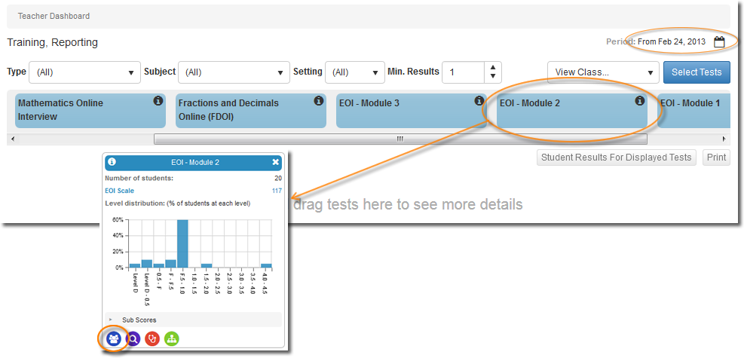

Tip: If it looks like you are missing data, you may need to adjust the reports’ time period. To do this, click on the calendar icon and adjust the calendar to your preferred dates.
- Click on the Class Profile icon .
- Select your class.
- In the View field, select DATE tools.
- For each student, you will see a selection of recommended DATE tools determined by their EOI responses. For example, in the report below the Concepts of Print assessment at Beginning level has been recommended for Sienna Brown. Students who have undertaken EOI Module 1 or EOI Module 2 will be directed to DATE’s Early Literacy in English Tools. Students who have undertaken EOI Module 3 or EOI Module 4 will be directed to DATE’s Monitoring Progress Tools.
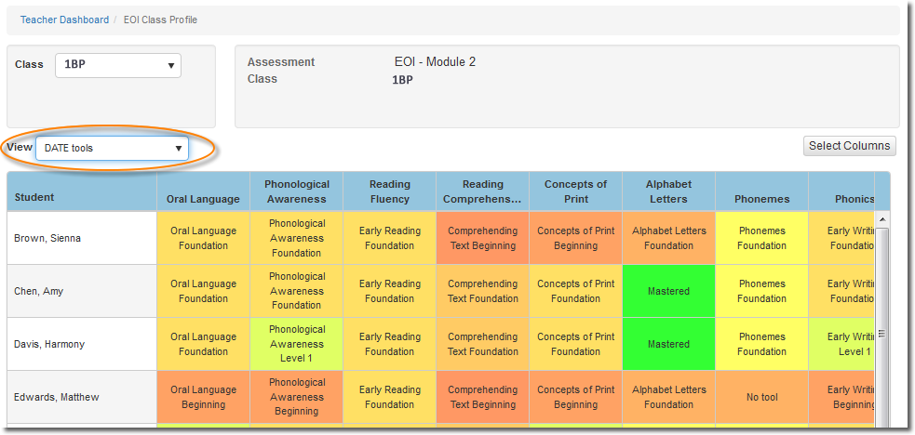

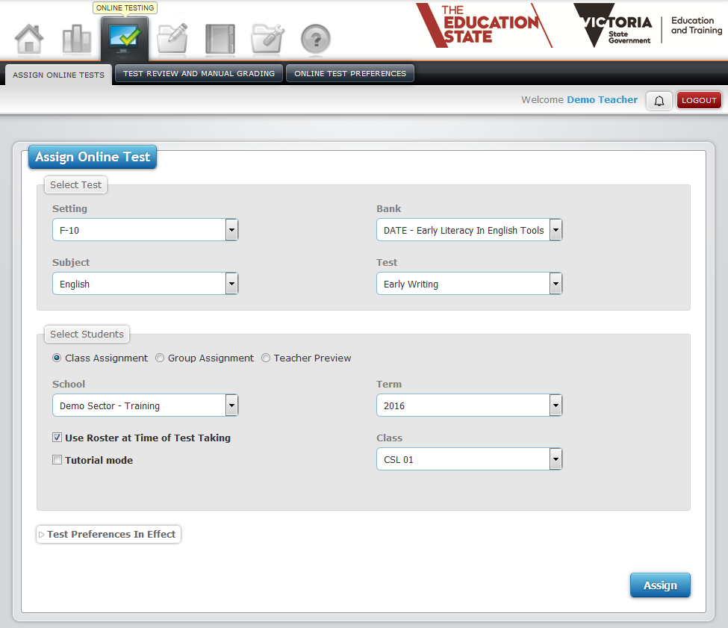
Assigning an assessment to your students

To assign a DATE assessment to your students:
- Go to Online Testing > Assign Online Tests.
- In the Select Test section:
  - Setting: F–10
  - Subject: English
  - Bank: DATE – Early Literacy in English Tools or
DATE – Monitoring Progress Tools
  - Test: Choose assessment from list. The assessment level, such as Beginning Foundation, Foundation, and Level 1, is selected for each student in the assessment itself.
- In the Select Students section:
- Choose Class Assignment
- Class: choose a class if you have more than one attached to you in Insight. Your students are automatically brought into Insight and attached to you via CASES21.
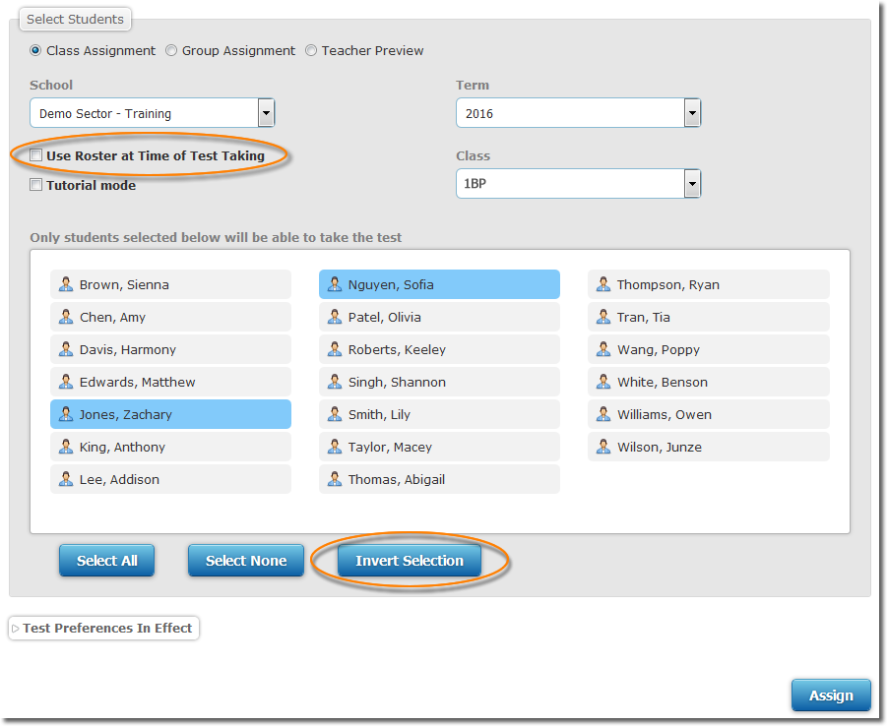
Tip: You do not need to assign assessments to your students separarately or assign the same assessment to a student multiple times. Doing so makes it very difficult to know which test codes are associated with which students and can create confusion if a student is partially assessed under multiple test codes. This can then have flow-on effects into the student’s data and reporting. If you have four students you would like to assign an assessment to, you can select those four students from your class list and assign them to the assessment. This will generate one test code, but when you go to the test taker, you will see all four students listed. Do not create multiple test codes for the same student for the same assessment. You only need to assign a student to the same assessment again if you have submitted the previous assessment and would like to reassess the student again at a later date.
- Deselect Use Roster at Time of Test Taking to display a list of your students. You can then deselect the students you do not want to undertake the assessment. Deselected students are greyed out.
- Click Assign.

Tip: If you are assigning an assessment to a small number of students, a quick way to select those students is to click on their names, which deselects them, and then click Invert Selection. This swaps around the selected and deselected students.

Assessing students using the test code
When you assign an assessment a unique test code is automatically generated and will appear at the bottom of the window. When you log out and log back in, your assigned assessments will move to Test Review and Manual Grading under the Online Testing tab.
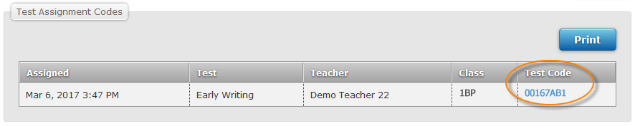

To undertake an assessment:
- Click on the test code in Insight (it’s hyperlinked), OR go to https://test.linkitau.com and enter the test code.
- You will see the list of students assigned to that assessment. Click on a student’s name and click Select to begin their assessment.
- Once the assessment is open, the first question you will be asked is to select the appropriate level for your student. The EOI to DATE report lists the appropriate level.
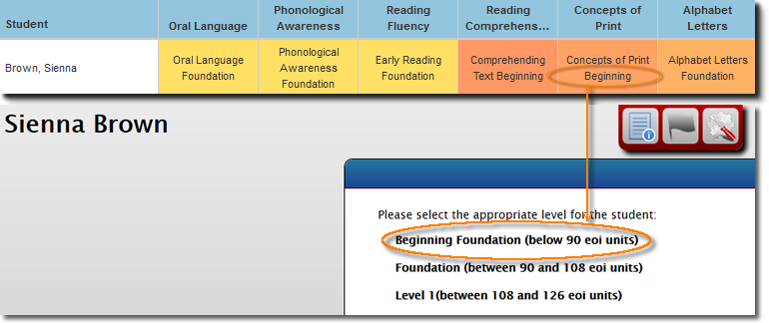
- Submit the assessment once it is completed.

reviewing DATE assessments
DATE does not produce reports in the same way that other assessments in Insight do, but you can review and create PDFs of students’ reponses for any of their DATE assessments.
To review responses for a student’s DATE assessment:
- Log in to Insight.
- Click on Online Testing > Test Review and Manual Grading.
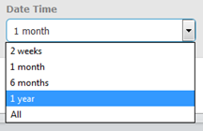
- Find the assessment you would like to look at the responses for.
Tip: You will need to change the date in the Filter Test Assignments section if the assessment was assigned more than a month ago.
- Click on the Review icon to review the assessment responses.
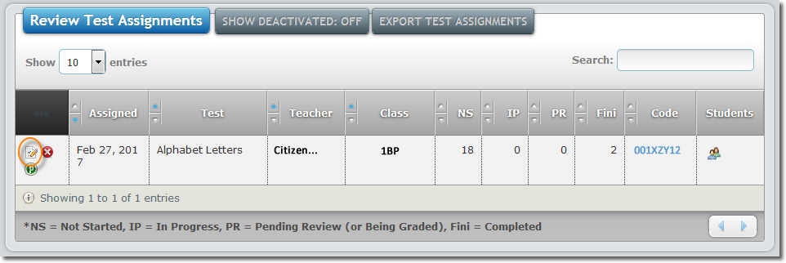
- Choose the student from the Select Student to Review filter to see their responses to individual questions. Click on a question in the Question List to see the student’s response.
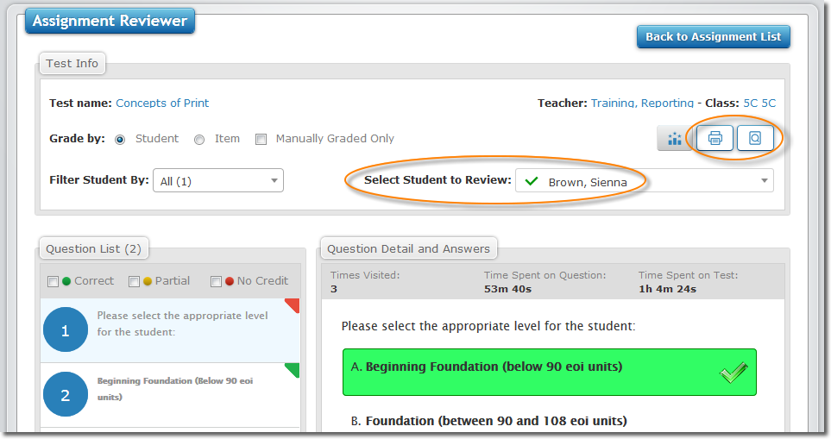
- Click on the Print icon 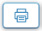 to create a PDF of the student’s questions and responses. An Options window will open so that you can choose what is printed. Click Create PDF.
- Click on the Batch Printing icon to view the status of the PDF. When the Status changes to Completed, click on Completed. This will open the PDF in your browser and you can then download or print it.

Troubleshooting
What if one or some of my students are missing from my class list?

Check with your school’s CASES21 operator that:
- your school name, class name and your details are appearing and spelled correctly
- the previous year’s staff/students have been rolled into the current year at the start of the school year.
- the eduPay task to assign User IDs (TO numbers) and email addresses to staff has been run.
- each home group has a teacher and campus ID assigned to it. (KGC11001/SCI21002)
If the above have been checked and changes have been made in CASES21, then overnight refresh of data will take place and your students should appear on Insight in the morning. If this issue continues, escalate to your School Assessment Administrator and, if they cannot resolve the issue, contact the Service Desk:
- Service Gateway: https://servicegateway.eduweb.vic.gov.au/MSMSelfService/
- Email: servicedesk@edumail.vic.gov.au (Subject line: Insight)
- Phone: 1800 641 943.

What if the assessment doesn’t open?
If the assessment does not open in your browser, try using another browser, such as Google Chrome.

While taking the assessment, the page froze.
If the assessment freezes in the middle of a session you can refresh the page using the reload/refresh function of your Internet browser. Answers are saved incrementally, so you can use the same test code to pick up at the last automatic save point in the assessment. Please make a note of any issue or inconsistency that is found and if it impacts one or more computers. If the assessment cannot be completed, students (or teachers in the case of teacher-led assessments) should reload the browser (as described above) and sign in again after a few minutes by entering the same test code to resume taking the assessment.

Images, graphs and tables in the assessment are not displayed?
In some cases, depending on the network bandwidth allocated during the assessment session, the assessment content may not fully download on each device. If this issue affects only a few devices in the classroom, please reload the assessment by logging the student or teacher out and logging back into the assessment. The assessment content should be displayed. If the assessment content is not displayed for all assessment users, the teachers should contact their school’s technical staff to confirm that firewalls are configured for Insight. School technical staff can find more information on the Insight Assess Portal: http://www.insight.vic.edu.au/Pages/support_school_IT.aspx

What if computers or the internet crash during an assessment?
In the event that you have a system crash during the session, the student or teacher should be able to reload their browser by clicking the refresh button or the back button. If these options do not work, it may be necessary to quit the browser and re-launch it a second time. After reloading, students (or teachers as applicable) may enter the same code that they originally used to resume assessment. All of previous answers should already be saved, provided that they use the same test code to enter the assessment environment.

Support
For information and resources on DATE, see: https://www.education.vic.gov.au/school/teachers/teachingresources/discipline/english/Pages/date.aspx

If you have an issue you cannot resolve, escalate to your School Assessment Administrator and, if they cannot resolve the issue, contact the Service Desk:
- Service Gateway: https://servicegateway.eduweb.vic.gov.au/MSMSelfService/
- Email: servicedesk@edumail.vic.gov.au
- Phone: 1800 641 943
You can access the Practice Space to familiarise yourself with conducting assessments on Insight. For more information, see: http://www.insight.vic.edu.au/insight-platform/using-the-practice-space
For further information about the Insight Assessment Platform, see: http://www.insight.vic.edu.au/insight-platform

About privacy
Protecting the personal information of students and staff is a serious responsibility. Schools already apply rules that govern the collection, use, storage, access and retention of this information. The privacy laws support and clarify existing good information management in schools by setting out how such information should be handled, according to Privacy Principles contained in the Privacy and Data Protection Act 2014. The Privacy Principles seek to minimise risk of misuse of personal and health information. They also give individuals some control over what happens to their information. The Department has taken reasonable steps to ensure that all personal information used by the Insight Assessment Platform is managed in accordance with the Privacy Principles.
For more information, see:
- Information Privacy Policy
http://www.education.vic.gov.au/Pages/privacypolicy.aspx
- Privacy
https://edugate.eduweb.vic.gov.au/sites/i/Pages/production.aspx#/app/content/2058/support_and_service_(schools)%252Flegal%252Ffoi,_privacy_and_copyright%252Fprivacy

Using and sharing personal information
Any person who has access to personal information about a student or staff member has a responsibility towards protecting this information. Staff should share information about a student with other staff members on a need-to-know basis and are required to report any suspected breach of privacy to senior staff or the principal.
Staff must act in accordance with the Department's privacy policies and the law when extracting personal information, such when exporting or printing data reports containing students’ names or other identifying information, from the Insight Assessment Platform. Personal information should only be extracted from Insight where necessary and should only be used for assessment purposes and for supporting students’ educational needs.
When sharing personal information, it should be done in a way that minimises the possibility of a privacy breach. For example:
- The more copies of personal information there are the more likely it is that a breach of privacy may occur. For this reason paper records should not be copied unless it is necessary to do so. When practical, identifying information should be blocked out on the copied record.
- When printing a file, remove it from the printer as soon as it is printed.
- When emailing a file, make sure the information is accurate, the person you are sending it to is authorised to receive the information and will not forward it on without your expressed permission.

Destruction of digital files and printed documents
When no longer required, paper-based and electronic documents created in, or for, the Insight Assessment Platform, such as data reports or CASES21 files, should be disposed of in a way that protects the privacy of staff and students. For example:
- Shredding, using secure disposal bins, or de-identifying documents containing personal information when no longer needed
- When deleting digital files, also delete the file from the digital device’s recycle bin.
- Be aware that your digital files may be saved in more than one place when deleting.

