Purposeful collaboration for excellence through Professional Learning Communities and Communities of Practice
“Collaboration is a powerful way to deepen educator capacity, to increase the total value of the professional capital in the school, and to harness the power of the collective.”

Overview
This Professional Practice Note provides school leaders with an insight into purposeful collaboration structures within and across schools. To drive excellence and continuous improvement in teaching and learning, school leaders and teachers can collaborate through:
- Professional Learning Communities (PLCs) within the school
- Communities of Practice (CoPs) across a number of schools
This Professional Practice Note, together with the Framework for Improving Student Outcomes (FISO) Improvement Cycle, may be a useful reference point for future planning and improvement.

What is purposeful collaboration
International evidence demonstrates that the best performing education systems are those in which the foundations for collaboration are well-established.
By recognising and strengthening collaboration at all levels of the system, an ecosystem of leaders, teachers and students who learn together is created. Student wellbeing, equity and learning are supported by empowering educators to de-privatise leadership and teaching practices, to innovate, and to co-create improvements in professional knowledge, skills and practices.
Collaboration drives practice excellence, professional learning, student-centered inquiry and deep learning. A culture of collaboration within and across schools, provides an environment in which teachers and leaders are committed to their own learning and that of their peers, while building the professional expertise required to support the diverse learning needs of all students.
Collaboration means working together to develop solutions to practice challenges. Stretching each student from their current point in their learning requires co-designing, trialling and evaluating approaches to ensure every student benefits from collective knowledge, to realise their potential.
Purposeful collaboration requires the building of collective responsibility and collective efficacy. Purposeful collaboration is underpinned by clear moral purpose, and a commitment to improvement of self and peers.
Highly effective teacher collaboration is characterised by teachers working in teams to deepen and transfer their learning through recurring cycles of inquiry, to accurately diagnose student learning needs, and respond by changing what and how they teach and assess.
Highly effective principal collaboration is characterised by leaders working in teams across schools, on a narrow improvement challenge to deepen and transfer their learning through recurring cycles of inquiry. This work allows them to accurately diagnose student learning needs, and respond by agilely changing the focus and how they lead school improvement back in their own school.

In-school collaboration in a PLC
PLCs are one of the most effective ways to build professional capital, facilitate collaboration and transfer learning between teachers.
PLCs are a collaborative approach to school improvement. Groups of teachers take collective responsibility, at the school level, to improve student outcomes through shared practice and pedagogical change.
The new Professional Learning Online Modules support the implementation of a PLC approach in all Victorian schools. School leaders and middle leaders are guided to lead changes required to deepen collaborative practices.
PLCs can connect the FISO improvement priorities in the school’s Annual Implementation Plan (AIP) and School Strategic Plan (SSP) to classroom practice through teacher Performance and Development Plans (PDP) goals that are aligned to these documents. PLCs can also make this connection through professional learning schedules.
PLCs use the FISO Improvement Cycle to participate in cycles of collaborative inquiry, focusing on data to inform changes in professional practice that improve student outcomes.

CROSS-SCHOOL COLLABORATION IN A CoP
Collaboration between schools can improve both schools’ performances more quickly than the national average.
A CoP creates a compelling space for principals and school leaders to learn together and share best practice to drive improved learning outcomes for all students. Leaders also explore and learn how best to lead this school improvement back in the structures and context of their own school.

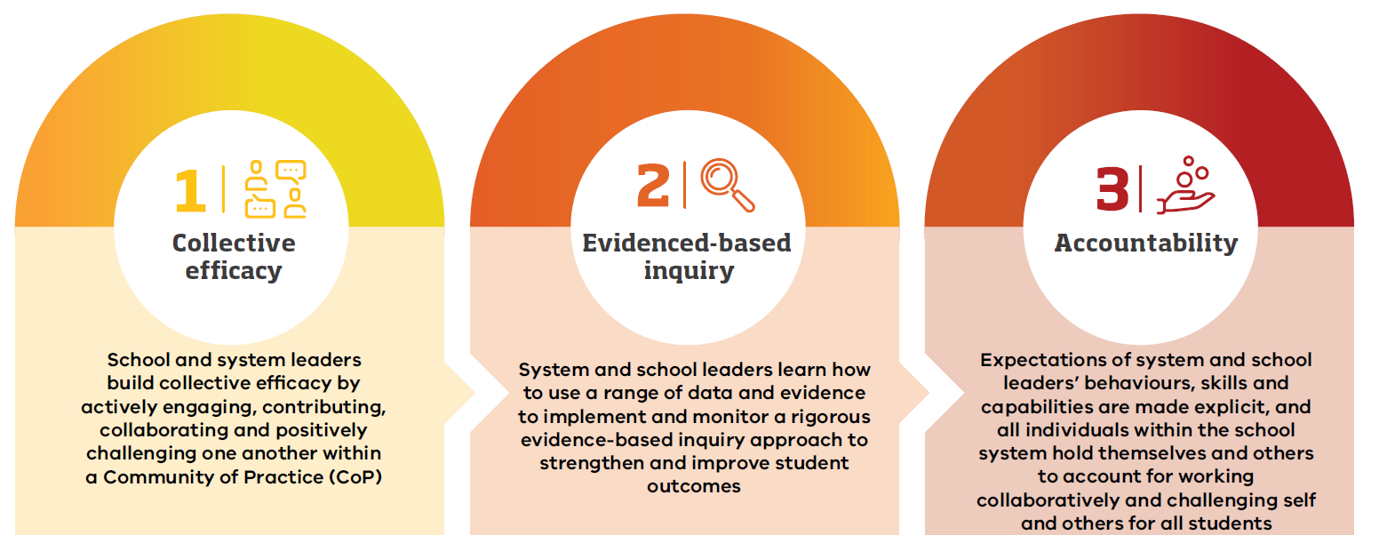

The Three Pillars identify the key foundational elements required for CoPs to be successful.
- How we work together – Leaders build collective efficacy by actively engaging, contributing, collaborating and positively challenging one another within a CoP.
- Evidence Based Inquiry (FISO Improvement Cycle) – Leaders learn how to use a range of data and evidence to implement and monitor an evidence based inquiry approach to strengthen and improve student outcomes across all CoP schools.
- Accountability – Leaders’ behaviours, skills and capabilities are made explicit, and all individuals within the CoP hold themselves and others to account for working collaboratively to challenge self and others for all students.
A CoP approach generates a culture of learning that includes building the capacity of its members’ mindsets, knowledge and practice in each of the elements to strengthen collective effort for improvement.

Advice for school leaders
Use the FISO Improvement Cycle to deepen shared understanding, monitor students’ learning growth and improve teaching practices. Effective use of the Improvement Cycle is a collaborative and professional endeavour, which can challenge teachers’ sense of professional identity and practice, ultimately leading to the improved achievement, engagement and wellbeing of all students.
Consider using the PLC Maturity Matrix, for in-school collaboration. This matrix is designed to help schools track their own progress toward becoming an effective PLC.
In all school settings, consider implementing structures and protocols that support purposeful collaboration. You may also want to consider how you can privilege time to support a range of observation practices, including peer observation and learning walks.
Support and encourage middle leaders to engage in a CoP with their peers from other schools within or across networks to enhance learning from others outside of their own context.
Consider using the Communities_of_Practice_Self-Assessment_Tool, which is designed to help networks track their own progress toward becoming an effective CoP.

Advice for middle leaders
Speak to your principal about opportunities to use a PLC approach in your school.
Work with your PLC:
- to establish a shared moral purpose
- create agreed protocols
- to put faces on the data
- to develop a collective responsibility for learning growth of all students⁷
- to plan how to scaffold, pace, stretch and lift the outcomes of all students from any starting point.
The PLC Guide: Implementing FISO with precision, collaboration and inquiry provides teachers, PLC instructional leaders (middle leaders who run PLCs) and schools leaders with the knowledge and strategies to use the FISO Improvement Cycle to monitor students’ learning growth and improve their teaching practices.
Consider initiating contact with your PLC Regional Manager to arrange visiting other PLCs within and outside your network.
_________________________
7 Sharratt, L. 2019, CLARITY: What Matters MOST in Learning, Teaching, and Leading. Thousand Oaks, California: Corwin.
In all school settings, consider:
- how you can create opportunities for your peers to observe your classroom practice
- developing a schedule that promotes when a particular practice will be modelled
- privileging time for collaboration in varied contexts.
Consider engaging in a CoP with peers from other schools within or across networks to enhance co-learning from outside of your own context.

illustrations of practice
Case Study (PLC example)
Since 2015, Victoria University Secondary College has embedded structures and supports to create an effective PLC. The school has recently developed their vision and values to lay the ground work for a cultural shift that included the development of a school-wide approach to pedagogy that would drive excellence and equity.
The PLC approach, where staff collaborate within their school, has had a very positive impact on student learning outcomes and staff collective efficacy.
Read the Case Study: Embedding purposeful collaboration within schools
Case Study (CoP example)
The Hume/Moreland network formed a CoP to collaboratively and purposefully improve student learning outcomes in numeracy. Using collective NAPLAN data, seven primary schools and two secondary schools worked together to enhance the numeracy capabilities of their students. Through the establishment of a common purpose, the CoP goal was to embed agreed consistent practices across their schools. As a result of this purposeful collaboration, data from all schools within the CoP has demonstrated common patterns of growth.
Read the Case Study: Embedding purposeful collaboration across schools and networks

resources and tools
FISO Improvement Cycle
Professional Learning Communities
PLC Professional Learning Online Modules
The PLC Guide: Implementing FISO with precision, collaboration and inquiry
PLC Maturity Matrix
Bastow's Communities of Practice System Leadership Approach
Learning About Adopting the Communities of Practice Approach
Communities of Practice Self-Assessment Tool
Leading Communities of Practice: Roles and Responsibilities
Video Case Study: How can PLCs improve teacher collaboration?
For more information, or to share your feedback on this resource, please email: professional.practice@edumail.vic.gov.au.

Sharratt, L. & Planche, B. 2016, Leading Collaborative Learning: Empowering Excellence. Thousand Oaks, California: Corwin.
Farrar, M. 2015, Learning together: The power of cluster-based school improvement. Centre for Strategic Education.
3 Hargreaves & Fullan (2012). Goddard, R. D., Hoy, W. K., & Woolfolk Hoy, A. 2004, Collective efficacy beliefs: Theoretical developments, empirical evidence, and future directions. Educational Researcher, 33(3), 3–13.
Hargreaves, A., & Fullan, M. (2012). Professional capital: Transforming teaching in every school. New York: Teachers’ College Press. 6 Bentley and Cazaly (2015)

