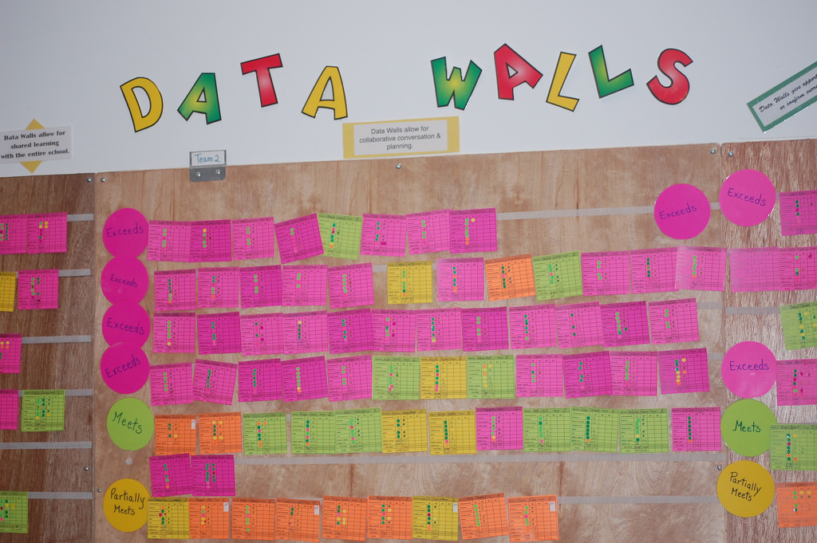
USING DATA WALLS TO TURN DATA INTO INSTRUCTION
“Data today is instruction tomorrow”.
– Dr Lynn Sharratt

Introduction to data walls
What is a data wall?
A data wall uses simple and inexpensive materials like sticky notes and masking tape to visualise individual students’ achievement over time on a physical wall.
Why use a data wall?
Building a data wall is a practical and powerful way to focus the work of every teacher on the growth and achievement of every student.
Any grouping of students, from a single class to the whole school, can form the basis of a data wall. The power of a data wall comes from including every student in that group – not just those struggling, flying or doing okay. This shifts the conversation from ‘my students in my classroom’ to ‘our students in our school’; and it shifts the motivation from ‘improving my practice’ to ‘improving our practice’.
A data wall can become the place where teachers gather to tame the torrent of data coming at them and transform it into actionable classroom strategies. Over time, this not only builds teachers’ confidence with incorporating evidence into everyday teaching – it also builds their belief in collective efficacy, that is, teachers’ collective power to improve learning outcomes for all students.
What does the research tell us?
Building collective teacher efficacy is one of the most powerful things schools can do for students – delivering three times the boost to outcomes as a privileged background.
A data wall can also overcome barriers to putting collective efficacy into practice. High-performing schools have found simple visual approaches to integrating and analysing data sources just as effective as complex IT approaches.

The building blocks of data walls
You can set up a data wall at any time. The beginning of a unit of work or a key point in a learning sequence can be a good place to start. It can also begin an inquiry-based improvement cycle for a Professional Learning Community (PLC) team.
To build a data wall:
- Find a confidential location
A data wall should be accessible to school staff only. Professional learning spaces and team preparation areas make ideal locations.
- Identify and moderate common assessments
Common assessments are the foundation of a data wall – providing the achievement yardstick to measure student growth. These can be diagnostic (like unit pre-tests), formative (running records) or summative (NAPLAN). Whatever the type, common assessments should address a Victorian Curriculum achievement standard linked to an agreed learning goal along the continuum of student learning (whole-school, year- or learning area-specific).
- Link data to individual students
Prepare a separate, physical sticky note (or card) for each individual student. Consider using coloured notes or dots to show individual student’s achievement level (using written scores makes it harder to spot patterns in the data).
More than one assessment can be represented on the sticky note. This can identify students that need support or extension across several learning areas.
- Find patterns and set learning goals
After plotting each card on the wall, look for patterns in the data. Consider using the following prompts in PLC teams:
- Generalisations: “In general, I noticed...”
- Exceptions: “Exceptions to this were...”
- Contradictions: “On the one hand....but on the other hand...”
- Surprises: “Things I was (wasn’t) expecting to see, but didn’t (did) see were…”
- Puzzles: “Things that still puzzle me that may need following up on are…”
Teams can then ask “why” these patterns might be evident, and keep asking “why” until they get to root causes they can target with instruction. These causes can be used to set learning goals for individual and groups of students, and identify professional learning opportunities for teachers.

- Map individual students’ progress
The physical act of moving an individual student’s sticky note is a tangible measure of teachers’ impact – and a powerful spur to search for the next classroom intervention to keep that note moving.
Motivating and guiding the search for improvement is an important benefit of a data wall. Updating it regularly binds that search to real and current learning needs, while being a persistent reminder that students at all levels have those needs.

Advice for school leaders
- Align data wall focus to a school improvement goal
A data wall can be a rallying point for school improvement if it measures progress towards a goal in the school AIP.
- Develop whole-school norms and protocols
Engaging staff in developing norms and protocols is a must for successful implementation. These should cover the purpose of data walls and set out clear expectations for their use by teachers, including who will update them and how often.
Norms and protocols can also support a culture of ethical and responsible data use. Schools are required to protect student privacy and maintain confidentiality of student data under the Schools’ Privacy Policy.
- Use a data wall to build data literacy
On an electronic screen, data can seem disconnected from students. On a physical wall, data is reconnected to individuals. So a data wall is more likely to lead to data-driven teaching because it connects data to teachers’ strong emotional commitment to their students.
As data-driven teaching through a data wall becomes routine, leaders can support teachers to continue building their data literacy through further professional development.
- Use a data wall to build collective responsibility for all students
Professional conversations around a data wall will ensure the learning needs of every student drive teacher learning and practice.

Advice for teachers
- Moderate assessments before they go on display
Moderation ensures the data wall displays each student’s proficiency. It also establishes a common language for discussing effective teaching, built on a consensus of what achievement standards mean, and what constitutes proficiency at each achievement level.
- Anchor professional conversations to the data wall
Consider making the data wall a standing item on your team’s meeting agenda. Even if there are no updates, just referring to it will help centre the conversation on how to move every student forward – and stop the data wall becoming a colourful record of past performance.
- Use high impact strategies to impact learning
The search for classroom interventions to keep students moving along the data wall should be guided by reliable teaching principles and strategies. The Practice Principles for Excellence in Teaching and Learning, High Impact Teaching Strategies and Literacy Teaching Toolkit draw on the best available evidence from international research, leading experts and high-performing Victorian schools.

EVALUATING DATA WALLS
As with any tool, the use of data walls should be evaluated to confirm it is having a positive impact on student learning outcomes. This can be done at both a team and whole-school level, and include classroom observations. PLC and school improvement teams might consider asking whether the data wall:
- prompts rich conversations about teaching and learning
- generates questions that lead to changes in classroom practice
- leads to the building of a new, more precise data wall
- builds a collaborative professional culture
- impacts teaching practice and student learning.

extending data walls
Like any tool, data walls can be extended to open up new opportunities for incorporating evidence into everyday teaching.
- Virtual data walls
Screen-based displays of student data can overcome some of the limitations of physical data walls:
- A data wall can show only one measure of student achievement at a time – data analysis software can combine or switch quickly between multiple measures.
- A data wall is in one place only – data stored online is available to teachers wherever they have an internet connection.
- A data wall can be time-consuming to set up and maintain – data analysis software can generate colour-coded displays at the click of a mouse, and automatically incorporate data from online assessments.

- Classroom data walls
Data walls can be opened up to students and even parents/carers. Teachers can use visual displays of carefully-selected and appropriate data to provide ongoing, learner-specific feedback that excites and engages students toward continued growth. This builds student capacity to monitor and evaluate their own progress and achievement. Before opening up your data wall, consider how it might affect the confidence and self-esteem of some students.

FOR FURTHER EXPLORATION
Many primary schools are already successfully using data walls to support literacy-related key improvement strategies in their school AIP. Introducing data walls to a large school, or a secondary school with many learning areas, can present challenges. The Department is keen to hear from leaders and teachers that are (or have ideas about) adapting data walls for these settings (see contact email address at end of note).

LINKS TO KEY EDUCATION STATE INITIATIVES
Framework for Improving Student Outcomes
Evaluating the impact of teaching on student learning is a critical step in the Framework for Improving Student Outcomes (FISO) Improvement Cycle. Analysing assessment data to guide each cycle of practice improvement is an essential element of the FISO high-impact Improvement Initiative Building practice excellence. By using data walls and other tools to monitor student learning as part of the FISO Improvement Cycle, schools can ensure the teaching in every classroom is improving the learning of every student.
Practice Principles for Excellence in Teaching and Learning
The Practice Principles for Excellence in Teaching and Learning (Practice Principles) provide a foundation for the conversations, collaborations and actions at the centre of teaching and learning. A substantial body of research links each Practice Principle to improved student achievement and motivation.
Practice Principle 6: Rigorous assessment practices and feedback inform teaching and learning supports the use of data walls and other monitoring tools to diagnose student learning needs and identify areas of practice for improvement.

Other support
This note is part of a series of professional practice notes to support school-based staff to continue improving their practice. See Professional Practice Elements for more information.
International education expert Dr Lyn Sharratt presented at the 2017 Regional Conferences on data walls. A video of the presentation can be found here.
For more information, or to share your feedback on this resource, please email: professional.practice@edumail.vic.gov.au.

Sharratt, L. and Fullan, M. (2012). Putting FACES on the data: What great leaders do! Thousand Oaks, CA: Corwin.
Visible Learning (unknown), Hattie Ranking - Interactive Visualization. Retrieved February 22, 2018, from https://visible-learning.org/nvd3/visualize/hattie-ranking-interactive-2009-2011-2015.html
Goss, P. and Hunter, J. (2015). Targeted teaching: How better use of data can improve student learning. Grattan Institute.
DET – Professional Learning Communities: http://www.education.vic.gov.au/school/teachers/management/improvement/Pages/proflearncommunities.aspx
For literacy assessment ideas and resources, see the Victorian Literacy Portal: http://www.education.vic.gov.au/school/teachers/teachingresources/literacynumeracy/Pages/literacyportal.aspx
The Knowledge Institute: https://knowledgeinstitute.co.nz/
DET – Schools’ Privacy Policy: http://www.education.vic.gov.au/Pages/schoolsprivacypolicy.aspx
Sharratt, L. and Fullan, M. (2012). Putting FACES on the data: What great leaders do! Thousand Oaks, CA: Corwin.
The Bastow Institute of Educational Leadership offers programs and courses covering data literacy: https://www.bastow.vic.edu.au/
See Principle 6: Rigorous assessment practices and feedback inform teaching and learning of the Practice Principles (op. cit.)
DET – Practice Principles for Excellence in Teaching: http://www.education.vic.gov.au/school/teachers/teachingresources/practice/Pages/principlesexcellence.aspx
DET – High Impact Teaching Strategies: http://www.education.vic.gov.au/school/teachers/teachingresources/practice/Pages/hits.aspx
DET – Literacy Teaching Toolkit http://www.education.vic.gov.au/school/teachers/teachingresources/discipline/english/literacy/Pages/default.aspx
Adapted from: Sharratt, L 2016, Data Walls: Living Wallpaper!, Sharratt Educational Group, viewed 23 February 2018,http://lynsharratt.com/text-blog/data-walls-living-wallpaper/
See Principle 3: Student voice, agency and leadership empower students and build school pride of the Practice Principles (op. cit.)
DET – Framework for Improving Student Outcomes http://www.education.vic.gov.au/school/teachers/management/improvement/Pages/FISO.aspx

