At a glance - Literacy and Numeracy
Teaching Resources

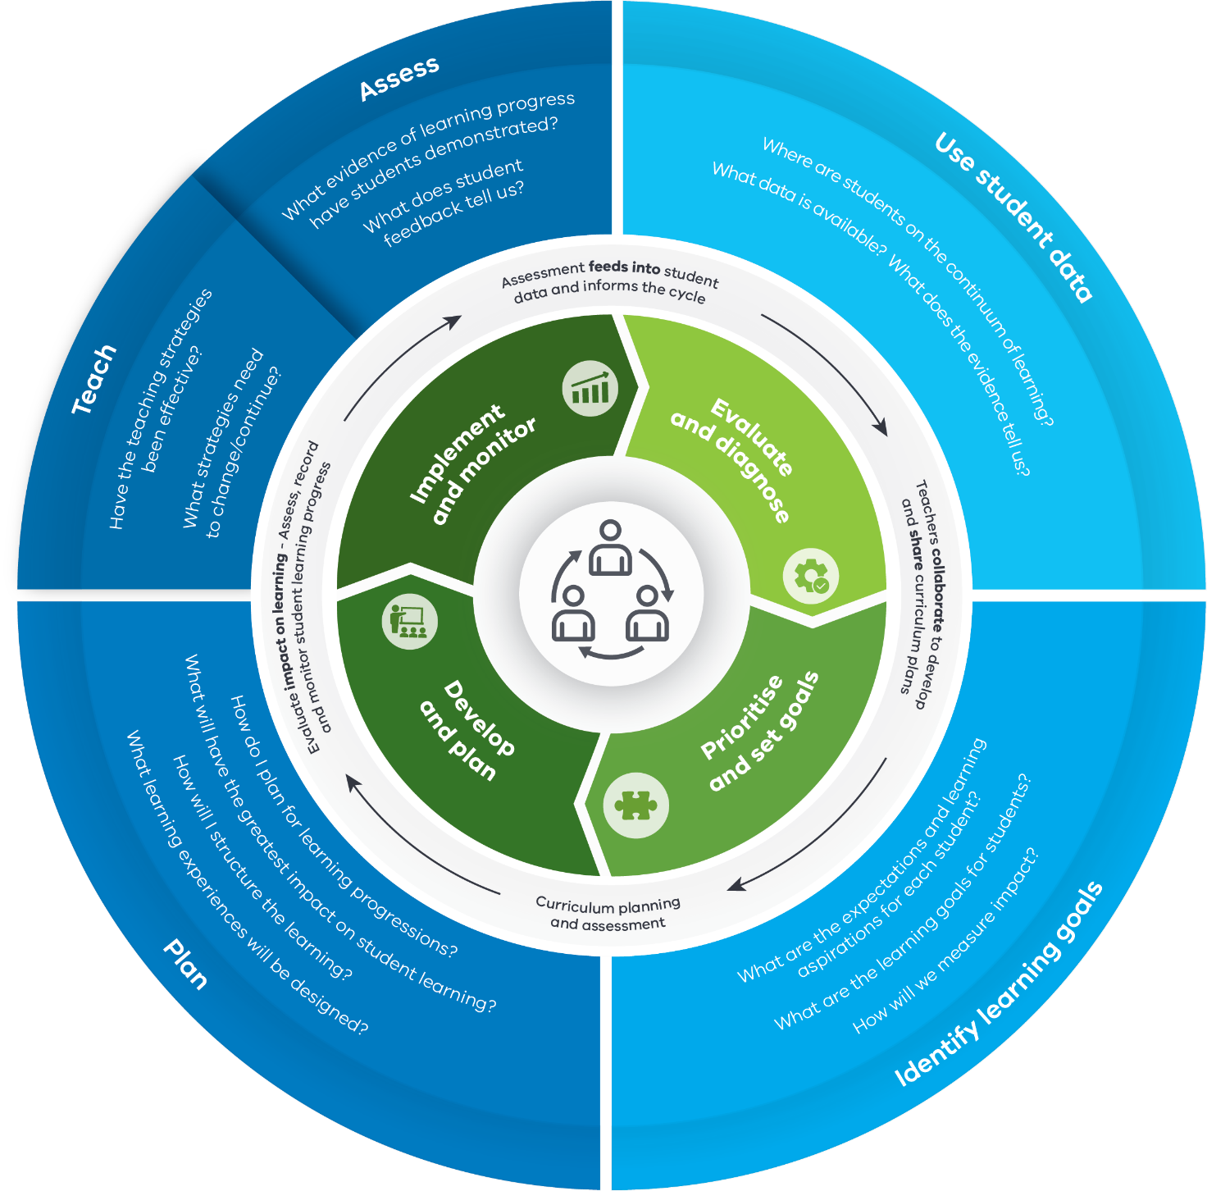

Text alternative for Literacy and Numeracy teaching resources diagram

Phase 1: Evaluate and diagnose
Teachers collaborate to develop and share curriculum plans

Use student data
- Where are students on the continuum of learning?
- What data is available? What does the evidence tell us?

Resources available:
- Insight Online Assessment Platform
- Transition Learning and Development Statements (Level F) (2018)
- English Online Interview (EOI) (Levels F-4)
- Diagnostic Assessment Tools in English (DATE) (Levels A-4)
- Abilities Based Learning and Education Support (ABLES) (Levels F-10)
- Mathematics Online Interview (MOI) (Levels F-4)
- Fractions and Decimals Online Interview (FDOI) (Levels 3-8)
- VCAA On Demand Tests English/Mathematics (Levels 3-10)
- Early ABLES (ages 2-5 for children with additional needs)
- Tools for Enhancing Assessment Literacy (TEAL)
- NAPLAN
- School based assessment data, such as:
- Validated tools
- Anecdotal evidence
- Teacher moderated student assessment tasks
- Student self reflections/interests/surveys (student voice)

Phase 2: Prioritise and set goals
Curriculum planning and assessment

Identify learning goals
- What are the expectations and learning aspirations for each student?
- What are the learning goals for students?
- How will we measure impact?

Resources available:
- Victorian Curriculum F-10 achievement standards*
- Curriculum mapping templates – English and Curriculum mapping templates – Mathematics
- VCAA Indicative progress templates – English and VCAA Indicative progress templates – Mathematics (Levels F-10)
- Literacy Learning Progressions and Numeracy Learning Progressions
- Abilities Based Learning and Education Support assessment tools - achievement advice (ABLES) (Levels F-10)
- Tools for Enhancing Assessment Literacy (TEAL)
- High Impact Teaching Strategies (HITS) including learning intentions, setting goals and success criteria
- Victorian Early Years Learning and Development Framework (Birth to 8 years)
- School based resources, such as:
- Individual Learning Plans
- 1:1 Conferences
- Student Reflections

* Foundation level (F) is inclusive of Towards Foundation levels A to D

Phase 3: Develop and plan
Evaluate impact on learning - Assess, record and monitor student learning progress

Plan
- How do I plan for learning progressions?
- What will have the greatest impact on student learning?
- How will I structure the learning?
- What learning experiences will be designed?

Resources available:
- Victorian Curriculum Content Descriptors and Achievement Standards
- Literacy/Numeracy Portal
- Literacy Teaching Toolkit
- Mathematics Teaching Toolkit (2018)
- FUSE Digital Resources (Numeracy)
- EduSTAR Catalogue
- High Impact Teaching Strategies (HITS)
- Practice Principles for Excellence in Teaching and Learning
- Victorian Early Years Learning and Development Framework Illustrative maps (Birth to 8 years)
- Tools for Enhancing Assessment Literacy (TEAL)
- VCAA Curriculum Planning Resource including
- School Planning
- Curriculum Area Planning
- Year Level Planning
- Unit/Lesson Planning
- Self Assessment tool
- VCAA sample units English (F-10)
- VCAA sample programs Mathematics (F-10)
- Scope and Sequence Charts – English and Scope and Sequence Charts – Mathematics (Levels A – 10)

Phase 4: Implement and monitor
Assessment feeds into student data and informs the cycle

Teach
- Have the teaching strategies been effective?
- What strategies need to change/continue?

Resources available:
- High Impact Teaching Strategies (HITS)
- Teaching and Learning Tool Kit
- Abilities Based Learning and Education Support (ABLES) (Levels F-10)
- Early ABLES teaching advice (ages 2-5 for children with additional needs)
- Tools for Enhancing Assessment Literacy (TEAL)
- Literacy Leaders’ Guide (ePub)
- Literacy Teaching Toolkit
- Mathematics Teaching Toolkit
- Practice Principles of Excellence in Teaching and Learning

Assess
- What evidence of learning progress have students demonstrated?
- What does student feedback tell us?

Resources available:
- Insight Online Assessment Platform
- Transition Learning and Development Statements (Level F)
- English Online Interview (EOI) (Levels F-4)
- Diagnostic Assessment Tools in English (DATE) (Levels A-4)
- Abilities Based Learning and Education Support (ABLES) (Levels F-10)
- Early ABLES (ages 2-5 for children with additional needs)
- Mathematics Online Interview (MOI) (Levels F-4)
- Fractions and Decimals Online Interview (FDOI) (Levels 3-7)
- VCAA On Demand Tests English/Mathematics (Levels 3-10)
- Tools for Enhancing Assessment Literacy (TEAL) (Levels F-10)
- NAPLAN
- VCAA Annotated Work Samples in Reading and Viewing
- School based assessment such as:
- Feedback and reflection
- Student self assessments
- Student Portfolios
- Validated tools
- Anecdotal evidence
- Teacher moderated student assessment tasks
- Student self reflections/interests/surveys (student voice)

Return to Literacy and Numeracy teaching resources diagram

Resource URLs

http://www.insight.vic.edu.au/insight-platform
http://www.education.vic.gov.au/childhood/professionals/learning/Pages/transitionstat.aspx?Redirect=1
http://www.education.vic.gov.au/school/teachers/teachingresources/discipline/english/assessment/Pages/default.aspx
http://www.education.vic.gov.au/school/teachers/teachingresources/discipline/english/Pages/date.aspx
http://www.education.vic.gov.au/school/teachers/support/diversity/Pages/ables.aspx
http://www.education.vic.gov.au/school/teachers/teachingresources/discipline/maths/continuum/Pages/mathsinterview.aspx
http://www.education.vic.gov.au/school/teachers/teachingresources/discipline/maths/continuum/Pages/fracdecint.aspx
http://www.vcaa.vic.edu.au/Pages/prep10/ondemand/index.aspx
http://www.education.vic.gov.au/school/teachers/learningneeds/Pages/ablesassessment.aspx
http://teal.global2.vic.edu.au/
https://www.nap.edu.au/
http://victoriancurriculum.vcaa.vic.edu.au/overview/curriculum-design/standards-and-levels
http://www.vcaa.vic.edu.au/Pages/foundation10/viccurriculum/english/englishcmt.aspx
http://www.vcaa.vic.edu.au/Pages/foundation10/viccurriculum/maths/mathscmt.aspx
http://www.vcaa.vic.edu.au/Pages/foundation10/viccurriculum/english/cpa.aspx
http://www.vcaa.vic.edu.au/Pages/foundation10/viccurriculum/maths/cpa.aspx
http://www.vcaa.vic.edu.au/Pages/foundation10/viccurriculum/literacy/intro.aspx
http://www.vcaa.vic.edu.au/Pages/foundation10/viccurriculum/numeracy/intro.aspx
http://www.education.vic.gov.au/school/teachers/support/diversity/Pages/ables.aspx
http://teal.global2.vic.edu.au/
http://www.education.vic.gov.au/school/teachers/teachingresources/practice/Pages/hits.aspx
http://www.education.vic.gov.au/childhood/providers/edcare/Pages/veyladf.aspx
http://victoriancurriculum.vcaa.vic.edu.au/overview/curriculum-design/standards-and-levels
http://www.education.vic.gov.au/school/teachers/support/Pages/litnum.aspx
http://www.education.vic.gov.au/school/teachers/teachingresources/discipline/english/literacy/Pages/default.aspx
http://www.education.vic.gov.au/school/teachers/teachingresources/practice/Pages/principlesexcellence.aspx
http://fuse.education.vic.gov.au/pages/numeracyresources
https://www.edustar.vic.edu.au/Catalogue/Pages/SoftwareHome.aspx
http://www.education.vic.gov.au/school/teachers/teachingresources/practice/Pages/hits.aspx
http://www.education.vic.gov.au/school/teachers/teachingresources/practice/Pages/principlesexcellence.aspx
http://www.vcaa.vic.edu.au/Pages/earlyyears/vfldoutcomes/index.aspx
http://teal.global2.vic.edu.au/annotated-units-of-work/integrating-assessment-teaching-and-learning/
http://curriculumplanning.vcaa.vic.edu.au/
http://curriculumplanning.vcaa.vic.edu.au/by-school
http://curriculumplanning.vcaa.vic.edu.au/by-curriculum-area
http://curriculumplanning.vcaa.vic.edu.au/by-year-level
http://curriculumplanning.vcaa.vic.edu.au/by-unit-lessons
http://curriculumplanning.vcaa.vic.edu.au/sat/self-assessment-tool
http://www.vcaa.vic.edu.au/Pages/foundation10/viccurriculum/english/teachresources.aspx
http://www.vcaa.vic.edu.au/Pages/foundation10/viccurriculum/maths/teachresources-about.aspx
http://victoriancurriculum.vcaa.vic.edu.au/english/introduction/scope-and-sequence
http://victoriancurriculum.vcaa.vic.edu.au/mathematics/introduction/scope-and-sequence
http://www.education.vic.gov.au/school/teachers/teachingresources/practice/Pages/hits.aspx
http://evidenceforlearning.org.au/the-toolkit/
http://www.education.vic.gov.au/school/teachers/learningneeds/Pages/ables.aspx
http://www.education.vic.gov.au/school/teachers/learningneeds/Pages/ablesintegrating.aspx
http://teal.global2.vic.edu.au/professional-learning/involving-learners-actively-in-assessment/
https://www.bastow.vic.edu.au/leadership-initiatives/literacy-leader-learning-suite
http://www.education.vic.gov.au/school/teachers/teachingresources/discipline/english/literacy/Pages/default.aspx
http://www.education.vic.gov.au/about/programs/learningdev/vicstem/Pages/numeracyportal.aspx
http://www.education.vic.gov.au/school/teachers/teachingresources/practice/Pages/principlesexcellence.aspx
http://www.insight.vic.edu.au/insight-platform
http://www.education.vic.gov.au/childhood/professionals/learning/Pages/transitionstat.aspx
http://www.education.vic.gov.au/school/teachers/teachingresources/discipline/english/assessment/Pages/default.aspx
http://www.education.vic.gov.au/school/teachers/teachingresources/discipline/english/Pages/date.aspx
http://www.education.vic.gov.au/school/teachers/learningneeds/Pages/ables.aspx
http://www.education.vic.gov.au/school/teachers/learningneeds/Pages/ablesassessment.aspx
http://www.education.vic.gov.au/school/teachers/teachingresources/discipline/maths/continuum/Pages/mathsinterview.aspx
http://www.education.vic.gov.au/school/teachers/teachingresources/discipline/maths/continuum/Pages/fracdecint.aspx
http://www.vcaa.vic.edu.au/Pages/prep10/ondemand/index.aspx
http://teal.global2.vic.edu.au/
https://www.nap.edu.au/
http://www.vcaa.vic.edu.au/Pages/foundation10/viccurriculum/english/readingsamples/readingsamples.aspx

