TARNEIT P-9 COLLEGE
Tarneit P-9 College is located in the western suburbs of Melbourne in the local area of Wyndham. The school experienced significant growth from an initial enrolment of 330 students in 2013 to over 2000 students in 2019. Maintaining consistency and a high standard of teacher practice through this growth period required focused effort.

Student Centred Coaching

Since it opened in 2013, Tarneit P-9 College has built a culture of continuous improvement and professional growth for every staff member, with a sharp focus on the teaching of literacy and numeracy through an agreed school-wide teaching model. The school established four key aspects of this culture:
- professional learning teams work effectively
- instructional coaching is embraced
- a culture of feedback is encouraged
- a guaranteed, documented curriculum is in place, supported by an agreed pedagogical approach, with a rigorous assessment schedule.
From the school’s opening, the principal and leadership team determined that staff should set and achieve ‘high expectations and more than one year’s growth for all students’ as the foundation for their work.

Adopting a coaching model
School leaders researched different coaching models and decided on an approach based on Dianne Sweeney’s work, Student Centred Coaching. The key factor in this decision was that this model placed the student at the centre and provided an opportunity (using student data) to measure and monitor the impact of the coaching program across the school. They adopted the student centred coaching approach, adapted to Tarneit P-9 College’s context, in 2015.
Student centred coaching is an in-depth examination of the learning needs of a specific student or group of students. It is the students’ learning journey that is at the centre of the coach and teacher’s work together.
After the initial trial of the coaching program, the Curriculum and Pedagogy team took responsibility for embedding the coaching work in 2016 with the establishment of four coaching teams. While the teams’ roles and responsibilities were similar, they worked in different curriculum and pedagogy areas: English, Mathematics, Instructional and Engagement. Coaching became part of the school’s core business.
From 2016, school leaders reduced the teaching load of designated coaches to enable them to focus on their coaching role. In addition to the weekly Curriculum and Pedagogy team meeting, all coaching teams continue to meet with an Assistant Principal each week to map out what they will be working on in the next week.

The Whole coaching cycle
Preparation for the coaching cycle
The school surveys teachers at the beginning of each year. Through the survey, teachers indicate when they would like coaching, what they felt they are/are not competent in, what they would like to do, and what they need. The initiative enjoys significant staff support and all teachers are keen to participate.
The school runs professional learning sessions on coaching. Teachers receive a coaching handbook which provides information on the teacher/coach pre-coaching agreement and the coaching tracker that records the strategies and data used in the coaching cycle.
Developing a pre-coaching agreement
Each teacher identifies a specific student or group of students who will be the focus of the coaching cycle. The teacher uses their student data to identify a focus, discusses the desired improvement with the coach and then together they gather any additional information.
After this discussion, the coach goes into the classroom to gauge if the teacher is on the right track with their analysis of student learning needs. The coach provides constructive feedback to the teacher and together they work out what they hope to see the student/s doing as a result of the coaching partnership.
They set a goal around a particular student outcome and break down what the goal means in terms of discrete learning targets. They also identify the data and evidence needed to monitor progress and achievement of the goal during the coaching cycle.
The type of data used in coaching depends on the focus of the coaching cycle. For example, the coach may review a writing sample at the start and at the end of the coaching cycle, to check the impact of the practices or strategies implemented during the coaching cycle.
The coaching cycle
The coach and teacher work through a six to eight week cycle, usually following a discrete unit of work or topic happening in the classroom.
The teacher and coach meet weekly to work collaboratively through the cycle. The coach provides support through planning,
co-teaching and modelling parts of the lesson. The coach also observes and provides feedback to further support the teacher in monitoring impact on the selected student/s.
“For me the most helpful aspect of the coaching cycle would be that authentic relationship that you develop with the coach. You get to work with them.”
Christelle, teacher
Post-coaching assessment
At the end of the coaching cycle the teacher and coach collaboratively analyse student data and evidence of progress and achievement of the desired goals.
Coaches also gather feedback, suggestions to improve the coaching process and identify missed opportunities through a formal survey completed by the teacher at the end of the coaching cycle.
This provides a great opportunity for reflection and consideration of how coaching affects instructional practice in the short and long-term.

The coach role

Data and curriculum
In addition to the work coaches do with individual teachers they work within a range of school structures to support improvement in student outcomes.
Coaches analyse school data to identify areas in need of improvement and play a key role in undertaking NAPLAN question analysis to identify possible skills gaps from Years 7 to 9.
They keep up to date with educational research, delivering professional learning to address skills gaps and modifying curriculum if needed. They support staff moderation practices, and source and strategically share professional readings.

Parent/carer engagement
Coaches also run workshops for parents to update them on changes in the curriculum and research, and engage them in their child’s/children’s learning.
In 2018, coaches delivered workshops for parents on:
- How to support reading at home
- How to support vocabulary learning
- STEM
- Mathematics.

‘I think parent involvement in students’ education is really important and the more we can get parents in through the door and engaged, I think that really has benefits for the students’
Lucy, English coach

Signs of Impact
NAPLAN assessment results for student cohorts between Years 5 and 9 show that Tarneit P-9 College has steadily improved student outcomes in Reading and Numeracy, with:
- a 33 percent reduction in the percentage of students in the bottom two bands in NAPLAN Reading assessment from Year 5 to Year 9
- a 27 percent reduction in the percentage of students in the bottom two bands in NAPLAN Numeracy assessment from Year 5 to Year 9.
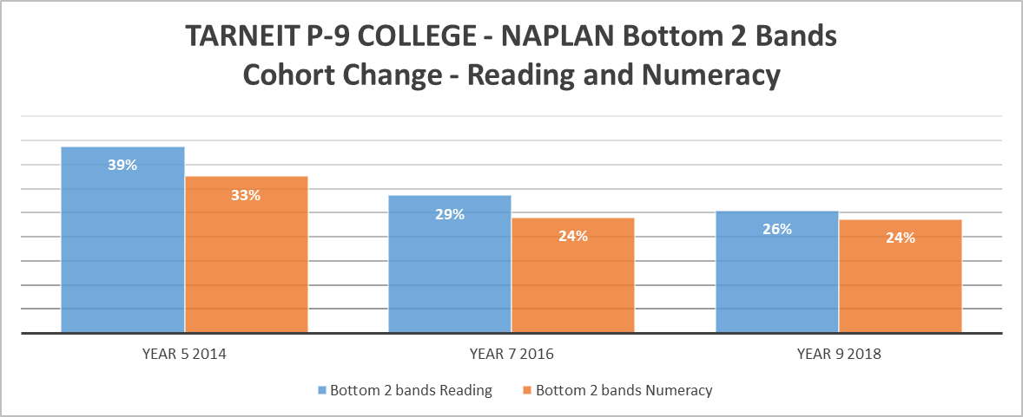

Sweeney, D. (2011), Student-Centered Coaching: A Guide for K-8 Coaches and Principals, SAGE Publications Inc.

