Swan Hill College
Swan Hill College is a single campus Year 7–12 coeducational school located in the regional town of Swan Hill, in the North Western Victoria Region. In 2012, student data showed that students with lower literacy levels were not achieving a full year’s growth and teachers felt ill-equipped to teach foundational literacy skills.

Whole school literacy

Determining where to start
Two Leading Teachers within the English Key Learning Area (KLA), Lisa and Julie, identified that teaching practice needed to improve to achieve student improvement at the expected rate. They shared their belief that it was essential for the school to embrace literacy as a shared responsibility and invest in building teacher capability.
Lisa and Julie recognised the challenge of implementing a whole school literacy approach within a subject-based KLA environment. At the Bastow Institute of Educational Leadership (Bastow), they studied a number of different theories of change in the Leading Literacy course and were particularly influenced by research showing the value of an iterative process in achieving successful change of practice in schools.
Lisa developed a proposal for school leaders on a whole school approach to improving literacy instruction. School leadership endorsed the proposal, agreeing to implement two key initiatives for a whole school approach in 2013.
- A whole school focus on literacy through the Professional Learning Teams (PLT).
- Professional development sessions for the English KLA on teaching reading comprehension.

Previous structures and processes

Professional Learning Teams
From 2013, KLA-based PLT meetings included professional learning twice per term on strategies to improve instruction on academic vocabulary based on Dr John Munro’s High Reliability Literacy Teaching Procedures. These sessions were supported with an observation and feedback cycle.
Consistent messaging was vitally important in securing the buy-in of teachers across KLAs to the importance of a whole school approach to literacy. Lisa did mini sessions in PLT meetings at various times, providing updates on work underway within the English KLA and how it was helping teachers in the classroom.
The Teaching and Learning School Improvement Team regularly reviewed progress on the whole school literacy focus in PLTs and adapted the implementation accordingly. This included narrowing the literacy focus of PLTs to engaging boys with literacy during 2014-15.

Professional Learning Communities
Swan Hill College joined the Professional Learning Communities (PLC) pilot program in August 2016. The PLC structure has built purposefulness within the school, teaching teachers to apply the FISO Improvement Cycle.
PLTs transformed into PLCs at Swan Hill College and they progressively worked on the High Impact Teaching Strategies (HITS) through a literacy lens, with questioning as the inquiry focus in Term 2 and 3 of 2018.
The practical focus on literacy in PLCs helped strengthen buy-in from teachers. The cross-disciplinary nature of the PLCs and small PLC teams also supported richer professional conversations within the school.
PLC literacy professional learning included whole staff, mandatory sessions with session materials circulated via email to all staff. Teachers brought evidence of student learning to PLC meetings to discuss the impact of their practice. In some cases, they also trialled particular practices in the classroom to then share their learning with the PLC the next week.
PLCs continue to meet seven times per term and run three inquiry cycles in the year - Term 1 reviews the previous year with Terms 2 and 3 focusing on new learning. Term 4 is reserved for curriculum planning. Each inquiry cycle includes an observation phase prior to reflection at the end of the term. Each meeting follows a similar structure and is aligned to the annual plan for PLC activity.
The PLC work is connected to staff Performance and Development Plans through the literacy and numeracy goals in the Annual Implementation Plan. The PLC literacy focus built a whole school awareness and recognition of the importance of literacy. Teachers get ongoing communication about the literacy support program and general information on useful strategies for students with higher literacy support needs.

System and structural supports
PLC initiative professional learning encouraged the team to keep learning and sharing. The two leading teachers responsible for the PLC were given a time allowance of five lessons per week, which included time for PLC planning. This planning time helped scaffold literacy professional learning. The instructional materials developed for the whole school literacy focus were made available to new staff, embedded in the curriculum and modelled through the junior years reading classes.
The school also introduced a collaborative platform (Office 365 Teams) to facilitate the PLC teams’ work.
For many high school teachers, adopting such pedagogy requires a shift, not only in their behaviour but also in their associated beliefs and values. To the extent that math and science teachers believe that the teaching of literacy is the job of the English department… These beliefs go to the heart of professional identity…and touch on professional capabilities that go well beyond science and math teaching.

Practice change
The PLC focus on literacy and HITS uncovered some underlying issues for teachers across the different KLAs. In working through the PLC focus on questioning, one maths and science teacher, Jesse, identified that a student couldn’t work through a maths problem on the board because the student was unable to spell key terms used in the problem. Understanding that informed how Jesse differentiated his teaching for that student.
His own capability to support students in their literacy has grown with the professional learning in PLCs. He is now more conscious of reading strategies and has been able to apply some of the broader strategies, such as getting knowledge ready, using visual aids, and predicting text and concepts, in his maths and science classes.
Jesse values the whole school literacy approach and recognises the importance of literacy support for students with higher literacy support needs.

Building teacher capability

Lisa knew there was variability of literacy instruction across the school through her lead role in curriculum and assessment.
The school had literacy coaches within the English KLA prior to 2010 but there had been limited visibility of what coaches were doing in individual classrooms and, as a consequence, practice change had not filtered consistently through the English KLA. Overcoming the variability in practice between teachers required a change in approach to encourage teachers to work and develop together. Collective learning was imperative in achieving consistency of message and practice, and allowing teachers to scaffold the development of the team.
The Bastow Leading Literacy course exposed Lisa and Julie to research on the nature of literacy and how it is acquired, providing guidance on how to identify and plan a literacy initiative. The course included information on effective pedagogical approaches to maximise student outcomes and the leadership models and frameworks that facilitate change in teaching and learning.
Travelling from Bastow to Swan Hill after each module of the course gave them valuable reflection time to discuss what they had learnt and how they could bring a whole school approach to literacy to Swan Hill College.
They decided to start the work with a strong focus on the teaching practice in the English KLA, based on two key cultural factors:
- English KLA teachers already held the belief that literacy was part of their work.
- There was established professional trust between Lisa, Julie and the English KLA.
These factors provided Lisa and Julie with a distinct advantage, allowing them to learn and take risks within the safe space of their own team, and focus effort on practice change.

Professional trust supports professional learning
Lisa recognised that the English KLA as a group was receptive to learning and ready to engage with new practices. One of the most experienced teachers within the KLA was very engaged, and that helped model the approach to professional learning for the less experienced teachers. The trust and commitment to professional learning that existed within the team made it the ideal setting to pilot the literacy initiatives.
Professional learning sessions for the English KLA started in 2012 and were intensified in 2013 with the introduction of the additional time release approved by school leadership.
Reviewing student data made it clear that they needed to teach foundational literacy skills. The allocation of a time allowance showed the importance that school leadership placed on this initiative, and recognised the English KLA’s role in piloting this work. This supported teacher engagement and explicitly reinforced the importance of literacy within the school.
Lisa used the school’s instructional model as the organising framework and modelled the classroom practices that the English KLA teachers were trying to learn in the professional learning sessions. She monitored and responded to the level of teacher engagement in the professional learning, adjusting the structure of these sessions as she learnt to build in time for teachers to plan their next steps and share ideas.
Classroom observations of practice supported professional learning in two to three week cycles. Protocols were put in place to frame the observations as a way to share practice. In each observation, there was a clear focus on a specific practice identified in the professional learning session rather than on teacher performance. Lisa emphasised to staff that they were trialling practices and learning together through this process.
The structure of the observations reinforced this message. They were designed to feel less like conventional peer observation and more like an additional teacher coming in to work alongside the teacher with students. This strategy built teacher confidence in the process and modelled specific literacy teaching practices in the classroom.

Leadership support
The existing year leader structure supported the work across the English KLA. Year leaders took responsibility for building the reading strategies into their year level materials, which helped keep the momentum of practice change going.
There was also demonstrated leadership support from the principal who attended some of the professional learning sessions in 2014. Teachers felt that the work they were doing was important and recognised, and that the principal understood that they were investing in their own professional learning.

Sustained engagement
Teacher feedback through the Performance and Development Plan (PDP) process reflected higher levels of teacher confidence and positive feedback on the professional learning. Teachers found it relevant and useful, a belief that translated into action when the majority of English KLA staff involved in professional learning and observations in 2013 participated again in optional sessions delivered in 2014.

Reading program

Development

Early stages of the reading program
A reading program had developed progressively at the school from 2013, with different strategies and models being trialled by staff. It was linked to the general studies classes and initially consisted of free reading lessons conducted in the library.
These lessons had variable success. It was difficult to facilitate independent reading and get students to read aloud, particularly when reading levels of students in any one class could span from Foundation to Year 10. English KLA teachers also observed differing levels of student engagement and beliefs about the value of reading.

Strategic use of resources
The allocation of equity funding in 2016 provided the opportunity to further develop the reading program. The new program design included two interventions supporting a high degree of differentiation to meet students’ learning needs. These interventions were split into:
- a junior years reading program
- a targeted literacy support program.
School leaders assigned Lisa and Julie as reading teachers and established a dedicated reading classroom within the school’s learning centre. Lisa and Julie believed it was important to make the reading classroom an enjoyable reading space and established an in-class library stocked with a selection of books from the school’s main library.

Junior years reading program
Dedicated reading classes for all Year 7 and 8 students were timetabled weekly as part of general studies, focused on reading comprehension skills and reading time. Strategies used in the class included:
- Student journals capturing reflections on their reading.
- Reading records (common assessment).
- Reading diaries signed off by parents and carers for their child once a week.
- Goal setting with students at the end of each term.
- Reading behaviour modelled by teachers who shared reflections on their own reading.
- Students’ selection of reading books facilitated by having a photocopied first page of a number of books to read.
Reading teachers led the class with the general studies teacher assisting them. This allowed reading teachers to demonstrate literacy strategies to general studies teachers within the framework of the school’s instructional model.
Drawing on the Victorian Curriculum F-10, reading teachers developed a scaffolded curriculum that set out what would be taught in the reading classes and made it available to other teachers in the school on a shared drive.
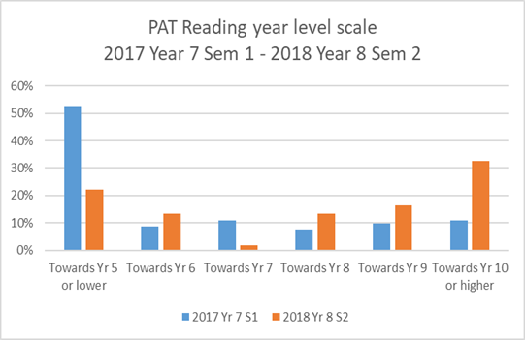
Reading teachers engaged in ongoing research to identify resources that would engage students. Reading circles with staff were introduced to support a culture of valuing reading. This practice contributed to identifying mini class reading sets. The classroom library, which originally followed the Dewey system, was sorted by genre headings in 2017 for ease of access by students to books that interested them.
Lisa and Julie saw the language used by general studies teachers change as the new knowledge and language they gained from the reading program transferred into the general studies classes. This common language strengthened the links between the reading program and general studies.
School leaders also observed that parents booked in parent/teacher interviews with reading teachers, a clear indicator that parents also saw value in the program.

Data and assessment
Reading teachers regularly surveyed Year 7 and 8 students on their attitudes to reading using Pivot. Benchmark assessment was also undertaken twice a year, in February and August, to monitor student growth.
Reading teachers reviewed this data together with NAPLAN data, reading data from primary schools and interviews with each student to identify and monitor student learning needs. Reading teachers met with general studies teachers regularly to discuss student progress, teacher practice and reading strategies.
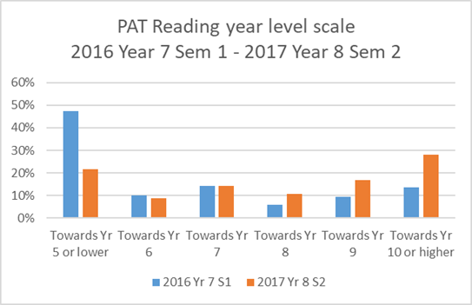
Benchmark assessment data has shown student growth in reading in Year 7 and 8 cohorts across 2016, 2017 and 2018, with stronger growth in Year 8.

Signs of impact

Practice change and student learning behaviour
The development of a common language across reading and general studies classes was followed by the adoption of specific reading practices within general studies classes. General studies teachers who assisted in reading classes benefited from observing experienced teachers modelling specific literacy practice. It generated discussion within the English KLA and teachers started to trial practice changes in their own classes.
In 2017, Jorgen, a Year 7 general studies teacher, implemented a trial of ten minutes free reading in a double period general studies class.
Students had to bring a book to class and were aware that the intent was that they read for engagement. They could source books from the library or home. The free reading session would often be followed by an activity that made students accountable for what they had just read.
Jorgen observed that this regular short period of free reading created a routine for the students, helping students settle down after recess and focus on learning. It set the tone for the rest of the lesson. Over time, he observed changes in student learning behaviours with reluctant readers coming to class prepared with a book and excelling students extending themselves by choosing more challenging texts.
Jorgen reflected with Lisa on this trial and the positive changes he had seen in student learning behaviours. Lisa suggested that he survey students to gather evidence that could support the roll out of this practice across all junior years general studies classes. The survey feedback from students confirmed his observations and Jorgen proposed a roll out of this practice to the rest of the KLA.
Some teachers were initially worried about regularly ‘losing 10 minutes of teaching time’. The survey data and Jorgen’s observations allayed their concerns, paving the way for discussion on how to adjust lesson plans to accommodate this practice. As a result, free reading was implemented across Years 7–10 general studies classes in 2018.

Literacy intervention

Literacy support program
‘It’s when you get a kid that all of a sudden decides that they want to read, that they’re doing it for them. They’re no longer seeing it as a chore...that’s the biggest win.’
Janene, literacy support team

Selecting literacy support resources
This program operates on a withdrawal model using high-impact literacy instruction resources. The selection of appropriate literacy instruction resources was based on several factors:
- the availability of the resources
- knowledge of resources used by local feeder primary schools
- recognition that teaching staff at Swan Hill College didn’t have the time or expertise to create suitable resources themselves.
Using the Fountas and Pinnell literacy resources that were already used by local feeder primary schools created continuity for students with higher literacy support needs in their transition from primary to secondary. An added benefit was that Lisa and Julie could observe how these resources were being used in other schools within their network.

Identifying eligible students
Benchmark assessment in February each year identified up to 40 students with higher literacy support needs. Approximately 20 of these students were then offered a place in the program.

Program structure
The program started in Term 2 for Year 7 students and Term 1 for Year 8 students. Four groups of up to five students received literacy support for 15 minutes, three times a week.
Literacy support teachers provided short, explicit instruction in phonics, comprehension, fluency and word study. They used a range of activities and game-based learning to engage students.
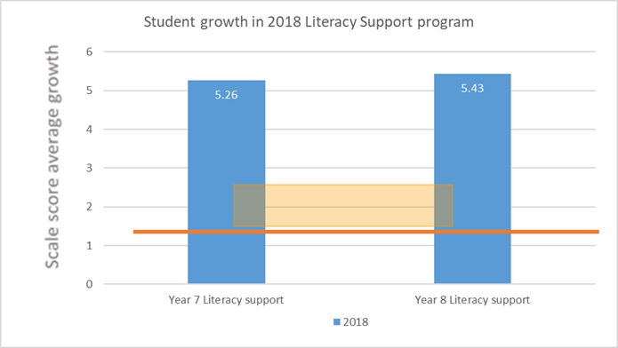
Teachers from mainstream classes were able to negotiate the timing of the release of students to the literacy support program to accommodate student preferences and key priorities for their subject.
All staff received ongoing communication about
the logistics of the program and general information on useful strategies for students with higher literacy support needs.
Julie also worked with teachers impacted by the literacy support program to adjust their expectations of catch up work versus modified work. Teachers knew from this communication that additional work for these students was not an option without close teacher instruction.
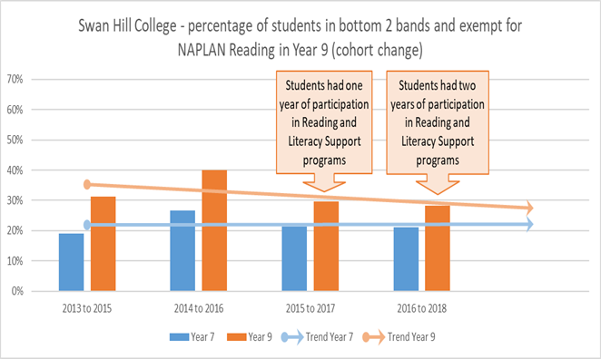
‘I recognise that for this student it is more important to improve his reading (through literacy support). It’s not ideal that he misses out on some lessons but he needs to learn how to read to get more out of the maths and science classes.’
Jesse, maths and science teacher

Signs of impact

Growth evident in benchmark assessment
The literacy support program strives to achieve a year’s growth with participating students. There has been strong growth in reading for students in this program, with the average growth of these students being more than three times the benchmark expected growth.

Reduction in bottom two bands NAPLAN Reading
The improvement within cohorts in the percentage of students in the bottom two bands of reading in NAPLAN indicates that more students are being retained in the middle two bands from
Year 7 to Year 9.

Robinson, V (2017), Reduce change to increase improvement, Corwin Press.

