Mordialloc College
Mordialloc College is a co-educational 7-12 secondary school in Melbourne’s south-east that has experienced steady increases in student enrolments over the last six years, climbing from 577 students in 2014 to 966 students in 2019.
In 2016, the school engaged an experienced primary school teacher to develop and deliver a literacy intervention program for Year 7 and 8 students. Students who participated in the program felt well supported and asked the school to extend targeted literacy and numeracy support into Year 9. The school established a Year 9 Literacy and Numeracy elective in response.

Extending Literacy and numeracy support into the middle years

Junior Years Literacy and Numeracy Intervention

Laying the groundwork
In 2016, Mordialloc College recognised the need for specialised literacy and numeracy teaching skills to assist students with higher literacy and numeracy support needs. The school used equity funding to engage an experienced primary trained teacher, Liz Evans, to develop and deliver a junior years Literacy and Numeracy Intervention program.
In the first year, Liz and an education support staff member, Julie, ran two staff professional development sessions to raise awareness of the work they were doing. With support from the Year 7-10 Program Coordinator, ongoing discussion of the Intervention program was built into the weekly Year 7-8 team meeting. This enabled Liz and Julie to update staff on program activities and students’ progress each week. Initial staff reservations about the withdrawal of students were quickly overcome as the growth in students’ skills and confidence became evident. The Intervention program continues to be well supported by staff.
Communication with parents was also key to the positive reception of the program. Information on the program was shared at open nights for Grade 6 families and at the beginning of Year 7. Letters sent to parents informed them of the opportunity students had to be in the program. Conversations with parents in formal and informal forums built support from parents.

Literacy
The literacy intervention operated through a withdrawal model, with Intervention teachers working with groups of four students. Initially, literacy intervention students were withdrawn from either English or Humanities lessons for three literacy intervention sessions of 30 minutes duration each week. The Literacy Intervention teachers worked flexibly with the subject teachers, giving them the option of when in the lesson the students would be withdrawn, and working around assessment schedules when needed.
In 2017, timetabling challenges resulted in a move to four literacy intervention sessions each fortnight. The focus of these sessions was on developing reading comprehension skills, looking at accuracy, fluency and vocabulary.
Explicit instruction of the primary level strategies was coupled with guided reading activities. Liz and Julie regularly used Daily 5 and the CAFE Reading Menu strategies in their withdrawal sessions. Recreational reading was structured into the program with students encouraged to read between sessions. Student choice was an important part of developing a positive relationship with the students, so students were able to choose their texts. Liz saw literature circles as the next step in getting students to share what they were reading and build their understanding together.

Numeracy
The numeracy intervention also operated through a withdrawal model, with Intervention teachers working with groups of four or more students in four 30 minute sessions per fortnight.
Liz and Julie noticed that while these students had access to Year 7 and Year 8 curriculum, they were struggling to be successful in their mainstream Mathematics classes. The students needed more practice and more time to go over key concepts. The Numeracy Intervention sessions gave students the time and space they needed, and the opportunity to use hands-on materials that supported the curriculum to help develop their understanding of key concepts. These hands-on materials included MAB or Base 10 blocks, dice and cards which are more frequently used within primary settings.

Data and assessment
Each term Liz used Fountas and Pinnell (F&P) reading assessment to track students’ progress through the program.
As students missed class time, there was recognition that this impacted on the work they could be expected to complete for the subject. Liz and Julie established an understanding among classroom teachers that the work expected from students in the Literacy Intervention program should be modified, rather than expecting students to catch up. This approach was supported by the Principal.
The improvement in achievement and confidence of the first group of students in the program prompted expansion of the range of students invited to participate. The literacy team started inviting students with higher literacy support needs into the program, and continued to achieve positive results.

Year 9 literacy and numeracy elective

Responding to student voice
The introduction of a Year 9 literacy elective in 2017 was driven by a request from students who had participated in the Literacy and Numeracy Intervention program through Year 7 and 8. Students wanted to know what type of literacy and numeracy support the school could offer in Year 9. At that time, the school did not have an equivalent program on offer in Year 9. In response to this request from students, Liz and Julie sought feedback from students, parents and the teachers involved across Year 8 and 9.
The decision to develop a Year 9 elective came out of this feedback, analysis of student data and consideration of the timetabling of subjects and the number of students who were interested. The elective structure provided students with full periods on literacy and numeracy where they received targeted specific feedback and support from a specific intervention teacher in a smaller sized class.

Student engagement
The school’s Year 9 literacy and numeracy support offering to students mirrored the Year 7 and 8 Intervention program’s aim to improve students’ confidence and build their foundational literacy and numeracy skills.
However, the structure of the elective differed significantly from the Year 7 and 8 intervention program’s withdrawal model. The Literacy and Numeracy elective was set up as a one semester elective that students took in addition to their mainstream English and Mathematics classes.
School leaders wanted students to be proud that they were taking on a subject that would assist them with all their other subjects. They encouraged students to select the elective with a guarantee that if they picked the Literacy and Numeracy elective they would get their first choice in the elective system.
The first year of the Year 9 Literacy and Numeracy elective was highly successful, but there were some challenges in the second year. Liz found that class size became an issue, with the elective class size increasing to over 20 students in the first semester of the second year. This size increase affected the Intervention teacher’s capacity to provide targeted feedback to all students in the class.
Recognising the importance of building authentic relationships with students in the elective, the class was split to reduce class size to 14 students, with an emphasis on retaining students who positively engaged with the program. Students could also opt to take the elective twice in the year if there was sufficient demand.

Elective structure
The elective was closely and deliberately aligned to the curriculum for the mainstream English and Mathematics classes but was more loosely structured with far less pressure overall. In each fortnightly cycle, students had three literacy periods and one numeracy period.
The Intervention teacher was in close contact with teachers from the students’ mainstream English and Mathematics classes. They shared and discussed the tasks and texts that would be used in the mainstream classes so that they could be integrated into the students’ work in the elective.

Goal setting and content
At the start of the elective, students did a Strengths, Weaknesses, Opportunities and Threats analysis to identify what they needed to work on during the semester. Students used this to track their own progress during the elective.
Students had a say in what they learned. This meant students were able to select particular topics or tasks that they wanted to focus on, such as a specific unit or assessment task in English or Mathematics. This allowed students to prepare for or revisit topics from their mainstream classes and improve both their understanding of key concepts and their confidence in applying those concepts in the classroom.
In 2019, the elective had a strong focus on writing, including spelling, grammar and essay writing support. Students regularly undertook low stakes writing tasks and also practiced tasks, such as writing comparative paragraphs, to build their skills and confidence leading into assessments in their mainstream English class. Continuity from the Year 7 and 8 Intervention program was maintained with independent reading and reading comprehension activities continuing to feature in the class.

Assessment
Assessment within the elective was more fluid and less pressured. Students were encouraged to self-assess their writing against exemplars and the school’s editing code, and re-write for improvement. Peer review was also used, looking at what has been done well and what could be improved. This helped create a supportive environment and get disengaged students back on board.

Amplifying student voice and agency
The Year 9 Literacy and Numeracy elective demonstrates how incorporating student voice and student agency into assessment and the selection of tasks and topics can transform students’ learning experiences.
The learning environment that Mordialloc College has created, the practices and attitudes of the teaching team and their use of High Impact Teaching Strategies aligns with Amplify: The student voice practice guide and the Victorian Teaching and Learning Model.
If we want to do math, we would say ‘we want to do indices or algebra’… I feel like I’ve improved a lot. I understand more things… Just the way the school is, and how positive they are, it just puts a positivity on you.
Kynan, student

Signs of impact
Analysis of student data has shown that since the introduction of these initiatives the lowest achieving students have achieved the highest levels of growth.

Between 2016 and 2018, Mordialloc College achieved significant improvement in Year 9 NAPLAN results:
Reading
- 50 percent increase in the percentage of students with high relative growth.
- 17 percent increase in the percentage of students in the top two bands.
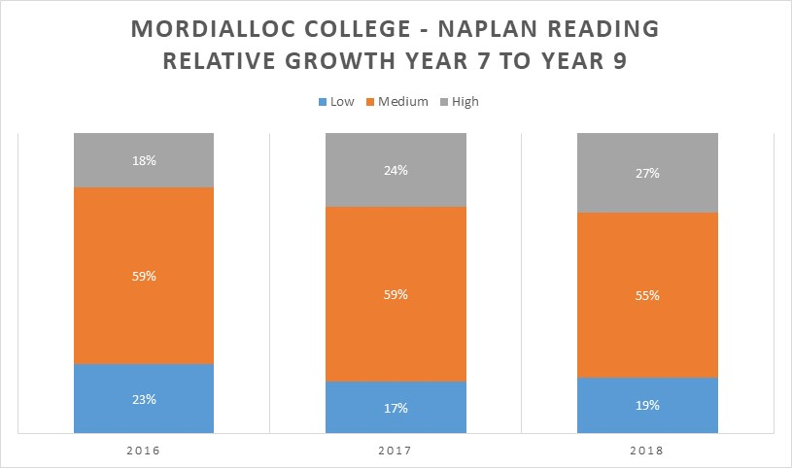
- 44 percent decrease in the percentage of students in the bottom two bands.
Numeracy
- 81 percent increase in the percentage of students with high relative growth.
- 146 percent increase in the percentage of students in the top two bands.
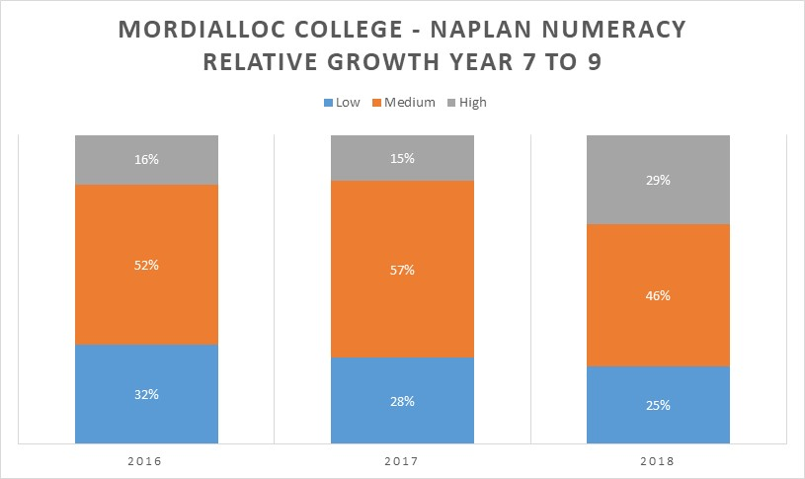
- 61 percent decrease in the percentage of students in the bottom two bands.

The CAFE Reading Program and the Daily Five are literacy support programs created by the 2 Sisters Company.

