Braybrook College
Braybrook College is a single campus Year 7 to 12 coeducational school located in the western suburbs of Melbourne. The school has a large proportion of students from culturally and linguistically diverse backgrounds with 34 nationalities represented. The school has a junior years Literacy program and a Numeracy centre and in 2019, the school appointed both Literacy and Numeracy Improvement Teachers to provide targeted literacy and numeracy support into the middle years.

Literacy
Since 2009 Braybrook College has invested heavily in whole school professional learning in literacy and numeracy that focuses on explicit teaching strategies used by teachers across all domains.
The programs employ evidenced-based principles key to whole school literacy improvement:
- all teachers are teachers of literacy
- opportunities for reading, writing and oral language development need to be incorporated in every lesson in every subject
- a consistent, systematic, whole-school approach to the teaching of literacy across all subjects.
The school’s recent literacy work has focused on strengthening explicit teaching of academic vocabulary across all domains.

Literacy program

Time allocation
A key aspect of the literacy program was establishment of weekly literacy lessons for all Year 7 and 8 students. The majority of Year 7 and 8 students have four periods of literacy per week. This is in addition to the four periods of English that are timetabled at Year 7 and 8.
Literacy lessons include 20 minutes reading time in each session. Students in the Comprehension and Strategies groups can opt to do two periods of Languages other than English (LOTE) in place of two of the literacy lessons based on their family’s preference for language.
In order to achieve this time allocation, lesson time from other disciplines had to be relinquished to the literacy program. The decision on which disciplines should relinquish lesson time was determined through a vote by all teaching staff.

Staff and professional learning
A cross-disciplinary team of teachers deliver the literacy lessons to students. These teachers often go back to their faculties and share their new learning and strategies which has been highly effective in spreading literacy practice across the school.
New teachers to the school worked with a literacy partner as part of their induction to the College’s literacy program and practice. There was professional learning around High Impact Teaching Strategies (HITS) at staff meetings. Teachers had opportunities to observe classes, team-teach, and share strategies that could be used across all content areas.

Structure
Students undertake a standardised
Test of Reading Comprehension (TORC) in Years 6, 7 and 8. The school uses this test to identify student literacy needs and capabilities, and structure future learning experiences.

Data and assessment
TORC results are formative assessment that demonstrate learning progress at a given point in time. These assessments are used to track student improvements throughout the Literacy program. In this test, students complete four timed subtests: general vocabulary, syntactic similarities, paragraph reading and sentence sequencing.
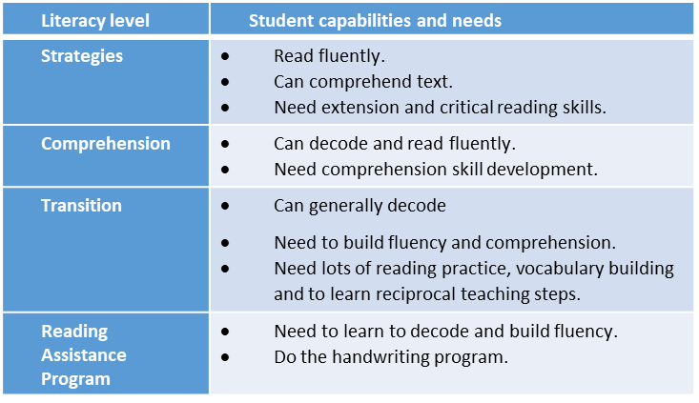
The questions become more challenging as students progress through the test, highlighting where they need support to improve comprehension.

Curriculum and lesson plans
The Literacy Coordinator develops lesson plans for all literacy lessons to ensure consistency across all classes.

Numeracy

Numeracy Centre
Braybrook College identified a gap in their support of numeracy in 2015. The introduction of equity funding in 2016, enabled the school to set up a Numeracy Centre to provide additional one on one support to students outside of the classroom.
The aim in establishing the Numeracy Centre was to see 25 percent more students in
Year 7 and Year 9 reaching the highest levels of achievement in mathematics.
The Numeracy Centre provided a collaborative space staffed by maths teachers where students could drop in and access support, resources and systems to assist their learning in numeracy.
Maths teachers provided one-on-one and small group instruction to students in the Numeracy Centre during lunch times.

Signs of impact

Literacy outcomes
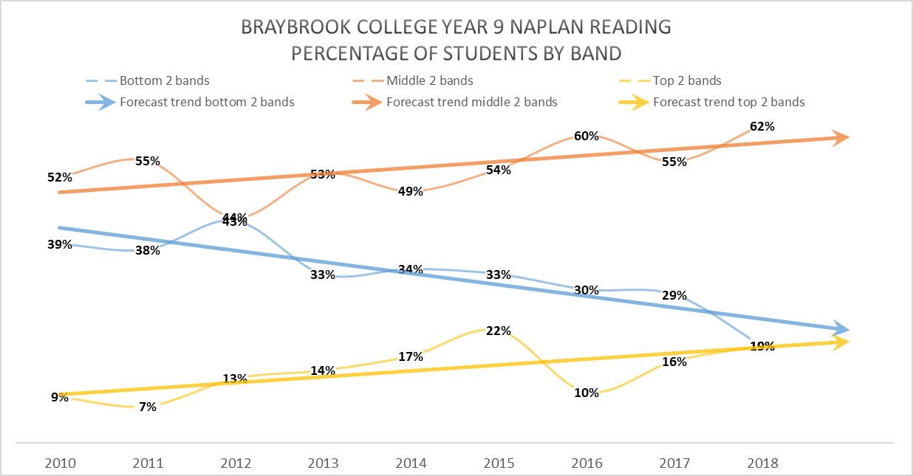
Braybrook College’s Year 9 NAPLAN data shows a sustained improvement trend since 2010. The percentage of Year 9 students in the top two bands for Reading increased from nine percent in 2010 to 19 percent in 2018. Over the same period, the percentage of Year 9 students in the bottom two bands for Reading reduced from 39 percent to 19 percent.

Numeracy outcomes
NAPLAN Year 9 Numeracy assessment results also show a sustained improvement trend in the percentage of students in the top two bands, lifting from 14 percent in 2010 to 31 percent in 2018, and the bottom two bands, which reduced from 33 percent to 19 percent over the same period.
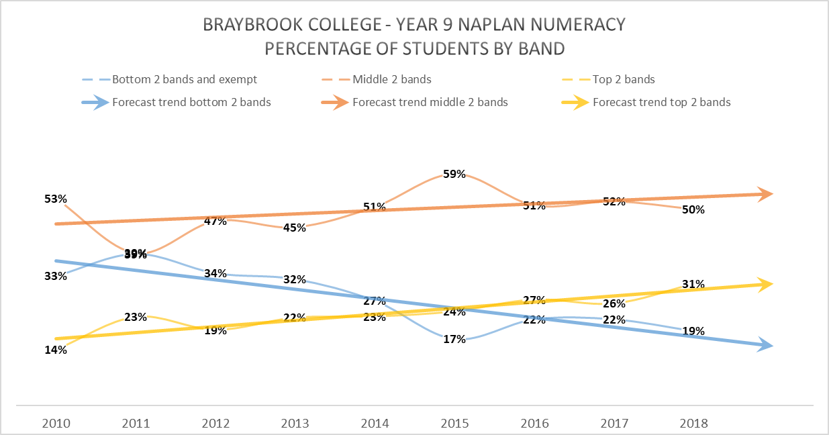

MYLNS Improvement Teachers

Early adoption
School leaders at Braybrook College recognised the importance of the Middle Years Literacy and Numeracy Support (MYLNS) Improvement Teacher roles in complementing existing literacy and numeracy initiatives and providing targeted support for identified students.
The school advertised the roles in late 2018 to ensure their Improvement Teachers could be appointed and ready to begin their work from day one in 2019.
The school’s Literacy Improvement Teacher, Alex, and Numeracy Improvement Teacher, Zoe, both started in Term 1, 2019. They introduced themselves to all staff at the first staff meeting of the year to raise staff awareness of their roles and worked collaboratively to identify and trial approaches to support students.
School leadership’s support of the MYLNS initiative was made explicit through the Principal, Teaching and Learning Coordinator and Numeracy Coordinator attending all MYLNS meetings.

Literacy
Alex started as the Literacy Improvement Teacher role with a 0.6 FTE allotment. He knew that supporting teachers would be a big part of his role and that working as a team was essential to shifting outcomes for the students identified for additional support under the MYLNS initiative.

Evaluate and diagnose

Using data and evidence
During Term 1, Alex contacted parents and carers, and conducted a diagnostic meeting and introduction with each identified student.
He used a range of data from formal and informal sources to develop his understanding of each student’s learning needs.
Alex examined NAPLAN results, OnDemand data and school reports, along with other evidence drawn from in-class student observations, team teaching, and interviews with previous and current teachers. He also examined student effort and motivation in various subjects and gaps in engagement to develop a more holistic picture of each student.

Prioritise and set goals
This wide variety of data and evidence informed Alex’s development of student profiles. The analysis of student data enabled him to determine literacy levels and student needs.
Alex worked with each student to set goals and incorporated these and the actions that the student could take to achieve these goals into their student profile.

Develop and plan

Structures and processes
Alex recognised that his role needed structures. There were structural issues that needed to be addressed, including:
- timetabling individual support meetings/observations
- scheduling time to build relationships across a large number of teaching and support staff
- identifying a dedicated space or room to meet with students for literacy support.
Alex identified the specific classes where he would provide in-class support using his analysis of students’ reports and observation of student engagement in class.
He identified opportunities to tap into existing meeting structures, such as faculty meetings, to start the conversation with different faculties on differentiation.
A classroom adjacent to his office and the library were identified as spaces that could be used to meet with and support students during break times or when withdrawing them from classes.
School leaders provided ongoing support in this work. They acted as a sounding board for both Alex and Zoe regarding processes, procedures, professional learning sessions and student and staff support strategies.

Establishing relationships
From day one, Alex focused on building relationships with staff and the school wide awareness and understanding of his role.
He shared student profiles with staff on Compass, making them easily accessible for teachers. Alex recognised that he could do more to support teachers to implement the identified support strategies. He aligned his approach to the school wide focus this year on HITS (High Impact Teaching Strategies), in particular Explicit Teaching and Worked Examples.
Alex saw the Improvement Teacher role as part of a whole school approach, and his attendance and support of classes across a range of subject areas reflected that belief. In Term 2, Alex started to work with individual faculties and modelled explicit teaching strategies.

Building capability
Alex also saw the role as being a source of specialist literacy pedagogy for his colleagues. He initiated his own professional learning, carrying out academic reading on areas such as language acquisition and best practice interventions, and developed his skills in reading and analysis of data.
The student profiles he developed included suggested teaching strategies that would be most effective based on the individual student’s strengths and areas for improvement. Classroom teachers had access to the profiles for their students and could use them to support student learning in the classroom. The profiles helped to equip classroom teachers with the knowledge they needed to support the student to develop their literacy skills.

Implement and monitor

Delivering support to students
Alex provided direct support to MYLNS students in one-on-one or two-on-one meetings with students for one period each week.
These meetings focused on specific literacy skills and goal setting. The students either came out of a class (rotating withdrawal from a class each week on a 3 week cycle) or met with him outside of class time.
This work was then re-enforced with an additional period of in-class support to further practise the skills and provide additional support. Alex also worked directly with students in the EAL Homework Club during lunchtimes.
Some students did not want to engage with him weekly. In these cases, direct support was negotiated with the student and provided to them outside this established format.

Numeracy
Zoe started as the Numeracy Improvement Teacher role with a 0.2 FTE allotment.

Evaluate and diagnose

Using data and evidence
Zoe conducted an in-depth analysis of the data for students identified for numeracy support, breaking down their NAPLAN data by question and Victorian Curriculum Achievement Standards. She also drew on in-school data, OnDemand and teacher assessments to develop a profile on each of her students to share with their classroom maths teachers.

Prioritise and set goals
Zoe found that consultation with the Numeracy Coordinator, Curriculum Coordinator, EAL Coordinator, Year Level Coordinators and Literacy Improvement Teacher was vital to gain insight into the ‘whole’ student.
Triangulating data and evidence with observations of the students in class enabled Zoe to identify their numeracy levels and learning needs. She was then able to share her findings with teachers to enable them to better support their students.

Develop and plan

Establishing relationships
Zoe shared information about her role and the MYLNS initiative to the Mathematics faculty meetings and addressed all teachers at staff meetings.
This paved the way for Zoe to go into classes to support students by making it clear that she would assist the classroom teaching with specific strategies for the identified students. She also articulated that the strategies she would be using would work with all students.
Zoe enabled classroom teachers to feel confident with her in their classroom, as her role would support them in building the numeracy skills of their students.

Building capability
Zoe drew inspiration and ideas from the work of Jo Boaler, a British education author and Professor of Mathematics Education at the Stanford Graduate School of Education who promotes mathematics education reform and equitable mathematics classrooms.
Zoe believes in making maths visible in the classroom and developing resources and posters to provide explicit anchors for students’ thinking in the classroom and as means of ‘broadcasting’ mathematics for everyone. She decided to develop resources and strategies to share with all math teachers in the school to assist them with the teaching and learning of numeracy.

Implement and monitor

Delivering support to students
Typically, Zoe attended one class per week with her identified students, although a timetable clash has meant that she meets with one student at a mutually agreed time outside of class.
Zoe worked with students in small groups. She overcame any hesitation students felt by creating a safe space where students could admit they didn’t know things, ask questions, get immediate feedback on their work and build their confidence. She encouraged students to take risks, make mistakes, count with their fingers, use a calculator or other aides, draw pictures or watch a video to support their learning. This approach is enabling students to move forward with their learning.
Zoe has observed that her students’ confidence with their maths work is building.

Building capability
The resources Zoe developed aim to build teachers’ knowledge on how to use different strategies to assist students to recognise and understand mathematics in the real world and build their capabilities and skills. They include strategies for helping students to:
- build deep levels of thinking
- be reflective and question their learning
- write about mathematics
- display visual thinking
- use Information and Communication Technology (ICT) as a tool in mathematics
- build connectedness
- build a mindset towards the learning of maths.
These tools have been placed in a dedicated place in the school’s curriculum planning infrastructure for all to access.

