AT A GLANCE
There are three pathways in the Victorian Curriculum F-10 EAL:
- Pathway A (Years F –2)
- Pathway B (Years 2 – 8)
- Pathway C (Years 7 – 10)

Pathway A contains two levels: A1 and A2.
Pathway B contains four levels: BL, B1, B2 and B3.
Pathway C contains five levels: CL, C1, C2, C3 and C4.
VICTORIAN CURRICULUM F-10 EAL 2020 REPORTING TOOL
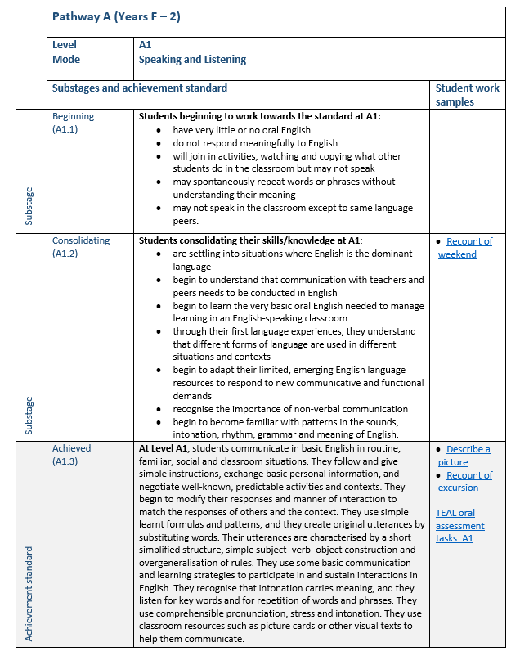
Links are provided to the assessment resources in the Tools to Enhance Assessment Literacy for teachers of EAL students (TEAL) online assessment resource centre.
Links to student work samples are provided to support teacher assessment decisions.
Some Speaking and Listening samples are in PDF because they are transcribed conversations, not video or audio samples.
Each level contains two substages - more granular descriptions of student English language proficiency than is described by the achievement standards.
Substages do not appear in the Victorian Curriculum F-10 EAL, they are provided by the Department of Education and Training for reporting purposes.
The achievement standards are drawn directly from the Victorian Curriculum F-10 EAL.
EAL students’ reports will show the word, for example, Achieved, and the number, A1.3, to indicate their proficiency in the relevant mode.
A one-page document describes the skills and knowledge a student will demonstrate at each substage and achievement standard for each level and each of the modes – Speaking and Listening, Reading and Viewing and Writing.

