Autism Spectrum Disorder: Do other parents feel like this?
Dr Avril V Brereton and Dr Kerry J Bull

Parents respond in different ways to learning about their child’s diagnosis of ASD depending on many things that are unique to them, their family and their situation. Common reactions include feeling sad, angry, worried or relieved.

One of the reasons for different responses is that there are a number of pathways leading to diagnosis. Some parents are worried about their infant who is not babbling or developing first words. Other parents notice their child losing words and social skills. Others become worried when their child starts kindergarten and has difficulty managing the demands of a busy social environment. Sometimes someone else expresses their concern (e.g. a relative, the kindergarten teacher or a maternal and child health nurse). Some families are placed on a lengthy waiting-list for assessment, whilst others receive a diagnosis very quickly. Their experiences are all very different.

It is natural for you to feel a range of strong emotions at the time of diagnosis and in the years to come. Over time you may develop different feelings, but there will still be times of worry and sadness – that’s all part of being a loving parent.

It is important to acknowledge and share your feelings with friends or family members who can provide help and support. Some parents also find it helpful to talk with other parents of a child with ASD to share experiences, knowledge and information. There are many parent-to-parent support groups and ASD family networks throughout Victoria. Many parents find that learning more about ASD by participating in education sessions and by seeking professional information and support is helpful.

Others talk to a professional such as their GP or Key Worker through early intervention to get help and support about the feelings associated with adjusting to their child’s diagnosis. It’s okay to ask for help.

Guidance on where to find help, support and information is available at AMAZE.

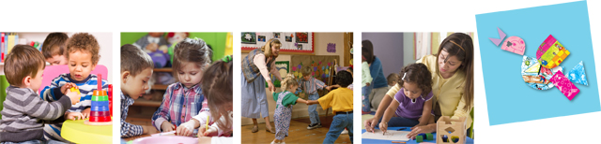
Phone 1300 308 699

http://www.amaze.org.au/

For more information about the Department of Education and Early Childhood Development’s Autism Friendly Learning website go to:
http://www.education.vic.gov.au/autism

