Profile Report

Student name: Student code: Student class: School code: Print date:

ALO0002 ABLES 9999
4 February 2015

English, Speaking and Listening:
02-13

11-12

Current level description for student

English, Speaking and Listening:
The student is learning to recognise basic social rules of communication, and explore ways to convey information to others (AusVELS Level C).The student is learning to recognise basic social rules of communication, and explore ways to convey information to others (AusVELS Level C).

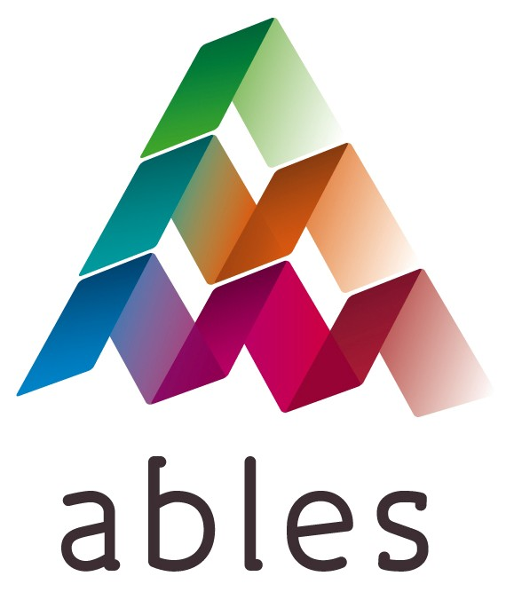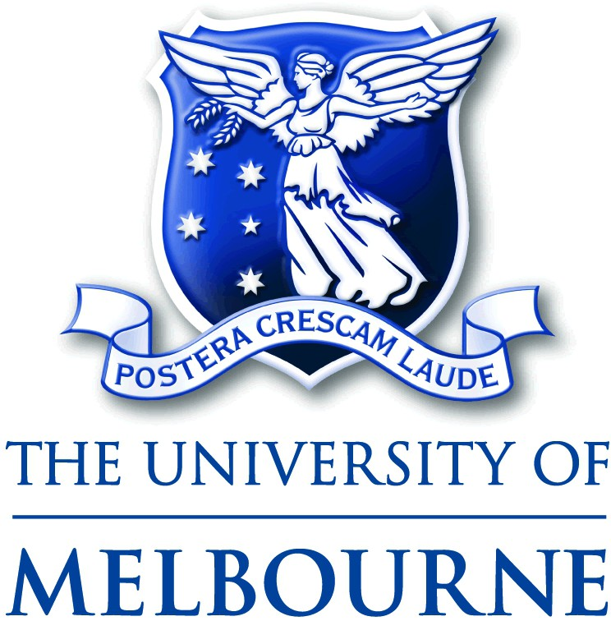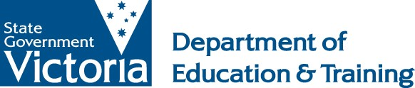

Most recent record Second most recent record Third most recent record

Profile Report

Student name: Student code: Student class: School code: Print date:

AWW0001 ABLES 9999
4 February 2015

English, Speaking and Listening:

English, Reading and Writing:
08-14

08-14
11-12

01-13

Personal Learning:

Interpersonal Development:
08-14

05-14
08-14
10-11

Current level description for student

English, Speaking and Listening:
The student is learning to receive and respond to environmental stimuli and communication from others (AusVELS Level A).

Reading and Writing:
The student is exploring objects within a familiar environment, and may show interest in photographs of familiar objects/people (AusVELS Level A).

Personal Learning: The student is learning to attend and respond to different stimuli in the environment (AusVELS Level A).

Interpersonal Development:
The student is learning to focus attention on others and acknowledge their presence (AusVELS Level A).

Most recent record Second most recent record Third most recent record

Profile Report

Student name: Student code: Student class: School code: Print date:

BUI0001 ABLES 9999
4 February 2015

English, Speaking and Listening:

English, Reading and Writing:

08-14
08-14
11-12

01-13

Personal Learning:

Interpersonal Development:
08-14

08-14
08-14

Current level description for student

English, Speaking and Listening:
The student is learning to make simple requests, and communicate basic needs, wants, and feelings (AusVELS Level B).

Reading and Writing:
The student is learning to identify objects, pictures, shapes and sounds, and may role-play reading, scribble freely, or recognise own name in print (AusVELS Level B).

Personal Learning: The student is learning to attempt simple tasks and make simple choices with support (AusVELS Level B).

Interpersonal Development:
The student is learning to participate with the support of familiar adults who direct and regulate the student's involvement (AusVELS Level B).

Most recent record Second most recent record Third most recent record

Profile Report

Student name: Student code: Student class: School code: Print date:

CRI0002 ABLES 9999
4 February 2015

English, Speaking and Listening:
02-13

11-12

Current level description for student

English, Speaking and Listening:
The student is learning to recognise basic social rules of communication, and explore ways to convey information to others (AusVELS Level C).The student is learning to recognise basic social rules of communication, and explore ways to convey information to others (AusVELS Level C).

Most recent record Second most recent record Third most recent record

Profile Report

Student name: Student code: Student class: School code: Print date:

HIN0003 ABLES 9999
4 February 2015

English, Speaking and Listening:
01-13

11-12

Current level description for student

English, Speaking and Listening:
The student is learning to recognise basic social rules of communication, and explore ways to convey information to others (AusVELS Level C).The student is learning to recognise basic social rules of communication, and explore ways to convey information to others (AusVELS Level C).

Most recent record Second most recent record Third most recent record

Profile Report

Student name: Student code: Student class: School code: Print date:

MOU0003 ABLES 9999
4 February 2015

English, Speaking and Listening:

English, Reading and Writing:

08-14
08-14

02-13
11-12

Personal Learning:

Interpersonal Development:
08-14

08-14
08-14

Current level description for student

English, Speaking and Listening:
The student is learning to recognise basic social rules of communication, and explore ways to convey information to others (AusVELS Level C).

Reading and Writing:
The student recognises the difference between text and pictures, and may sort, match, or identify letters and numbers. The student may recognise very familiar words by sight, and link these to basic needs and wants (AusVELS Level C).

Personal Learning: The student is learning about responsibility for actions, and becoming more socially aware (AusVELS Level C).

Interpersonal Development:
The student is learning to independently participate in simple familiar and/or highly personally valued social activities (AusVELS Level C).

Most recent record Second most recent record Third most recent record

Profile Report

Student name: Student code: Student class: School code: Print date:

PAV0001 ABLES 9999
4 February 2015

English, Speaking and Listening:
11-12
08-14

01-13

English, Reading and Writing:
08-14

Personal Learning:

Interpersonal Development:
08-14

08-14
08-14

Current level description for student

English, Speaking and Listening:

Reading and Writing:
The student is learning to take turns, ask and answer questions, and extend vocabulary to include descriptions and observations (AusVELS Level D).The student is learning to take turns, ask and answer questions, and extend vocabulary to include descriptions and observations (AusVELS Level D).
The student names some letters of the alphabet and identifies their common sounds. S/he recognises the connection between print and the spoken word, and reads some familiar words and signage using partial cues and illustrations (AusVELS Level D).

Personal Learning: The student is developing memory skills required to complete simple tasks and answer questions (AusVELS Level D).

Interpersonal Development:
The student is learning to use contextual cues to guide their behaviour and participation in familiar social environments (AusVELS Level D).

Most recent record Second most recent record Third most recent record

Profile Report

Student name: Student code: Student class: School code: Print date:

PEA0003 ABLES 9999
4 February 2015

English, Speaking and Listening:

English, Reading and Writing:

02-13
08-14

08-14

Personal Learning:

Interpersonal Development:
08-14

08-14
08-14

Current level description for student

English, Speaking and Listening:
The student is learning to use communication skills appropriately in a variety of contexts and with different audiences (AusVELS Foundation Level).

Reading and Writing:
The student matches print and spoken text in the environment, and recognises how sounds are represented alphabetically. In writing, the student uses conventional letters, groups of letters, and simple punctuation such as full stops and capital letters (AusVELS Foundation Level).

Personal Learning: The student is learning to take initiative by asking questions when needed, and beginning to attempt small projects (AusVELS Foundation Level).

Interpersonal Development:
The student is learning to participate independently and cooperatively, and to negotiate most routine social situations without adult assistance (AusVELS Foundation Level).

Most recent record Second most recent record Third most recent record

Profile Report

Student name: Student code: Student class: School code: Print date:

ROB0003 ABLES 9999
4 February 2015

English, Speaking and Listening:

11-12
02-13

Current level description for student

English, Speaking and Listening:
The student is learning to recognise basic social rules of communication, and explore ways to convey information to others (AusVELS Level C).The student is learning to recognise basic social rules of communication, and explore ways to convey information to others (AusVELS Level C).

Most recent record Second most recent record Third most recent record

Profile Report

Student name: Student code: Student class: School code: Print date:

SCO0001 ABLES 9999
4 February 2015

English, Speaking and Listening:

English, Reading and Writing:
11-12

02-13
08-14

08-14

Personal Learning:
08-14

08-14

Interpersonal Development:
08-14

Current level description for student

English, Speaking and Listening:
The student is learning to adapt, elaborate, adjust and use different strategies to communicate with different people and across a range of familiar and unfamiliar social contexts (AusVELS Levels 1 and 2).

Reading and Writing:
The student reads and responds to short texts with familiar ideas and a small amount of unfamiliar vocabulary. The student makes use of known spelling patterns to attempt the spelling of unfamiliar words (AusVELS Levels 1 and 2).

Personal Learning: The student is learning to be responsible for managing time and resources within the context of structured tasks (AusVELS Levels 1 and 2).

Interpersonal Development:
The student is learning to flexibly apply social understanding across familiar and less familiar situations (AusVELS Levels 1 and 2).

Most recent record Second most recent record Third most recent record

Profile Report

Student name: Student code: Student class: School code: Print date:

SLA0003 ABLES 9999
4 February 2015

English, Speaking and Listening:

English, Reading and Writing:

11-12
01-13

08-14

Personal Learning:
08-14

08-14

Current level description for student

English, Speaking and Listening:

Reading and Writing:
The student is learning to recognise basic social rules of communication, and explore ways to convey information to others (AusVELS Level C).The student is learning to recognise basic social rules of communication, and explore ways to convey information to others (AusVELS Level C).
The student uses a range of strategies to confirm or modify understanding of text. S/he interprets the main ideas and purpose of texts, and is working towards ordering ideas in written work (AusVELS Levels 3 and 4).

Personal Learning: The student is learning to make and explain decisions about learning, and to independently plan and complete short tasks (AusVELS Levels 3 and 4).

Most recent record Second most recent record Third most recent record

Profile Report

Student name: Student code: Student class: School code: Print date:

WOO0002 ABLES 9999
4 February 2015

English, Speaking and Listening:
01-13

11-12

Personal Learning:

08-14

08-14

Current level description for student

English, Speaking and Listening:
The student is learning to recognise basic social rules of communication, and explore ways to convey information to others (AusVELS Level C).The student is learning to recognise basic social rules of communication, and explore ways to convey information to others (AusVELS Level C).

Personal Learning: The student is learning to implement plans to complete short-term and long-term tasks, and to persist when experiencing difficulty with tasks (AusVELS Levels 5 and 6).

Most recent record Second most recent record Third most recent record

