Print Date:
4 February 2015

Class Report
School: 9999
Class: ABLES
Assessment: English, Reading and Writing

Round 2 2014
Level A Level B Level C Level D Foundation Level Levels 1 and 2 Levels 3 and 4

SLA0003

SCO0001

PEA0003

PAV0001

MOU0003

BUI0001

AWW0001

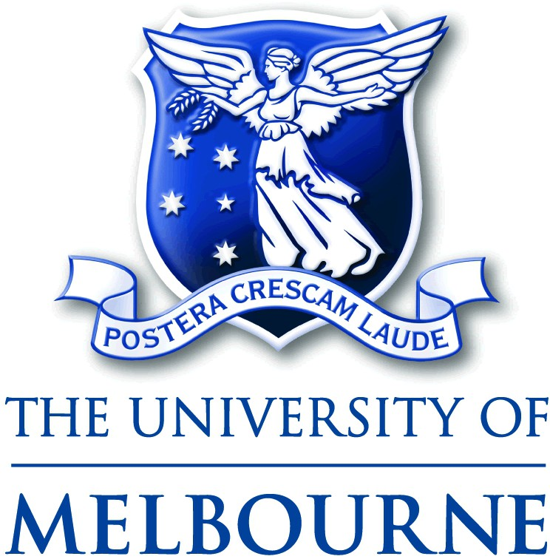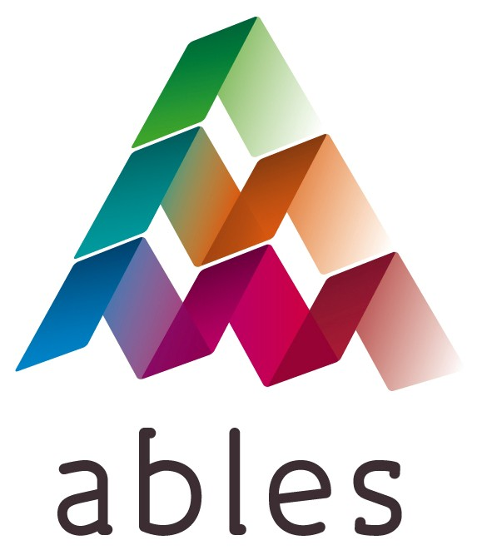
Derived from the University of Melbourne’s Students with Additional Needs (SWANs) materials, authored by Kerry Woods and Patrick Griffin

Page 1 of 1

