Task Description
Students research and report on the use of the Golden Ratio in art, architecture and the environment.

Length of Task
90 minutes

Materials
- Golden Ratio Task Worksheets, internet access, paper, ruler, calculators.

Using the Activity
Introductory
The teacher creates a mind map of the students’ understanding of Golden Ratio and related topics such as golden section, golden rectangle, golden spiral, Fibonacci, and the perfect face.

Main Activity
Students select a task to investigate and report back to the group. Each task is considered part of a puzzle that links with the other tasks in assisting the class build an understanding of the Golden Ratio (1:1.618). These tasks may extend over a couple of lessons to complete.
- The Golden Ratio in Art – Examining famous paintings by Leonardo Da Vinci to find the golden ratio.
- The Golden Ratio in Architecture – A look at buildings in ancient civilisations.
- Fibonacci’s sequence – Exploring the link between Fibonacci’s sequence and the Golden Ratio.
- The Perfect Face – Measuring features of the face to discover if it is “golden”.
- The Golden Ratio in Nature – Uncovering examples of the golden spiral in nature.

Reflection
In a whole class discussion, the students reflect on the following discussion questions and include the new information to mind map:
What have you discovered about the golden ratio?
What examples of the golden rectangle or ratio have you seen in nature, art or architecture?

Key Mathematical Concepts
- Recognition of golden ratio representations in the environment. Appreciation for the aesthetic appeal of the golden ratio.

Prerequisite Knowledge
- Understanding simple ratios.

Links to VELS

Dimension | Standard
Number (Level 4) | Students use decimals, ratios and percentages to find equivalent representations of common fractions (for example, 3/4 = 9/12 = 0.75 = 75% = 3 : 4 = 6 : 8).
Working mathematically (Level 4) | Students engage in investigations involving mathematical modelling. They use calculators and computers to investigate and implement algorithms, explore number facts and puzzles, generate simulations, and transform shapes and solids.
Working mathematically (Level 4) | Students recognise and investigate the use of mathematics in real and historical situations.

Assessment
To be working at Level 4, students should be able to:
- Recognise representations of the golden ratio in the environment.

Extension Suggestions
For students who would benefit from additional challenges:
- View flickr.com for photos that a specifically grouped into the golden rectangle theme http://www.flickr.com/groups/golden_rectangle/ Students may experiment with composing photos around the school grounds that fit the golden rectangle criteria.
- The Perfect Face: The following websites can be explored to assess the perfect face.
http://www.intmath.com/Numbers/mathOfBeauty.php
http://cuip.uchicago.edu/~dlnarain/golden/activity8.htm

Teacher Advice and Feedback
The available information regarding the historical significance of the Golden Ratio in art and architecture over the centuries is immense and the mathematics can be complicated to understand. Breaking the topic into smaller tasks for students to undertake appeared to assist the students in building a picture of the golden ratio. However, it is important for the students to understand the links between these tasks. Ensure time is dedicated at the conclusion of the tasks to reflect and discuss the different elements of the Golden Ratio.

A clear description of the link between Fibonacci and the Golden Ratio can be found at the following site: http://www.homeschoolmath.net/teaching/fibonacci_golden_section.php

Searching the web hints
After entering Golden Ratio into the Google search engine prompt students to select show options situated directly under the search box. The timeline view and wonder wheel view offer the researcher different helpful ways to view the Golden Ratio information on the web (see below).

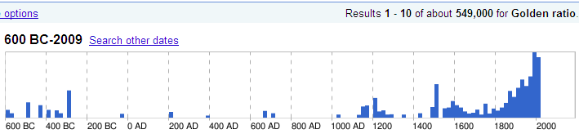

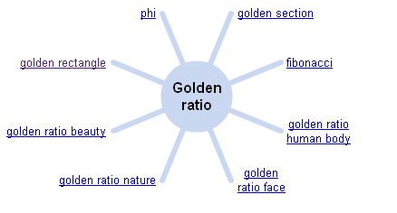

Potential Student Difficulties
The range of tasks offered in this session varies in complexity. Students having difficulty with Golden Ratio may wish to commence with The Golden Ratio in Art. The students in this task may need assistance with finding 61.8% of the painting. It might be helpful to have pre-made golden rectangle made for each of the paintings to assist students in focusing on the significance of the junction points in the paintings.

References / Acknowledgements
Source: http://math.rice.edu/~lanius/Geom/golden.html

http://mathbits.com/MathBits/PPT/FibFaces.htm

Thank you to the teachers and students from Lloyd Street PS, for providing valuable feedback on the use of this activity.

