Task Description
Students are introduced to creating a two-way table.
Students are given the opportunity to create a set of ‘yes/no’ questions, relevant to their class, and gather data for a two-way table. The data is analysed to create generalisations about the class. Alternative ways to present these data are also explored.

Length of Task
40 minutes

Materials
Butcher’s paper, post-it notes, coloured markers

Using the Activity
Introduction to focus the investigation
The teacher commences with a whole class focus on students’ prior knowledge of data collection and representation. The teacher asks students to “Name different ways of collecting data.” Students share responses that are listed on the whiteboard. “How might we represent the data you have listed?” Students share responses.

Teacher reveals a two-way table on large (butcher's) paper or whiteboard. Teacher explains how to collect data through the use of a two-way table. In the case of the example below all questions must be read and each question can only be answered ‘yes’ or ‘no’. In order for students to place their name in a cell, they must have answered ‘YES’ to both a corresponding row and column question. It is similar to reading coordinates.

 | Watches  The Simpsons | Doesn’t Watch  The Simpsons
Plays sport outside school
Doesn't play sport outside school
Students write their names on a post-it note and place their name in the corresponding cell. As students place their names on the table, the teacher asks if they are surprised by the data to date. The teacher can take the opportunity to check that students are placing their names in the correct cell, e.g. ‘We can see that Kate doesn’t watch The Simpsons and doesn’t play sport outside school. Is that correct?’ When all the names are on the two-way table, the teacher tallies the names, summarising and writing the total in each cell.
Teacher asks, ‘How do you read this information?’ ‘What conclusions can we draw from these data?’ Encourage students to read data in rows and columns when making statements.

Main Activity
In pairs, students develop two questions to ask their classmates and place these questions on a two-way table.

A sample of the questions students asked include:
- Are you going to Berwick High next year?
- Do you have a Wii console?
- Do you play on the computer?
- Do you have pets?
- Do you have an iPod?

Students share methods for a systematic way of collecting the data from the whole class, e.g. noting names instead of using tally marks for individuals; interviewing the students in alphabetical order or by table groupings; etc. Students commence surveying the class.

Data are collected and presented using a two-way table. After these data are collated, students are asked to consider and record conclusions gained from the information presented in the table. The teacher encourages the use of percentages and fractions during this analysis phase the task.

Students exchange their two-way table with another pair. Students make statements about the information in their peers’ table.

The whole class gather to share, display and discuss the data collected. The teacher asks, ‘What conclusions/generalisations can you draw from the information presented on the table? What conclusions/generalisations can you not draw? When might it be useful to present information in this way? Who might use this method for collecting and representing data? What other ways might you be able to represent these data?’

Key Mathematical Concepts
- Exploring alternative ways to represent data.
- Interpreting and analysing data to form generalisations about a group.
- Identifying the features of a table.

Prerequisite Knowledge
- Understanding the process of surveying.

Links to VELS
Dimension | Standard
Measurement, Chance and Data (Level 4) | Students present data in appropriate displays.
Measurement, Chance and Data (Level 4) | Students organise and present grouped and ungrouped data using displays such as simple frequency tables.

Assessment
To be working at Level 4, students should be able to:
- Develop ‘yes/no’ questions to use in a two-way table.
- Record information correctly onto a two-way table.
- Interpret and analyse data to form generalisations about the data sample.

Extension Suggestions
For students who would benefit from additional challenges:
- Online self-guided tutorials on two-way tables can be found at: http://www.cimt.plymouth.ac.uk/projects/mepres/book7/bk7i1/bk7_1i2.htm
- Students can develop Venn diagrams from the information gathered in the two-way tables.
- Students design two-way tables with more than 2 variables in the columns and rows.

Teacher Advice and Feedback
Teachers were pleased that all students were able to understand the information collated in the tables and found that the task catered to all levels in their classroom.

The two-way table can be created on an interactive whiteboard for ease of use.
Try using ‘Super Sticky’ post-it notes or sticky labels instead of regular post-it notes as these may come loose from the butcher’s paper.

Potential Student Difficulties
Students may have difficulties in framing questions. The teacher might suggest: ’What are you interested in finding out about your classmates that you don’t know already?’ ‘What topics might be interesting to ask?’ ‘How can we turn your question into a YES/NO answer?’ Only assist the students with creating one YES/NO question and instruct them to create the other YES/NO question.

Students may treat the four questions separately and gather the data as individual questions, thereby developing confusion about the way to present the data, especially if they have used tally marks to record answers. Creating the table before gathering the data will assist students in overcoming this problem.

Source
Andrini, B. (2006) ‘Just a Sample’, in Cooperative Learning and Mathematics., Heatherton, Victoria: Hawker Brownlow Education. p. 135– 140.
Acknowledgements
Thank you to the teachers and students from Timbarra Primary School for providing valuable feedback on the use of this activity.
Creating a whole class two-way table
The teacher presents a blank two-way table to the class.

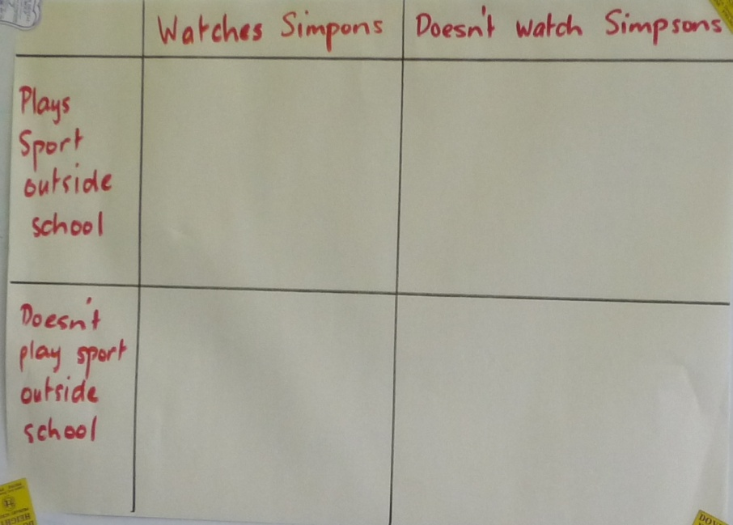

Students write their name on a post-it note and place it in the appropriate cell (the cell they have answered yes to both questions).

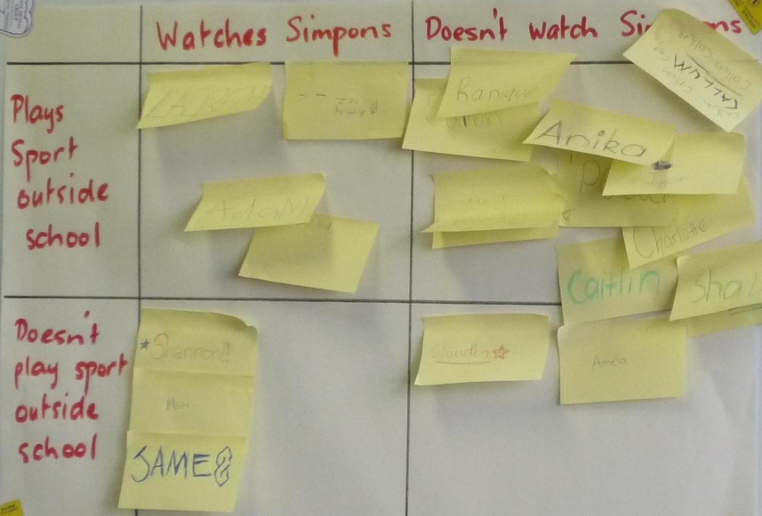

The teacher then tallies the results and records inside the cells.
Students’ Work Samples
Example 1: Working at Level 4
Students record their names and note the total in each cell.

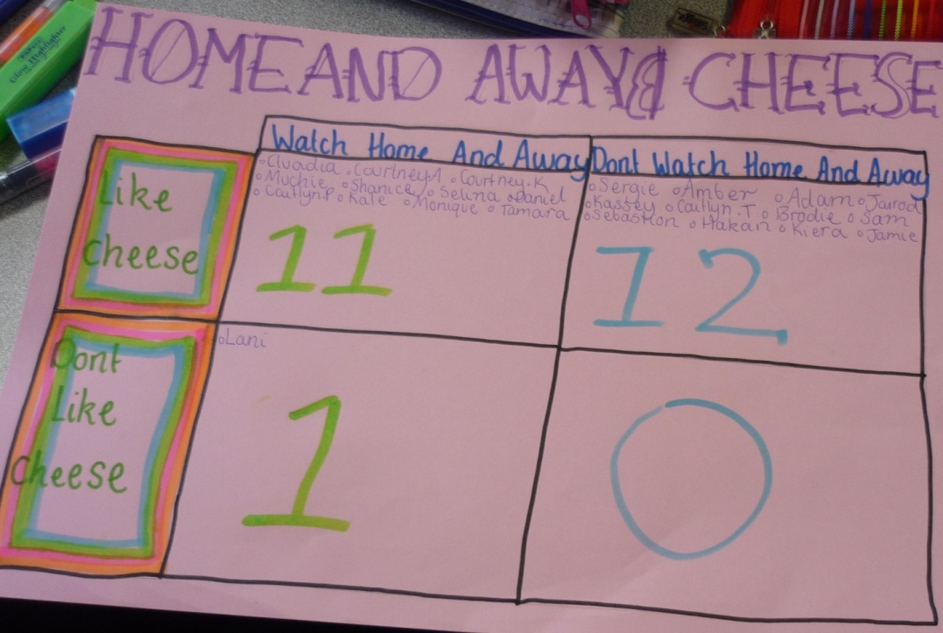

The students who created the two-way table below have created subcategories of gender within each cell, thus providing another level data for interpretation.
