Insight assessment platform
Reference Guide: Step-by-step guidance on using the Fractions and Decimals Online Interview (FDOI)

Logging in
- Navigate to the Insight Assessment Platform on the Victorian Curriculum and Assessment Authority (VCAA) website: https://www.vcaa.vic.edu.au/assessment/f-10assessment/insight/Pages/login.aspx
- Read the privacy statement and click the DET button at the bottom of the page.
- Use your Department User ID (TO number) and password to log in.

Assigning an assessment to your students
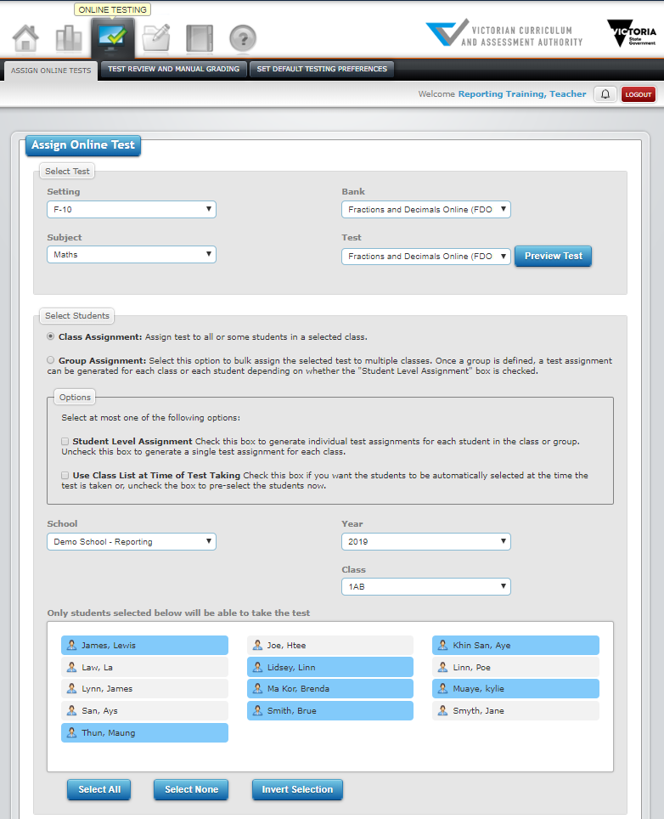
To assign an FDOI assessment to some, or all, of your students:
- Go to Online Testing > Assign Online Tests.
- In the Select Test section, complete:
  - Setting: F–10
  - Subject: Maths
  - Bank: Fractions and Decimals Online Interview (FDOI).
  - Test: Fractions and Decimals Online Interview (FDOI)
- In the Select Students section:
  - Select Class Assignment.
  - Select a Class if you have more than one. Your students are automatically brought into Insight and attached to you via CASES21. If you are attached to more than one class, each student list will appear when you select the corresponding class.
- You can deselect students if you would like only some of them to undertake the assessment. Selected students are blue, deselected students are grey.
- Options: You do not have to choose an option.
  - Student Level Assignment creates an individual test code for each student (this is used for student-led assessments and is not recommended for FDOI).
  - Use Class List at Time of Test Taking assigns the entire class to the assessment, including students joining the class at a later date. The student list will disappear if you select Use Class List.
- Click Assign. This will create a single test code for the students you selected.
Important: You do NOT need to assign a different test code to each student in your class. You can assign FDOI to multiple students from a class at the same time and when you click on the test code you created, all the students you selected will appear in the Test Taker.

About the test code
When you assign an assessment, a unique test code is automatically generated and will appear at the bottom of the window. This is a temporary location; the test code will disappear from here when you log out.
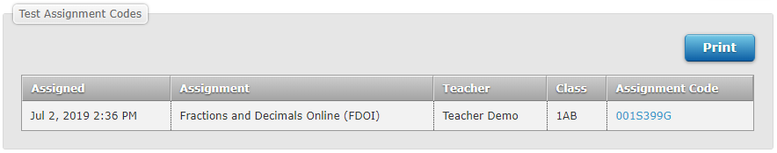
It will also appear in Test Review and Manual Grading under the Online Testing tab. All of your test codes are stored here
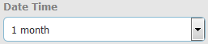
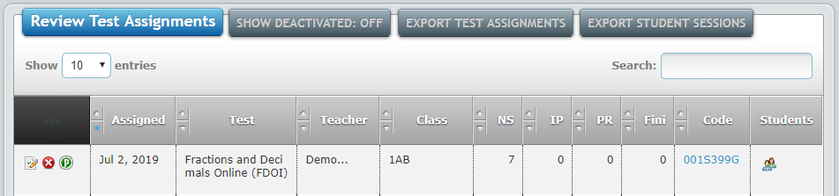
Tip: If you assigned your assessment a while ago, you may need to adjust the Date Time filter for it to appear in the list.

Conducting the Interview
FDOI uses a kit when undertaking the assessment, which should be prepared in advance (See Resources p.8 for link)
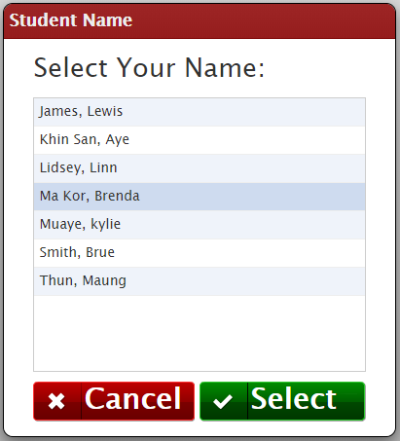
To undertake an FDOI assessment:
- Log in to Insight and click on the test code (it is hyperlinked), OR, go to https://test.linkitau.com and enter the test code.
- You will see the list of students you assigned to FDOI. Click on a student’s name and click Select to begin their assessment.
- Once the interview has been completed, click the Submit icon .

Test Taker navigation
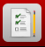
Arrows: Click the forward arrow to save the responses and move to the next page, or the back arrow return to previous questions. If the arrow background is grey, there are still questions on the page requiring a response.
Flag: Marks the question for later reference
Questions: Shows a list of the questions and whether they have been answered. A green Q is unanswered and a blue A is answered
Submit: Finalises the assessment. The student’s data for the assessment will not appear in Reporting until Submit is clicked.
Speech bubble: Indicates instructions to be read to the student.
Instruction: Provides instructions on an action the teacher needs to perform.

FDOI reports

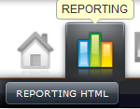
To access FDOI data analytics and reporting, click: Reporting tab > Reporting HTML. The Teacher Dashboard will open, and your students’ FDOI data analytics and reporting can be accessed from here. You can also view your students’ FDOI assessment histories by clicking on Student History.
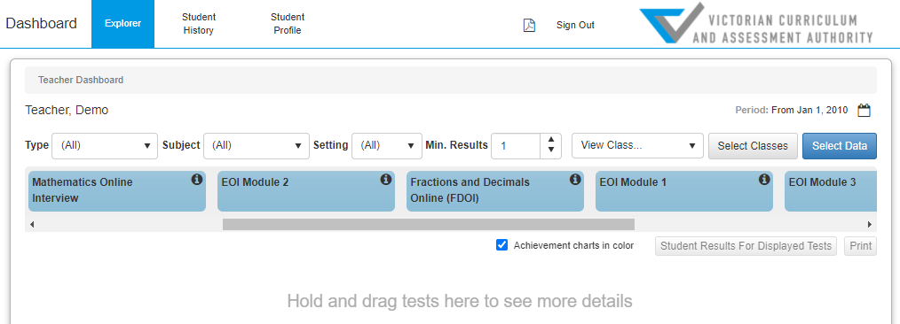

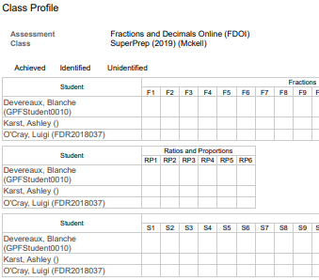
Printing reports
Browsers are not always set up to print background colours and images. If you notice that there are no data graphics in a report when you print it or save it as a PDF, your browser settings may need changing.
In Chrome, the Background graphics checkbox appears in the print window:
- Once you click on Print, the print window will open, click on More settings.
- Tick the Background graphics checkbox.
In Edge, the Background graphics checkbox appears in the print window:
- Once you click on Print, the print window will open, click on More settings.
- Tick the Background graphics checkbox.
In Firefox, background printing can be set up as a default setting in the browser:
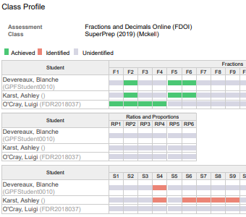
- Click File > Page Setup.
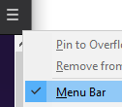
- Format & Options > Tick the Print Background (colours & images) checkbox.
* If you can’t see File, you might have the browser menu hidden. Right-click on the hamburger in the browser’s top right corner and select Menu bar.

In Safari, the Background graphics checkbox appears in the print window:
- Once you click on Print, the print window will open, click on More settings.
- Tick the Background graphics checkbox.

In Internet Explorer, background printing can be set up as a default setting in the browser:
- Click File* > Page Setup.
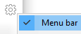
- Tick the Print Background Colors and Images checkbox.
*If you can’t see File, you might have the browser menu hidden. Right-click on the cog in the browser’s top right corner and select Menu bar.

FDOI: Summary
What it shows | - Number of student assessments and percentage distribution across overarching ideas and misconceptions/alerts for your students within a given timeframe.
How to access | 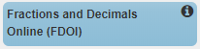  - On the Teacher Dashboard, drag and drop the FDOI data cube into the viewing area below to see summary data.
Tip | - Filter your data by clicking:  - View Class to select a particular class if you have more than one attached to you in Insight.  - Select Classes to choose one or more classes you are currently attached to in Insight, as well as classes your current students have been attached to historically in Insight (you will only see your current students’ data, not data from other students from those classes).  - The Calendar icon to change the time period for the data displayed.

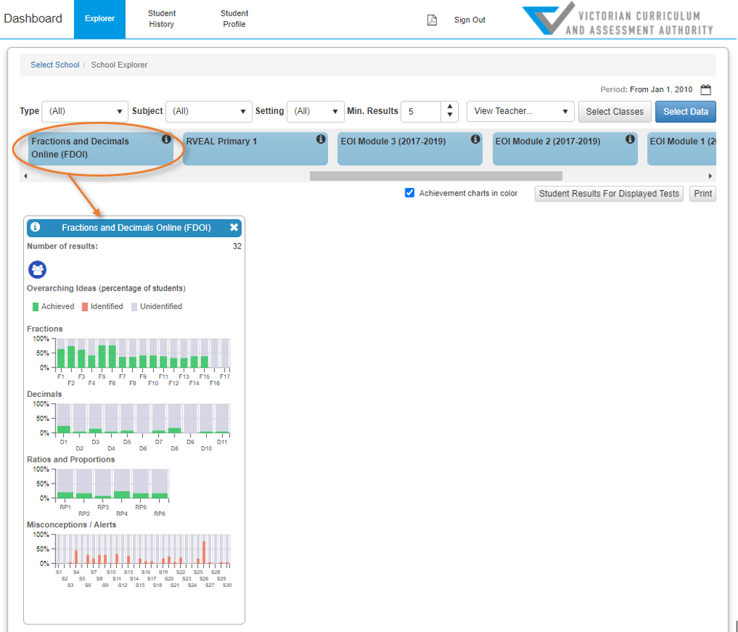
FDOI: Student Results
What it shows | - Students’ raw FDOI scores and result dates.
How to access | 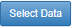  - On the Teacher Dashboard, click Select Data > select FDOI > click View Student Results to view summary data.
Tip | - In Single Result Per Row view, click on a column heading, e.g. Student, to sort by that column.  - Click Select columns to select further data fields to view.  - In Single Result Per Row view, click on Options to export data

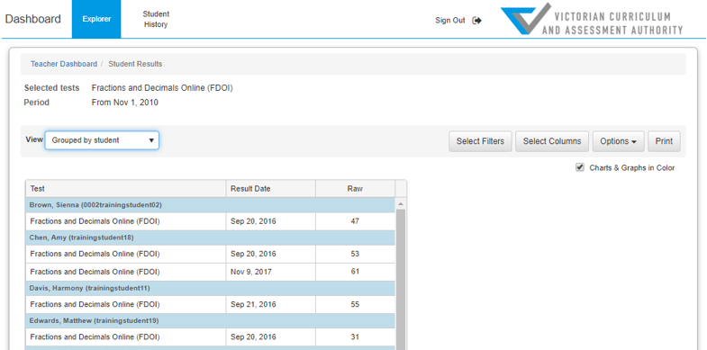

FDOI: Class Profile
What it shows | Overarching ideas (green) and misconceptions/alerts (orange) demonstrated by each student. Also shows overarching ideas and misconceptions that have not been identified during the assessment (grey).
How to access | - On the Teacher Dashboard, drag and drop the FDOI assessment into the viewing area below to see summary data.  - Click on the Class Profile icon .  - Select a class.
Tip | - Select the Show dates checkbox to display when the overarching idea or misconception/alert was achieved.

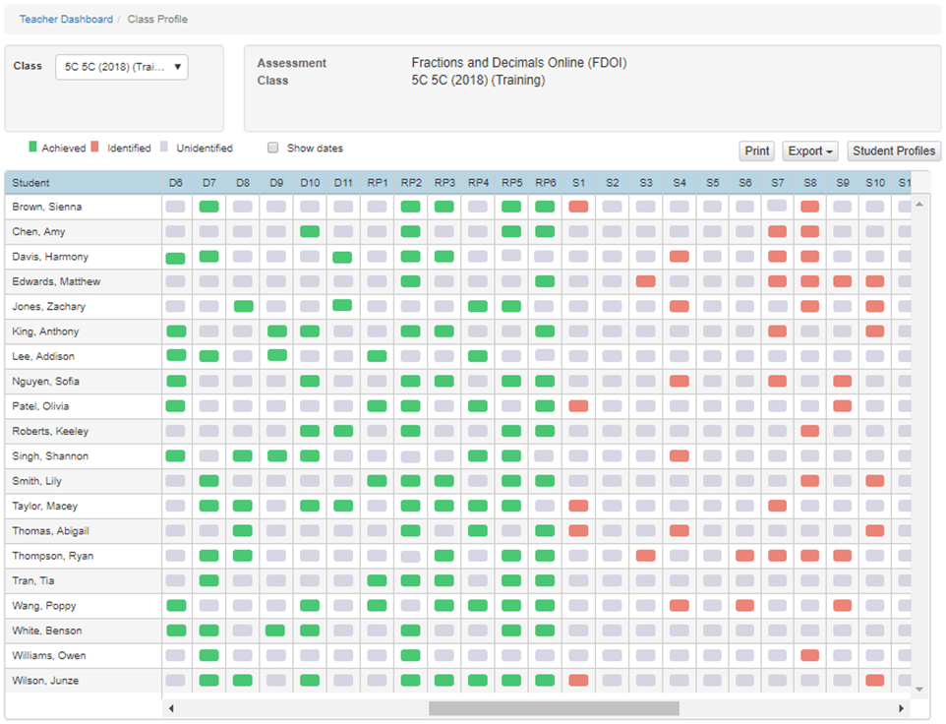

FDOI: Student Profile
What it shows | Overarching ideas and misconceptions/alerts achieved for each student and the date(s) they were achieved.
How to access | - On the Teacher Dashboard, drag and drop the FDOI assessment into the viewing area below to see summary data.  - Click the Class Profile icon .  - Select a class.  - Click Student Profiles and select a student.

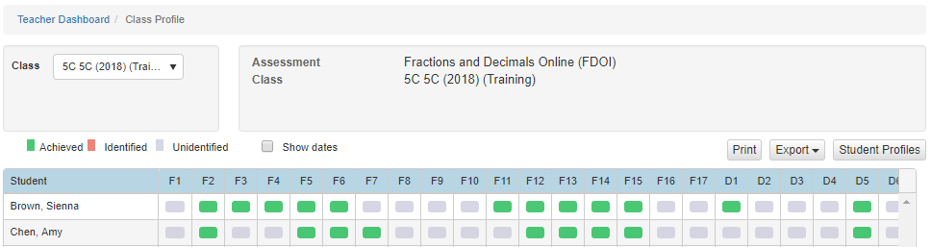

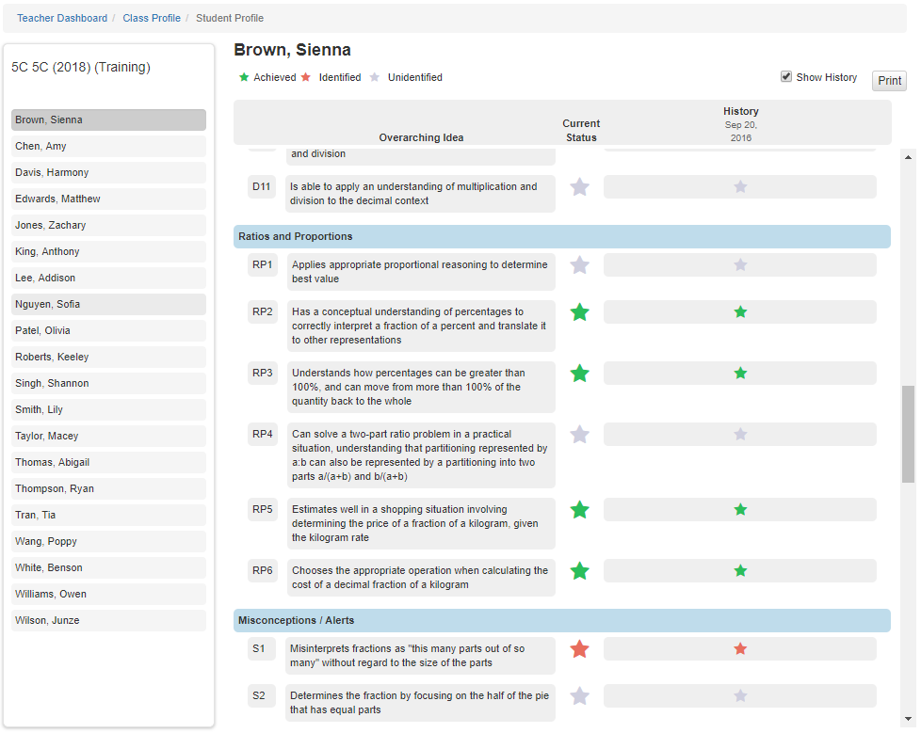

Student History
What it shows | Individual student assessment history for your current students.
How to access | - Click Reporting > Reporting HTML > Student History  - You can search by a student’s name or choose a class and select a student from the class list.
Tips | - Click Select Tests to filter results to FDOI only.  - Click Print to print/create a PDF of the history. You can Print Current Student or Batch Print Class. If you Batch Print Class, a PDF icon will appear and turn green when the PDF is ready. Click the PDF icon, select the report and click Open to view it.  - The Print button also provides data export options when you select a class to view.

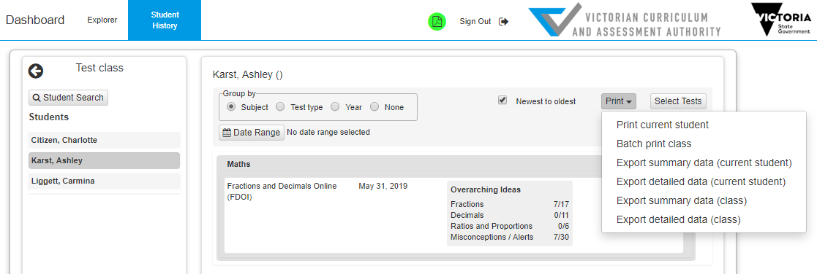

Further support

Service Desk
If you have an issue you cannot resolve, escalate it to your School Assessment Administrator. By default, your school’s Administrator is your principal. Principals can nominate other people in your school to have the Administrator role as well. If the Administrator cannot resolve the issue, contact the Service Desk:
- Services Portal: services.educationapps.vic.gov.au/dp
- Email: servicedesk@edumail.vic.gov.au
- Phone: 1800 641 943.

Resources
- Information about FDOI, including an equipment checklist (scroll down webpage): https://www.education.vic.gov.au/school/teachers/teachingresources/discipline/maths/assessment/Pages/mathsassess.aspx
- Insight support on FUSE: https://fuse.education.vic.gov.au/pages/insight
- Insight workshops and training: https://arc.educationapps.vic.gov.au/eventhub/providers/AssessmentImpl
- Assessment Implementation Unit: assessment.implementation@education.vic.gov.au

