Mathematics Online Interview (MOI)

Information Guide

Contents

1. Introduction 2

What is the Mathematics Online Interview (MOI)? 3

MOI background 3

Assessment sections 3

Differences between the MOI and the Fractions and Decimals Online Interview (FDOI) 4

2. Growth Points 5

The purpose of Growth Points 6

The Growth Point Framework 6

Description of the Growth Points 6

Growth Point profiles 7

Progressing from one Growth Point to the next 7

How Growth Points are assigned 7

Mapping MOI Growth Points to the Victorian Curriculum F-10: Mathematics Version 2.0 8

3. Preparing for the assessment 9

Recommended use of MOI 9

Advice for English as an Additional Language (EAL) and Culturally and Linguistically Diverse (CALD) students 9

4. Administering the MOI 10

Interview kit requirements 11

Duration of the assessment 11

Assigning students for interview 11

Recording teacher comments 12

Exiting and continuing the interview 12

Tips for an efficient interview process 13

Subsequent administrations of the MOI 14

5. Reports 14

Types of reports 15

6. Professional Learning 18

Department resources 19

Articles and books 19

7. Help and support 20

MOI Technical Support 20

Further Support 20

# Introduction

## What is the Mathematics Online Interview?

The Mathematics Online Interview (MOI) is an online assessment tool developed to test student mathematical understanding and inform responsive teaching targeted to student need.

The assessment is conducted as a one-to-one task-based interview between the teacher and student, typically during the early years of schooling (Prep to Year 2). It assesses a student’s mathematical knowledge, thought processes and methods at a point in time.

The results of MOI are used to generate reports providing an overview of student achievement and diagnostic information to inform responsive teacher practice and curriculum program planning. Student results can also be compared within schools to monitor student cohort achievement and progress.

The tool provides valuable data sets on student numeracy performance across the state, which inform targeted provision of supports at the local, network, area, region and system levels.

The MOI is complemented by the [Fractions and Decimals Online interview (FDOI).](https://www.education.vic.gov.au/school/teachers/teachingresources/discipline/maths/assessment/Pages/mathsassess.aspx)

## MOI background

The MOI was developed from the *Early Numeracy Research Project (ENRP, 1999-2001),* commissioned by the Department of Education. The ENRP developed a framework of growth (a learning trajectory) in mathematics understanding to provide a means of both measuring and tracking student learning.

The MOI was originally called the *Early Numeracy Interview (ENI)* and was administered with a hardcopy record sheet completed by the interviewer. The name was updated to the *Mathematics Online Interview (MOI)* when the tool was adapted to an online platform in 2016.

## Assessment sections

The MOI is comprised of ten sections with a total of 77 questions:

* Counting
* Place value
* Addition and Subtraction
* Multiplication and Division
* Time
* Length Measurement
* Mass Measurement
* Properties of Shape
* Visualisation
* Foundation Detour.

A student’s mathematical knowledge is measured against the Growth Point framework (see Chapter 2), which is derived from key ‘milestones’ in a typical learning trajectory for a school aged student across each of the above domains, excluding Foundation Detour.

### Foundation Detour

Foundation Detour tests the mathematical knowledge and understanding of students as they enter primary school. This short section of the MOI consists of five questions and is designed as a diagnostic tool for all Prep students at the beginning of the school year. It reveals the gaps in student mathematical understanding, and identifies students who may require additional supports during teaching of the Mathematics Curriculum in Foundation Stage (Prep to Year 2). Students’ on-entry MOI Foundation Detour results also offer a baseline for teachers to measure student growth in understanding across the Prep year, supporting teachers to deliver early interventions if learning is not following the expected trajectory. Finally, the MOI’s Foundation Detour section can be used at the end of Prep for summative assessment purposes.

Data generated from the MOI’s Foundation Detour section includes indicators of students’:

* early Number sense (understanding quantities: more and less, subitising, conservation, ordinal numbers)
* understanding patterns and patterning (algebra)
* location and spatial language (space)
* ordering sizes (measurement).

For some students, the Foundation Detour section can continue to be a useful diagnostic tool in Year 1 and Year 2. For example, it may offer a teacher a more nuanced understanding of a student’s level of mathematics knowledge where the student is assessed as not yet being a rational counter (i.e. not meeting Growth Point (GP) 2 in Counting).

The Foundation Detour has also been used successfully with 4-year-old children in prior-to-school settings to provide valuable insights for Early Childhood educators.

## Differences between the MOI and the FDOI

### Content

The MOI is one of two mathematics assessment tools accessible via the Insight Assessment Platform. The MOI is used to measure a student’s mathematical knowledge of counting, place value, addition and subtraction, multiplication and division, time, length measurement, properties of shape, and visualisation, whereas the FDOI assessment tool is used to measure a student’s mathematical knowledge of fractions and decimals. Further information about the FDOI can be found in the [FDOI Information Guide](https://education.edugate-cms.eduweb.vic.gov.au/Documents/school/teachers/teachingresources/discipline/maths/continuum/FDOI_Information_Guide.docx).

### Target year levels

Regular assessment to monitor learning progression and inform teachers’ decisions to accelerate, slow down or direct targeted interventions is a key practice within the Victorian Teaching and Learning Model (VTLM) 2.0.

The MOI is an effective tool for assessing students’ mathematics understanding from Prep to Year 4. It can continue to support teachers to monitor the learning progression and identify areas requiring further support of ‘at risk’ students from the middle primary to secondary levels.

As a minimum, it is recommended that the MOI is used:

* at the start and end of Prep, to assess all students with the Foundation Detour section
* at least once in each of Prep, Year 1 and Year 2 to assess all students in the four number domains (Counting, Place Value, Addition and Subtraction and Multiplication and Division)
* at least once during the Foundation Stage (Prep – Year 2) to assess all students across all other domains.

Teachers may choose to use the MOI outside of this range, for example, where a student is indicating readiness for acceleration, or is experiencing difficulties in understanding mathematical concepts.

Unlike the MOI, the FDOI is typically used to assess students in Years 5 to 8 as fractions and decimals are the more advanced mathematical concepts that are generally taught in upper primary year levels.

### Algorithmic branching

The MOI is a branched assessment tool, whereby an algorithm determines an individual student’s pathway through the assessment based on their performance on each item. The assessment is designed to inform teachers of students’ current levels of individual knowledge (Growth Point) and provide insights into misconceptions or gaps in their mathematics learning. Where a student answers initial questions correctly, the tool offers questions testing deeper understanding of that body of knowledge. If the student answers incorrectly, the tool returns to the main section menu.

The algorithmic branching is linked to a set of ‘Growth Points’, marking milestones in student learning progression within each domain (i.e. addition, subtraction, multiplication, division etc.). Achievement of Growth Points determines students’ progression to more advanced questions. A student’s level of success in one domain of the MOI, such as the ‘Addition and Subtraction’ section, does not predict their level of success or access to more advanced questions in another domain, for instance the ‘Time’ section.

# Growth Points



## The purpose of Growth Points

The MOI’s Growth Points mark milestones along typical learning trajectories within each of MOI’s domains. Teachers can generate a profile in the tool of a student’s mathematics understanding, based on a student’s achievement of Growth Points. The Growth Point profiles for each student and the whole class inform teachers’ adaptive teaching and planning to support student learning.

The Growth Points framework also provides teachers with the typical learning trajectory in each of the domains.

## Description of the Growth Points

Knowing and understanding the Growth Points in each domain ensures efficient interpretation of MOI data to inform targeted learning experiences.

The MOI’s nine domains have the following Growth Points:

Number domains:

* Section A: Counting – **7 Growth Points**
* Section B: Place Value – **6 Growth Points**
* Section C: Addition and Subtraction – **7 Growth Points**
* Section D: Multiplication and Division – **8 Growth Points**

Measurement domains:

* Section E: Time – **6 Growth Points**
* Section F: Length measurement – **6 Growth Points**
* Section G: Mass measurement – **6 Growth Points**

Space domains:

* Section H: Properties of Shape – **5 Growth Points**
* Section I: Visualisation – **5 Growth Points**

Notes:

* All domains start with GP0. ‘GP0’ does not mean a student does not know anything in that domain, it just means that they have not yet reached the first key milestone in that domain’s learning trajectory.
* The Growth Points are independent of each other (e.g. GP2 in ‘Place Value’ has no correlation with GP2 in ‘Multiplication and Division’).

For more information about individual Growth Points, see: [MOI Growth Point Descriptions](https://education.edugate-cms.eduweb.vic.gov.au/Documents/school/teachers/teachingresources/discipline/maths/continuum/MOI_Growth_Point_descriptions.docx).

## Growth Point profiles

A Growth Point profile is an efficient way to recognise each student’s position along the typical learning trajectory in each of the domains and what they are ready to learn.

For example, a Year 1 student profile could reveal as follows:

* GP3 for **Counting**: the student understands the concept of counting by ones up to and beyond 100 and is ready to explore the efficiency of skip counting in a meaningful way
* GP1 for **Place Value**: the student understands the concept of naming, writing, ordering and interpreting 1-digit numbers in place value and requires targeted learning based on 2- and possibly 3-digit numbers
* GP1 for **Addition and Subtraction**: the student can combine/add two quantities to determine a new quantity. However, the student needs to count all by ones to determine this new quantity so requires lots of experience with addition and subtraction scenarios to further develop number sense and develop more efficient ways to determine a new quantity
* GP2 in **Multiplication and Division**: the student is already aware of using the equal group structure in multiplicative problems where the problem is modelled. This means the student is ready to have some of these models screened (partial modelling) and for exposure to multiple forms of multiplication and division (e.g. groups of, times as many, arrays, quotative/partitive division).

A working knowledge and understanding of Growth Points enables teachers to recognise when a student has progressed to the next Growth Point. Teachers may readminister the MOI for confirmation but there is no requirement to do so.

## Progressing from one Growth Point to the next

Effective mathematics learning and teaching is conceptual and progressive and cannot simply involve a skill-based introduction of independent topics.

Constructing new concepts is supported by explicit explanations, repetition, scaffolded practice and spaced recall to ensure students:

* can access the new concept
* develop a thorough and accurate understanding of the concept
* can embed the concept in their long-term memory and apply it independently, flexibly and fluently, using efficient procedures.

Progression from one Growth Point to the next, in any given domain, will not occur after one or two lessons. For example, the average length of time for students to progress from GP1 to GP2 in Place Value is approximately one year. Some students will require more explicit explanations, modelling and scaffolded practice than others, while other students will progress more quickly to demonstrating mastery and applying more sophisticated concepts.

## How Growth Points are assigned

The [Growth Points Descriptions](https://education.edugate-cms.eduweb.vic.gov.au/Documents/school/teachers/teachingresources/discipline/maths/continuum/MOI_Growth_Point_descriptions.docx) document demonstrates the rationale for allocating each Growth Point.

Note: the interview questions are required to interpret this document.

## Mapping MOI Growth Points to the Victorian Curriculum F-10: Mathematics Version 2.0

The Victorian Curriculum F-10: Mathematics Version 2.0 provides the content that students should learn in each year level, with a description of the expected standard to be reached by the end of that year.

Growth Points measure a student’s proficiency in this content (understanding, fluency, reasoning and problem-solving).

Mapping the MOI Growth Points to the Victorian Curriculum F-10: Mathematics Version 2.0 content is complex as it needs to consider the strategies and/or explanations students provide to demonstrate their proficiency, and not just whether a student can deliver a correct answer.

For example, a student may demonstrate the capacity to *“Add and subtract numbers within 20, using physical and virtual materials, part-part-whole knowledge to 10 and a variety of calculation strategies*” as per [VC2M1N04](https://victoriancurriculum.vcaa.vic.edu.au/Curriculum/ContentDescription/VC2M1N04). The same student might sit at GP1, GP2 or GP3 in the MOI’s Addition and Subtraction domain depending on which strategies and/or explanations were given.

The [*Mapping the Mathematics Online Interview to the Victorian Curriculum F-10: Mathematics Version 2.0*](https://www.education.vic.gov.au/Documents/school/teachers/teachingresources/discipline/maths/continuum/MOI-mapping-to-victorian-curriculum.docx) document should be considered with this context in mind.

# Preparing for the assessment

## Recommended use of MOI

### Who should run the assessment

The MOI is designed to be administered by the students’ regular classroom teacher. This is because:

1) the classroom teacher is the main person who needs to gain an understanding of what individual students know and can do mathematically, as they will be the ones acting on this information

2) the interview is a great opportunity for the teacher and student to get to know each other in a one-on-one environment and for the student to demonstratewhat they know and can do independently.

For the above reasons, it is not recommended for the interviews to be conducted by someone other than the student’s classroom teacher, such as a school mathematics leader or mathematics specialist.

### When to assess certain sections with a student

The four Number domains of the MOI are best administered at the beginning of the school year. This is because start of year assessments provide insight into students’ consolidated knowledge and understanding, rather than content from a recently completed unit of work, which may not yet be fully embedded in their long-term memory.

Teachers are advised not to assess only one domain in Number (e.g. Counting), as this can limit the teacher’s understanding of the level of a student’s number sense.

Whilst the interview provides an opportunity for teachers to get to know individual students and their current mathematical knowledge and understanding, the one-on-one interview mode has implications for teachers’ time. Accordingly, it is recommended that teachers only assess the four number domains at the beginning of the year and assess the other domains (e.g. length measurement, time, etc) prior to teaching a relevant unit of work.

It is not necessary to administer a section of the MOI to a student more than once a year, except for the Foundation Detour (which is administered at the start and end of prep) and in exceptional circumstances, such as a student receiving learning intervention. Student progress can be effectively monitored and ongoing learning needs adapted through other assessment practices by a teacher who is familiar with and understands Growth Points and the Growth Point framework.

## Advice for English as an Additional Language (EAL) and Culturally and Linguistically Diverse (CALD) students

The MOI is generally accessible to EAL students due to the practical nature of the questions, the wording of each question, and its direct instruction. However, students with limited English language acquisition may face linguistic barriers to demonstrating their mathematical knowledge.

The interview is conducted verbally with some questions requiring a student to provide verbal justifications for their answer. This can be challenging for students with limited English oral skills, as they may be unable to articulate their answer clearly and/or confidently. Students may also find complex mathematical language challenging to understand and/or use, such as the ‘Properties of Shape’ (Section H) and ‘Visualisation’ (Section I) sections of the MOI.

It is important that teachers do not assume a lack of mathematical knowledge when administering the MOI to EAL students.To ensure a positive experience for the student, the teacher should determine whether a student has an appropriate level of English prior to commencing the assessment. To achieve this, the teacher should:

* explicitly teach the mathematical vocabulary students will encounter
* identify and teach the language students will need to understand questions and to describe and explain as they answer, for example, the language of sequencing and location to describe pattern and order, or conditional clauses to explain alternative solutions
* provide multiple opportunities for practice through classroom activities using worded questions similar to those in the interview.

If the teacher becomes aware of specific topics or themes that are unknown to the student during the interview, or observes the student experiencing difficulty articulating their answers, the teacher is encouraged to:

* consider alternative modes of response to reduce language barriers, such as providing visual aids/drawings to support the student to respond
* engage with the school’s Multicultural Education Aid (if applicable), to assist with translating the student’s justification
* administer a different section of the interview (noting not all sections of the assessment need to be submitted at one time, and they may be re-visited)
* pause the interview and return to the challenging section at a later date after providing further targeted teaching and practice.

# Administering the MOI

## Interview kit requirements

The MOI interviewer must be prepared for and familiar with the interview tasks.

The required equipment needs to be sourced, sorted and stored for easy access throughout the interview. It is recommended that the equipment is sorted into each of the ten (including Foundational Detour) interview sections.

The [MOI Equipment list](https://www.education.vic.gov.au/Documents/school/teachers/teachingresources/discipline/maths/continuum/MOI-equipment-checklist.docx) includes printable templates, where the suggested colours on the printable templates is designed to ensure a more efficient and smooth administration of the interview. Teachers should be alert to potential barriers for students with colour blindness and amend colours as required. Teachers are encouraged to print, assemble, and laminate the materials using the required colour of paper for easier identification.

Equipment can be sourced independently or interview kits can be purchased, such as the *Early Numeracy Interview Kits,* through educational suppliers. These kits can be bought in full (sections A-I and the Foundation Detour) or as individual kits for each section.

## Duration of the assessment

The full assessment takes approximately 30 - 45 minutes to administer depending on:

* the number of questions students are asked based on the branching process
* the interviewer’s experience in both administering the interview and understanding the mathematics underpinning it, in order to record the responses efficiently
* the length of time the student takes to respond to each question.

## Assigning students for interview

Users will need a test code to assign students for interview. Step-by-step guidance on creating test codes can be found in the [MOI User Guide](https://www.education.vic.gov.au/Documents/school/teachers/teachingresources/discipline/maths/continuum/MOI-user-guide.docx).

You **do not** need to assign a different test code to each student in your class.You can assign MOI to multiple students from a class at the same time. When you click on the test code created, all the students selected will appear in the *Test Taker* screen.

## Left-hand and right-hand panes

Figure 1 shows how the MOI assessment screen is split into two panes. This only applies to questions where further guidance is needed to support teachers in administering the question, or select the appropriate response based on the student’s response.

**The left-handpane** provides helpful information, such as equipment required, definitions, and possible strategies, explanations and responses from students.

**The right-hand pane** displays the question(s) and speaking points. This guides the teacher through the interview and includes all instructions needed.

Figure 1: MOI Left- and right-hand pane

## Recording teacher comments

The MOI has a comments box at the bottom of every question, enabling teachers to enter free text to record notes and observations on the student’s response to the question (refer to Figure 2).

Figure 2: Free text comment boxes for user input on student responses

## Exiting and continuing the interview

If a teacher is unable to complete the assessment in full during a single sitting, or the student is struggling to continue with particular questions, the teacher can submit the assessment at any point to save the student’s partially completed assessment. If the teacher is to reassess the same student and continue the assessment, the user can access the same test code used for the student’s initial assessment, and then can select the student still ‘In Progress’, and continue the assessment.

Figure 3 below illustrates how to return to a student or class test code to continue their MOI assessment. Teachers can view the assessment status of their student/s or class, such as Not Started (NS), In Progress (IP), Pending Review (PR), and Finished/Completed (Fini).

Figure 3: How to continue an assessment interview

## Tips for an efficient interview process

Teachers may practise using the MOI with teaching colleagues and/or family members prior to interviewing any students: [Insight Assessment Platform - Practice Space](https://www.vcaa.vic.edu.au/assessment/f-10assessment/insight/Pages/practicespace.aspx).

By practising, teachers familiarise themselves with the administration processes (e.g. how to manage the interview kit equipment) and online platform, supporting a more efficient and relaxed assessment environment.

It is also important that teachers are familiar with (i) the mathematics being assessed by each item; (ii) common strategies used by students; and (iii) common misconceptions. This will enable quick and efficient analysis and interpretation of the students’ responses.

The wording of each question is intentional and research-based. For example, it is important to follow the script and resist the temptation to re-word a question or to prompt students for an answer. Understanding mathematics vocabulary is as important for students’ ongoing learning of mathematics as being able to calculate the response to a specific question.

If in doubt, it is better to err on the side of caution and provide a student with further learning experiences for consolidation than to risk assuming understanding that has not been fully constructed and embedded.

## Subsequent administrations of the MOI

The online assessment automatically navigates the user back to the first incorrect response made by the student. Whilst a teacher may like to re-visit this task as a means of reinforcing a concept, it is not always necessary to re-commence the assessment from the beginning of the interview, as it measures point in time knowledge and understanding.

It is important to commence from a point where students have previously shown full understanding (i.e., their previously assessed Growth Point). The nature of the interview is such that the data collected needs to provide current evidence of full understanding of a Growth Point in order to assign that Growth Point.

Furthermore, a teacher should not assume that a student will have reached the next Growth Point when re-administering the interview. It is important for a teacher to re-visit the assessment from a realistic entry point to ensure the student experiences some success before they encounter more challenging tasks in the interview.

# Reports

## Types of reports

MOI Growth Point data is only effective and useful if it is analysed and interpreted accurately. Classroom teachers can analyse the data at both individual student and class levels. Schools can also conduct whole school data analyses.

A range of reports for the MOI can be generated to view student and class data. School Assessment Administrators can generate reports for any class, as well for the whole school. Reports can only be generated for students whose assessment/s have been submitted. The reports highlight the Growth points that students have achieved at any given time, helping users to assess a students’ mathematical skill level, and provide support in areas with which the student has difficulty. Question-based reports are also available to show which questions students have answered correctly or incorrectly, at an individual, class, and group level.

This section provides a summary of reports available through the Insight Assessment Platform. For a more detailed step-by-step guide on how to access each report, refer to the [MOI User Guide](https://www.education.vic.gov.au/Documents/school/teachers/teachingresources/discipline/maths/continuum/MOI-user-guide.docx) located on the [MOI and FDOI web page](https://www.education.vic.gov.au/school/teachers/teachingresources/discipline/maths/assessment/Pages/mathsassess.aspx).

### Class profile

##### Growth Points class data

Figure 4 shows that users can view a comparison of the Growth Points achieved (green), achieved by backfill (light green) or unidentified (grey) of students in their current class.

Figure 4 - Growth Points – class profile view

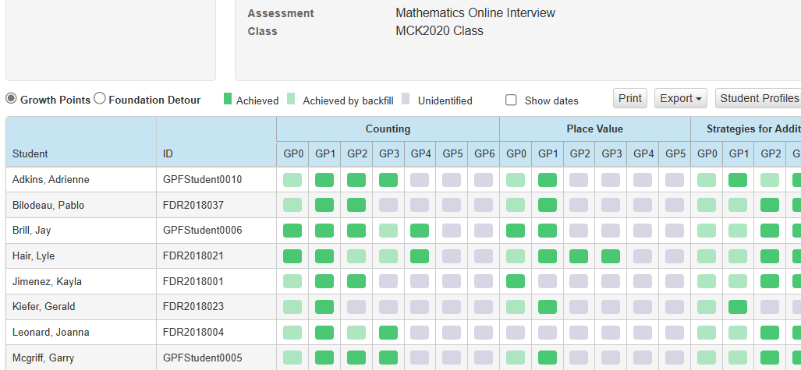

*Foundation Detour - Question-based responses - class view*

Figure 5 shows that users can view a question-based report for Foundation Detour that displays a class overview, showing which students answered each question correctly or incorrectly (this question-based view is only available for Foundation Detour at this time).

Figure 5: Foundation Detour - class response view

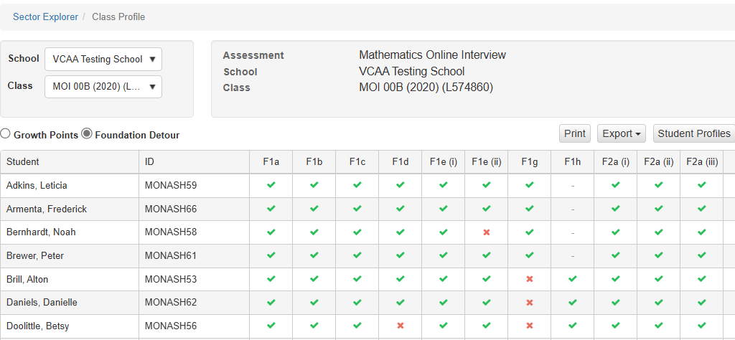

##### Individual student profile

*Student profile data*

Figure 6 shows that users can view a specific students’ progress by clicking on ‘Student Profiles’. Users can then see the descriptions of the Growth Points and the current and historical status of a student’s assessment progression.

Figure 6: Detailed Growth Points - student profile view

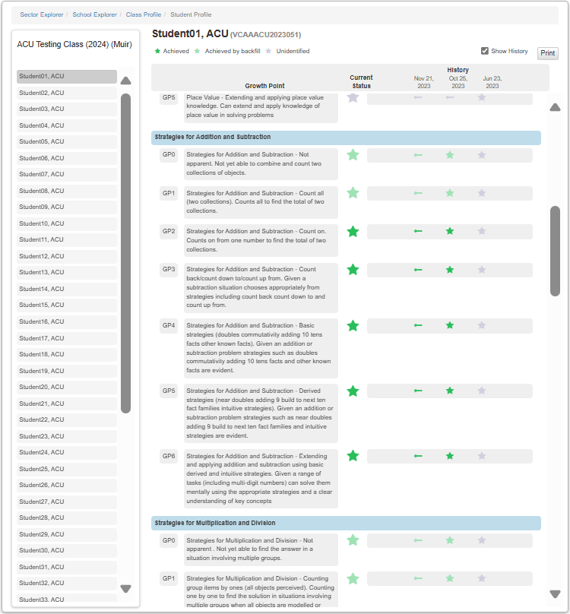

##### Overall MOI student Growth Point scoring

Figure 7 shows that users can view an individual student’s overall ‘scoring’ (in the ‘Student History’ tab) of their full assessment based on how many Growth Points they achieved for each section at the time their assessment/s were submitted.

Figure 7: Highest achieved Growth Points scoring – individual student view

##### Student responses to questions

Figure 8 shows that users can view individual student responses to questions, which are colour-coded to indicate which questions students answered successfully or not.

Figure 8: Student responses to questions – individual student view

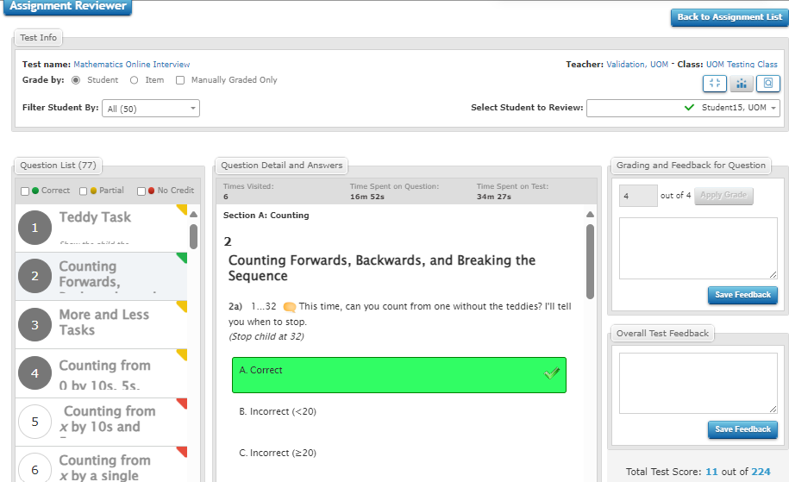

School profile view

*Growth point percentage comparison*

Figure 9 displays the percentage distribution of students across Growth Points for each MOI domain within a given timeframe. Users can view growth point achievement at a school level (noting this level of detail may be restricted to those with administrative access only i.e. Principals).

Figure 9: Growth point percentages - school profile view

# Professional Learning

Teachers can access a range of professional learning to support their use of the MOI.

## Department resources

### On-demand webinars

Teachers can access a series of on-demand webinars via the Arc Learning Platform:

[Mathematics Online Interview (MOI) Webinar: Making the most of the MOI (Part one)](https://arc.educationapps.vic.gov.au/event/8407)

[Mathematics Online Interview (MOI) Webinar: Making the most of the MOI (Part two)](https://arc.educationapps.vic.gov.au/event/8703)

[Mathematics Online Interview (MOI) Webinar: Foundation Detour](https://arc.educationapps.vic.gov.au/event/8233)

### Videos

A series of short guidance videos are available to support teachers in using and interpreting MOI reports:

[Mathematics Online Interview and Fractions and Decimals Online Interview (education.vic.gov.au)](https://www.education.vic.gov.au/school/teachers/teachingresources/discipline/maths/assessment/Pages/mathsassess.aspx#guidance-videos)

## Articles and books

**Key research underpinning the MOI (and task-based one-on-one assessment interviews generally) include:**

Clarke, D., Clarke, B., & Roche, A. (2011). [Building teachers’ expertise in understanding, assessing and developing children’s mathematical thinking: The power of task-based, one-to-one interviews.](https://aus01.safelinks.protection.outlook.com/?url=https%3A%2F%2Farc.educationapps.vic.gov.au%2F1673.efm&data=05%7C02%7CDoug.Clarke%40acu.edu.au%7C3dfb8a0894ab4c08a04008dd57a7bc38%7C429af009f196448fae7958c212a0f2ce%7C0%7C0%7C638763100485922612%7CUnknown%7CTWFpbGZsb3d8eyJFbXB0eU1hcGkiOnRydWUsIlYiOiIwLjAuMDAwMCIsIlAiOiJXaW4zMiIsIkFOIjoiTWFpbCIsIldUIjoyfQ%3D%3D%7C0%7C%7C%7C&sdata=MB%2FZgWyzbG%2BPUU5dupH84y9gwWxgs2b5lL%2F7SdLgZ3c%3D&reserved=0) *ZDM Mathematics Education,* 43(6), 901-913.

Clements, M. A. & Ellerton, N. (1995). Assessing the effectiveness of pencil-and-paper tests for school mathematics. In B. Atweh & S. Flavel (Eds.), *GALTHA: Proceedings of the 18th annual conference* *of the Mathematics Education Research Group of Australasia* (pp. 184–188). MERGA.

Department of Education (1999-2001). [*Early Numeracy Research Project Summary*](https://aus01.safelinks.protection.outlook.com/?url=https%3A%2F%2Fwww.education.vic.gov.au%2FDocuments%2Fschool%2Fteachers%2Fteachingresources%2Fdiscipline%2Fmaths%2Fenrpreport.pdf&data=05%7C02%7CDoug.Clarke%40acu.edu.au%7C3dfb8a0894ab4c08a04008dd57a7bc38%7C429af009f196448fae7958c212a0f2ce%7C0%7C0%7C638763100485895599%7CUnknown%7CTWFpbGZsb3d8eyJFbXB0eU1hcGkiOnRydWUsIlYiOiIwLjAuMDAwMCIsIlAiOiJXaW4zMiIsIkFOIjoiTWFpbCIsIldUIjoyfQ%3D%3D%7C0%7C%7C%7C&sdata=Bjric4DWUBkD%2FgSQ1oJcYEduaynUHM%2Bvg4B8Pj4Nhw8%3D&reserved=0)

Gervasoni, A. M. (2005). Using growth points to describe pathways for young children's number learning. In H. Chick and J. Vincent (Ed.)*, Proceedings of the 29th Conference of the International Group for the Psychology of Mathematics* (pp. 156 – 161). PME.

**Written by the original developers of the interview, the following papers outline useful teaching activities relating to the importance of assessing and understanding children’s mathematical progression:**

Clarke, D. M. (2001). [*Understanding, assessing and developing young children’s mathematical thinking: Research as powerful tool for professional growth*](https://aus01.safelinks.protection.outlook.com/?url=https%3A%2F%2Fwww.researchgate.net%2Fprofile%2FDoug-Clarke%2Fpublication%2F228700076_Understanding_assessing_and_developing_young_children%2527s_mathematical_thinking_Research_as_a_powerful_tool_for_professional_growth%2Flinks%2F553960450cf226723aba1910%2FUnderstanding-assessing-and-developing-young-childrens-mathematical-thinking-Research-as-a-powerful-tool-for-professional-growth.pdf&data=05%7C02%7CDoug.Clarke%40acu.edu.au%7C3dfb8a0894ab4c08a04008dd57a7bc38%7C429af009f196448fae7958c212a0f2ce%7C0%7C0%7C638763100485910236%7CUnknown%7CTWFpbGZsb3d8eyJFbXB0eU1hcGkiOnRydWUsIlYiOiIwLjAuMDAwMCIsIlAiOiJXaW4zMiIsIkFOIjoiTWFpbCIsIldUIjoyfQ%3D%3D%7C0%7C%7C%7C&sdata=LYYoJPYT6iyrQSkxTIIqdO92jmLVuhC8odTGsVgVolI%3D&reserved=0)*.* In J. Bobis, B. Perry, & M. Mitchelmore (Eds.), Numeracy and beyond (Proceedings of the 24th Annual Conference of the Mathematics Education Research Group of Australasia, Vol. 1, pp. 9-26). Sydney: MERGA.

Clarke, D. M., Cheeseman, J., Gervasoni, A., Gronn, D., Horne, M., McDonough, A., Montgomery, P., Roche, A., Sullivan, P., Clarke, B. A., & Rowley, G. (2002). *The Early Numeracy Research Project: Final report.* Mathematics Teaching and Learning Centre, Australian Catholic University.

Gervasoni, A. (2015). *Extending mathematical understanding: Intervention*. BHS Publishing.

# Help and support

## MOI Technical Support

In the first instance, when experiencing technical difficulties in using the MOI teachers can:

* speak with their School Assessment Administrator
* refer to the support documentation on the [Insight Assessment Platform](https://www.vcaa.vic.edu.au/assessment/f-10assessment/insight/Pages/login.aspx).

Technical assistance is available for schools via the Services Portal:

Self service: [Services Portal](https://services.educationapps.vic.gov.au/dp) (staff login required)  
Phone: [1800 641 943](tel:1800641943)  
Email: [servicedesk@education.vic.gov.au](mailto:servicedesk@education.vic.gov.au)

When lodging a Services Request, provide as much information as possible about the issue including user name, school name and campus number. Screenshots displaying error messages should also be provided where possible.

## Further Support

For more information or further support on the MOI assessment tool, contact the Curriculum, Assessment and Reporting Unit at [studentlearning@education.vic.gov.au](mailto:studentlearning@education.vic.gov.au).