Mathematics Online Interview (MOI)
  - January 2018 User Guide

Mathematics Online Interview (MOI) 1
What is MOI? 1
Structure of the Interview 1
Insight Assessment Platform 2
Framework for Improving Student Outcomes (FISO) 2
Introducing 2018 MOI Updates 2

What is MOI?
The Mathematics Online Interview (MOI) is an online tool for assessing the mathematical understanding of students in the early years of schooling. The Interview assesses students’ knowledge, skills and strategies in relation to key ‘growth points’ in the strands of Number and Algebra, Measurement and Geometry.
MOI has been developed from the Early Numeracy Research Project (ENRP), commissioned by the Department of Education, Employment and Training (1999 – 2001). Through the ENRP, a framework of growth in numeracy learning was created to provide a means of tracking student learning.
The Interview primarily targets students in the early years of schooling however it may also be used as an assessment tool for ‘at risk’ students in middle to upper primary levels.Teachers record student responses directly into the online system, which can generate a range of profiles of student understanding, organised around the growth points. These profiles provide information for teachers in planning to meet student learning needs.

Structure of the Interview
The assessment takes the form of a one-to-one interview, and consists of 77 questions. Students are engaged in hands-on assessment tasks where they demonstrate mathematical understanding and strategies for solving increasingly complex tasks. The assessment takes approximately 30 to 45 minutes to administer.
An ongoing record of student assessment and achievement data recorded through the online interview supports monitoring of student learning and progress over time.
Sections of the Interview are as follows:
          - Section A: Counting
          - Section B: Place Value
          - Section C: Addition and Subtraction
          - Section D: Multiplication and Division
          - Section E: Time
          - Section F: Length measurement
          - Section G: Mass measurement
          - Section H: Properties of Shape
          - Section I: Visualisation
          - Detour (for students in the first year of school)

Insight Assessment Platform
The Insight Assessment Platform is an Education State initiative aimed at helping teachers assess the progress of all learners and to support more targeted teaching practices.
The Insight Assessment Platform has been run by the VCAA since August 2017 and provides a collection of quality online assessment instruments aligned to the Victorian Curriculum F – 10.
Insight supports high-quality assessment practices and provides teachers with specific information to target the learning needs of students through its powerful data analytics and instrument reporting capabilities. Students' assessment data can be reviewed by teachers for diagnostic, formative and summative assessments.
Currently, Insight has five assessment instruments, with more under development:
• English Online Interview (EOI): target student cohort: F – Year 2
• Diagnostic Assessment Tools in English (DATE): target student cohort: K – Year 6
• Mathematics Online Interview (MOI): Target student cohort: F – Year 2
• Fractions and Decimals Online Interview (FDOI): target student cohort: Year 5 – 10
• Abilities Based Learning and Education Support (ABLES): target student cohort: F – Year 12

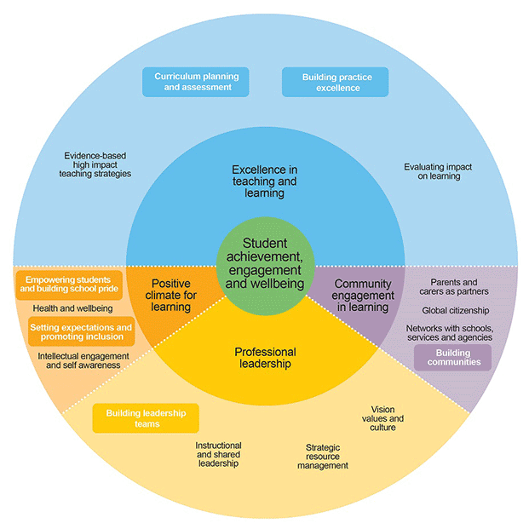
Framework for Improving Student Outcomes (FISO)

The Insight Assessment Platform supports the development of high impact evidence-based teaching strategies as identified in the Framework for Improving Student Outcomes (FISO). Assessment is an integral part of the teaching and learning cycle. FISO is designed to foster a targeted, evidence-informed focus on student outcomes, providing a common approach for our professional workforces across the system, and is intended to lift student outcomes.

Introducing 2018 MOI Updates

Since launching the MOI on the insight platform in 2017, a number of enhancements were identified to improve the usability and functionality of the online interview. A number of updates have been made to MOI for 2018. The updates include:
- Edits to improve clarity of instructions.
- Reduction of visual clutter including green highlighting, sad and smiley faces, and unnecessary free text boxes.
- Fixed branching issues based on advice from educational experts, for example, the loop in Section B back to Question 9 has been addressed.
- Growth Point 0 will now be awarded to a student for a section when they answer at least one question (correct or incorrect) in that section, but not enough to achieve a Growth Point greater than 0.
- A Foundation Detour report is now available.
- Strategies are now required for some questions, a message alerting users to “Please select a strategy” will appear for questions requiring a strategy to calculate a growth point if the required field is left blank.

A tip sheet that details steps for using MOI on the Insight Assessment Platform can be found here.

