Fractions and Decimals Online Interview (FDOI) - Overarching Ideas and Misconceptions
Updated January 2025
This document provides a detailed description of how ‘Overarching Ideas’ and ‘Misconceptions’ are assigned throughout the FDOI assessment.

Overarching Ideas
“Overarching ideas” are statements that describe what a student understands and/or can do, in the three domains of the FDOI; i.e., Fractions (F), Decimals (D), and Contextual Problems (CP). These may link to one item (e.g. Question 2), part of an item (e.g. 2a), or several parts of items (e.g. 2e and 2f).

Misconceptions
Misconceptions (M) are ideas that describe an erroneous understanding that a student has formed, in the three domains of the FDOI; i.e., Fractions (F), Decimals (D), and Contextual Problems (CP). These may link to one item, part of an item, or several parts of items.

 | OVERARCHING IDEAS |  |  |  |  | MISCONCEPTIONS
Question | ID | Description | Decision making process for assigning the overarching idea | Correct solution(s) for assigning the overarching ideas | ID |  | Description | Decision making process for assigning the misconception
Fractions
1. Fraction Pie | F1 | Understands that fractions are equal shares, with careful attention to the whole | Determines the correct solution in 1a) AND 1b) | 1a) $\frac{1}{4}$ or equivalent  1b) $\frac{1}{6}$ or equivalent | M1 |  | Misinterprets fractions as "this many parts out of so many" without regard to the size of the parts | Incorrectly indicates $\frac{1}{5}$ as the solution in either 1a) OR 1b)
 |  |  |  |  | M2 |  | Determines the fraction by focusing on congruent parts only | Incorrectly indicates $\frac{1}{2}$ as the solution in 1a) OR $\frac{1}{3}$in 1b)
2. Pattern Blocks | F2 | Can determine the part when given the whole | Determines the correct solution in 2a) AND 2b) | 2a) 3  2b) $\frac{1}{3}$ or equivalent | M3 |  | Is unable to iterate one piece to determine what fraction it is of another piece | Provides incorrect solutions for 2a) OR 2b)
2. Pattern Blocks | F3 | Understands that the whole can change within a given task, and adjusts thinking accordingly | Determines the correct solution 2b) AND 2e) AND 2f) | 2b) $\frac{1}{3}$ or equivalent  2e) $\frac{2}{3}$ or equivalent  2f) $\frac{1}{3}$ or equivalent | M4 |  | Can only conceive of one shape covering another a whole number of times | Provides a whole number solution in 2c) (i.e., 2) AND does not correct this response in 2d) (i.e. Yes)
2. Pattern Blocks | F4 | Can determine the size of a shape in relation to the whole, when the shape is greater than the whole | Determines the correct solution in 2c) OR 2d) AND 2g) | 2c) 1 $\frac{1}{2}$ or equivalent  OR  2d) 1 $\frac{1}{2}$ or equivalent  2g) 1 $\frac{1}{2}$ or equivalent
3. Dots Array | F5 | Can name a fraction of a collection in a discrete situation | Determines a correct solution in 3a) | 3a) $\frac{12}{18}$ OR $\frac{4}{6}$ OR $\frac{2}{3}$ OR $\frac{6}{9}$  OR Other (correct)
3. Dots Array | F6 | Recognises two equivalent fractions in a discrete situation | Determines a correct solution in 3a) AND 3b) | 3a) $\frac{12}{18}$ OR $\frac{4}{6}$ OR $\frac{2}{3}$ OR $\frac{6}{9}$  OR Other (correct)  3b) $\frac{12}{18}$ OR $\frac{4}{6}$ OR $\frac{2}{3}$ OR $\frac{6}{9}$  OR Other (correct) – different from (a) | M5 |  | Is only able to describe a proportion in one way (e.g., 12 out of 18 are shaded, so the answer is $\frac{12}{18}$ ) | Provides any correct response in 3a) but does not provide a second correct response in 3b)
4. Simple Operators | F7 | Can mentally partition a number and identify the resultant part of the action involving a fraction and a whole number | Determines a correct solution in 4a AND 4b) AND 4c) | 4a) 3  4b) 2  4c) 6
4. Simple Operators | F8 | Can mentally partition a number and identify the resultant part of the action in problems involving two fractions | Determines a correct solution for 4d) AND 4e) | 4d) $\frac{1}{6}$ or equivalent  4e) $\frac{1}{6}$ or equivalent | M6 |  | Is unable to visualise a fraction of a fraction (e.g.$\frac{1}{ 3}$ of $\frac{1}{2}$) in any way other than ‘seeing’ the symbols | ‘No’ selected on both occasions in 4d) AND 4e)
5. Fractions on a Number Line | F9 | Can correctly locate a proper fraction on a number line | Correctly locates zero, two-thirds, and 1 on a number line in 5a) | 5a)  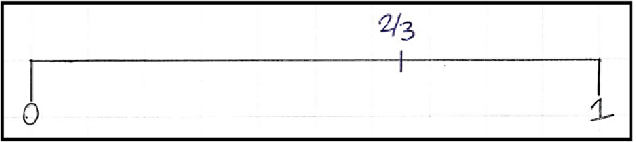 | M7 |  | Is unable to locate a proper fraction on a number line | Incorrect response in 5a)
5. Fractions on a Number Line | F10 | Can correctly locate fractions (proper and improper) on a number line | - Correctly locates and labels zero, two-thirds, and 1 on a number line in 5a), AND;  - Correctly locates and labels six-thirds in 5b), AND;  - Correctly locates and labels eleven-sixths in 5c) | - 5a)  - 5b)  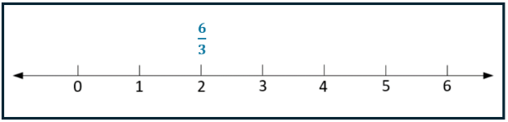  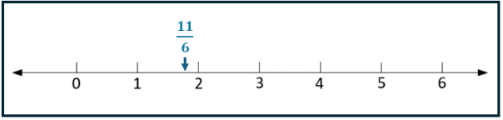  - 5c) | M8 |  | Is unable to locate an improper fraction on a number line | Incorrect response in 5b) OR 5c)
6. Pizza | F11 | Has an appropriate strategy for a sharing-type situation | Determines a correct solution in 6a) OR 6b) | 6a) $\frac{3}{5}$ or equivalent  OR  6b) $\frac{3}{5}$ or equivalent | M9 |  | Does not have an appropriate strategy for a sharing-type situation | Incorrect response in 6a) and did not correct this response in 6b)
 |  |  |  |  | M10 |  | Changes the unit inappropriately in a sharing situation, e.g. from one pizza to three | Incorrectly indicates $\frac{3}{15}$ in 6a) OR 6b)
7. Draw Me a Whole | F12 | Can determine the whole when given a part which is less than one | Creates an image that correctly shows a whole in 7a) | 7a)  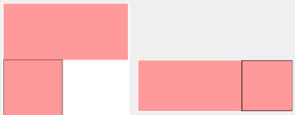  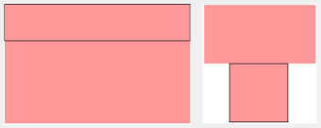  OR Other (correct) | M11 |  | Is unable to conceive a shape as being a fraction of a hypothetical larger object | Creates an image that is incorrect in 7a)
7. Draw Me a Whole | F13 | Can determine the whole when given a part (including parts greater than one) | Creates an image that correctly shows a whole in 7a) AND 7b) | 7a) (above) AND 7b):    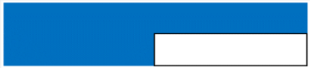  OR Other (correct) | M12 |  | Is unable to determine the “whole” when a shape represents more than one whole  (e.g., $\frac{4}{3}$ ) | Creates an image that is incorrect in 7b)
8. Construct a Sum | F14 | Can determine two fractions that when added are close to one | Provides a satisfactory solution in either 8a) OR 8c) | Satisfactory answers that fall between 0.9 – 1.1 (excluding 1): | M13 |  | Appears to misunderstand the size of an improper fraction | Has created at least one improper fraction
  $\frac{1}{7}$ + $\frac{4}{5}$ | $\frac{1}{3}$ + $\frac{5}{7}$ | $\frac{3}{4}$ + $\frac{1}{5}$ | $\frac{4}{7}$ + $\frac{1}{3}$
  $\frac{1}{7}$ + $\frac{5}{6}$ | $\frac{1}{3}$ + $\frac{4}{7}$ | $\frac{3}{4}$ + $\frac{1}{6}$ | $\frac{5}{6}$ + $\frac{1}{4}$
  $\frac{1}{6}$ + $\frac{3}{4}$ | $\frac{1}{4}$ + $\frac{5}{7}$ | $\frac{4}{5}$ + $\frac{1}{7}$ | $\frac{5}{6}$ + $\frac{1}{7}$
  $\frac{1}{6}$ + $\frac{4}{5}$ | $\frac{1}{4}$ + $\frac{5}{6}$ | $\frac{4}{5}$ + $\frac{1}{6}$ | $\frac{5}{7}$ + $\frac{1}{4}$
  $\frac{1}{5}$ + $\frac{3}{4}$ | $\frac{3}{7}$ + $\frac{4}{6}$ | $\frac{4}{6}$ + $\frac{3}{7}$ | $\frac{5}{7}$ + $\frac{1}{3}$
  $\frac{1}{5}$ + $\frac{6}{7}$ | $\frac{3}{6}$ +$\frac{4}{7}$ | $\frac{4}{7}$ + $\frac{3}{5}$ | $\frac{6}{7}$ + $\frac{1}{5}$
9. Fraction Pairs | F15 | Can compare the relative size of fractions with related denominators or numerators | Selects the correct fraction(s) for each pair, from 9a) to 9e), and uses any satisfactory strategy | 9a) $\frac{7}{8}$  9b) $\frac{2}{4}$ equal to $\frac{4}{8}$  9c) $\frac{5}{8}$  9d) $\frac{4}{2}$  9e) $\frac{4}{5}$ | M14 |  | Has difficulty determining the relative size of fractions | Did not select the correct fraction(s) or provided an unsatisfactory strategy in any of 9a) to 9e)
9. Fraction Pairs | F16 | Can compare the relative size of fractions with related or unrelated numerators and denominators | Selects the correct fraction(s) for each pair, from 9a) to 9h), and uses any satisfactory strategy | 9a) $\frac{7}{8}$  9b) $\frac{2}{4}$ equal to $\frac{4}{8}$  9c) $\frac{5}{8}$  9d) $\frac{4}{2}$  9e) $\frac{4}{5}$  9f) $\frac{5}{8}$  9g) $\frac{7}{8}$  9h) $\frac{7}{9}$ |  |  | Has difficulty determining the relative size of fractions

 | OVERARCHING IDEAS |  |  |  |  | MISCONCEPTIONS
Question | ID | Description | Decision making process for assigning the overarching idea | Correct solution(s)- assumes "or equivalent" or where applicable "other (correct)" | ID |  | Description | Decision making process for assigning the misconception
Decimals
10. Decimals on a Number Line | D1 | Can identify a decimal fraction on a number line, when the calibrations are tenths | Correctly Identifies the point on the number line in 10a) | 10a) 1.3  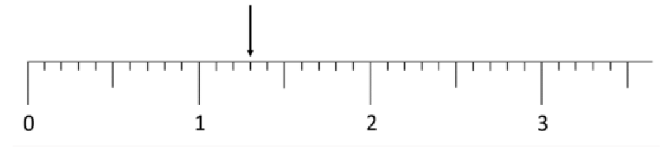 | M15 |  | Counts markers to determine the decimal value, irrespective of the intervals | Incorrectly indicates the mark is at '8 and a half' in 10b)
10. Decimals on a Number Line | D2 | Can identify a decimal fraction on a number line, in a practical context, including when the calibrations are not tenths | Correctly identifies the points on the number line in 10a) AND 10b) AND 10c) | 10a) 1.3  10b) 8.05  10c) 1.7 mL | M16 |  | Count markers to determine the decimal value irrespective of the calibrations | Incorrectly indicates the mark is at 1.14 mL in 10c)
11. Decimal Density | D3 | Understands that between any two distinct decimal numbers there is an infinite number of decimal numbers | Provides a number between 0.1 to 0.11 in 11a) AND provides an answer that matches one of A to F in 11b) | 11a) A correct solution must begin with 0.10x e.g., 0.101, 0.102, 0.103, etc  11b) An infinite number OR Lots and lots OR Heaps OR Billions/Millions OR Thousands/Hundreds OR Other (correct) | M17 |  | Cannot conceive a decimal being between 0.1 and 0.11 | Provides a number that is not between 0.1 and 0.11 in 11a)
 |  |  |  |  | M18 |  | Has little understanding of decimal density (i.e., infinite number of decimals between two distinct decimals) | Incorrect response in 11a) AND any incorrect response in 11b)
12. Make Me a Decimal | D4 | Can connect fractional language with decimal notation including regrouping and renaming | Provides a correct answer for 12a) AND 12b) AND 12c) AND 12d) | 12a) 0.2 or .2 or .20  OR Other (correct)  12b) .027 or 0.027 OR Other (correct)  12c) 1.0 or 1  OR Other (correct)  12d) 2.7 or 2.70  OR Other (correct) | M19 |  | Is unable to connect fractional language with decimal notation when regrouping and renaming are required | Incorrect response in 12b) OR 12c) OR 12d)
13. Ordering Decimals | D5 | Understands the relative size of decimals | Provides a correct solution in 13) | 13)  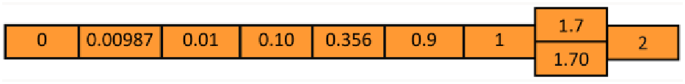 | M20 |  | Has difficulty ordering decimals | Any error is present in 13)
 |  |  |  |  | M21 |  | May consider decimals to be less than zero | Zero was not placed first (as the smallest number) in 13)
14. Connecting fractions, decimals and percents | D6 | Can interpret an area model divided into hundredths and represent this as two equivalent fractions | Provides two equivalent fractions that correctly represent the shaded portion in 14a) AND 14b) | 14a) $\frac{6}{100}$ OR $\frac{3}{50}$  OR Other (correct)  14b) $\frac{6}{100}$ OR $\frac{3}{50}$  OR Other (correct) | M22 |  | Has difficulty with equivalence of fractions, decimals, and percentages | Incorrect response in any of 14a), 14b), 14c), OR 14d)
14. Connecting fractions, decimals and percents | D7 | Can interpret an area model divided into hundredths and represent this as a decimal | Provides a correct solution to 14c) | 14c) 0.06 or .06  OR Other (correct) |  |  |  | Incorrect response in any of 14a), 14b), 14c), OR 14d)
14. Connecting fractions, decimals and percents | D8 | Can interpret an area model divided into hundredths and represent this as a percentage | Provides a correct solution to 14d) | 14d) 6% or 6.0% |  |  |  | Incorrect response in any of 14a), 14b), 14c), OR 14d)
15. Decimal Comparison Test | D9 | Can compare the relative size of a pair of decimals | Correctly selects the larger decimal in each pair in 15) | 15)  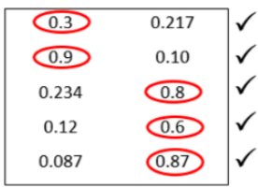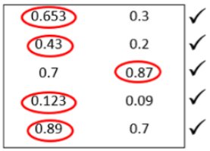 | M23 |  | Misinterprets decimals as larger when there are more digits to the right of the decimal point | Selects the number with more digits to the right of the decimal point for at least 9 pairs
 |  |  |  |  | M24 |  | Misinterprets decimals as larger when there are less digits to the right of the decimal point | Selects the number with less digits to the right of the decimal point for at least 9 pairs
16. Decimal Operations | D10 | Can apply an understanding of multiplication and division to a decimal context | Provides correct solution in 16a) AND correctly determines the solutions in 16b) AND 16c) | 16a) 8 ÷ 0.1  16b) 0.8  16c) 80 | M25 |  | May believe that "multiplication always makes bigger" AND/OR "division always makes smaller" | Incorrectly selects  8 x 0.1 in 16a)

 | OVERARCHING IDEAS |  |  |  |  | MISCONCEPTIONS
Question |  | ID | Description | Decision making process for assigning the overarching idea | Correct solution(s)- assumes "or equivalent" or where applicable "other (correct)" | ID | Description | Decision making process for assigning the misconception
Contextual Problems
17. Music Cards | CP1 |  | Applies appropriate proportional reasoning to determine best value | Selects MySongs in 17a) AND provides a satisfactory explanation | 17a) MySongs  AND  Satisfactory explanations include:  - Unitising per song  - Unitising per dollar  - Unitising for a fixed number of songs (greater than one)  - Intuitive methods | M26 | Is not able to make a multiplicative comparison | Does not select MySongs in 17a) OR has an unsatisfactory explanation in 17b)
18. Reserve Bank | CP2 |  | Can correctly interpret a fraction of a percent and translate it to other representations | Provides two different correct solutions in 18a) AND 18b) | 18a) $\frac{1}{4}$ % OR 0.25%; OR 0.0025 OR $\frac{1}{400}$  OR Other (correct)  AND  18b) $\frac{1}{4}$ % OR 0.25%; OR 0.0025 OR $\frac{1}{400}$  OR Other (correct) | M27 | Has difficulty conceiving percentages that are less than 1% and is therefore unable to move flexibly between different representations of these | Provides an incorrect solution for 18a) OR 18b)
19. Chocolate milk | CP3 |  | Understands how percentages can be greater than 100%, and can move from more than 100% of a quantity back to the whole | Provides a correct solution in 19) | 19) 20 mg | M28 | Has difficulty working with percentages greater than 100% | Provides an incorrect solution in 19)
20. Cordial | CP4 |  | Can solve a two-part ratio problem in a practical context | Provides a correct solution in 20) | 20) 120 mL | M29 | Is unable to solve a two-part ratio problem in a practical situation | Provides an incorrect solution in 20)
 |  |  |  |  |  | M30 | Misinterprets the context as one of x parts and not a comparison between two quantities (i.e., one part to x parts) | Incorrectly indicates that 150 mL is the solution in 20)
21. Cheese please | CP5 |  | Estimates well when determining the price of a fraction of a kilogram, given the kilogram rate | Provides a correct solution in 21a) | 21a) Answer between $4 and $4.30 inclusive | M31 | Is unable to offer a reasonable estimate in a shopping situation involving a decimal fraction of a dollar amount | Provides an incorrect solution for 21a)
21. Cheese please | CP6 |  | Chooses the appropriate operation when calculating the cost of a decimal fraction of a kilogram | Provides a correct solution in 21b) | 21b) 12.59 x 0.34 OR 0.34 x 12.59 OR Other (correct) | M32 | Is unable to calculate the cost of a decimal fraction of a dollar amount when using a calculator | Provides an incorrect solution in 21b)

© State of Victoria (Department of Education) 2024. Except where otherwise noted, material in this document is provided under a Creative Commons Attribution 4.0 International Please check the full copyright notice

