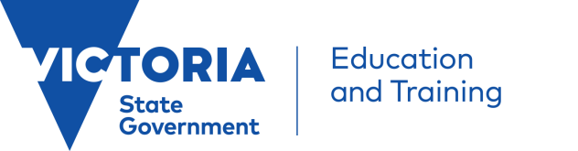

My Passport to Languages (the Passport) has been developed as a resource for language teachers and as a means of engaging Prep to Year 3 students and their families in languages education.
All students starting Prep in government schools in 2018 can use the Passport to keep as a record of their language learning over their first four years of school. Passports are available in Chinese, French, German, Greek, Indonesian, Italian, Japanese and Spanish, which are eight of the most widely-taught languages in Victorian government schools.
The Passports have been developed to align with the Victorian F-10* curriculum. They reflect common concepts and content areas taught in primary level languages programs. The Passports have been designed to complement a languages program and to support language teachers plan topics, themes and/or units based on commonly taught content areas.
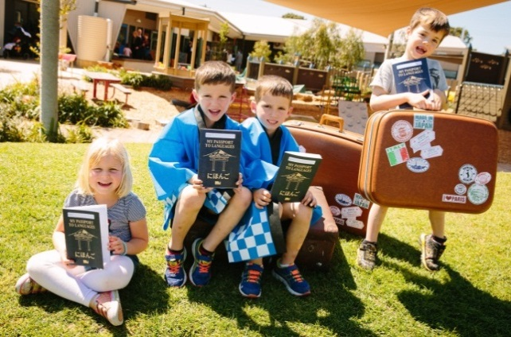

* The Victorian Curriculum Foundation to Year 10 provides a common set of knowledge and skills required by students for life-long learning. The Victorian F-10 curriculum incorporates the Australian Curriculum and reflects Victorian priorities and standards, which schools use to plan student learning programs, assess school progress and report to parents.
http://victoriancurriculum.vcaa.vic.edu.au/

My Passport to Languages -

Teachers’ Guide

The Passports are not intended as a stand-alone teaching resource or unit of work, therefore language teachers are encouraged to integrate the Passports into their language program as an ongoing record of students’ learning.
It is important that the Passports are not used or viewed as an assessment tool. The Passport is a student and family engagement tool, which provides a record of students’ developing language skills.
My Passport to Languages is:
- a means of celebrating students’ language learning in the primary years;
- an ongoing record of language learning achievements using ‘can do’ statements;
- a document which can be kept by the student or the teacher;
- a valuable source of information for teachers, students and parents, particularly in students’ transition to the next year level.
It helps students to:
- develop an awareness of the benefits of learning languages;
- understand, appreciate and celebrate cultural diversity;
- develop a sense of ownership and responsibility for their learning;
- develop an understanding of the sequential nature of language learning;
- build their knowledge, confidence and understanding of the language they are learning.
To order Passports please visit: http://languagespassport.wfds.com.au
For queries or further information regarding My Passport to Languages, email:
languages.passports@edumail.vic.gov.au

