Composition and structure of the image

How is the image organised to create a cohesive, coherent whole?
Students learn how texts are structured to achieve particular purposes, and that visual design choices are used to create texts that are logical, cohesive and coherent with varying levels of complexity. Students learn how the image maker guides the viewer through the text through the deliberate choices of visual design at the level of the whole text, and components within the text. In examining how the image or text is organised, students learn how visual design choices can prioritise some meanings and background others (Painter, Martin & Unsworth, 2013).
For each discussion question, ask students to expand on their responses by explaining reasons why, and encourage them to use evidence from the image to justify their responses, using visual design metalanguage.
- How is the image flow of information in the image organised ?
- What do you notice first? How has the author drawn your attention to this part of the image? (Salience)
- How is your eye drawn from one point to another across the image? (Reading path)
- If you imagine the image to be divided equally into four quadrants, where is the main subject/s and the action placed in the text? For example, is this in the top or bottom of the image? On the left or right side? Or in the middle?
- Is there a frame around the image? How thick is the frame border? Is there a lot of white space on the page around the edges? Or is the image spread across two pages?
- How do these elements draw the image together as a cohesive whole?
- If you changed any of these aspects, how would that affect the meaning of this image?

Salience
Salience is how the viewer's eye is drawn to what is important in the image. An aspect of an image can be highlighted by placement in the foreground, size of the object, and contrast in tone or colour. For example, what do you notice first in the image below from Into The Forest, by Anthony Browne?
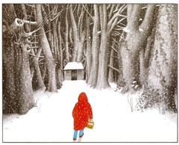
Here, the red hooded cloak draws our eye. The line of the trees leading towards the cottage with its open door, then leads the eye along a reading path.
From INTO THE FOREST by Anthony Browne
© 2004 Anthony Browne
Reproduced by permission of Walker Books Australia Pty Ltd

Viewing/Reading Path
Reading paths are how the eye is drawn to something in the image first, and then vectors lead the viewer from this object through the image from point to point. Vectors can be visible, using lines and arrows as shown in the Vectors section. Vectors can also be invisible, for example the direction in which a participant is looking, as this leads the viewer's eye towards what is being looked at.
Usually, the English-speaking reader will read a page from left to right and from top to bottom. However, image authors can design specific reading paths which can begin and end in different ways.
Identify the vectors in this image. Where are these vectors directing your gaze? Do these vectors direct your gaze towards a particular viewing/reading path in the image?
Along a horizontal line we can be directed to view from left to right, or from right to left. For example, in the example below from Scary Night by Lesley Gibbes and Stephen Michael King, our eye is first drawn to the large moon, in the top left hand quadrant, and is then lead down to the first character on the left.
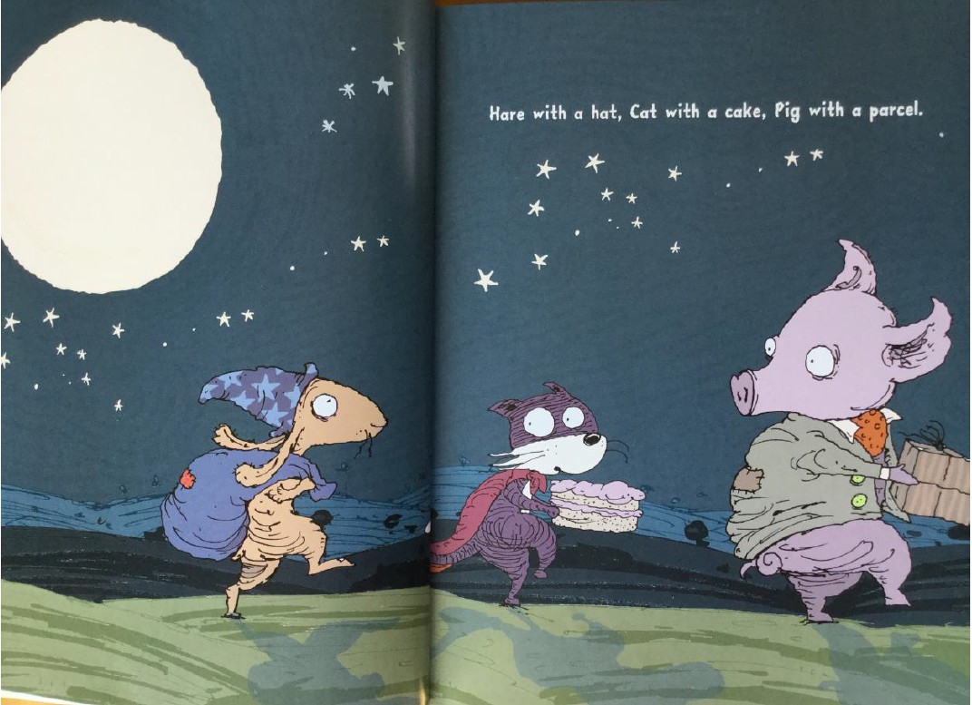
This character points the viewer to read to the right across the image. However, at the end of this horizontal vector, the largest and final character on the right is facing back to the left. This points the viewer back to the left again, focusing our attention on the smallest character in the middle. Each of the characters on the left, and the right of this character, are directing us to this point.
From Scary Night by Lesley Gibbes and Stephen Michael King
Copyright © 2014, Adelaide SA: Working Title Press
The vector lines in the Piggy Book image below, marked in red, show how this image has a more complex reading path. The reader's eye is first drawn to the most salient item, the large pink expanse of the father pig's head. The reading path then follows the father pig's gaze down to the small pig's eyes. The father pig’s ears are also pointing us in this direction. The reading path then follows the son's gaze back up to the father's eyes, emphasised by the small pig's ears also pointing us back in this direction. The reading path then follows the line of the father's snout pointing across to the left, to draw the viewer's attention to the window and to the wolf.
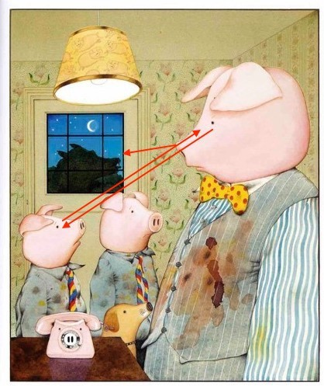
From PIGGY BOOK by Anthony Browne
© 1986 Anthony Browne
Reproduced by permission of Walker Books Australia Pty Ltd

