  - Syllable awareness
The adapted diagram below indicates words into syllables is the least complex phonological awareness skill.
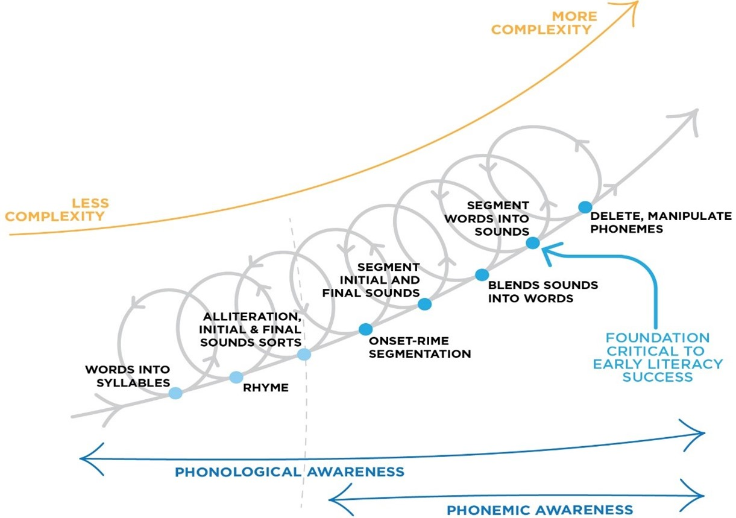
Syllable awareness involves activities like counting, tapping, blending, or segmenting words into their syllables.
Every word can be broken down into syllables. Every syllable has at least a nucleus (vowel). Most syllables will also have an onset (consonants before vowel), and coda (consonants after the vowel). The nucleus and coda together make up the rime of the syllable (the part that rhymes).
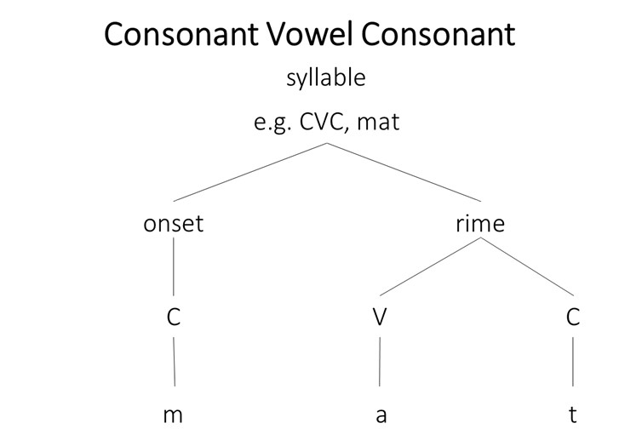
Recognising syllable boundaries, counting the number of syllables in words, and blending separate syllables to make words are all important introductions to phonological awareness.
Words can be characterised as monosyllabic or multisyllabic (see table below).
Syllable | Number of Syllables | Examples (with syllable breaks)
Monosyllabic | 1 | jump thought cup range fifths
Multisyllabic: Disyllabic | 2 | ki.tten ab.sent fo.ssil co.met ha.bit sun.set vel.vet tid.bit zig.zag
Multisyllabic: Trisyllabic | 3 | ma.gi.cal In.di.an cen.tu.ry vi.si.tor po.pu.lar i.ma.gine per.son.al op.po.site ex.er.cise
Multisyllabic | 4+ | ki.lo.me.ter in.te.res.ted me.cha.ni.cal ad.van.ta.ges es.pe.cial.ly im.me.di.ate e.qua.li.ty u.su.al.ly  per.son.al.i.ty el.ec.tri.ci.ty a.ppre.ci.a.ted i.ma.gin.a.tion cu.ri.o.si.ty com.mu.ni.ca.tion

Compound words are words that combine two separate words to create a new word,for example, doghouse, footpath, lifetime. Compound words can be a good starting point to introduce syllable awareness, as teachers can present two words separately and show how they blend together to make one word with two syllables.
For example dog+house g dog.house (2 syllables/beats) foot+path g foot.path (2 syllables/beats)
life+time g life.time (2 syllables/beats)
Activities for syllable awareness can take place without any written words. In the early years of primary school and beyond, phonological awareness activities can be progressively embedded within written language activities using the written word as well.

References
Diagram above adapted from Schuele & Boudreau (2008). Phonological Awareness Intervention: Beyond the Basics. Language, Speech, and Hearing Services in Schools 39, 3-20.

