  - Onset-rime segmentation
The adapted diagram below shows onset-rime segmentation. It is the first skill in the continuum that contributes to phonemic awareness. Phonemic awareness is an important sub-set of phonological awareness because it has a reciprocal relationship with reading (Hoover & Tunmer, 2020, p. 66).
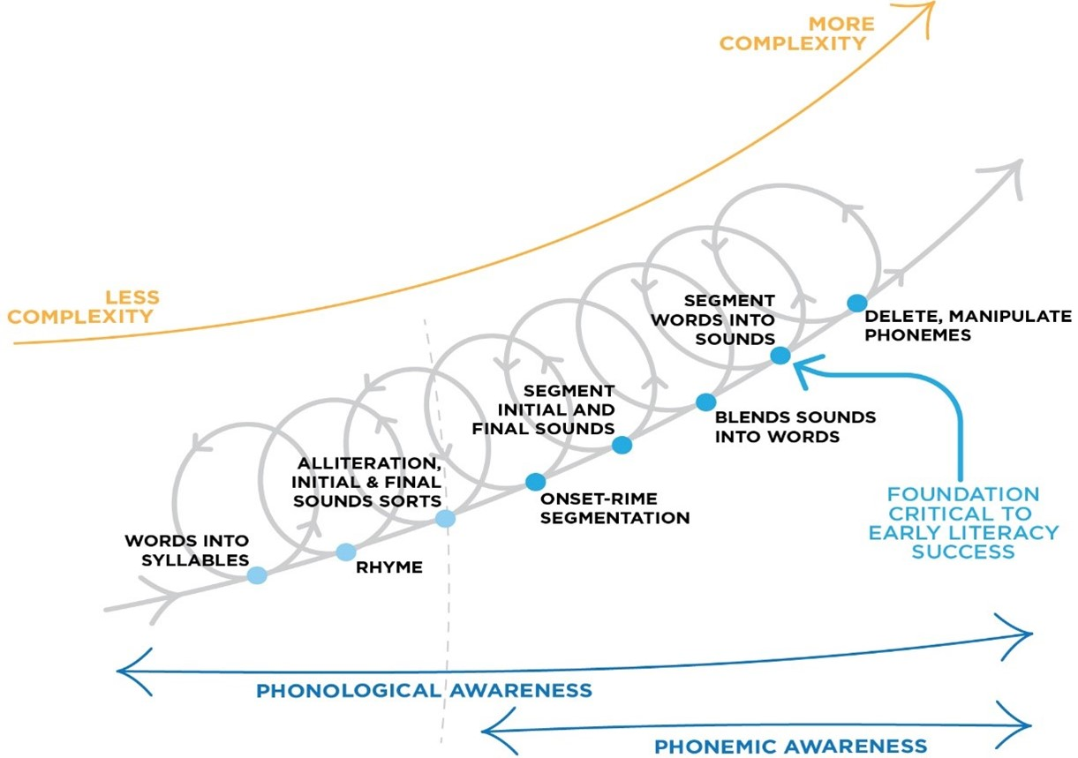

When focussing on onset-rime segmentation it is important to understand the structure of English syllables including simple and complex syllables.
Note that the structure of syllables is based on the phonemes (sounds) of the words, not the graphemes (sound letter patterns) that comprise them. So some syllables may have multiple letters but only one speech sound (phoneme), see example "eye" and "oar" below).
Every syllable has at least a nucleus (vowel). Most syllables will also have an onset (consonants before vowel), and coda (consonants after the vowel). The nucleus and coda together make up the rime of the syllable (the part that rhymes).
Description of Syllable | Consonant (C) and Vowel (V) Structure | Example (with phoneme breaks)
Single Vowel | V | eye oar
Vowel Consonant | VC | u p eigh t
Consonant Vowel | CV | g o s ee m y
Consonant Vowel Consonant | CVC | d o g s a p p u n
Initial Double Consonant Blend | CCV or CCVC | p l ay s t o p
Initial Triple Consonant Blend | CCCV or CCCVC | s t r aw s p l i t
Final Double Consonant Blend | VCC or CVCC | a s k t o p s
Final Triple Consonant Blend | VCCC or CVCCC | a s k s j u m p s t e m p t
Complex Syllables (Combinations of above) | e.g. CCVCC, CCVCCC, CCCVCC, CCCVCCC | s l u m p r i s k s s t r u t s s p l i n t s

Learn more about the structure of English syllables and consonant blends.
Onset-rime activities involve breaking words into their onsets (consonants before the consonants), and the rime (everything left in the word).
For example the rime "own" as in "down" could have the following onsets to make the words in this table

Onset  (Consonant or Consonant Blend) | Rime | Word
d | own | down
br | own | brown
cl | own | clown
dr | own | drown
g | own | gown

References
Hoover, W. A., & Tunmer, W. E. (2020). The cognitive foundations of reading and its acquisition: A framework with applications connecting teaching and learning. Cham: Springer.
Diagram above adapted from Schuele & Boudreau (2008). Phonological Awareness Intervention: Beyond the Basics. Language, Speech, and Hearing Services in Schools 39, 3-20.

