  - Alliteration - Sorting initial and final sounds
The adapted diagram below positions alliteration – sorting initial and final sounds as the third skill on the continuum of phonological awareness skills.

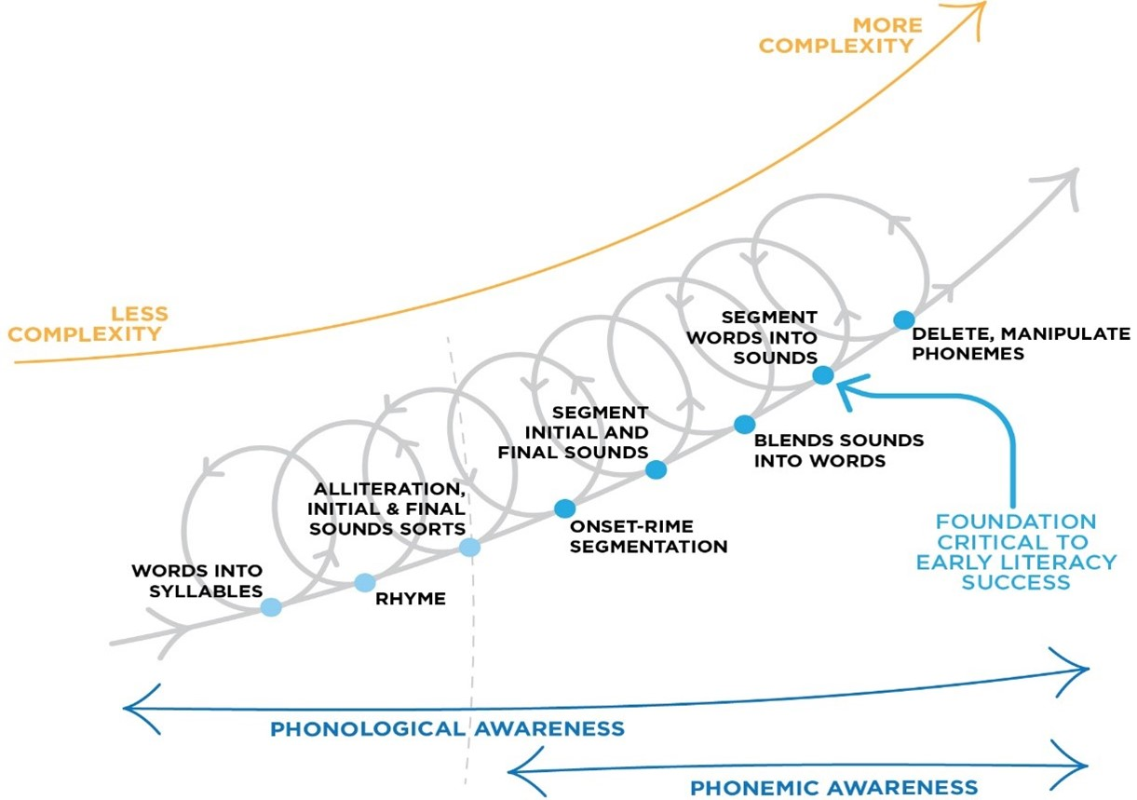

Alliteration activities are another early phonological awareness activity useful for early childhood settings and the early years of primary school.
It is important to note that sorting words by initial and final sounds is not about the initial or final letter. In a phonological awareness activity remember that the goal is for children to hear the sounds (phonemes) within words, rather than see the letters, and read the letter patterns (graphemes).
When sorting by initial and final sound, remember to listen to see if the words have the sound phoneme (and not just the same letter).
In alliteration activities it is important to focus on the sounds (phonemes) not the letters. Also, remember that these activities are also important to do with pictures or real objects, rather than written words, to emphasise the sounds (rather than the letters).
For example, phone and physical are not sorted under the /p/ sound, but instead both have an initial /f/ sound.
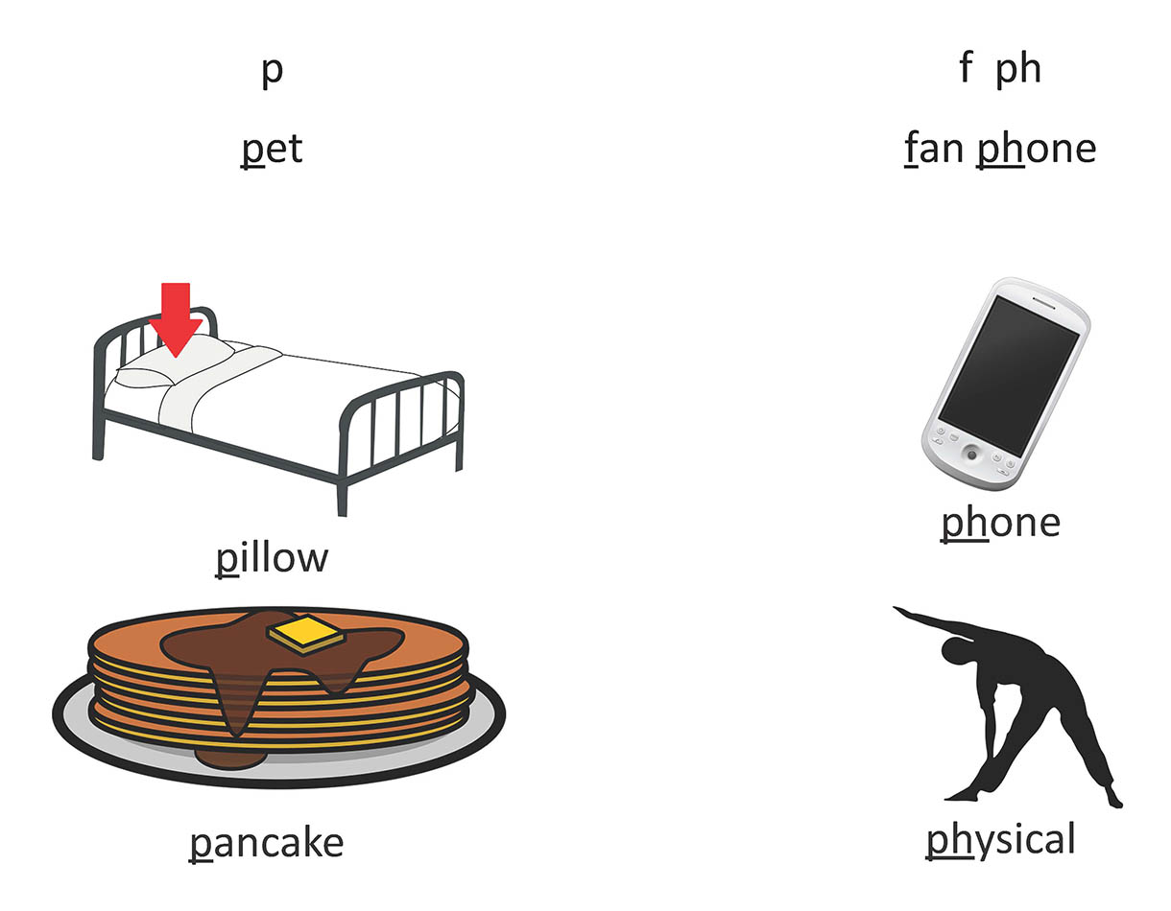

In the below example, some children may think of "shark" as a letter starting with the /s/ sound, but it is important to sort this example word as a /sh/ sound:

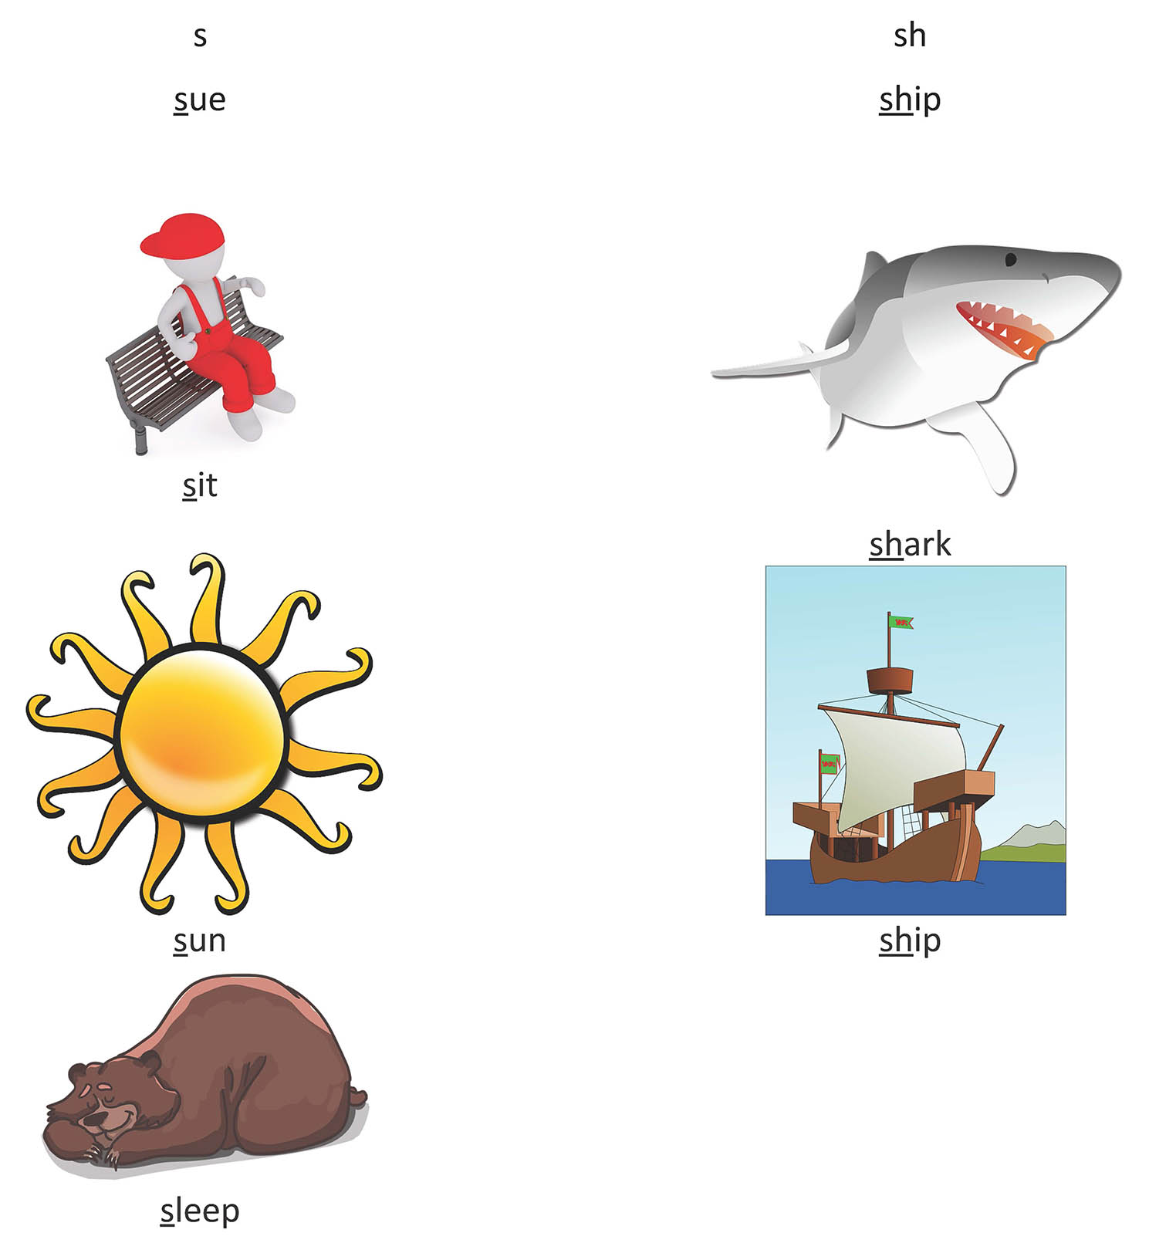

Alliteration activities can also focus on the last (final) sounds in words, so teachers can draw children's attention to the last sounds in words. For example, you could sort out which sounds end in a /t/ or a /d/ in the example below:
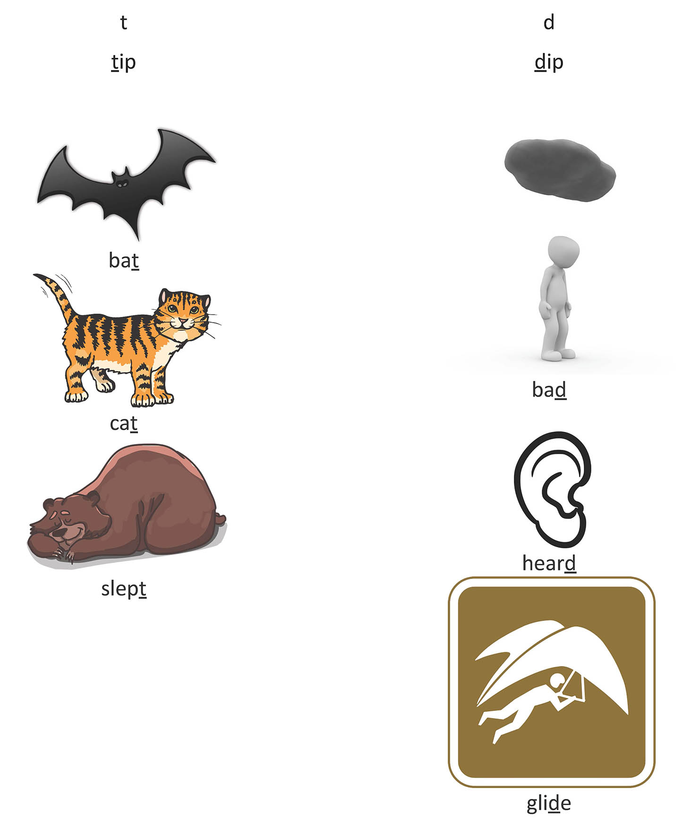

References
Diagram above adapted from Schuele & Boudreau (2008). Phonological Awareness Intervention: Beyond the Basics. Language, Speech, and Hearing Services in Schools 39, 3-20.

