Inflectional Morphemes

Morphemes can be divided into inflectional or derivational morphemes.
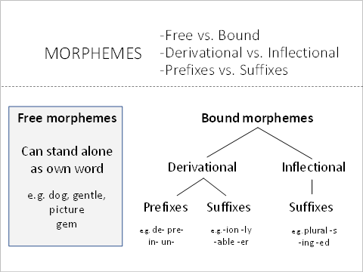
Inflectional morphemes change what a word does in terms of grammar, but does not create a new word.
For example, the word <skip> has many forms: skip (base form), skipping (present progressive), skipped (past tense).
The inflectional morphemes -ing and -ed are added to the base word skip, to indicate the tense of the word.
If a word has an inflectional morpheme, it is still the same word, with a few suffixes added. So if you looked up <skip> in the dictionary, then only the base word <skip> would get its own entry into the dictionary. Skipping and skipped are listed under skip, as they are inflections of the base word. Skipping and skipped do not get their own dictionary entry.
Originating from Anglo-Saxon, inflectional morphemes are always suffixes in English, and they include the following:

The inflectional morphemes of English
Suffix | Function | Example | Attaches to
-s | plural | cats | Nouns
-’s | possessive | brother’s | Nouns
-er | comparative | taller faster | Adjectives
-est | superlative | tallest fastest | Adjectives
-s | third person singular present tense | (she) walks (he) eats | Verbs
-ed | past tense | walked called | Verbs
-ing | progressive | walking giving | Verbs
-en | past participle | (have) given (have) eaten | Verbs
These morphemes are useful to highlight to students, as they are usually spelt the same way, and have a consistent meaning. However, the pronunciation of these morphemes often change according to the ending of the words.
It is useful to listen for how the inflectional suffixes are pronounced depending on the word they attach to.

Irregular inflectional morphemes
Because of the rich history of English as a language and spelling system, there are numerous irregular morphemes.
When children learn inflectional morphemes (like plurals, past or progressive tense) they can
over-generalise morphological rules. This means they may use an inflectional morpheme when it does not apply.
Irregular inflectional morphemes are exceptions to the rules. Here is a bank of examples of these irregular inflectional morphemes that may be useful to refer to if students are making these kinds of errors in their spoken or written language:

Regular Suffix | Function | Example | Attaches to | Examples of Irregular Morphemes
-s | plural | cats | Nouns | algae alumni analyses appendices bacteria calves children cacti fish stimuli syllabi syntheses synopses teeth  and many more!
-ed | past tense | walked | Verbs | was began broke brought built bought caught chose came crept drew drank drove ate fell fed fought flew found sang  and many more!
-en | past participle | (have) given | Verbs | (have …) begun sung drunk grown known thrown ridden rung seen  and many more!

Plural -s, possessive -'s, and present tense -s rules
The suffix plural -s changes in spelling and pronunciation depending on the word it attaches to:

Base word | -s Spelling | -s Pronunciation | Example Words
Word ends in voiceless consonant (like the /p/ in tip)  p th t k c  tap fifth bit pick | -s | s  sue | cat+s dock+s wrap+s
Word ends in sibilant (high pitched) consonant (like the /z/ in quizz)  s z sh ge “zh”  floss whiz wish beige  ch j  pitch lodge | -es | SCHWA z  across zoo | kiss+es quizz+es bush+es  witch+es ridge+es*
Word ends in any other sound  (voiced consonants or vowels) | -s | z  zoo | dog+s tray+s  wave+s dayspa+s
*Note when the -es is added to ridge, an "e" is dropped to avoid two vowels next to each other (another spelling rule).
The suffixes -s rule also works for third person singular -s (e.g. she walk+s, he wash+es)
It also works for possessive -s but the spelling of -s does not change (e.g. Alex's …, the club's …)
Base word | -'s Spelling | -'s Pronunciation | Example Words
Word ends in voiceless consonant  p th t k c  tap fifth bit pick | -'s | s  sue | Kat+'s hat
Word ends in sibilant (high pitched) consonant  s z sh ge “zh”  floss whiz wish beige  ch j  pitch lodge | -' or -'s | SCHWA z  across zoo | Jess+' hat or Jess+'s hat
Word ends in any other sound  (voiced consonants or vowels) | -'s | z  zoo | Dan+'s hat the club's hat

Adjective -er and -est rules
The comparative (-er) and superlative (-est) inflectional morphemes usually attach to adjectives that have one syllable:
-er | comparative | taller braver smarter darker straighter
-est | superlative | tallest bravest smartest darkest straightest

This is why we say more beautiful rather than *beautifuler. And why we say most distinctive rather than *distinctivest
There are some exceptions to this rule, including:
simple | simpler | simplest
quiet | quieter | quietest

Other exceptions to this are words which end in the -y adjective derivational morpheme
Base word | -y suffix | -y + -er suffix | -y + -est suffix
n/a | happy | happier | happiest
smell | smelly | smellier | smelliest
bump | bumpy | bumpier | bumpiest

From http://www.englishgrammarexpress.com/grammar/comparatives-superlatives

