  - Comprehension Example Lesson: Evaluative Comprehension

Reading Model Text Analyst/Text Participant
Lesson Configuration Whole-Part-Whole: Modelled reading-Independent reading-Reflection
Lesson Three Learning Intention We are learning the strategy of asking and answering questions as we read to help us understand what we read.
Success Criteria I can ask and answer at least one evaluative question as I read to help me think about the message in the text. I can write an evaluative question on a post it note and share the answer with the class at the end of the lesson.
- Introduce the learning intention and the success criteria for the lesson.
  - Today we are learning about a strategy that can help us understand what we read. As we read we can ask ourselves questions to check that we have understood. Today I am going to show you how to ask and answer an evaluative question as I read. Evaluative questions ask us to go beyond the text and think of the bigger picture or message of the text. I will use this anchor chart to help me ask an evaluative question. (Refer to an anchor chart displayed so all students can view it. It will have the evaluative question stems listed. See: Comprehension
  - After I have shown you what to do, you are going to read independently. As you read I want you to check for your own understanding. You can do this by asking yourself an evaluative question and then thinking about the message in the story. You can look at the anchor chart to help you think of a question. You will know if you are successful at asking an evaluative question if you can write your question on a post it note and can share your question with others at the end of the lesson.
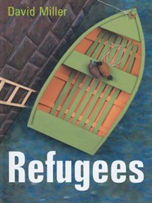
- Reread the picture story book Refugees by David Miller, Lothian Children’s Books, an imprint of Hachette Australia, 2004. Model the strategy e.g. David Miller has written a story about ducks looking for a new home but the title of the story is Refugees.
Why has he used this title when the story is about ducks? What is he trying to make us think? Write the question on a post it note.
Model thinking:
- If we think of the ducks as people, I think the author is trying to tell readers that there are people around the world who are also escaping their home because they cannot live there anymore. We call this a metaphor when we say one thing is another. The author is trying to make the point that we should be helping refugees to find another safe place to live. We know the author thinks that because on the last page of the story, the ducks were placed in a beautiful habitat that was safe.
3. Model the strategy one more time. What other messages could the author want us to think or believe?
- At the start of the story, the ducks’ environment was destroyed. Does the author want us to think about the environment and our responsibility to protect the animals that live in it?
- In part of the story, we saw hunters killing ducks. Does the author think we should not kill animals for sport or food?
Do I agree or disagree with these messages? Why or why not?
- Ask students to turn and talk to a partner? What do they think about the author’s messages? Can they justify their answers?

- Revise expectations for independent reading, e.g. Sit in one place, select a book from your individual book box and start to read straight away, read quietly for 20 minutes and read for meaning.

- Revise success criteria.
  - To practise this skill, today I want you to look at the anchor chart, find a question stem and ask yourself an evaluative question as you read. What does the author want me to think or believe? Write down the question on a post-it note. Put your name on the post-it note because I am going to collect them at reflection time. Hand out post-it notes.
  - Be prepared to share your question and have a reason for why you answered the question like you did at reflection time. Last 10 minutes of the session.

- Students read independently for 20 minutes. During independent reading the teacher will work with a small group such as guided reading, or conduct reading conferences and goal setting with individual students.

- Reflection Time-Whole Group
  - Students put their name on their evaluative question post-it note and return to the main group.
  - Ask some students to share their questions. Encourage students to share what they think or believe about the question. Ensure students give reasons and justify their answers. Repeat this several times.
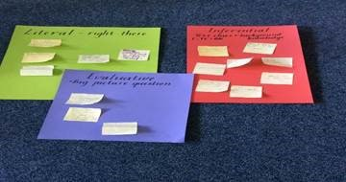
  - Collect the questions and stick on a prepared sheet with the heading ‘Evaluative Questions’ Display. Use these charts as an assessment record. Who can successful ask an evaluative question? Teacher annotates student records.

Photo: Example displays of questions we can ask and answer when we are reading for understanding.
- Revisit Success criteria. Check if everyone has at least one written evaluative question. Clarify students’ understanding of evaluative questions. Write a class definition and display.

Going further: Repeat the explicit teaching of asking and answering evaluative questions with a range of text types, see: Multiple Exposures: High Impact Teaching Strategy

