Guide to the Literacy Teaching Toolkit:
Foundation to Level 6
  - READING AND VIEWING VERSION 1
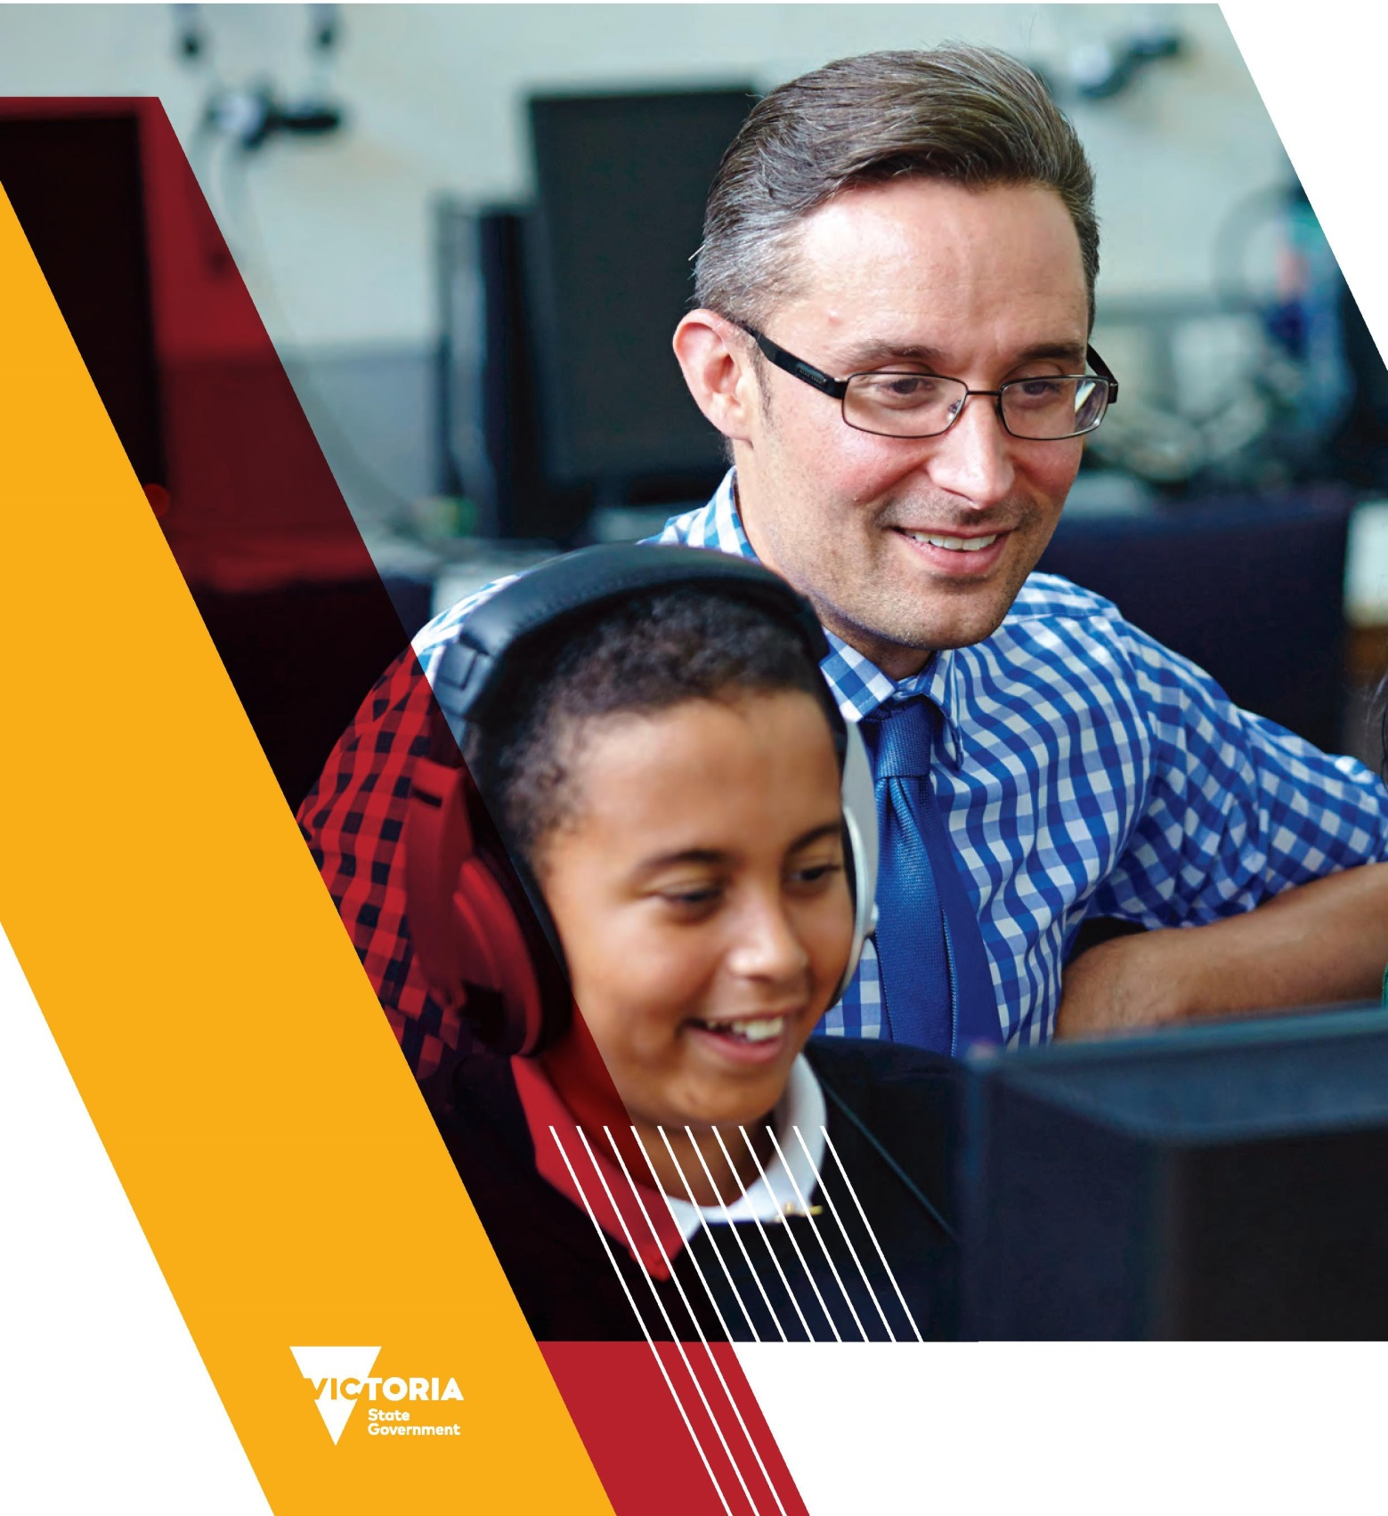

Melbourne Oct-17 Version 1
©State of Victoria (Department of Education and Training) 2017
The copyright in this document is owned by the State of Victoria (Department of Education and Training), or in the case of some materials, by third parties (third party materials). No part may be reproduced by any process except in accordance with the provisions of the Copyright Act 1968, the National Education Access Licence for Schools (NEALS) (see below) or with permission.
An educational institution situated in Australia which is not conducted for profit, or a body responsible for administering such an institution may copy and communicate the materials, other than third party materials, for the educational purposes of the institution.
Authorised by the Department of Education and Training,
2 Treasury Place, East Melbourne, Victoria, 3002
CONTENTS

Foreword 6
Supporting literacy and numeracy in Victorian Schools 6
Long term impact 6
Focus on literacy 6
Introduction 8
What is in this Guide? 9
FISO Improvement Model 10
Literacy Teaching Toolkit: Foundation to Level 6 11
Overview 11
What is the Literacy Teaching Toolkit? 11
Clear and coherent structure 12
Reading and viewing 12
Speaking and listening 12
Writing 12
What does the current Toolkit include? 13
How can it be used? 13
Where to find the Literacy Teaching Toolkit 13
Literacy – The Wider Context 14
Defining literacy 14
Literacy today 14
Literacy across the curriculum 14
Reading and viewing in different media 14
English as an Additional Language (EAL) 15
Teaching reading and viewing 15
Setting the stage for reading development 16
Beyond print based literacy 17
Literacy teaching and learning 17
Literacy outcomes and leadership in schools 17
Recommendation to school leaders 18
Effective reading instruction 18
Reading and viewing in the Victorian Curriculum 18
Foundation to Level 2 18
Explicit teaching of reading comprehension – Foundation to Level 6 19
Key Aspects of Reading and Viewing 20
Introduction 20
Concepts of print 20
What is concepts of print? 20
Phonological awareness 20
What is phonological awareness? 20
How does phonemic awareness relate to phonological awareness? 21
Phonics 21
What is phonics? 21
What is the difference between phonological awareness and phonics? 21
Word morphology 21
What is word morphology? 21
Vocabulary 22
What is vocabulary? 22
Aspects of vocabulary 22
Oral vocabulary 22
Fluency 23
What is fluency? 23
Why fluency? 23
Comprehension 23
What is comprehension? 23
Teaching comprehension 23
Literature 24
What is literature? 24
Teaching literature 24
Multimodal literacy 24
What is multimodal literacy? 24
Why teach multimodal literacy? 24
Visual literacy 25
What is visual literacy? 25
Core Teaching Practices 26
What are the core teaching practices? 26
References 31
Appendix 33
FISO Improvement Model chart (text alternative) 33

Foreword
The Victorian Government’s promise is simple but bold: to build a world class education system and transform Victoria into the Education State.
The Literacy Teaching Toolkit: Foundation to Level 6 (the Toolkit) has been developed in response to requests from schools for easily accessible, high quality, differentiated literacy support.
The Victorian Government has set ambitious Education State school targets to focus efforts on those things that promote excellence across the curriculum, build the health and wellbeing of children, and break the link between disadvantage and learning outcomes. These targets reflect the ambition to improve children’s outcomes.

Supporting literacy and numeracy in Victorian Schools
The Department of Education and Training has introduced a Literacy and Numeracy Strategy to support the work teachers do in the classroom, and at their schools, to improve literacy and numeracy. The strategy was devised in collaboration with literacy and numeracy experts, principals, teachers, academics, key stakeholders and peak bodies.
A strong foundation in literacy and numeracy is vital for every child and young person. That foundation underpins their ability to:
- engage in education
- reach their potential
- participate fully in the community.
Achieving these goals contributes to a virtuous circle in which characteristics like the ability to reason critically, to experiment, to be resilient and persistent, also support literacy and numeracy development.
The Toolkit contributes to the Department’s support for schools and teachers through the Literacy and Numeracy Strategy.

Long term impact
Strong literacy and numeracy are keys to engagement in learning and achievement, completing Year 12 and tertiary education, and securing employment and higher income – factors also associated with better health and less involvement with the justice system. The consequences of lacking strong literacy and numeracy are substantial. A citizenry with high literacy and numeracy levels is best placed to tell opinion from fact, to understand a changing environment, to connect with others within and beyond our community, and to do meaningful work in a global, increasingly automated economy.

Focus on literacy
Literacy begins at birth and we want children and young people to:
- learn to adapt language to meet the demands of general or specialised purposes, audiences and contexts
- learn about the different ways knowledge and opinion are represented and developed
- learn about how to show more or less abstraction and complexity through both language and multimodal representations.
This breadth of learning expectations means print and digital contexts are included, and listening, viewing, reading, speaking, writing and creating are all developed systematically and concurrently.
Teachers are encouraged to explore and share the high impact literacy teaching strategies as an integral part of planning for teaching and learning.

Introduction
The Victorian Government has committed to making Victoria the Education State: improving outcomes for every child, in every classroom, in every community.
Literacy education is foundational to engagement in learning and lifelong achievement. Providing schools with clear direction and priorities to focus on student learning is a key part of the Education State. Ambitious targets in literacy and numeracy have been set as part of the Education State reforms.
Our targets focus on what matters most
Learning for life
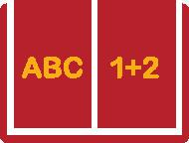 | By 2020 for Year 5, and the next 10 years for Year 9, 25% more students will reach the highest levels of achievement in reading and mathematics
 | By 2025, there will be a 33% increase in the proportion of 15-year-olds reaching the highest levels of achievement in scientific literacy
 | By 2025, more students will reach the highest levels of achievement in the arts
 | By 2025, 25% more Year 10 students will have developed excellent critical and creative thinking skills

To assist schools and teachers to reach our targets and support every student in Victoria to succeed in literacy, we have developed the Literacy Teaching Toolkit. The Toolkit is a web-based resource that supports teachers to implement the Victorian Curriculum F-10 and the Victorian Early Years Learning and Development Framework (VEYLDF).
The Victorian Curriculum and the VEYLDF set out what students are expected to learn about literacy in primary and secondary schools. Both require teachers to have sophisticated knowledge about language and literacy content. Teachers also require an appreciation of effective teaching practices that allow them to incorporate informed content and pedagogical knowledge into their practice. The Toolkit supports teachers by providing detailed evidence-based guidance on effective literacy instruction. The current version of the Toolkit contains guidance on reading and viewing for primary and secondary schools (for students working up to Level 6).
School leadership teams use the Framework for Improving Student Outcomes (FISO) to drive strategic and annual planning for excellence in literacy teaching and learning at the whole school level. The Toolkit supports schools and teachers in the FISO priority area of Excellence in teaching and learning. It provides guidance for teachers on each of the four dimensions within this priority. These are:
- Evidence-based high impact teaching strategies
- Building practice excellence
- Curriculum planning and assessment
- Evaluating impact on learning.
‘Sophisticated knowledge about language and literacy’
Recent research has shown that when school and early childhood educational leaders develop their specific knowledge about literacy teaching and learning, their educators and teachers feel supported and engaged in raising achievement in literacy.
The role of professional learning in literacy has taken ‘centre stage’ in leaders’ planning across the whole school setting.
Development of the Toolkit has drawn on extensive research that shows to be an effective reader requires skills and understandings in decoding, text use and text analysis. Teachers should employ a range of evidence-based literacy approaches to tailor teaching and learning to the needs of their students. Teachers are expected to teach phonics explicitly, for example, alongside supporting students’ literal, inferential and evaluative comprehension. It is important to support students’ interest, engagement and enjoyment with books and other texts that they read and view. The Toolkit is a web-based resource that supports teachers to implement the Victorian Curriculum and the VEYLDF.

What is in this Guide?
This Guide is designed to support school leaders and teachers to understand and use the Toolkit. The Guide covers Reading and Viewing – Foundation to Level 6 as contained in the current version of the Toolkit. The Guide contains the following sections:
- The ‘Literacy Teaching Toolkit: Foundation to Level 6’ section provides information about what the Toolkit is, how it is structured, what it includes, how teachers might use it and where to find the Toolkit.
- The ‘Literacy – The Wider Context’ section provides a definition of literacy and information about teaching reading and viewing, literacy teaching and learning, and literacy in the Victorian Curriculum.
- The ‘Key Aspects of Reading and Viewing’ section provides information about key aspects of the Toolkit.
- The ‘Core Teaching Practices’ section provides an overview of the range of core practices that can be used to teach literacy.

FISO Improvement Model
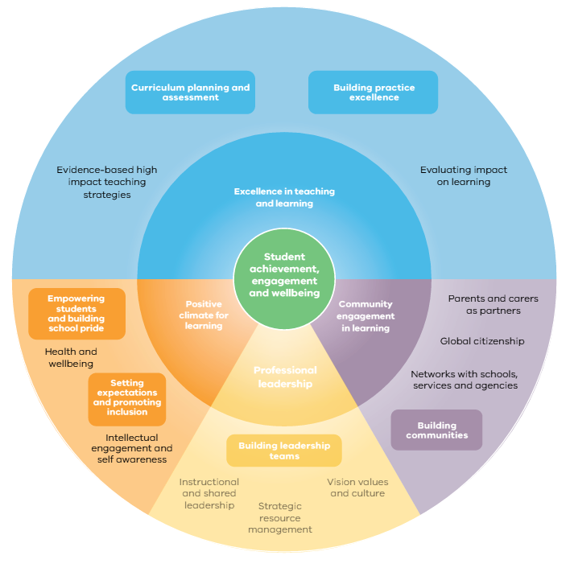
Text alternative for ‘FISO Improvement Model’ chart

Literacy Teaching Toolkit: Foundation to Level 6
This section provides information about what the Literacy Teaching Toolkit is, the purpose of the Toolkit, what it includes, how it is structured, how teachers might use it and where to find it.

Overview

What is the Literacy Teaching Toolkit?
The Toolkit is a web-based resource that supports teachers to implement the Victorian Curriculum and the VEYLDF. The Toolkit provides practical advice about high-impact teaching practices that improve literacy outcomes. The Toolkit supports teachers to:
- activate their knowledge
- understand what excellence in practice looks like for the teaching of language and literacy
- understand the manageable steps that teachers can take in the teaching of language and literacy in each domain of practice
- understand the learning continuum for literacy as it relates to the Victorian Curriculum, to locate a student’s progress and a teacher’s next steps.
It is designed to provide access to evidence-informed understandings about effective language and literacy teaching and learning through:
- detailed accounts of essential elements of what needs to be taught
- descriptions of key language and literacy teaching practices and their role in scaffolding learning
- linking theory and practice
- detailed instructional guides and sequences of lessons which illustrate practical examples of language and literacy teaching
- video vignettes which demonstrate literacy teaching practices
- video vignettes of experts discussing various dimensions of literacy for use in professional learning or discussions within schools.
The Toolkit recognises the importance of high quality teaching and learning experiences in language and literacy, alongside the use of rich literature.
The Toolkit is currently in development and will be released in stages from October 2017 through to March 2018:
- The current version of the Toolkit contains the first part of the reading and viewing component for primary and secondary schools (for students working up to Level 6).
- Pedagogical videos will be released from November 2017 through to March 2018.
- The complete Toolkit, which will include written guidance and pedagogical videos for the teaching of reading and viewing, writing, and speaking and listening from Birth to Level 6, will be available via the Victorian Literacy Portal in March 2018.
A timeline of the stages of release of the Toolkit is outlined below.
Phase 1 Literacy Teaching Toolkit release dates
‘Activate their knowledge’

Clear and coherent structure
The Toolkit provides clear and coherent learning pathways for each stage from Foundation through to Level 6. These stages are:
- Foundation to Level 2
- Levels 3 and 4
- Levels 5 and 6.
The current version of the Toolkit describes the reading and viewing component of the Victorian Curriculum at each of these three stages.

Reading and viewing
Reading and viewing identifies the skills and resources for the reader as a text:
- decoder
- participant
- user
- analyst.
The complete Toolkit will also describe the speaking and listening and writing elements of the Victorian Curriculum at each stage.

Speaking and listening
Speaking and listening identifies the skills and resources for language:
- form
- content
- use – social
- use – academic.

Writing
Writing identifies the skills and resources for the writer as a text:
- encoder
- participant
- user
- analyst.

What does the current Toolkit include?
The current version of the Toolkit includes:
- indicators of literacy learning and development in reading and viewing that illustrate learning progress between the achievement standards set out in the Victorian Curriculum F-6
- written guidance for teachers in language and literacy instruction aligned to the Victorian Curriculum and VEYLDF.

How can it be used?
Teachers can use the Toolkit to:
- strengthen classroom literacy teaching and learning programs
- support professional learning meetings
- develop school-wide literacy plans
- plan for teaching and learning to build success in literacy
- personalise student learning experiences
- support self-reflection
- develop a scaffolded approach to building their language and literacy knowledge and practices
- develop subject matter knowledge across curriculum.

Where to find the Literacy Teaching Toolkit
The Toolkit is:
- located on the home page of the Victorian Literacy Portal, which brings together in a single repository the Department of Education and Training’s literacy and language related resources
- connected to the FISO and associated early childhood resources.

Literacy – The Wider Context
This section provides a definition of literacy and information about teaching reading and viewing, literacy teaching and learning, and reading and viewing in the Victorian Curriculum.

Defining literacy
Literacy is defined as the learner’s developing ability to interpret and create texts with context, accuracy, confidence, fluency and efficacy.

Literacy today
Literacy today is diverse and complex. It is recognised as being ‘social, community-based, culturally-defined, varied, and potentially transformational’ (Snow, 2004, p.5).
Literacy encompasses the interrelated modes of reading and viewing, writing, speaking and listening. Although each mode requires specific teaching and learning programs and practices, the reciprocal nature of these domains means more than one is likely to be in operation at any one time.
Texts encompassed by literacy today include literature, media texts, everyday texts, and workplace texts from increasingly complex and unfamiliar settings. They range from the everyday language of personal experience to abstract, specialised and technical language, including the language of schooling and academic study.

Literacy across the curriculum
Literacy across the curriculum requires children and young people to have skills which enable them to interpret and compose texts across different disciplines. This involves teaching that prompts learning that:
- embeds a grasp of how different language choices and patterns represent and document ideas and views of the world through a range of genres
- develops a sense of the way disciplinary knowledge is organised (for example, in science, history or geography).
Each subject or discipline, such as Science or History, has its own distinctive literacy demands (Christie & Derewianka, 2008). The Toolkit promotes an informed understanding of texts common to various disciplines, including English, which contributes to teachers’ capacity to support children’s interpretation and composition of a variety of print based and multimodal texts (Myhill, Jones & Watson, 2013).

Reading and viewing in different media
Contemporary texts are increasingly multimodal. This gives rise to the need for children and young people to become ‘multi-literate’ – to have the competence to use a range of static and dynamic modes in print and digital formats which enables them to develop the capacity to:
- decode
- interpret
- analyse
- construct texts.

English as an Additional Language (EAL)
Every year, more than 6,000 newly arrived EAL students enrol in Victorian government schools. EAL students are defined as students who come from a language background other than English, and speak a language other than English as their main home language. In 2016, newly arrived EAL students came from 135 language backgrounds.
EAL students are a diverse group. They can:
- be born overseas or in Australia
- enter the Australian education system at any year level
- have little, some or no exposure to English or English literacy
- have varied experience of formal schooling, ranging from little or no schooling, or severely interrupted schooling, to schooling equivalent to that received by their chronological peers in Australia.
‘Literacy today is diverse and complex’

Time required for mastery
Students can master basic interpersonal communicative skills in English in two to three years (Cummins, 1998). The time it takes to become proficient in more complex academic English required across the school curriculum is influenced by factors such as age, previous education, literacy and involvement in specialist EAL programs.
Students who are not literate in their first language require more time to achieve proficiency than those who are literate in their first language, and who have educational experiences similar to those expected for their age group.
In the classroom, EAL students require exposure to English language with targeted teaching and support to meet their individual needs.

Teaching reading and viewing
There is a rich history of theory, research, and findings on the teaching of reading. The most important meta-analysis in recent years is Teaching children to read: An evidence-based assessment of the scientific research literature on reading and its implications for reading instruction (National Reading Panel, 2000). Commonly known as the National Reading Panel report, it identified the ‘five pillars of reading’ as:
- phonemic awareness
- phonics
- fluency
- vocabulary
- comprehension.
The five pillars of reading are defined in the following table:
Term | What it means
Phonemic awareness | Ability to focus on and manipulate phonemes in spoken words.  Phonemic awareness is an important skill in acquiring reading and writing skills.
Phonics | Knowledge of letter-sound correspondences.  Essential for beginning to learn to read. Phonics involves learning the alphabetic system as letter-sound correspondences.
Fluency | Capacity to read texts with speed and accuracy.  A critical component of skilled reading. Fluency is developed with guided oral reading practice that improves word recognition, the speed and accuracy of oral reading, and comprehension.
Vocabulary | Knowledge of the meaning of words.  Oral vocabulary is a key to learning to make the transition from oral to written forms. Reading vocabulary is crucial to a skilled reader’s comprehension processes.
Comprehension | Capacity to analyse the meaning of sentences and texts.  An active process in which cognitive engagement is central. Comprehension is regarded as a series of interactions between the text and the reader.
Source: National Inquiry into the Teaching of Literacy, 2005
More recently, Deslea Konza (2014) argues the case for the inclusion of oral language and early literacy activities as an additional sixth pillar.

Setting the stage for reading development
Scott Paris (2005, p.200) discriminates between constrained and unconstrained reading skills. Most children can reasonably quickly master constrained skills, such as print awareness, phonemic awareness, alphabetic knowledge and fluency. Unconstrained reading skills, such as vocabulary and comprehension, are broader in scope and are developed continually.
Paris notes that while constrained skills are necessary, they are not sufficient for other reading skills. He states that constrained skills ‘enable automatic decoding, deployment of attention, and application of comprehension strategies so they set the stage for reading development, but they are not simple causes for complex reading skills to develop’ (Paris, 2005, p.200).
‘Most children can reasonably quickly master constrained skills, such as print awareness, phonemic awareness, alphabetic knowledge and fluency.’

Beyond print based literacy
As communication practices have become increasingly shaped by developments in information and multimedia technologies, it is no longer possible for us to think about literacy solely as a linguistic accomplishment (Jewitt, 2008, p.241).
Multimodal literacy recognises that meaning in many texts is communicated through combinations of two or more semiotic (meaning making systems) modes. Semiotic modes include written language, spoken language, visual, audio, gestural, and tactile and spatial systems of meaning (The New London Group, 1996; Kalantzis, Cope, Chan, and Dalley-Trim, 2016). Multimodal is the combination of two or more of these modes to create meaning.
Most of the texts that we use are multimodal, including picture books, text books, graphic novels, films, e-posters, web pages and oral storytelling as they require different modes to be used to make meaning. Each individual mode uses unique semiotic resources to create meaning (Kress, 2010) and teaching of these needs to be explicit.
The English curriculum in the Victorian Curriculum sets out what students should learn about visual literacy. Students examine how meaning is made in still and moving image texts. It is addressed through the mode of ‘viewing’. Like reading, viewing is a process of making meaning and ‘involves decoding, comprehending and questioning all types of texts’ (Callow, 2013, p.3), as students develop critical skills and understandings about how visual texts work across a range of text types and formats including paper based and digital.
‘As communication practices have become increasingly shaped by developments in information and multimedia technologies, it is no longer possible for us to think about literacy solely as a linguistic accomplishment.’

Literacy teaching and learning

Literacy outcomes and leadership in schools
Research findings from the Australian Primary Principals Association pilot project, Principals as literacy leaders: Confident, credible and connected (Dempster et al., 2012), suggest lifting literacy outcomes requires:
- an understanding of:
  - how literacy is learnt
  - how best to teach literacy
- strong school leadership.

Recommendation to school leaders
The National Inquiry into the Teaching of Literacy (2005) recommended that schools develop schoolwide literacy plans which can create and sustain organisational conditions that enable exemplary literacy learning and teaching to take place. In Victoria the FISO provides a model for schools to frame, implement, monitor and evaluate school wide literacy plans. The Victorian Curriculum F-10 sets out what every student should learn during their first eleven years of schooling. Using the Victorian Curriculum and FISO, school leaders are able to set clear directions and priorities in School Strategic Plans that focus on improving students’ literacy achievement and build practice excellence.

Effective reading instruction
Effective reading instruction:
- encompasses a range of teaching practices that provide varying levels of support at different points of need – these practices include modelled reading (including thinking aloud), shared reading, guided reading and independent reading
- uses these teaching practices to provide explicit instruction in comprehension
- provides opportunities to maximise engaged reading and deep thinking about texts through practices such as literature circles and reciprocal teaching, or through providing prompts to promote extended talk about texts
- includes explicit instruction about foundational early literacy skills, such as phonics, as well as knowledge about language and all textual codes for example, visual literacy
- uses a range of genres and modes of texts
- features models of rich, authentic texts
- takes place in English and across the curriculum
- allows for substantial time in the classroom
- includes whole group, small group and individual instruction.
'Build vocabulary and language knowledge'

Reading and viewing in the Victorian Curriculum

Foundation to Level 2
Planning literacy teaching and learning in Foundation to Level 2 should be based on these core elements:
- reading programs that develop phonological awareness such as rhymes, songs and clapping games which strongly support successful later reading
- effective reading instruction includes the explicit, systematic and direct teaching of phonics and phonemic awareness
- a rich language context that uses real books
- meaning making needs to be central to all teaching of reading.
Children’s learning and development is enhanced when they experience relationships with early childhood professionals who respect their culture and ways of knowing and being.

Explicit teaching of reading comprehension – Foundation to Level 6
Duke et al. (2011) recommend ten practical strategies for the explicit teaching of reading comprehension:
- Build disciplinary and world knowledge
- Provide exposure to a volume and range of texts
- Provide motivating texts and contexts for reading
- Teach strategies for comprehending
- Teach text structures
- Engage children in discussion
- Build vocabulary and language knowledge
- Integrate reading and writing
- Observe and assess
- Differentiate instruction.
Reading comprehension is not a generic skill across all curriculum areas. Children require discipline specific instruction to learn the ‘curriculum literacies’ associated with different learning areas.
‘Effective reading instruction encompasses a range of teaching practices that provide varying levels of support at different points of need.’

Key Aspects of Reading and Viewing
This section provides information about key aspects of literacy in Reading and Viewing that are covered in the Literacy Teaching Toolkit. Further information can be found in the Victorian Curriculum F-10.

Introduction
The Literacy Teaching Toolkit includes extensive references and exemplars of best practice about:
- concepts of print
- phonological awareness
- phonics
- word morphology
- vocabulary
- fluency
- comprehension
- literature
- multimodal literacy
- visual literacy.
Definitions of these are provided below.

Concepts of print

What is concepts of print?
Concepts of print refers to the awareness of “how print works”. This includes the knowledge of the concept what books, print, and written language are, and how they function. It encompasses a number of understandings that allow the reading process to take place, including:
- understanding that print conveys a consistent message
- knowledge about book orientation and directionality of print
- distinction between sentences, words and letters
- knowledge of the alphabetic system and the difference between letters and words.

Phonological awareness

What is phonological awareness?
Phonological awareness is a crucial skill to develop in children. It is described as sensitivity to the sound structure of language. It is strongly linked to early reading and spelling success through its association with phonics. It is a focus of literacy teaching incorporating:
- recognising phonological patterns such as rhyme and alliteration
- awareness of syllables and phonemes within words
- hearing multiple phonemes within words.

How does phonemic awareness relate to phonological awareness?
Phonemic awareness is a critical subset of phonological awareness. Phonemic awareness refers to the specific ability to focus on and manipulate individual sounds (phonemes) in spoken words. Phonemic awareness is auditory and does not involve words in print it includes:
- onset-rime identification
- initial and final sound segmenting
- blending
- segmenting
- deleting/manipulating sounds.
'Awareness of these patterns is relevant for developing both reading and spelling.'

Phonics

What is phonics?
Phonics is concerned with sound-letter relationships in written words and builds upon a foundation of language and phonological awareness. Phonics instruction helps children learn the relationship between letters of the written language and the sounds of the spoken language. Phonics involves teaching introductory, basic, intermediate and advanced sound-letter patterns. Awareness and recall of these patterns is relevant for developing both reading and spelling.
As children learn to read and spell, they fine-tune their knowledge of the relationships between speech sounds and letters, or letter patterns, in written language.

What is the difference between phonological awareness and phonics?
Phonological awareness and phonics are not the same, but tend to overlap.
- Phonological awareness includes awareness of speech sounds, syllables and rhymes.
- Phonics is the mapping of speech sounds to letters, or to letter patterns.

Word morphology

What is word morphology?
Morphology is the study of words and their parts. Morphemes, like prefixes, suffixes and base words, are defined as the smallest meaningful units of meaning. Morphemes are important for phonics in both reading and spelling, as well as in vocabulary and comprehension.
Teaching morphemes unlocks the structures and meanings within words. It is very useful to have a strong awareness of prefixes, suffixes and base words. These are often spelt the same across different words, even when the sound changes, and often have a consistent purpose and/or meaning.

Vocabulary

What is vocabulary?
Vocabulary refers to knowledge of words, including their:
- structure
- use
- meanings
- links to other words.

Aspects of vocabulary
Words all have:
- meaning, which can vary according to context
- phonology – that is, sounds
- morphology – that is, word parts
- syntax, that is, the way in which words are arranged to form phrases or sentences
- uses, which may be multiple, depending on context.

Oral vocabulary
Oral vocabulary refers to words children can understand or use while speaking and listening.
Oral vocabulary is closely related to reading vocabulary, which comprises the words children can recognise and use in their reading or writing.
‘Teaching morphemes unlocks the hidden structures and meanings within words. It is very useful to have strong awareness of prefixes, suffixes and base words.’

Fluency

What is fluency?
Reading fluency can be thought of in two different but complementary ways:
- Qualitative: the quality of a child’s reading. This includes the use of rhythm, phrasing, intonation, naturalness, and use of voice for different characters or moods.
- Quantitative: accuracy. The number of errors compared to number of correct words read, and speed or number of words read per minute.
Quality and accuracy together are indicators of fluent reading. Both are necessary for reading achievement, but not sufficient.

Why fluency?
It is an important goal for children to become accurate, efficient, and therefore fluent readers. Facilitating repeated practice of reading aloud is key to developing fluency. The goal for all children is for decoding to become easy and automatic, so they can free up their attention to focus on the meaning of the text.

Comprehension

What is comprehension?
Comprehension means understanding text: spoken, written and/or visual. Comprehension is an active and complex process which:
- includes the act of simultaneously extracting and constructing meaning from text
- enables readers to derive meaning from text when they engage in intentional, problem solving and thinking processes
- is a lived and institutionally situated social, cultural and intellectual practice that is much more than a semantic element of making meaning.

Teaching comprehension
Opportunities for teaching comprehension occur throughout the curriculum. The main strategies generally viewed as supporting comprehension are:
- activating and using prior knowledge to make connections
- predicting
- visualising
- asking and answering questions
- summarising
- synthesising
- identifying different levels of comprehension
- critical thinking.
‘It is an important goal for children to become accurate, efficient, and therefore fluent readers. Facilitating repeated practice of reading aloud is key to developing fluency.’
‘Literature forms a centrepiece to being a reader or a writer’

Literature

What is literature?
Literature forms a centrepiece to being a reader or a writer. It comprises literary texts, such as short stories, novels, poetry, prose, plays, film and multimodal texts. The pleasures and understandings afforded by engaged reading, interpreting, appreciating, evaluating and creating literature enable children to expand their ideas, think deeply and notice new things in their world.

Teaching literature
Classroom teaching should incorporate:
- dedicated classroom time for children to read, or be read to, and to discuss their reading
- opportunities for children to be read to, to read with others, and to read by themselves
- opportunities for children to respond to what they read in a variety of ways.

Multimodal literacy

What is multimodal literacy?
Many texts are multimodal, where meaning is communicated through combinations of two or more modes. Modes include written language, spoken language, and patterns of meaning that are visual, audio, gestural, tactile and spatial.

Why teach multimodal literacy?
Young people need to be able to communicate effectively in an increasingly multimodal world. This requires teaching children how to comprehend and compose meaning across diverse, rich, and potentially complex, forms of multimodal text, and to do so using a range of different meaning modes.

Visual literacy

What is visual literacy?
Visual literacy concerns how meaning is made in still and moving image texts. It is addressed in the Victorian Curriculum: English through the mode of ‘viewing’.
Visual literacy involves closely examining diverse visual texts across a range of text types. Text types include non-fiction, textbooks, picture books, art, advertisements, posters, graphic novels, comic strips, animations, film clips, web pages, and more.*
The completed Toolkit will also cover:
- literacy across the curriculum
- literacy from birth onwards.

Core Teaching Practices
This section provides an overview of the range of core practices that can be used to teach literacy.

What are the core teaching practices?
The core teaching practices offer multiple opportunities for explicit teaching of all aspects of reading and viewing in the Victorian Curriculum, including phonics, vocabulary, fluency and comprehension strategies. For example, explicit teaching can take place during:
- modelling
- close reading
- focussed mini lessons in guided reading
- deconstructing and annotating texts in the teaching and learning cycle.
In all instances, explicit teaching incorporates ‘clearly defined and boundaried knowledge and skills, and teacher-directed interaction’ (Luke, 2014, p.1).
'Build reading competence and confidence'
Practice | Meaning | Using the practice
Modelled Reading | Children listen to a text read aloud by the teacher/educator modelling skilled reading behaviour, enjoyment and interest in a range of writing and types of text. Children listen and observe the teacher thinking aloud to model their own reading processes. | Teacher models skilful use of:  - concepts of print  - phonological awareness  - phonics  - vocabulary  - comprehension  - fluency  - visual literacy  - understandings of literature.
Shared Reading | Involves a whole class or small group. The teacher/educator reads an enlarged text beyond the level children can read by themselves. Children follow the words as the teacher/educator reads. Initially the teacher/educator may do much of the reading. | As the child becomes more familiar with the text they will assume more control, particularly at repetitive sections or when rhyme and rhythm are present.
Guided Reading | The teacher/educator supports a small group of children to read a text independently. | Children are in groups of similar reading ability and/or learning needs.  The teacher/educator selects texts to match the needs of the group. The children, with specific guidance, are supported to read sections or whole texts independently and usually silently. While children are reading, the teacher works one to one with children to provide individualised support for them to use the skills of:  - concepts of print  - phonological awareness  - phonics  - vocabulary  - comprehension  - fluency  - visual literacy  - understandings of literature.
Independent Reading | Individualised practice supported by explicit teaching during the whole group focus at the start of a reading lesson.  Provides opportunities for reflection at lesson closure.  When children read independently, they are mindful of the explicit lesson and draw on those skills to help them practise, read and understand text. After independent reading, they share how those skills assisted their reading by giving an example or articulating their new knowledge or learning. | Independent Reading is a practice that can be directly related to:  - the learning intention  - success criteria.  Independent Reading also supports the practise of new and reinforced strategies and knowledge. The teacher provides support by conferring with individuals or grouping students with like needs for a strategy group.
Reciprocal Teaching | A reading practice that develops and supports comprehension. It scaffolds talk between a teacher/educator and group members, or group members talking with each other.  Children who participate in this practice are encouraged to read, talk and think their way through the text.  Scaffolded talk about a text is guided by four comprehension strategies:  - predicting  - clarifying  - questioning  - summarising. | May be used with fluent readers to develop their comprehension skills.  A helpful teaching practice because it:  - helps children to develop comprehension strategies  - makes explicit what readers do – predict, clarify, question and summarise  - develops a child’s content knowledge and topic vocabulary  - fosters meaningful dialogue among children  - helps children to develop skills in locating, recording, and organising information in preparation for writing.
The Language Experience Approach | Integrates speaking and listening, reading and writing through a written text based on first-hand experiences.  Through scaffolded talk, the teacher/educator:  - supports a child to document experiences and ideas, using familiar and expanded vocabulary  - models ways in which their thoughts and words can be written down and later be read.  Understanding the difference between spoken and written language is critical in the primary years of schooling. | Through expanding and extending oral language based on their experiences, children are supported to write about these experiences.  The Language Experience Approach benefits many kinds of learners. It is particularly beneficial for English as an Additional Language children.
Literature Circles | Small group, peer-led book discussions that allow for authentic conversations to take place about texts of mutual interest to the children who form the group.  In-class time is set aside both for independent reading of selected books, and for literature circles/book clubs to meet to discuss the text read. | Rich conversations, observations and wonderings about texts are possible at all year levels, including children operating at the emergent literacy level to Level 2.  Teacher/educator support and involvement needs to be adjusted to reflect the child’s abilities and needs. Apart from familiarising children with scaffolds, teachers/educators could introduce the books and gently suggest aspects of each that the child might focus on.
Close Reading | An approach to teaching comprehension that insists children extract meaning from text by examining carefully how language is used.  The main intention of close reading is to engage children in reading complex texts.  Four elements support close reading:  - repeated reading of a short text or extract  - annotating the short text or extract to reflect thinking  - teacher’s/educator’s questioning to guide analysis and discussion  - children’s extended discussion and analysis. | Aim to develop ‘engaged readers who are able to comprehend, compose, converse about, and evaluate complex texts in thoughtful, critical ways’ (Fang, 2016).  To achieve this, close reading should:  - provide opportunities for multiple readings and discussions  - give attention to language as a meaning making resource  - integrate writing as a means of extending understanding and expanding repertoires  - support the reader to find text-based evidence in response to text-dependent questions.
Teaching-Learning Cycle: Reading and Writing Connections | This approach comprises four key stages. All stages incorporate social support for reading, writing, and speaking and listening, through varied grouping, such as whole group, small groups, pairs and individual.  The four stages are:  - Building the context or field – understanding the role of texts in our culture and building shared understanding of the topic  - Modelling the text–using mentor or model texts to focus explicitly on the structure and the language of the text, to identify how language choices work to shape meaning, and to build a metalanguage  - Guided practice – teachers and children jointly constructing a text  - Independent construction – children’s independent writing or approximation of the genre. | Explicit teaching about language choices and text. Teachers carefully select mentor or model texts which:  - are typically beyond what children can read independently  - relate to the area of study  - provide models of good writing in the focus genre  - provide clear illustrations of available grammatical choices and how these choices shape the meanings of the texts.  Dependent on the year level, the selected text and the teaching focus, whole texts or text extracts can be used.  For example:  - in a focus on narrative texts, a complete narrative might be used to illustrate the main stages of Orientation, Complication, Resolution  - an extract might be selected for close reading to examine action-reaction patterns; that is, characters’ responses to what is unfolding in the narrative.

‘Support and involvement needs to be adjusted to reflect the child’s abilities’

References
Callow, J. (2013). The Shape of Text to Come: How Image and Text Work. Primary English Teaching Association (Australia) (PETAA).
Christie, F., & Martin, J. R. (Eds.). (2007). Language, knowledge and pedagogy: Functional linguistic and sociological perspectives. London and Oakville: Continuum.
Cox, R. (2015). Contextualising multilingualism in Australia today. English in Australia, 50(1), 13-20.
Cummins, J. (1998). Beyond adversarial discourse: Searching for common ground in the education of bilingual students. Presentation to the California State Board of Education. Sacramento, California.
Dempster, N., Konza, D., Robson, G., Gaffney, M., Lock, G., & McKennariey, K. (2012) Principals as literacy leaders: Confident, credible and connected. Canberra, ACT: Australian Primary Principals Association.
Duke, N. K., Pearson, P. D., Strachan, S. L., & Billman, A. K. (2011). Essential Elements of Fostering and Teaching Reading Comprehension. In S. J. Samuels & A. E. Farstrup (Eds.), What Research Has to Say About Reading Instruction (4th ed.) (pp.51-93). International Reading Association.
Fang, Z. (2016). Teaching close reading with complex texts across content areas. Research in the Teaching of English, 51(1), 106-116.
Fisher, D., Frey, N., & Hattie, J. (2016). Visible learning for literacy, grades K-12: implementing the practices that work best to accelerate student learning. Thousand Oaks, California: Corwin Literacy.
Fountas, I.C. & Pinnell, G.S. (2016). Guided Reading, Second Edition: Responsive Teaching Across the Grades. Portsmouth, United States: Heinemann USA.
Hattie, J. (2009). Visible learning: A synthesis of over 800 meta-analyses relating to achievement. Routledge UK.
Hattie, J. (2013). Visible Learning for Teachers: Maximizing Impact on Learning. Routledge UK
Jewitt, C. (2008). Multimodality and Literacy. School Classrooms. Review of Research in Education, Vol. 32, pp. 241–267.
Kalantzis, M., Cope, B., Chan, E., & Dalley-Trim, L. (2016). Literacies. Port Melbourne, VIC, Australia: Cambridge University Press.
Konza, D. (2014). Teaching Reading: Why the “Fab Five” should be the “Big Six”. Australian Journal of Teacher Education, 39(12).
Kress, G. (2010). Multimodality: a social semiotic approach to contemporary communication. London; New York: Routledge.
Kress, G., & van Leeuwen, T. (2006). Reading images: the grammar of visual design (2nd ed.). London: Routledge.
Luke, A. (2014). On explicit teaching and direct instruction. ALEA ‘Hot Topic’. Australian Literacy Educators’ Association. Retrieved from https://www.alea.edu.au/documents/item/861
Myhill, D., Jones, S. & Watson, A. (2013). Grammar matters: How teachers’ grammatical knowledge impacts on the teaching of writing. Teaching and Teacher Education, 36, 77-91.
National Inquiry into the Teaching of Literacy (Australia) (2005)
National Reading Panel (U.S.), & National Institute of Child Health and Human Development (U.S.). (2000). Report of the National Reading Panel – Teaching children to read: An evidence-based assessment of the scientific research literature on reading and its implications for reading instruction: Reports of the subgroups. Washington, D.C.: National Institute of Child Health and Human Development, National Institutes of Health.
New London Group. (2000). A pedagogy of multiliteracies: designing social futures. In B. Cope, & M. Kalantzis (Eds.), Multiliteracies: Literacy learning and the design of social futures. Melbourne, Australia: Macmillan.
Paris, S. (2005). Reinterpreting the development of reading skills. Reading Research Quarterly, 40(2), 184-202.
Snow, C.E. (2004). What counts as literacy in early childhood? In K. McCartney & D. Phillips (Eds.), Handbook of Early Child Development (pp. 274–293). Oxford: Blackwell.
Snow, C. & O’Connor, C. (2016). Close reading and far-reaching classroom discussion: Fostering a vital connection. Journal of Education, 196(1), 1-8.

Appendix

FISO Improvement Model chart (text alternative)
FISO Improvement Model – This figure is a wheel with the words Student achievement, engagement and wellbeing at the centre. The wheel is divided into four portions, the top half is Excellence in teaching and learning. In this category, the outer circle reads from left to right: Evidence-based high impact teaching strategies; Curriculum planning and assessment; Building practice excellence; Evaluating impact on learning. In the second largest portion at the bottom is Professional Leadership. In this category, the outer circle reads from left to right: Building leadership teams; Instructional and shared leadership; Strategic resource management; Vision values and culture. The two smaller portions are Positive climate for learning under which there are the words Empowering students and building school pride; Health and Wellbeing; Setting expectations and promoting inclusion; and Intellectual engagement and self-awareness. There is also Community engagement in learning under which there are the words Parents and carers as partners; Global citizenship; Networks with schools, services and agencies; Building communities.
Return to FISO Improvement Model chart

www.education.vic.gov.au/school/teachers/support/literacy

