Text deconstruction of The City by Armin Greder, first published by Allen & Unwin, Australia in 2010. Downloadable information about the visual and written grammar of The City, which can be used to lead teacher discussion or be explored with students in small groups.

Double  Pages | Visuals | Written
1st | The sequence of multiple images of the woman, with the child, framed by white spaces, directs the viewer’s focus to the actions of the woman and her absorption with the care for the son. The woman’s gaze on the child supports this point. | The woman is referred to as ‘the woman’ and subsequently as the pronoun ‘she’. The son is referred to as the ‘son’ and then as ‘he’. The  Adverbial of place (in a distant country, where the sky was always grey and winter would sometimes last three years), provides a sense of bleakness, intensifying the warmth between the woman and the child.
2nd | The woman’s body is salient, as she embraces her son, suggesting protection over him. | The use of complex sentences, which can be broken down at the clause level provides information about the past, the present and the woman’s plans for the future.
3rd | The shadows act as vectors, guiding the viewer’s eye across the page, signifying the woman’s journey. | Sentence themes (what is placed first in a sentence) focus the reader’s attention on the woman or struggle of her journey (Artic winds, Snowdrifts, Sleet). Isolation is demonstrated through adjectives (ruined barns, deserted stables) and through a noun triptych (no fields, no roads, no bridges).
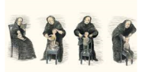  4th | As with the first page, the sequence of multiple images of the woman, with the child, framed by white spaces, directs the viewer’s focus to the actions of the woman and her absorption with the care for her growing son, and suggests the passing of time. Again, the woman’s gaze is on the son. | The conjunction ‘and’ is used multiple times, suggesting a list, and supporting the idea that the woman’s focus is always on the care of her son.
5th | The travellers are illustrated with bright colours, which are in contrast to the muted tones used for the woman and the son. The woman’s face, foregrounded, shows her unwelcoming gaze towards the travellers. | Use of an adjectival inserted into a simple sentence, links the woman to the city and the past.  ‘She, who had come from there, showed them the way.’
6th | The multiple images are reflective of the double pages 1 and 4. However, here the viewer has the image of the son, foregrounded in the bottom left hand corner of the pages, gazing back at the travellers. | The son’s dialogue shows his interest the city.
7th  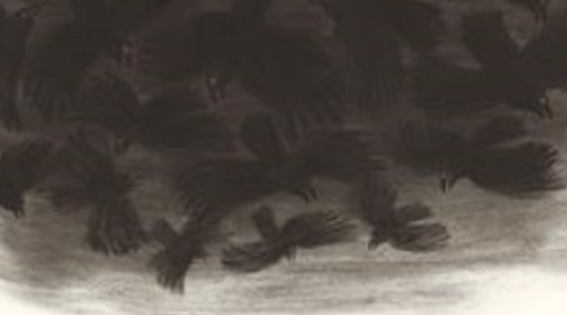 | A black cloud of crows dominates the page. Crows are cultural symbols of death. | A simple sentence is used to communicate the woman’s death.
8th | The white spaces turn into black, as the viewer’s eyes cross the page from left to right, highlighting the sense of loss and grief suffered by the son. | The sentence themes focus the attention on the dead woman and provides the reader a sense of the son coming to terms with his mother’s death (At her eyes…At her naked feet…At her still hands…At her closed mouth…).
9th | Salient is the house surrounded by white spaces and covered in black sky, highlighting isolation and hopelessness. | Nouns as sentence themes provide the reader with an understanding of the uninhabitable environment (Winter, Storms. Ice rain, Moths, Woodworm, Ants). The verbs add to the sense of harshness (tore, drenched, gnaw, hollowed).
10th | The footprints in the snow act as vectors, showing the viewer that the son begins his travels. The places he visits to bury his mother’s bones are shown in multiple frames, in muted colours rather than the black and white colours that were part of his home environment. | Prepositional phrases give the reader information about the son’s travels away from the home (Under a tree, In front of a cave, At the edge of the forest, At a lake).  The dialogue of the woman’s bones show how the son was still tied to his mother and the past.
11th | Horizontal lines show the passing of distance, with the figure of the boy on the far right, as he moves forward. | Adverbials of place (through the wintry desolation) and time (at night) and adjectivals (weighing on his shoulders…keeping him awake) give the reader the opportunity to empathise with the difficulties faced by the son.
12th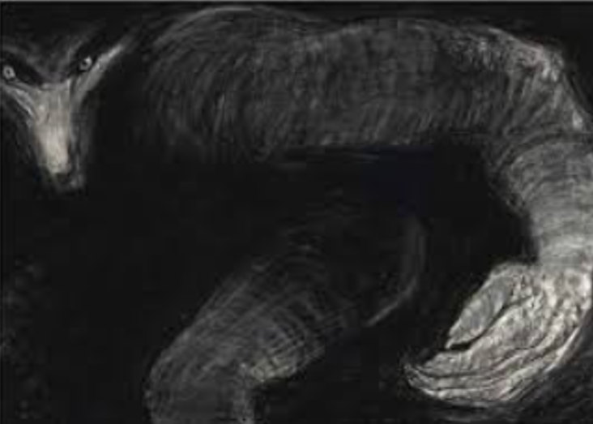 | A large grey wolf looms in the shadows. The wolf’s demand gaze meets the viewer highlighting the sense of threat. The wolf with his human like hands is a symbol of danger. | No text leaves the reader to infer from the visuals.
13th | The viewer’s eye is drawn to the white face of the wolf, which is salient.  Movement is shown through the multiple images and the multiple heads of the wolf.  The placement of the words across the page support the notion of movement. | Short clauses highlight action (fell to the ground, held onto his pole, lifted it, swung it).
14th | The man moves across the page from the dark to the light, with a determined look on his face and body language that signifies movement. His pole acts as a vector for moving onwards. | No text leaves the reader to infer from the visuals.
15th | The final double page spread shows a diagonal line from the son’s footprints, as he moves onwards and upwards towards a coloured sky, symbolising hope. | The simple sentence, with a complex verb group, that ends the text, provides the reader with a sense of hope (And then he set out to find the city).

