Running Record example
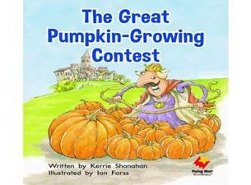
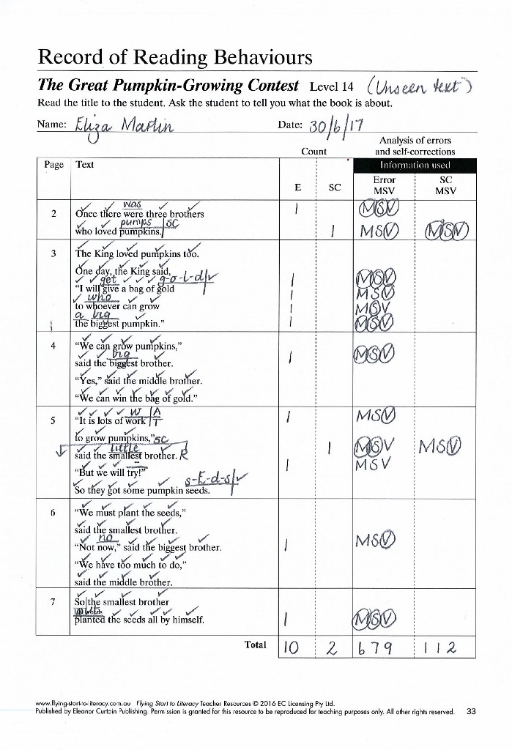
Reproduced with permission. Source: The Great Pumpkin Growing Contest, Author Kerrie Shanahan, Program Flying Start to Literacy (www.flyingstarttoliteracy.com.au) published by Eleanor Curtain Publishing Pty Ltd. (www.ecpublishing.com.au). © EC Licensing Pty Ltd. Reproduced with permission (Level 14)
