Premier’s Spirit of Democracy
Parent/Carer Declaration Form
  - Student Application

Parent contact information
First name
Last name
Relationship to student
Phone number
Email address

Consent for child to enter the competition
As the parent/carer of _________________________________, I have read and understood the Premier’s Spirit of Democracy Program (PSOD) 2022-23 background information available on the Smarty Grants Webpage, including:
- the student eligibility and commitment criteria, and
- the privacy notice
I understand that if my child wins a place on the study tour, I will be provided with further information regarding the tour arrangements and will be required to provide further information and consent to support their participation.
I give my permission for my child to enter this competition.

Signed _______________________________________ Date ________________

Parent / Carer statement of support
In 300 words or less, drawing upon your personal knowledge of the student applying for PSoD 2022-2023 – What experience, skills and attributes are held by the student applicant that will support a safe and successful experience whilst on study tour and as a future representative of PSoD?
Type your statement here (300 words or less)

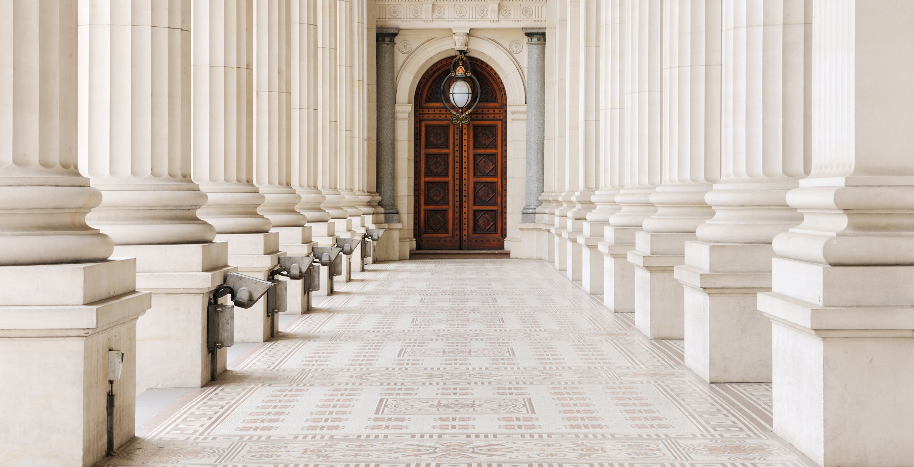

Copyright Consent

Permission to reproduce, publish and communicate work created by a student

The work that your child is entering into the Premier’s Spirit of Democracy 2022-23 competition may be chosen to highlight outstanding student achievement. We are seeking your permission to reproduce, publish and communicate your child’s work in the following ways:
- as part of a published book which may be provided in hard copy to your child, the Premier, Minister for Education, the Department of Education and Training, including the Languages and Multicultural Education Resource Centre Library, or your child’s school.
- As a PDF version of the above, published on the Premier’s Spirit of Democracy web page of the Department of Education and Training’s website (indefinitely).
- Listed or profiled in a media release from the Department, the Premier’s Office, the Minister or Parliamentary Secretary for Education’s offices.
- In a presentation at an event hosted by the Department, about the program, or about achievements in civics and citizenship education, or about student voice.
Please read this form carefully. If you do not understand any aspect, please contact The PSOD Team on spirit.of.democracy@education.vic.gov.au or the Copyright unit: copyright@education.vic.gov.au

Privacy Protection
For privacy purposes, the work and your child will be identified as agreed to in the signature panel of this form. The Department values the privacy of every person and must comply with Victorian privacy law when collecting and managing personal information. Find out more about the School’s Privacy Policy on the Department of Education and Training’s website: www.education.vic.gov.au

Your Permission
I have read this form and I give permission for the Department to reproduce, publish and share online (communicate) my child’s name and their work and I acknowledge that:
- the Department may use my child’s work, or copies of the work, in the ways described in this form from the date that I sign this form
- I must notify the Department by emailing the Premier’s Spirit of Democracy Team on spirit.of.democracy@education.vic.gov.au if I wish to withdraw my permission, but I may not be able to withdraw my permission if my child’s work has already been published.
Copyright consent
Name of student to be shown with their work
You and your child may choose how your child’s name appears e.g.:
- full first and last name (e.g. Tracy-Anne Collins),
- first initial and last name (e.g. T Collins), or
- first name and last initial (e.g. Tracy-Anne C)
We may also show the name of the school, year level and title of the work.
Title of the work
Please nominate a title for the competition entry

Signed ___________________________________________ Date _______________________

