Student worksheet - Workplace noise

Key messages
- When noise levels are too high they can permanently damage your hearing
- If the noise in your workplace is too loud, your supervisor should give you head phones or ear plugs
- If you experience any of the warning signs of hearing loss, you should talk about ways to reduce the risk of injury from noise with your supervisor.

What should you look out for when noise is too loud?
- Ringing in the ears after doing something which exposes you to noise
- Having trouble understanding what people say because you are unable to hear them properly
- Needing to turn up the volume on the radio or television, even though other people can hear
- Not hearing background noises like the telephone or doorbell even though you are close to the door or there is no other noise around you

What to do
- If the noise around you forces you to raise your voice to make yourself heard by someone a metre away, your hearing may be at risk
- Every effort must be made to reduce noise at its source
- If there is no way to separate people from potentially damaging causes of noise, your employer must provide the correct personal hearing protectors (earmuffs or earplugs)
- Personal hearing protection should be regularly cleaned and any damaged parts must be replaced
- To help reduce the risk of hearing loss you could also spend less time being exposed to noise

Activity 1: Identifying noise sources in the workplace
Below are some types of workplaces. List the sources of noise these workplaces might contain, and whether or not protective equipment (ear muffs or ear plugs) are like to be required to protect the hearing of workers.
Workplace | Source of Noise |  | Do you need protective equipment?
Kitchen | Food Processor  Dish Washer |  | No  No
Building Site | Drill |  | Yes
Garden Maintenance
Office
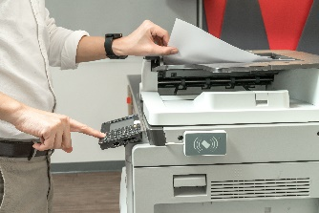
Factory

