Student worksheet - Planning how to get there

key messages
- You need to plan how you are going to travel to your work experience placement
- There are many ways you can get to your workplace:
  - Public transport such as a bus, tram or train
  - Walking
  - Riding a bike
  - Getting a lift with your parent or carer
  - Catching a taxi
- You will need to plan if you will go independently or with someone
- You will need to plan the trip to and from the workplace including mode of transport, the time it will take to get there, and how to use a map for directions

Activity 1: Location of your workplace
What is the address of the workplace?

Search for an image of the building and copy it into the box. Find your workplace using google maps

Room number |  |  | My Workplace
Building level
Street number
Name of street
Name of suburb
Telephone number

How will you get there? (Tick your travel choice)
- Train | 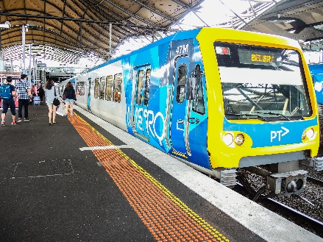 | - Walk | 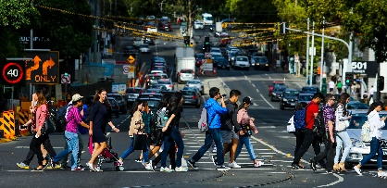
- Tram | 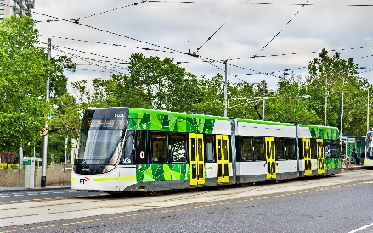 | - Get a lift in a car by parent or carer | 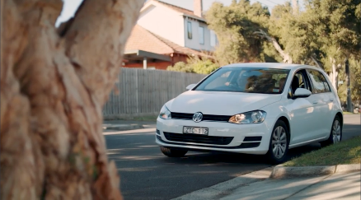
- Bus | 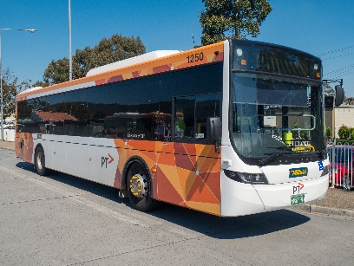 | - Ride a bike | 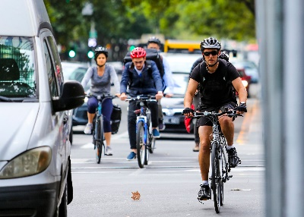
- Taxi | 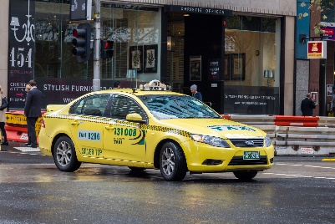 | - Other  (If you would take any alternative way to get there please draw or write)

Explain what you will do:

Activity 2: Using time to plan your journey
There are a few steps to planning a trip. You will have to work out how long it will take for you to get from one place to the next. If you are using public transport look up travel timetables to find out how long it will take.
Example only  Destination | How long will it take? | What time will I get there | What does the clock say?
What time will you need to leave home to get to your first point? In this example the bus stop. | 10 minutes | 7.30 am
What time will you need to be at the bus/tram stop or train station | Be there at least 5 minutes before the due time | 7.40 am | 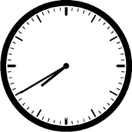
What time does the bus/tram/train get to your stop? | 20 minutes | 8.00 am | 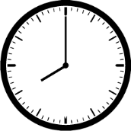
What time will it be when you get to your workplace? | 15 minutes | 8.15 | 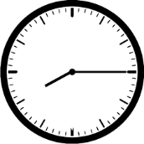

Now, use your timetable information and your own knowledge of how long your travel times take you to fill in your Journey Planner.
You can also use Public Transport Victoria Journey Planner online to complete this activity.

My Journey Planner
Destination | How long will it take? | What time will I get there | What does the clock say?
What time will you need to leave home to get to your first travel stop?
What time will you need to be at your first travel stop?
What time will you need to be at your second travel stop?
What time will it be when you get to your workplace?
What time will you need to leave your work experience to get to your return travel stop?
What time will you arrive at your first return travel stop?
What time will you arrive at your second return travel stop?
What time will you arrive home after work experience?

Draw or place a picture of a map showing the route you will take from your home to your work experience placement.

