WORKSHOP ACTIVITY INSTRUCTIONS
________________________________________________________________________________________________________________________________
Activity – Preferred Future
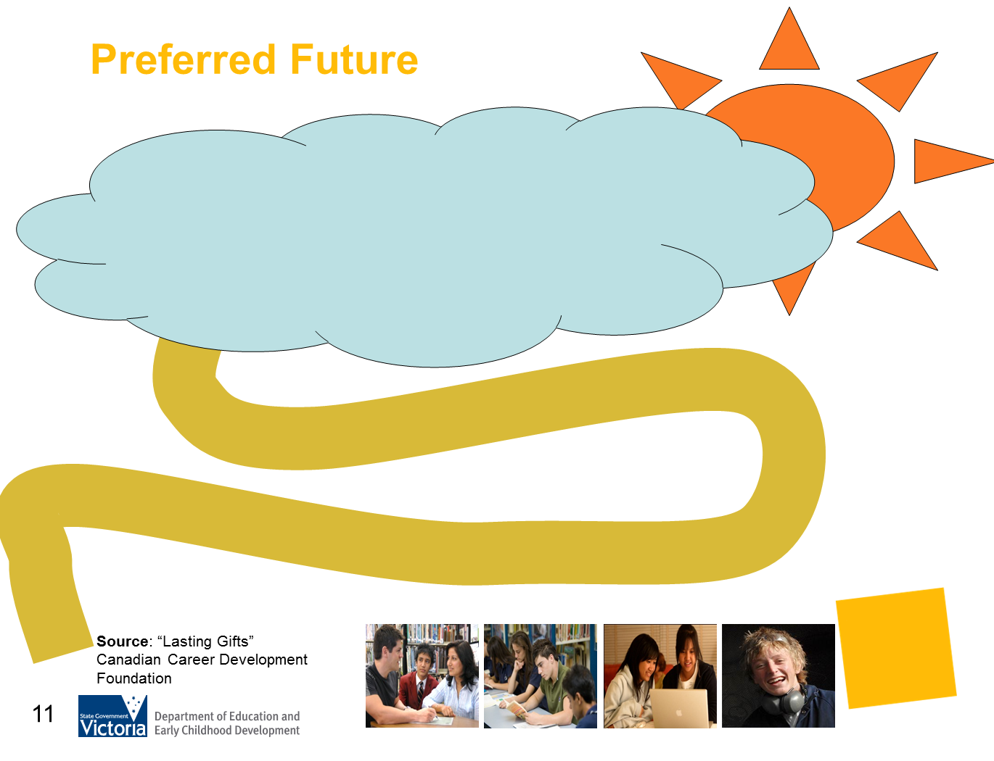

What is the purpose of this activity?
Using parents’ images of their own preferred futures, this activity provides a stimulus to understanding that one’s preferred future is much larger than the work we do for pay.
While we know this in our own lives, very often this does not get communicated to young people. As parents think of their teenager’s preferred future from this broader, more holistic perspective, they become more able to be a career ally.

Time: 5-7 minutes

Materials: Preferred Future handout. Pens, whiteboard and whiteboard markers

Preparation: Provide a handout of the Preferred Future diagram or refer parents to the diagram in their PowerPoint handout.

How do I do this activity?
Introduce the concept of ‘preferred future’ by inviting parents to close their eyes and think about the two words together. We all have a vision, a sense of ourselves and of the future we are hoping for and anticipating. For all of us, our preferred futures are about what matters to us, what we value, what brings us joy and satisfaction, and what we are striving towards.
Ask parents to think about their own ‘preferred future’, say “5 years from now” and ask them to imagine what they see. Where are they? Who is there with them? What are they doing? How are they spending time? What matters?
Allow a few minutes of individual reflection.
Draw a cloud image on the whiteboard. Ask parents to provide feedback on what broad categories they see for themselves as opposed to specific personal information.
As categories emerge, write these in the cloud. What will likely emerge is categories such as: relationships, health and lifestyle, location, values such as security and volunteer activities, meaningful paid work, learning opportunities and quality of life issues.
Once a range of categories has been recorded, allow time for reflection. Sometimes paid work is not an identified category (this is worth noting). For teenagers, the emphasis is often exclusively on decisions related to their future paid work. Broadening the focus to help them see their futures in this holistic way may be more realistic and much less pressured for them.
Draw a winding path leading to the ‘preferred future’ cloud. Introduce the idea that every decision we make moves us a little closer to or a little further away from our preferred future. Almost no decision precludes our preferred future – it might derail it for a period of time, but it is rare that one cannot take a new decision which will again move one closer to where they want to be. In this sense, every decision we make is a ‘career decision’.
Once we embrace the idea that our career lives are about much more than the work we do for pay the relevance of decisions becomes clearer and the anxiety diminishes. Paid work is a very large “footprint” on the path, but by no means the only one.
Just as our own preferred futures contain multiple life dimensions, so too for your teenager. And yet very often the message which they receive is that the paid work for which they are preparing is the most important, if not the only factor they need to focus their energy and attention.
Reflection and discussion
- What message do you think your teenager is hearing about their preferred futures?
- What categories are they hearing that are important for them to consider?
- What message are they receiving about making up their minds an also about changing their minds?
Give a few minutes for reflection and note-taking or for paired conversation.

Things to consider when using this activity:
- Some workshop participants may need additional encouragement to explore and share their imaginings.
- Re-assure participants that they do not have to share specific details, that you are exploring themes.

Source: The Preferred Future activity is taken from the Lasting Gifts resource (workshop 1), Canadian Career Development Foundation.

Source: “Lasting Gifts”
Canadian Career Development Foundation

