WORKSHOP ACTIVITY INSTRUCTIONS
________________________________________________________________________________________________________________________________
Activity – Pencil Equipping for Career Exploration

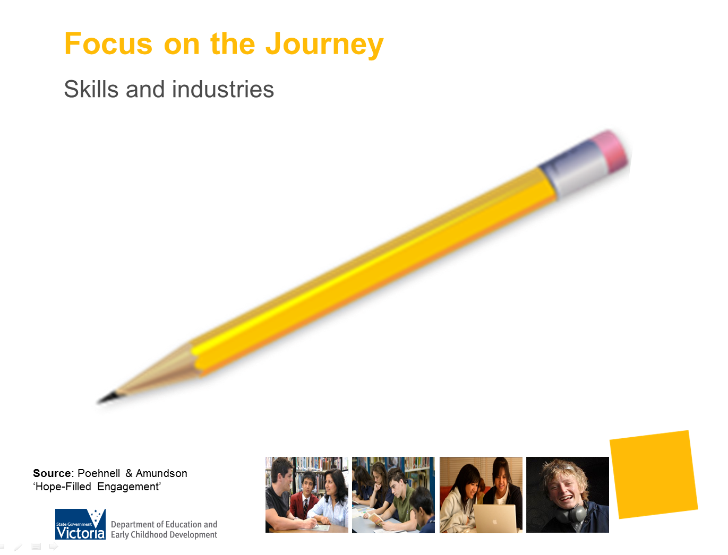

What is the purpose of this activity?

This activity relates to the web of work, which is a brainstorming technique that explores work possibilities for a specific industry or area. For example, there are hundreds of different jobs within the fishing industry including taking, culturing, processing, preserving, storing, transporting, marketing or selling fish or fish products.
This activity provides an opportunity for parents consider how they may have a conversation with their teenagers opening the possibilities about areas of interest.

Time: 10 minutes

Materials: Use whiteboard and butchers paper

Preparation: Parents to work in small groups using butcher paper to make their list

How do I do this activity?
Use the pencil to explore industries, ask the question “What industries are involved to get this pencil from raw products to you?”
Prompt participants to consider all bits of the pencil (point, wood case, colouring, metal ring, eraser).
Each group then considers one industry. Ask participants, in groups, to list specific jobs within these industries, such as rubber farmer, graphic designer, sales assistant, etc.
Encourage participants to consider where the raw materials come from, how they are transported, how the pencil was designed and produced, how it was distributed after production to reach you, etc.
Place butcher paper on the walls ask parents to either look at each or discuss and reflect on what does each have in common, and what it implies about careers and the world of work.
As they reflect they will see that there are many specific jobs directly related to each industry but there are also many jobs in common with all the different industries. There is a “world wide web of work” that is interconnected.

Things to consider when using this activity
- Participants with a limited work history may struggle to identify a wide range of jobs in each industry. Be prepared to prompt them with questions or ideas to help them get started.
- If working with an interpreter, encourage participants to discuss the activity in their first language.

Source: “Hope-Filled Engagement” - Gray Poehnell & Norman E. Admundson http://www.ergoncommunications.com/books/
or
http://www.brightandassociates.com.au/cgi-bin/oscommerce/product_info.php?products_id=58

