WORKSHOP ACTIVITY INSTRUCTIONS
________________________________________________________________________________________________________________________________
Activity – Concerns about the future
(Think, Pair, Share)
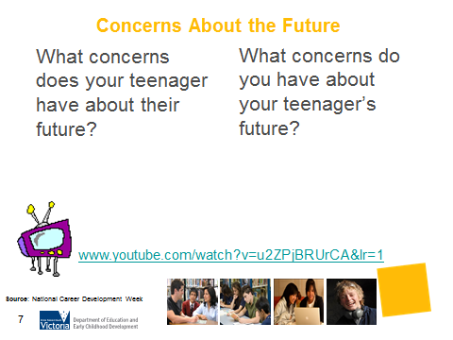
What is the purpose of this activity?
The focus of this workshop is to engage parents in career conversations and this activity is a good way to get the conversation going. It also:
- helps to set the tone of the workshop;
- provides a basis for further discussion throughout the workshop;
- provides an opportunity for parents to get to know one another;
- allows parents to share similar experiences;
- creates an environment where the parent is encouraged to participate and the facilitator is willing to listen; and
- conveys the message that the facilitator cares about understanding parents and their teenager’s concerns about the future.
Time: 10-12 minutes

Materials: A4 paper, pens, whiteboard or Flip Chart and whiteboard markers

Preparation: Provide one sheet of paper and a pen for each participant.

How do I do this activity?
Think Pair Share involves posing a question to parents, asking them to take a few minutes of thinking time and then turning to a nearby participant to share their thoughts. Think – 2 mins. Ask parents to think about the following questions:

- What concerns does your teenager have about their future?
- What concerns do you have about your teenager’s future?
Pair – 2 mins. Ask parents to form pairs and discuss their concerns.
Share – 6 mins. The facilitator then asks the pair to share their concerns with the broader group. The facilitator records these concerns on the Whiteboard or Flip Chart.
Allow enough time for discussion. Let the group know that they will come back to these concerns during the workshop.
What are some variations of this activity?
Watch the video ‘Parents as Careers Coaches’ 8.23min
Due to copyright restrictions, the video file is not embedded into this presentation.

Please copy and paste the following URL into a web browser to view the video: http://www.youtube.com/watch?v=u2ZPjBRUrCA&lr=1
Source: http://www.ncdw.com.au/index.php/ncdw-videos.html

Things to consider when using this activity:
- Be aware that parents of young people with a profound disability may find this activity highly emotional and confrontational.
- The video is over 8 minutes in length – is this too long for your workshop participants?
- The language in the video maybe difficult for parents from an EAL background

What concerns does your teenager have about their future? | What concerns do you have about your teenager’s future?

