WORKSHOP ACTIVITY INSTRUCTIONS
________________________________________________________________________________________________________________________________
Activity – Did you know?
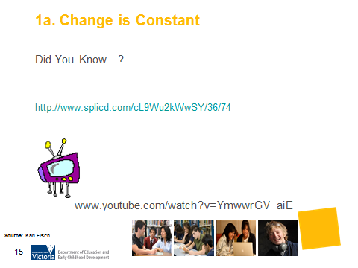
What is the purpose of this activity?
This video emphasises the progression of information and technology and how different the world-of-work is for teenagers. Through this video parents are made more aware of the progression of change. The questions for discussion challenge parents to consider the impact of what this change means to them and how it may inspire parents and their teenager to approach the future differently.

Time: 10 minutes
5 minutes – video
5 minutes – discussion

Materials: Internet connection, screen, data projector and speakers

Preparation: Test and upload the video prior to showing.

How do I do this activity?
- Present the video.
- Discuss the final statement, “So what does this mean?”
- What are your feelings about change and the pace of change?
- Ask parents the following questions
- How did this make you feel? (excited, anxious, interested)
- What opportunities does this create?
- Has it inspired you to approach the future /or do something in a different way?
- Predict what you think life will be like in 20 years’ time
- Do you think there is a limit to our technological and information development?

What are some variations of this activity?
- Ask parents to reflect on how mobile phones have changed our lives in the last twenty years. What is different about how we communicate, live and work? How would the world look if mobile phones were not around?

Things to consider when using this activity
- If the audience includes people from an EAL background or with a disability, presenters should consider the skill level of participants in reading English, especially given the rapid pace of the text.
- This may be a good video to use with parents and young people together if possible, with discussion time afterwards.

Source: Original video by Karl Fisch: Modified by VideoShredHead

