ACTIVITY INSTRUCTIONS
________________________________________________________________________________________________________________________________
Workshop Activity – Attributes that young people need …
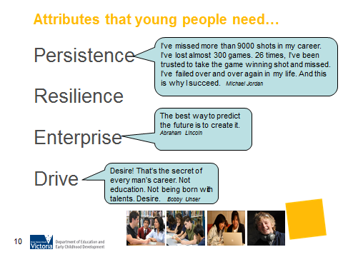
What is the purpose of this activity?
There are skills that sit outside of the mainstream curriculum that help young people to achieve their goals and to strive in the face of difficulty, opposition or failure. This helps to illustrate that these are attributes that young people need as they navigate their journey through education and the world of work.

Time: 3 minutes

Materials: N/A

Preparation: Consider persistence, resilience, enterprise and drive these are essential attributes in future economies. Think of some examples of past students or use the quotes given on the slide. Discuss these and then ask how the attributes are displayed.

How do I do this activity?
Group discussion
Ask participants to share examples of when their teenager has demonstrated persistence, resilience, enterprise and drive, so they can support their teenager to self-identify positive attributes in a later career conversation. Or you can give examples and asked how these attributes are displayed.

What are some variations of this activity?
Guests or past students could be invited to share their story.
Discussion of the Core Skills for Work may also be relevant at this point. These can be accessed at http://www.innovation.gov.au/Skills/CoreSkillsForWorkFramework/Pages/default.aspx.

Things to consider when using this activity:
- Depending on the background of your workshop participants, ask yourself if the words and/or quotes are appropriate. Do they need to be changed to resonate with my audience?
- A customised version of this slide can be found in the EAL and Disability specific PowerPoint presentations.

