Teachers' notes
Year levels

Year 7, 8, 9, 10
VELS

Level 5 & 6


Time One hour (plus further activities homework)

Purpose

To obtain some insight into what others think they are good at and what this means for themselves.

Rationale
Other people’s perceptions of yourself, can assist you in reflecting on your own abilities. It can confirm the view you have of yourself, or raise awareness of other strengths and weaknesses you may need to consider.

Activities
- Distribute one card to each student in the class (make sure you have as many cards as there are students). Ask them to award it to the person they think deserves it most. Students can only receive one award.
- Once cards have been awarded ask students to think about the award they have been given considering the following:
a. Were you surprised at what award you were given?
b. What sort of abilities would you need to do this?
c. Rate your own belief that you might do this from 0 - 10 i.e. how accurately does this fit with your image of yourself?
- Get students to write about what their life would be like if they ended up doing this.
- Discuss the life scenarios they have created with others in the class.

Further activities
- This series of activities could be repeated using the rest of the cards.
- Teachers could develop their own set of cards.

Resources
- One copy of the How others see me handout cut into separate cards for distribution
- Youth Central website http://www.youthcentral.vic.gov.au/
- Identifying step in the My Guide section of the myfuture website at http://www.myfuture.edu.au
- Job Guide – in print or online at http://jobguide.dest.gov.au/

Victorian Essential Learnings (VELS)

Level 5 and 6
Strand | Domain | Dimension
Physical, Personal and Social Learning | Interpersonal Development | Building social relationships  Working in teams
Physical, Personal and Social Learning | Personal Learning | The individual learner  Managing personal learning
Discipline-based Learning | The Humanities – Economics | Knowledge and understanding
Interdisciplinary Learning | Thinking Processes | Reflection, evaluation and metacognition

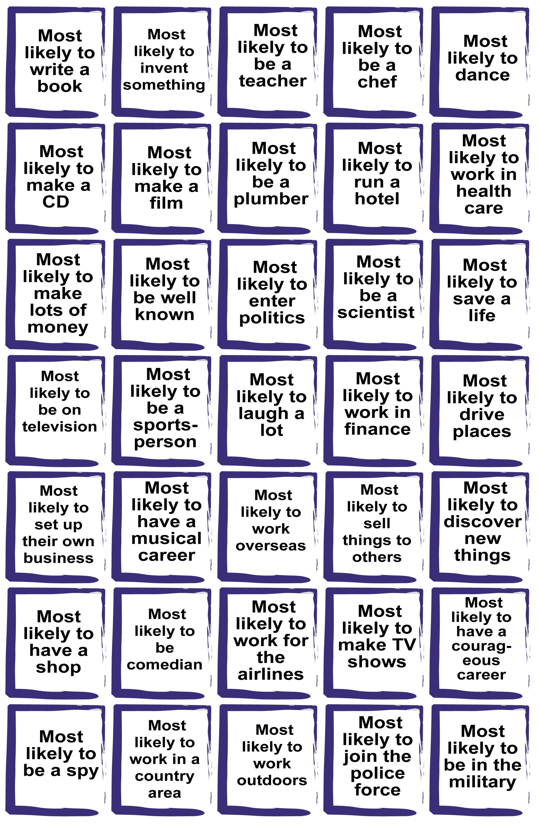
Cards to photocopy and cut up for distribution of individual cards to the students

