Strengthened Pathways Planning for young people with disabilities
Parent Information

Published by Student Inclusion and Engagement Division
Department of Education and Early Childhood Development
Melbourne
May 2014

© State of Victoria (Department of Education and Early Childhood Development) 2014

The copyright in this document is owned by the State of Victoria (Department of Education and Early Childhood Development), or in the case of some materials, by third parties (third party materials). No part may be reproduced by any process except in accordance with the provisions of the Copyright Act 1968 the National Education Access Licence for Schools (NEALS) (see below) or with permission.

NEALS is an educational institution situated in Australia which is not conducted for profit, or a body responsible for administering such an institution may copy and communicate the materials, other than third party materials, for the educational purposes of the institution.

Authorised by the Department of Education and Early Childhood Development, 2 Treasury Place, East Melbourne, Victoria, 3002

Acknowledgements
Strengthened Pathways Planning is a joint initiative of the Department of Education and Early Childhood Development and Department of Human Services.
Thank you to the following Victorian government schools involved in the trial and evaluation of Strengthened Pathways Planning:
Ashwood School, Barwon Valley School, Berendale School, Brauer College, Cobden Technical School, Doncaster Secondary College, Glenallen School, Heatherwood School, McClelland College, Naranga School, Newcomb Secondary College, North Geelong Secondary College, Warrnambool College and Warrnambool Special Developmental School.
Photos provided courtesy of Barwon Valley School, Berendale School and Montague Continuing Education Centre.

Contents
Section 1 Introduction 3
Section 2 Transitions and careers 4
Transitions 4
Careers 4
Section 3 Your role in career planning 5
The Student Support Group 5
Career Conversations 5
Activities at home and at school 6
Section 4 Strengthened Pathways Planning 7
An example 8
More information 8
Section 5 Post-school options 9
Employment 9
Education and training 11
Specialist Transition Supports 12
Specialist Community Based Supports 13
Section 6 More information 15
Parent Websites 15

Introduction
Our department is dedicated to improving the opportunities for all learners, without exception. We are committed to ensuring that school education is inclusive and engaging so that young people are equipped to undertake further study or enter the workforce.
Both parents and teachers share a significant role in helping young people identify their future aspirations and build work-readiness skills.
For young Victorians with disabilities, participating in further education, training and employment can lead to enhanced opportunities for greater economic and community involvement. It can be a protective factor against social exclusion and associated mental and physical health issues. Increased access to employment opportunities is key to improving economic security and personal wellbeing.
In short, every young person with a disability who is able to work should have an opportunity to participate in employment and be actively supported to do so.
For young people with high support needs, their post-school planning should include options that foster independence that support ongoing life skills development, social inclusion, and the pursuit of active and fulfilling experiences. The social participation of young people with disabilities adds value to a rich and diverse community.
This document provides guidance for parents on careers and transition planning for young people with disabilities, and brings together information about Strengthened Pathways Planning in schools, and the broad range of options available to their children when they leave school.

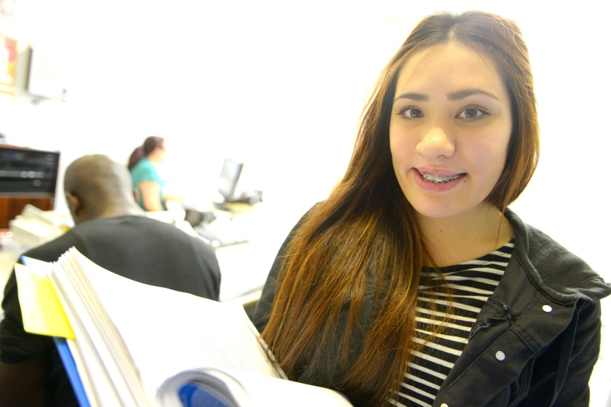

Transitions and careers

Transitions
Children and young people undertake a number of important transitions at key points during their education; moving from kindergarten to school, primary school to secondary school, and finally leaving school to pursue post-school options.
The transition from the familiarity of the school environment to post-school is a significant milestone and can be an exciting time for young people. For some, making decisions about future options can be daunting. For young people with disabilities, we recognise that there may be additional challenges and uncertainty. It is important to seek information, support and advice ahead of this transition.

Careers
Many parents seek to improve their knowledge of career development in order to assist their children. To help you provide the best possible information, advice and guidance, you will need to understand what “career” means in the 21st century. A career is no longer one job for life. A career includes a lifetime of experiences including periods of education, training, paid employment, unpaid employment, unemployment, volunteer work and life roles.
Young people with disabilities can participate in a variety of valued work activities regardless of the level of their ability.
Some young people with disabilities can undertake work activities independently, whereas others may require some additional support. Employers are required under the Commonwealth Disability Discrimination Act 1992 to make reasonable adjustments to the workplace to cater for specific support needs. A variety of work options are available for young people who cannot fully engage in open employment.
It is important to keep in mind that effective career planning supports young people to identify what they can do, rather than what they cannot do.
Our department recommends a career planning approach that is customised for young people with disabilities and builds upon existing school processes. An integrated and collaborative approach should assist young people with a disability and their families to:
- plan ahead for a fulfilling and active future; and
- understand what further education, training and employment options are available when they leave school.

Your role in career planning
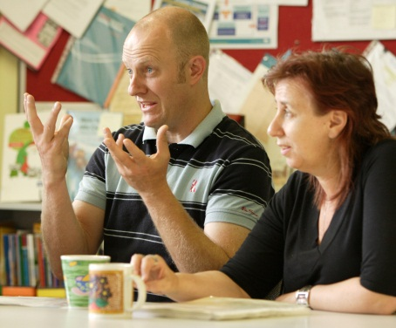
As a parent you have a key role to play in supporting your child with their career journey. You are generally the first point of call for career development information, advice and guidance for your child. Your attitude can have a powerful impact on your child’s career development and how they manage their careers. Having a positive attitude, watching for activities your child is drawn to and seeing their careers as journeys are some of the ways in which you can support your child to prepare for their future and be adaptable to change.

The Student Support Group
The Student Support Group (SSG) provides a valuable forum for ongoing discussions about your child’s career aspirations.
The SSG develops an Individual Learning Plan that sets out the young person’s short-term and long-term learning goals.
As young people with disabilities explore and refine their future options through the senior secondary years, the SSG should increasingly focus on setting learning goals within the Individual Learning Plan that prepare the young person for their long term aspirations. These learning goals should aim to foster independence, develop work related skills, and increase the young person’s confidence in their capacity to work.
A staff member with careers expertise or representatives from external agencies may be invited to attend SSG meetings for additional careers advice.
For further information about Student Support Groups and writing Individual Learning Plans, see: Student Support Group (www.education.vic.gov.au/school/principals/health/Pages/studentsupportgroup.aspx).

Career Conversations
It is helpful for young people to talk through the many options for further education, training and employment that are available to them following completion of school. They can have these conversations with you, a careers practitioner, teachers and other trusted adults.
You can start a conversation when your child asks questions about life after school. Most young people respond well to casual conversations about careers. Talk about the world of work as you have experienced it. Share some of your work and life experiences and those of other family members and friends. Encourage them to reflect on their experiences with questions like:
- What is it about _____ that interests you?
- What did you learn about yourself from that experience?
- How could you get experience in that field of work?
- I wonder what qualifications might be required for that field of work.
- Would you like to go to TAFE or university? Have you thought about doing an apprenticeship?
- What are you and your friends thinking of doing after school?
- Who could you talk with to get more information or careers advice about that field of work?
The most important thing is to be positive about the ideas and choices made by your child and their chances of finding a satisfying career path. This needs to include a consideration of their aptitudes (what they are good at), interests (what they like or enjoy doing), values (what is important to them), aspirations (what they want to achieve) and skills (what they can do).

Activities at home and at school
Other activities you can undertake to support your child’s career development include:
- practicing work skills at home
- talking with other parents of young people with disabilities who are undertaking their career journey
- contributing to the development of your child’s Individual Learning Plan which targets skills linked to your child’s career aspirations
- attending career workshops for parents
- attending open days, information sessions and Career Expos to fully explore the range of post-school options available to your child
- sharing relevant information with external departments, agencies and employers as required

Strengthened Pathways Planning
A range of career supports are available in schools for all young people. For young people supported under the Program for Students with Disabilities, a strengthened approach to career planning is recommended.
Strengthened Pathways Planning is an enhanced and integrated approach to career planning for young people with disabilities.
The planning is overseen by the young person’s Student Support Group and the agreed activities are incorporated within the young person’s Individual Learning Plan.

R U Ready
Student Profile

Career Action
Plan

Engaging Parents
in Career Conversations

Workplace Learning
Opportunities
Individual Learning
Plan

An Individual Learning Plan is the core planning document developed for all students supported under the Program for Students with Disabilities, and is recommended for any student with additional needs. The Individual Learning Plan contains a set of individualised goals and strategies that build upon a young person’s current profile and future aspirations.
The Individual Learning Plan binds the components of Strengthened Pathways Planning into a unified approach.
- The Engaging Parents in Career Conversations (EPiCC) Framework provides resources to help schools work together with parents to ensure that young people are empowered with positive career messages both at school and at home.
- The Career Action Plan is a student-owned career planning document designed to translate a young person’s dreams and aspirations into specific learning goals and identify relevant work experience opportunities.
- The R U Ready Student Profile provides a snapshot of a young person’s work-related skills and employability at a point in time. This helps young people, their parents and teachers engage in career conversations about what the young person can do, their strengths, and readiness for work.
- Workplace Learning Opportunities enable young people to trial post-school options and gain direct ‘hands on’ experience in a workplace.

An example
Joshua attends a mainstream school and has an intellectual disability.
Career Action Plan
From Year 7 Joshua updates his Career Action Plan in class as part of the Victorian Careers Curriculum Framework. He identifies cooking and working with people as areas that interest him, and he aspires to be a contestant on a television cooking show. The learning goals identified by Joshua in his Career Action Plan are incorporated into his Individual Learning Plan.
R U Ready Student Profile
In Year 10 Joshua’s parents attend a Student Support Group meeting and complete the R U Ready Student Profile with his teachers. They identify Joshua’s strengths with interpersonal skills and following written instructions, but also a need for him to further develop his confidence with managing money. The school then prioritises the development of money management skills in Joshua’s Individual Learning Plan. In Year 11 and Year 12 they review and update his R U Ready Student Profile.
Workplace learning opportunities
In Year 10 the school liaises with a local Workplace Learning Coordinator to identify and negotiate work experience for Joshua at a local bakery. The experience motivates Joshua to strengthen his maths skills, which is prioritised in his Individual Learning Plan.
Engaging Parents in Career Conversations (EPiCC) Framework
From Year 7 the school discusses career options with Joshua’s parents in Student Support Group meetings. In Years 10 and 11 his parents attend careers workshops at school and learn about pathways to VET programs in hospitality and School Based Apprenticeship and Traineeship programs. In Year 12 Joshua’s parents attend open days at the TAFE with Joshua and he enrols in a hospitality course for the following year.

More information
The Student Support Group is the ideal forum for discussions regarding your child’s career planning and specific components of the Strengthened Pathways Planning approach.

Post-school options
When young people leave school it is important to maintain social contact with peers, and undertake fulfilling activities that promote lifelong learning and development. Some young people with a disability aspire to pursue employment and financial independence. Other young people pursue further education or training which can provide social connections with peers, and opportunities for future employment. For young people with very high support needs, their post-school planning should include options that support ongoing life skills development, social inclusion, and the pursuit of active and fulfilling experiences.
This section provides an overview of options for young people with disabilities in the areas of:
- employment
- education and training
- specialist transition options
- specialist community based supports.
Additional information can be found in the Exploring the Possibilities resource guide, which aims to provide a starting point to explore the range of options that are available to young people with disabilities once they leave school.
See: Department of Human Services’ Exploring the possibilities: post-school options for young people with a disability (www.dhs.vic.gov.au/about-the-department/documents-and-resources/reports-publications/exploring-the-possibilities-post-school-for-disabled-young-people).

Employment
A range of employment services are available to help people find work. Most of these also offer specific help to young people with a disability.
- Centrelink
Young people looking for work should contact Centrelink Employment Services on 13 28 50 or visit a Centrelink Customer Service Centre.
Centrelink can determine the level of help a young person is eligible to receive and refer them to the employment service that best meets their needs.
Young people may also contact a local Job Services Australia provider or Disability Employment Network member directly for assistance.
For further help, contact a Job Access Adviser on 1800 464 800.
- Job Services Australia
Job Services Australia offers personalised help and services that are better targeted to the needs of a job seeker with more access to training opportunities and work experience to help people find and keep a job. Job Services Australia is a new approach to employment services, which gives a single entry point to a range of user friendly employment services for job seekers and employers. See: Job Services Australia (http://employment.gov.au/job-services-australia-jsa)

- Disability Employment Services
Disability Employment Services (DES) offer specialist assistance to job seekers with a disability, who require ongoing support to find and maintain employment.
DES members provide a range of specialist services individually tailored to meet a person’s employment needs. See: Disability Employment Services (http://www.humanservices.gov.au/customer/services/centrelink/disability-employment-services)
- JobAccess
JobAccess is a free information and advice service about the employment of people with disability. JobAccess helps people with disability, employers, service providers and the community to access information about services, financial assistance and workplace solutions. See: Australian Government’s JobAccess (www.jobaccess.gov.au/).
- Community and volunteer work
Volunteer work is an excellent way of experiencing new challenges and learning about the world of work.
Volunteers provide an unpaid but valuable service to the community.
There are a variety of organisations that rely on volunteers and it can be a great way to gain new skills and build on your work experience.
Young people with a disability may enjoy rewarding careers where volunteer activities are included. Volunteer programs are supported by Centrelink, local governments and numerous community organisations.
Being a volunteer frequently introduces people to networks that can lead to other career opportunities. See: Victoria’s Volunteering portal (http://www.volunteer.vic.gov.au/).
- CRS Australia
CRS Australia assists people who have an injury, disability or health condition to work independently in the open labour market. See: CRS Australia (http://www.crsaustralia.gov.au/).

More information
- Disability Employment Australia – represents the disability employment services sector and aims to help jobseekers and employees with a disability. (http://disabilityemployment.org.au/)
- Australian Apprenticeships Access Program – gives job seekers who experience difficulty entering skilled employment training, support and assistance. (http://www.humanservices.gov.au/customer/services/centrelink/australian-apprenticeships-access-program)
- Australian Disability Enterprises – are commercial businesses that provide employment for people with a disability, operating across a wide range of industries - from design, printing and packaging, to manufacturing, laundry and landscaping. Employees of Australian Disability Enterprises enjoy the same working conditions as those in the general workforce. There are over 350 Australian Disability Enterprise outlets across Australia so there is likely to be a provider in your region. (www.australiandisabilityenterprises.com.au/)
For information on different occupations, click on the links below:
- Youth Central’s Jobs and Careers – gives planning and career advice (www.youthcentral.vic.gov.au/Jobs+&+Careers).
- Myfuture’s Occupation Search (http://www.myfuture.edu.au/explore%20careers/browse%20occupations.aspx).
- Australian Government’s Job Guide (http://www.jobguide.education.gov.au/).

Education and training

Higher education
Higher education courses offered in Victoria, range from undergraduate and postgraduate degrees, to diplomas. Courses are available to students at universities, some TAFE institutes or at a private higher education provider.

Vocational Education and Training
Within the Vocational Education and Training (VET) sector, there is an extensive range of courses to choose from at TAFE institutes, Adult Community Education organisations, TAFE Divisions of some universities, or private training providers. Training opportunities range from short courses to vocational graduate diplomas. Many courses offer on-the-job training, and apprentices and trainees have the opportunity to learn while being employed.
Training is delivered through a range of options. The time it takes a young person to complete their qualification will depend on their prior level of skills and knowledge, whether the student is studying full-time, part-time or externally as well as what qualification they are studying. See: Victorian Skills Gateway (www.education.vic.gov.au/victorianskillsgateway/pages/home.aspx).

Short courses
If a student is unsure whether University or TAFE is right for them, they may do some short courses. Short courses are a valuable way of looking into career pathways and are often used as a stepping stone to further education.

Learn Local Courses
Learn Local – Adult Community Education (ACE) provides early, less formal learning opportunities in a friendly local environment. See: Learn Local Courses (www.education.vic.gov.au/training/learners/learnlocal/Pages/default.aspx).

Supports available
The National Disability Coordination Officer (NDCO) program targets the barriers that people with a disability face in successfully accessing and completing post-school education and training and subsequent employment. NDCOs perform a range of functions to help people with disability gain access to and successfully complete post-school education and training, and employment. NDCOs can provide practical assistance and advice to individuals with a disability and their families, education and training providers, as well as employment and community support agencies.
Most universities and TAFEs have links to NDCOs and some employ their own disability liaison officer, while others are employed regionally and are shared across campuses, particularly within the TAFE sector.
NDCOs can assist with:
- making the introduction to further study easier by talking to students and finding out about their needs
- putting students in touch with others who have similar support requirements
- information about scholarships and grants and how to apply for them
- pre-enrolment advice
- advice about special entry schemes available
- application and enrolment advice.
For more information, see: NDCO (http://www.ndcovictoria.net.au/).
The Victorian Training Guarantee makes vocational education and training more accessible to people who do not hold a post-school qualification, or who want to gain a higher level qualification than they already hold. For more information, see: The Victorian Training Guarantee (www.education.vic.gov.au/training/learners/vet/pages/funding.aspx).

Specialist Transition Supports
A range of specialist transition services are offered to support young people in their transition to further education, training or employment.
For more information, see: Department of Human Services’ Disability (www.dhs.vic.gov.au/for-individuals/disability).

Futures for Young Adults
Futures for Young Adults (FFYA) is a Victorian program offered by the Department of Human Services, that provides information, advice and support for up to three years to young people with a disability who have disability-related transition support needs that cannot be met through other available services and supports. FFYA focuses on helping these young people make a successful transition from school to further education and employment.
FFYA transition planners are available to assist young people with a disability, families and school personnel to explore a range of post school options. They can provide specialist information and advice regarding services available in the community for young people with a disability to support them to meet their post school goals.
Young people with a disability who meet the eligibility criteria for FFYA may be provided with:
- information about generic, community and specialist supports
- information and support to access disability supports, if required
- assistance to explore a range of post-school options
FFYA can provide funded support for young people with a disability to access disability-related supports where it is identified that generic community services are not able to meet their needs.

Transition to Employment
Part of the FFYA program, the Transition to Employment (TTE) initiative provides assistance to young people interested in pursuing employment, but who are not yet ready to move into employment or receive assistance through a Commonwealth employment program. TTE is focused on supporting this group to build the skills, capacity and work experience to facilitate entry into the paid workforce.
Transition to Employment aims to help young people with a disability by:
- supporting them to develop work and industry related skills and qualifications
- improving access to employment opportunities
- increasing participation rates in the workforce
- building their capacity to independently participate in the community.

Specialist Community Based Supports

Individual Support Packages
Individual Support Packages are funds that the Department of Human Services allocates to a person to meet their disability-related support needs. The funds may be used to buy a range of disability-related supports chosen by the person to assist them to achieve their goals. The funding may complement existing informal support arrangements from family and friends and/or generally available community services.
Individual Support Packages may assist people with a disability to continue living in the community by providing a range of supports to:
- maintain independence
- keep living in their own home
- move to more independent living arrangements
- learn new skills
- participate in the local community.
For more information, see: Department of Human Services’ Individual Support Packages (www.dhs.vic.gov.au/for-individuals/disability/individual-support-packages).

Community Based Day Services
Day services, provided by specialist disability service providers, provide group or individual activities across a range of lifestyle areas, including daily living, community participation and recreation. Day services are suited to people who have high physical or social support needs, require significant assistance with activities of daily living, or who have significant behaviour and safety issues.
For more information, see: Department of Human Services’ Day Services Handbook (www.dhs.vic.gov.au/about-the-department/documents-and-resources/policies,-guidelines-and-legislation/day-services-handbook).

National Disability Insurance Scheme
On 1 July 2013, the National Disability Insurance Scheme (NDIS) launched in Victoria’s Barwon Area encompassing the City of Greater Geelong, the Surf Coast Shire, the Borough of Queenscliff and the Colac-Otway Shire. The NDIS will gradually roll out across the rest of Victoria from July 2016.
The NDIS will consider a person’s care and support needs over their lifetime and is underpinned by principles of choice, control, inclusion and flexibility. Eligible people with a disability will receive individualised care and support that is flexible and adaptable as their needs change.
For more information, see: National disability insurance scheme (http://www.ndis.gov.au/).

Neighbourhood Houses
Neighbourhood houses are local organisations that provide social, educational and recreational activities for their communities in a welcoming supportive environment.
There are approximately 360 Neighbourhood Houses across Victoria with at least one Neighbourhood House in just about every town and suburb in Victoria.

More information
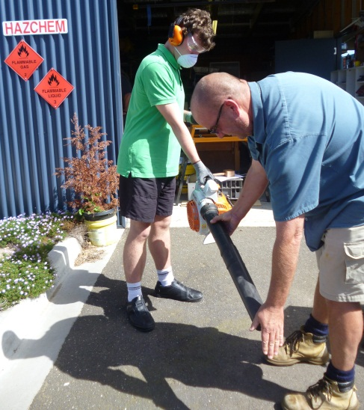
You can seek more information about career options from school staff, including:
- Careers practitioner
- Year level coordinator
- Year 11 or 12 coordinator
- VCE, VCAL or VET coordinator
Support is also available from Careers Centres at VET and University providers. Most institutions have dedicated staff to provide support for students with disabilities.

Parent Websites
There are a range of websites that can provide you with more information on career development and career pathways, including:
- The myfuture: Career Development for People with Special Needs website provides a wide range of useful information on career development for parents of students with special needs. See: myfuture’s Career Development for People with Special Needs (http://www.myfuture.edu.au/tools%20and%20resources/assistance%20for%20people%20with%20specific%20needs.aspx).
- The Career and Pathway Planning website provides information on possible pathways and support available specifically for students with a disability. See: Career and Pathway Planning (www.education.vic.gov.au/school/parents/needs/Pages/careersupport.aspx).
- The Victorian Skills Gateway is a one-stop shop for vocational training in Victoria. This site allows users to search occupations, courses, training providers, video and written case studies. This website is also viewable via a purpose built smartphone interface. The courses on the Victorian Skills Gateway website are either regulated qualifications under the Australian Qualifications Framework (AQF), or short training programs comprising units of competency from regulated qualifications. See: Victorian Skills Gateway (www.education.vic.gov.au/victorianskillsgateway/Pages/home.aspx).
- For specific help regarding support available to students with a disability and what to consider in choosing a training provider, see Victorian Skills Gateway’s Choosing a training provider (www.education.vic.gov.au/victorianskillsgateway/adult%20learners/pages/choosing-a-training-provider.aspx).

