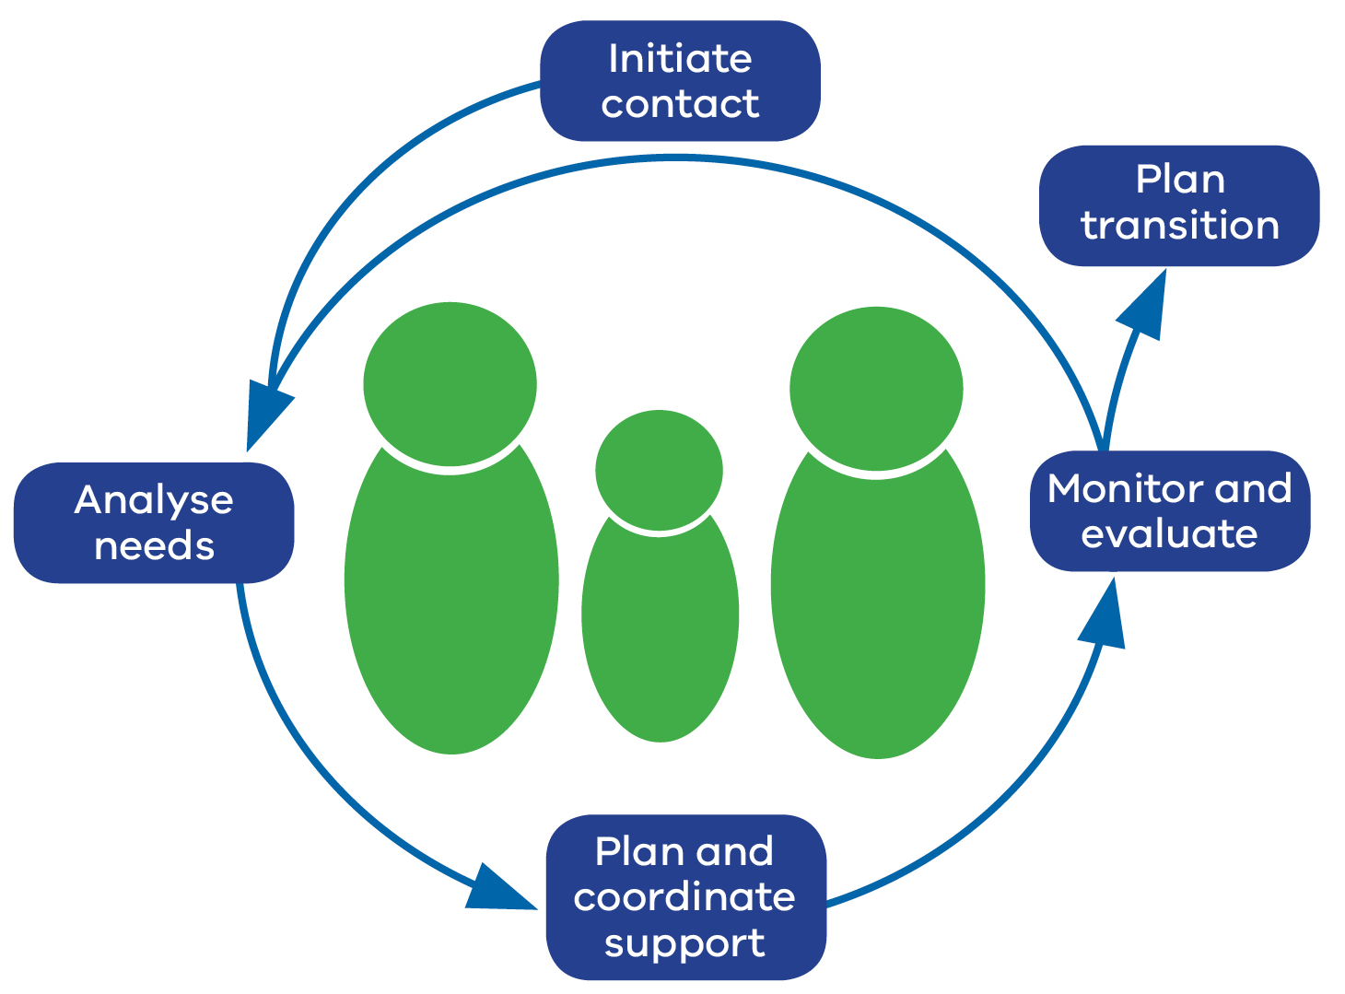

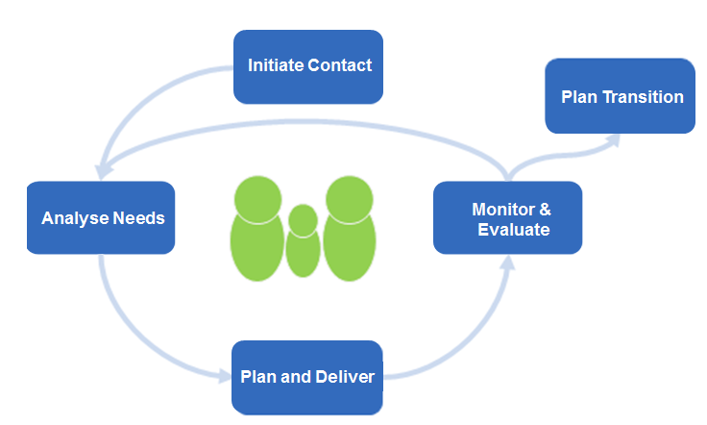
Transition from Additional Support Plan
Monitor & Evaluate
Initiate Contact
Plan & Coordinate
Analyse Needs
Plan Transition

Plans are made for a purposeful transition from the formalised TAL approach by gradually reducing additional support as the learner develops greater independence.

- A Transition from Additional Support Plan is completed once the learner, family and team agree that the goals outlined in the plan have been achieved and sustained.
- A Transition from Additional Support Plan is created taking into consideration the need for post-transition planning.
- At this stage of the TAL process there is a celebration of the achievements of the learner, family and team.

Name:
Strengths of the learner
Goals achieved:
1.
2.
3.
Future goals planned:
1:
2:
3:

Continued supports:
Who the learner will contact if additional supports are required:

Planned check-ins from Lead Professional: Date:
Date:
Date:

Additional information:

