reflective practice
Throughout the Team Around the Learner approach, schools often have to manage complex situations.
The aim of this document is to assist schools to engage in a reflective process to clarify thoughts and future actions.
What is reflective practice?
Reflective practice is a way of critically reviewing your own experiences in order to facilitate a greater understanding of how your beliefs and values influence your practice, teaching, learning, and actions.
- The process of reflection develops self–awareness and facilitates changes in thinking, professional behaviour and practice.
- It can occur before, during or after an event, i.e. on day to day practice, as a result of an incident or in preparation for a complex situation. Thus, to facilitate the reflective and learning process, it is imperative that reflective practice occurs in a supportive environment that allows for information to be shared freely, and where learning from the experience is the emphasis (Health, Education and Training Institute [HETI], 2012).
Reflective Practice could be part of a personal approach to improving practice. It could also be a more formal session for the team supporting a learner that is facilitated by the Lead Professional from within the school or engaged from an outside agency.
Considerations for reflective practice:
Professionals should consider reflection in action and reflection on action.
- Reflecting in action is the process of reflecting during an activity, e.g. becoming aware of the need to make split-second decisions about changes during an event. These changes would be based on a personal point of view and experience.
- It is also important to practise reflection on action: the process of thinking through an event after it has been completed and, if possible, discussing these thoughts with the team, e.g. reflecting on strategies used in managing a complex case which you felt were successful and those which you would like to improve.
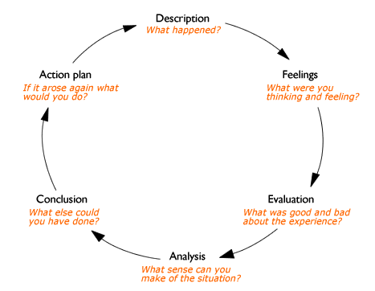
As an example, Gibbs’s Reflective Cycle (1988) is one model of reflective practice that involves returning to an experience to examine it in detail with the intention that the findings will influence future experiences.
Thoughts & Feelings
- Gibbs’s model emphasises reflecting on
the feelings of those involved in the
experience and concludes with a specific
action plan should the situation arise
again.

Reference: Adapted from Gibbs G (1988)
Learning by Doing: A guide to teaching and
learning methods.

The following questions can be used as a guide to identify and reflect on your experience:
Description – Describe what happened during the situation or chosen episode for reflection:
- When and where did this happen?
- Why were you there?
- Who else was there?
What happened?
- What triggers were observed?
- What did you do?
- What did other people do?
- What was the result of the situation?
- What was the impact on health and wellbeing as well as learning
Thoughts & Feelings – What were your thoughts and feelings at the time?
- What did you think or feel before this situation took place?
- What did you think or feel while this situation took place?
- What did you think other people felt during this situation?
- What did you think or feel after this situation?
- What did you think or feel before this situation now?
- What did you think other people feel about this situation now?
Evaluation – What was positive and what was negative about the experience?
- What was positive about the situation?
- What was negative?
- What went well?
- What didn’t go so well?
What did you and other people do to contribute to the situation? (either positively or negatively)
- What evidence do you have that the strategies used were appropriate?
Analysis – What have you learnt from the experience?
- What similarities or differences are there between this experience and other experiences?
- Think about what actually happened. What choices did you make and what effect did they have?
- Who do you need to consult to further develop your skills?
- What is the understanding of the learner’s strengths and challenges? (Learner Profile)
Conclusion – What else could you have done in the circumstances? What things might you not change?
- How could this have been a more positive experience for everyone involved?
- If you were faced with the same situation again, what would you do differently?
- What skills do you need to develop so that you can handle this type of situation better
Action Plan – If it arose again, what might you do differently?
- If a similar situation arose again, what would you do?
- How could you incorporate ew understandings or skills into your current practice?
- Have relevant assessments been completed/considered to inform an effective plan for the future?
Useful resources
- Trauma Informed Practice - https://edugate.eduweb.vic.gov.au/edrms/project/TSPNWVR/Pages/Home.aspx

