  - Transition Learning and Development Statement (TLDS) for government schools

About TLDS
A child’s transition learning and development statement summarises their abilities as they start school and identifies their individual approaches to learning. The information in the transition statement helps Prep teachers get to know the children entering their classes, and to plan appropriate learning and teaching programs.

Logging in

- Insight: https://www.vcaa.vic.edu.au/Pages/insightplatform/login.aspx
- Read the privacy information, click I agree
- Sector: click DET
- Use your eduMail User ID (TO number) and password to log in, if required.

For INsight administrators

Early childhood services create their transition statements in Insight and send them via the platform to the school nominated by parents/guardians. When a statement is sent to your school via Insight, all Insight Administrators at your school will receive an email notification to the effect of:
- A TLDS profile from [student’s name] has been submitted to [school name] for your action.
You can view, print, and link statements sent to your school to the relevant students.
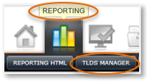
To access transition statements on Insight:
Click Reporting > TLDS Manager.

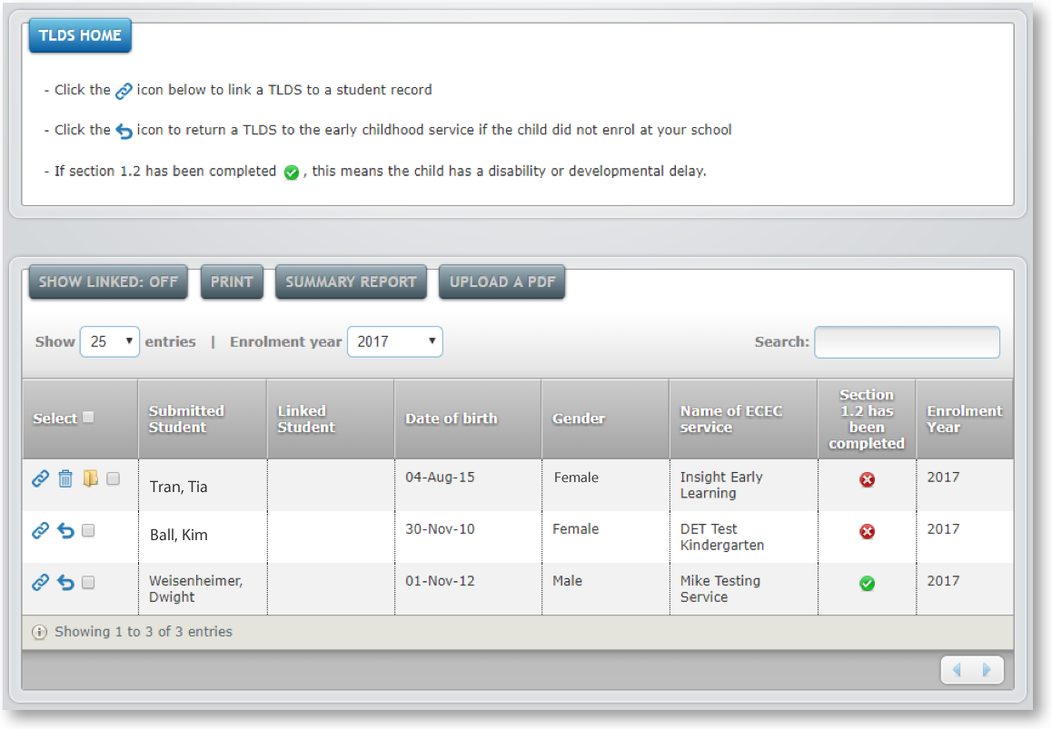
On the TLDS Home page, you will see a summary of statements that have been forwarded to your school from early childhood services.
The TLDS Home view shows statements that your school has not yet linked to a student. To view all statements (linked and unlinked), click Show Linked: Off.
Unlinked statements
Linked statements
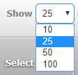
Tip: By default, you will only see 25 entries. If you would like to see more, change the Show Entry filter.

Linking a statement to a student
Insight automatically imports CASES21 data each night and uses this information to attach students to their teacher. Student information is only imported into Insight if the student is enrolled in CASES21 as a current student. Next year’s preps at your school might already be enrolled in your school’s CASES21, but listed as a future student until their enrolment is confirmed. As a result, you may not be able to immediately link a statement to a student, but you can still view, download and print it so you can use it in planning.

To link a statement to a student:
- Go to the TLDS Home student list and locate the student’s statement you want to link from the list.
- Click the statement’s Link with Student icon . A statement can only be linked to a student if they are enrolled at your school via CASES21. If the student is not in CASES21, they will not appear in the list of available students.
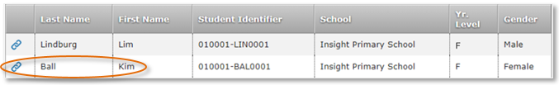
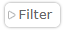
- A list of available students will open. If you would like to narrow down the list of students, click the Filter
button to refine the list. You can also click on the column headings to sort by that column or use the Search function at the top right of the student list.
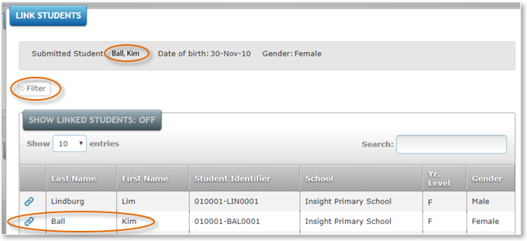
- Select the student you want to link the statement to and click on their Link with Student icon . The student will disappear from this list when linked, unless you have clicked Show Linked Student: Off.
- Click the Close button.
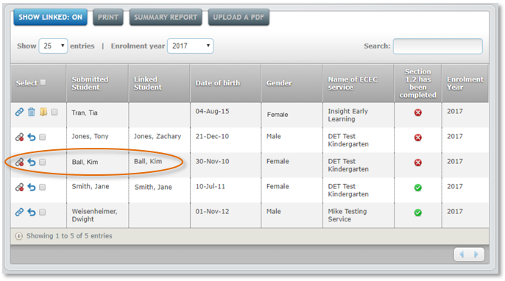
- The statement will now be linked to the student. You will know that it is linked because the Link icon changes to an Unlink TLDS from Student icon .

- If you link the statement to the incorrect student, go to the TLDS Home student list and click the Unlink TLDS from Student icon to unlink the student from the statement. You can then link the statement to correct student.
Tip: Names do not need to match to successfully link a statement. This is because there are instances where a student’s name may vary slightly in records, for example Benjamin and Ben.

Printing statements

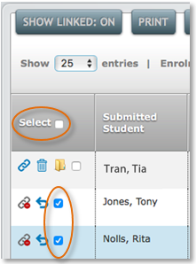
To print one or more statements:
- Go to the TLDS Home student list.
- Select the statement(s) by clicking the checkbox for the relevant student(s) in the Select column, or click Select in the table header to choose all students.
- Click Download PDF.
- Click Create PDF.
- Click Click Here to Download File. If you are printing one statement, it will open in the browser and you can download it or print it. If you are printing more than one statement, a folder/zip file will download onto your computer containing the PDFs.

Creating summary reports
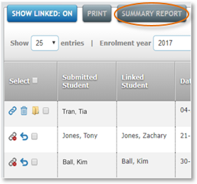
A Summary Report is a PDF document that lists students, their date of birth, gender, EC service, enrolment year and whether Section 1.2 of the transition statement has been completed.

To create a summary report:
- Go to TLDS Home.
- Click Summary Report.
- Click Create PDF.
- Click Click Here to Download File.
- This will download a folder/zip file onto your computer that contains two summary reports; one for linked students and one for unlinked students.
Tip: Section 1.2 provides additional information for Enhanced Transitions for children with a disability or developmental delay.

Uploading a PDF
There are times when you may want to manually upload a statement, for instance, if you have received a copy from the family or early childhood service directly (and not via Insight). To do this:
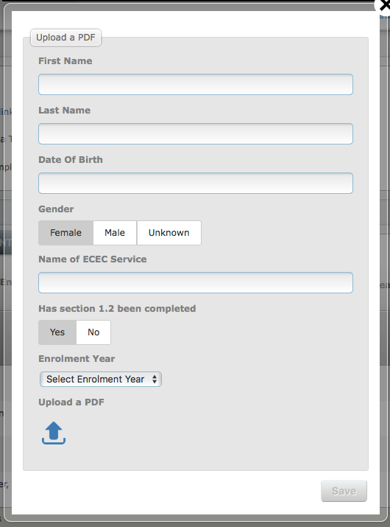
- Go to TLDS Home
- Click Upload a PDF
- Fill out the fields
- Click Upload a PDF > locate and click on the PDF file > Click Choose.
- Click Save.
- Students with manually uploaded statements have two extra icons in the Select column:
- Delete
- View PDF

Tip: Section 1.2 provides additional information for Enhanced Transitions for children with a disability or developmental delay.

Viewing statements in Student History
Once a statement has been linked to a student, both teachers and Administrators can view it in Student History. For steps on how to do this, see the section: Viewing a student’s transition statement, pp. 5–6.

Returning statements
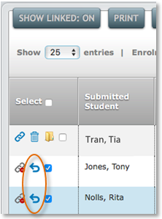
If a statement is sent to your school for a student who has not enrolled at your school, you can return the statement to the early childhood service.

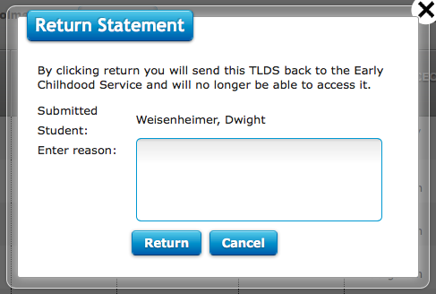
To return a statement:
- Go to the TLDS Home student list and locate the student’s statement.
- Click the Return icon .
- Fill out the Enter Reason field in the Return Statement pop up.
- Click Return.

Notifications
You will be sent an email if:
- your school receives a statement
- an early childhood service has recalled an unlinked statement (linked statements cannot be recalled).

For teachers
Early childhood services create their transition statements in Insight and send them to the schools nominated by parents/guardians. When a statement is sent to your school via Insight, your school’s Insight Administrator receives an email notification to let them know. The Administrator can then link the statement to the appropriate student if the student is listed in Insight. The Administrator can also view, download and print the statements.
For you to see a transition statement, it must be linked to a student and that student must be attached to you in Insight. Insight automatically imports CASES21 data each night and uses this information to attach your students to you. Student information is only imported if the student is enrolled in CASES21 as a current student. Next year’s preps at your school might already be enrolled in your school’s CASES21, but listed as a future student until their enrolment is confirmed. As a result, you may not be able to view the transition statement via your class list, and will need to seek a copy from your administrator instead. You will also only see statements for students who have you listed as their home group teacher in CASES21.

Viewing a student’s transition statement
To view a student’s statement:
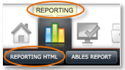
- Click Reporting > Reporting HTML
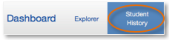
- Click Student History

- Click Student Search to search for the student or click your class name to see its class list and click on a student’s name.
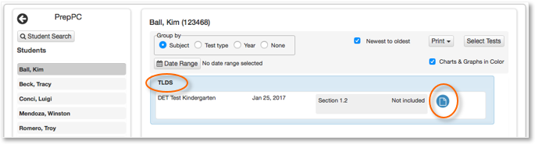
- If the student has a transition statement, a summary box labelled TLDS will appear.
- Click on the Open Report icon to view the transition statement.

Downloading zip files

Depending on the browser you are using, for example Internet Explorer, Chrome, Safari, the transition statements and summary reports may download as folders or zip files. If your computer does not automatically unzip the zip file, you will need to extract it. If you are using a Mac, double-click the zip file. This will extract its files into a normal, unzipped folder in the same location as the zip file. If you are using a PC, right-click the zip file to open the menu, then click Extract > Extract All. This will create a folder in the same location as the zip file (unless you nominate another location).
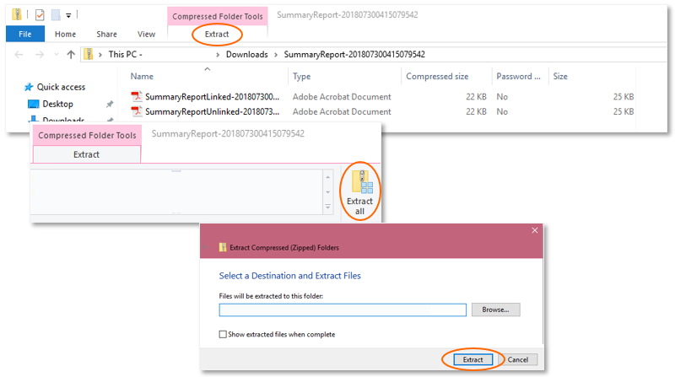

extra information
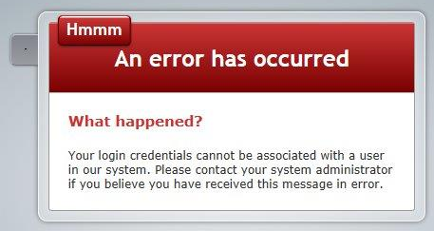
Accessing Insight
Insight uses CASES21 to automatically enable access by school staff. Teachers who are listed as home group teachers in CASES21 will be able to assign assessments to their students and access their reporting and data analytics. Staff who are also Insight School Administrators can assign assessments to all students in their school as well as access their reporting and data analytics. Staff who are listed in their school’s CASES21 data as current staff, but who are not attached to any students, will be able to log in, but will only be able to access minimal functionality. Staff who are not in CASES21 will not be able to access Insight.
If you receive the above message when you attempt to log in when you should be able to, check with your school’s CASES21 manager to confirm your details are up to date and correct in CASES21. CASES21 updates are automatically imported into Insight each night and appear in the system the following morning.

Missing students
If you are an Administrator attempting to link a statement to a student and you cannot see the student in the list, check with your school’s CASES21 manager that the student is enrolled via CASES21 and that their information is up to date and correct. Changes made in CASES21 are automatically imported into Insight each night and appear in the system the following morning.

Missing transition statements
If you are a teacher and did not receive a transition statement for a child enrolled in your class, check with your school’s Insight Administrator to make sure the statement is not still waiting to be linked. If this is not the case, you may also wish to follow up with the child’s family or their EC service to obtain a copy of the statement.

Support

For more information about TLDS, see: http://www.education.vic.gov.au/childhood/professionals/learning/Pages/transitionstat.aspx
If you have an issue you cannot resolve, contact your school’s Insight Administrator. By default, your school’s Administrator is your principal, but they can nominate other people in your school to also have the Administrator role. If the Administrator cannot resolve the issue, contact the Service Desk:
- Service Gateway: https://servicegateway.eduweb.vic.gov.au/MSMSelfService/
- Phone: 1800 641 943
- Email: servicedesk@edumail.vic.gov.au

You can access the Practice Space to familiarise yourself with Insight. For more information, see: https://www.vcaa.vic.edu.au/Pages/insightplatform/practicespace.aspx
For further information about Insight, see: https://www.vcaa.vic.edu.au/Pages/insightplatform/index.aspx

