ISC Learning and Developmental Guide
Capability Indicators

A ‘Learning and Developmental Guide’ has been developed to provide developmental targets for building capability and enhancing performance in this role over time. Workplace behaviours and activities provide objective indicators of the extent to which an International Student Coordinator (ISC) has developed the knowledge and skills that predict a high level of capability. The following ‘Learning and Developmental Guide for ISCs’ identifies three stages of capability development relevant to this role and accordingly identifies areas of knowledge and skills that are beginning to develop, are maturing or that have reached a high level of capability. Participation in professional learning activities can be informed by these developmental stages.

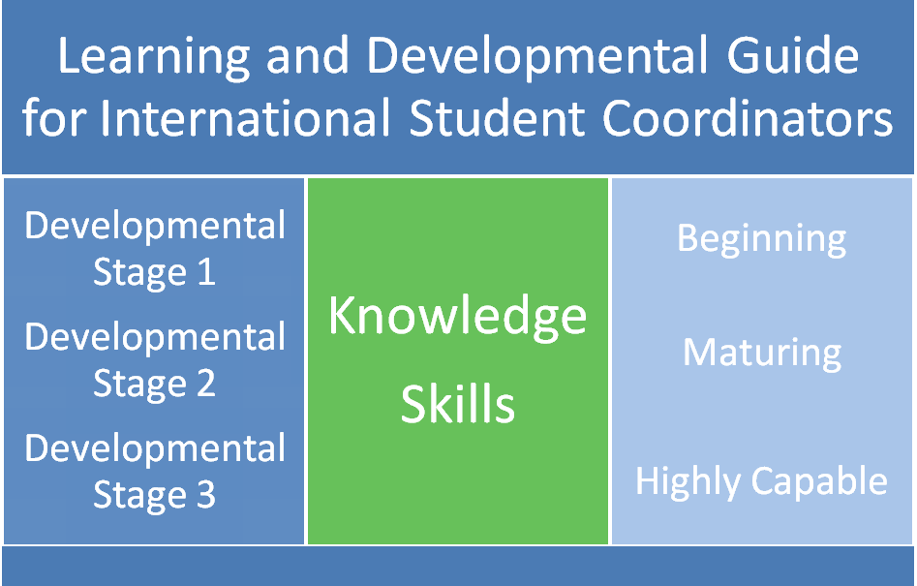
Dispositions
Specialist Knowledge
Behaviours and Activities | Stage 1 | Stage 2 | Stage 3
International Student Program | Initially relies on information being provided by the IED and becomes more self-reliant in accessing and optimising the use of departmental and school resources  Familiarises self with the structure and nature of the Quality Standards and associated resources, on the IED website and by the POSS  Has attained the required level of knowledge to begin administering the International Student Program | Makes requests to the POSS for assistance with complex matters  Utilises professional networks such as the Regional Cluster Networks and the ISC Reference Group to obtain clarification and to grow knowledge  Utilises opportunities in existing school practices to contribute to a greater understanding of the International Student Program  Identifies the pieces of legislation such as the ESOS Act, National Code, and Migration Act that govern the International Student Program and can readily locate information detailing the respective compliance requirements  Possesses the core skill set and knowledge required to effectively administer the International Student Program | Initiates opportunities to share knowledge with colleagues  Proactively provides input into IED initiatives, through Regional Cluster Networks, the ISC Reference Group or directly through the IED  Undertakes mentoring role to new ISC’s in Regional Cluster Networks  Participates on ISC expert panels and reference groups
Cross-Cultural Awareness | Makes contact with school personnel with a view to accessing their knowledge of the current international student population  Reviews relevant documentation and reports and makes contact with students and families who will be new to the school community before they arrive to ascertain particular needs and preferences  Is aware of the need to create a dedicated space/location/office at school for international students | Uses creative strategies to build a greater understanding of cross-cultural issues across the school community  Is aware of the cross-cultural complexities and acclimatisation issues in studying and living overseas.  Develops early intervention strategies to assist students experiencing cultural and acclimatisation issues  Recognises individual international student learning experiences and cultural diversity as applicable to student learning.  Identifies effective student engagement techniques, taking into consideration the particular international student cohort culture, origin and background. | Shares stories of good practice related to the provision of quality education and care for international students at professional learning activities and networks including the ISC Reference Group, Regional Cluster Networks and through ISC mentoring arrangements  Is aware of the cross-cultural complexities involving the international student cohort within the school and applies this awareness in accommodating for individual student needs and raising cultural awareness within the school community  Is aware of cultural diversity in international student learning methodologies and techniques and tailors learning and student engagement methods accordingly.
Adolescent Development | Locates school protocols related to student privacy and confidentiality  Respects privacy and confidentiality requirements, in accordance with school and departmental policy  Draws to the attention of school personnel particular challenges involving international students and adolescent development | Liaises with appropriate school personnel and undertakes research to gain an insight into the key developmental challenges faced by adolescents and the factors that influence the outcomes of these challenges | Guides students to be proactive and independent, in co-operation with relevant school staff  Possesses a strong understanding of cultural variations in the nature of adolescent developmental challenges, and addresses cultural sensitivities in tailoring support for international students
Developmental Standard | Beginning | Maturing | Highly Capable

System Knowledge
Behaviours and Activities | Stage 1 |  | Stage 2 | Stage 3
Victorian Education System | Identifies relevant school personnel and locates DET website links to access information about the structure of the school system, curriculum and reporting frameworks  Becomes increasingly familiar with the curriculum and organising structures of the school, such as curriculum and reporting frameworks, leadership and meeting structures and welfare and career counseling services and develops an understanding of tertiary and career pathways  Identifies opportunities for international student involvement in co-curricular activities, camps, study tutorials and school and departmental activities and celebrations |  | Identifies potential of organising structures to assist with compliance requirements, such as the monitoring of student attendance and progress to satisfy visa conditions  Implements support structures that are customised to meet the needs of international students, such as the formalisation of a homework/tutorial, ‘after school’ study program | Initiates activities to complement and maximize use of existing school structures to support the needs of international students, such as reporting modifications, buddy programs, international student peer to peer mentoring groups and cultural diversity celebrations / activities
Local Community | Locates homestay information, student files, supporting resources and any relevant community resources relevant to the International Student Program |  | Initiates community partnerships with local sporting, recreational, community support and student welfare groups and associations and identifies resources and activities that can be utilised by students in tailored areas of interest | Creates opportunities and engages international students to participate in cultural diversity initiatives within the local community
Developmental Standard | Beginning |  | Maturing | Highly Capable
Compliance Skills
Behaviours and Activities |  | Stage 1 | Stage 2 |  | Stage 3
Adherence to procedures |  | Refers to the Quality Standards and associated resources for direction and adheres to DET’s expectations of schools outlined in the Quality Standards  Becomes fully compliant with the Quality Standards as part of the International Education Division Quality Assurance Framework  Consistently implements and completes homestay checks and takes appropriate follow up action in accordance with the school homestay policy  Has the ability to make difficult decisions, including judgments about non-compliance with procedures and unsuitable homestay arrangements  Responds to POSS requests for information within required timeframe | Uses the Quality Standards and associated resources to develop a detailed understanding of how procedural requirements and policies are applied in practice  Responds to requests for advice from other ISCs  Utilises the Quality Standards and associated resources to cross-check decisions and advice  Develops good practice procedures in ensuring compliance with the Quality Standards as part of the International Education Division Quality Assurance Framework  Responds to POSS requests for information within required timeframe |  | Effectively interprets how procedural requirements are to be applied in highly complex situations  Possesses a detailed knowledge of the Quality Standards and applies this knowledge to cross check decisions and advice  Is recognised as a provider of International Student Program expertise, both in the administration and management of a highly effective program  Responds to POSS requests for information within required timeframe
Developmental Standard |  | Beginning | Maturing |  | Highly Capable

Coordination Skills
Behaviours and Activities | Stage 1 | Stage 2 | Stage 3
Planning, Organising & Monitoring | Uses the Quality Standards, local school resources and attendance at induction activities and IED programs to identify the key stages and respective steps involved in coordinating the International Student Program – application and enrolment, pre-arrival, arrival, school and homestay introduction, orientation and acclimatisation processes, student support and welfare, marketing and finance administration  Uses these support mechanisms to compile, or locate a ‘key contacts’ list for future reference to become familiar with the International Student Program | Develops, implements and shares education initiatives to support homestay providers  Proactively prepares and plans for QAFMR program audits, school development programs and re-accreditation processes.  Shares planning models with other ISCs  Participates in an ongoing cycle of professional learning and reflection | Mentors ISCs  Acts as an adviser and subject matter expert to the IED  Identifies opportunities for enhancing professional learning activities
Process and System development | Establishes the status of existing school processes and makes specific requests to the POSS and other ISCs with a view to fast tracking the development of essential processes to address gaps and compliance with the Quality Standards  Locates existing school planning documents, databases, files and other records relevant to the International Student Program  Establishes the status of a homestay provider register at the school  Establishes the relationship between the school’s International Student Program and English language providers, including transitional arrangements  In accordance with the Quality Standards, ensures plans for coordinating and monitoring the effectiveness of student arrivals, school orientation, homestay orientation and school support in relation to student welfare are developed, documented and accessible, as well as shared with students, their families and other relevant school and community stakeholders  Plans for multiple student intake periods and busy intake periods; and seeking technical support as needed, makes provisions for an international student file management system that respects privacy and confidentiality and notifies school personnel of this record keeping system and accessibility | Develops the ability to balance the standardisation of processes with opportunities to customise them to address specific student, parental, homestay and school needs  Looks for links with broader school systems, processes and practices and negotiates mutually beneficial modifications  Consciously uses systems and processes operating in other schools as benchmarks or areas for program development  Creates opportunities for users of processes to provide feedback about their effectiveness  Identifies professional learning needs and respective activities  Streamlines school processes for coordinating and managing international student matters, such as those related to communication, compliance, organisation, monitoring and evaluation, so they can be applied consistently and distinguished according to the particular need they address and accessed and utilised by other users | Sets benchmarks for other ISCs and schools to use when developing systems and processes  Makes suggestions for optimising the value of auditing processes  Proactively contributes to the sharing of best practice
Negotiation & Problem Solving | Refers to the Quality Standards and associated resources to become familiar with the complaints, appeals and dispute resolution process  Identifies existing school processes  Develops a range of informal and formal school protocols for communicating and managing student, parent, homestay and teacher interests and concerns | Troubleshoots effectively by using strategies such as ascertaining a clear understanding of the school’s expectations and commitment to supporting an International Student Program  Applies knowledge in fast tracking the development of homestay compatibility and capability | Intuitively responds to complex situations, particularly in the management of critical incidents involving international students  Demonstrates extensive knowledge of the International Student Program in approaches to problem solving and effective negotiation with stakeholders  Solutions provide examples of good/best practice to be shared in professional learning
Developmental Standard | Beginning | Maturing | Highly Capable

Interpersonal Skills
Behaviours and Activities | Stage 1 | Stage 2 | Stage 3
Communication | Identifies key stakeholders such as students, families, IED personnel, POSS, homestay providers, agents, the Principal class officer responsible for welfare and teachers  Contacts and introduces self to POSS and other ISCs  Confirms the protocols and availability of resources for utilising the telephone, e-mail, meetings and reports to communicate with stakeholders  Introduces self to students and families and provides contact detail information, reinforcing existing protocols where applicable and listens to students and distinguishes their needs  Initiates and maintains two way communication activities with students, parents, key school personnel, such as year level coordinators, ESL staff, multicultural aids and the student welfare coordinator  Clarifies stakeholder expectations, especially those between students, parents and homestay providers | Accurately draws inferences from observing student behaviour and provides appropriate support and adjusts communication practices accordingly  Consolidates communication practices that effectively manage stakeholder issues  Develops the ability to adjust communication practices to the specific needs of stakeholders | Communicates intuitively and effectively with a broad range of stakeholders  Improves communication practices as part of an ongoing cycle of action and reflection  Communication practices for international students contribute to the improvement of whole school practices  Effectively manages stakeholder expectations in the management of the International Student Program
Relationship Building | Considers the importance of building relationships with multiple stakeholders – students, families, professional colleagues, homestay providers, Departmental staff, agents and local community liaisons  Makes contact with the POSS, ISC Mentor and other IED staff and begins to build productive working relationships  Identifies opportunities for international students to interact with each other  Participates in established networks with other ISCs and departmental staff including Regional Cluster Networks, the ISC Professional Learning Program and the ISC mentoring arrangements  Develops a register of suitable homestay providers and a register of emergency accommodation arrangements comprising of school staff | Builds complementary informal networks with neighbouring schools, and colleagues with similar interests  Establishes a stable network of quality homestay providers  Acts to support and nurture relationship development between stakeholders  Approaches student interactions in a way that personalises and customises support  Consolidates relationships with IED staff  Creates opportunities for students participating in the International Student Program to interact with other international students, such as those participating in student exchange programs | Assists and engages other ISCs and school communities to participate in formal and informal networks  Initiates the sharing of knowledge created by formal and informal networks with the IED  Consolidates relationships with all International Student Program stakeholders and uses these relationships to develop best practice within the school’s International Student Program  Proactively seeks to create and develop new relationships with International Student Program stakeholders
Developmental Standard | Beginning | Maturing | Highly Capable

Influencing Skills
Behaviours and Activities | Stage 1 | Stage 2 | Stage 3
Advocacy | Communicates the expectations of the leadership team regarding responsibilities of individuals and school community related to the International Student Program and the provision of support for international students  Identifies and utilises reporting lines, review processes and feedback mechanisms  Clarifies the school’s vision for the International Student Program  Introduces self to staff and provides administrative updates at staff briefings  Ensures resources and mechanisms are in place to support the performance of the International Student Coordination role | Actively participates in school meetings to build the profile of the International Student Program and to highlight connections to the broader operations of the school  Contributes to leadership team meetings by participating or influencing agenda items  Uses the annual review process to reinforce resourcing and professional learning requirements | Contributes to the school strategic planning process  Makes the link between the performance of the ISC role and the development of leadership capability explicit  Understands and promotes the benefits of an International Student Program in enhancing cultural diversity as part of a broader internationalising education agenda
Marketing | Uses the Quality Standards and associated resources and induction activities to become familiar with marketing requirements, processes and protocols  Introduces self to person responsible for school marketing  Obtains and develops marketing resources for the International Student Program in accordance with IED and DET guidelines  Responds to requests for school involvement in IED marketing activities and projects | Implements creative marketing activities in the local community to further develop a quality homestay register  Involves broader school staff in marketing opportunities  Investigates and accesses IED opportunities to travel overseas  Directly involved in the development and implementation of the school marketing strategy  Consolidates and continues to develop productive working relationships with the IED marketing team | Works collaboratively with the IED to maximise school and divisional marketing opportunities.  Identifies good practice and innovation in school marketing activities and shares marketing developments with the IED
Developmental Standard | Beginning | Maturing | Highly Capable

