Procurement tips for high-demand items
The coronavirus (COVID-19) pandemic is challenging global supply chains and is in some cases limiting the supply of personal hygiene items and personal protective equipment (PPE).

Leverage existing supplier relationships
- Contact your suppliers frequently to ensure they understand your needs.
- Order in advance of what you normally would – some of the high-demand stock might not be available for several weeks from the order date.
- Use generic descriptions of items when searching online catalogues. Brand names or colours in your search criteria will limit the results.
- Consider purchasing substitute brands where usual choices may not be available.
- Consider purchasing substitute products where items may be limited, for example soap instead of hand sanitizer.

Use the state purchase contract
The Victorian Government has a State Purchase Contract with COS.
COS regularly updates the supply status of high demand products.
Other entities can access COS via the website and click “Register” to access retail pricing.

Retail Purchasing
Check local retailers such as supermarkets, home supply stores and pharmacies. They may have stock available.

Woolworths priority assistance
Schools and other educational providers complete and submit the: Priority Assistance Request Form
Orders placed via Priority Assistance are to be made six to seven days in advance.
Time on arrival of supplies will vary.

Coles online priority service
Schools and other educational providers can apply for Coles online priority service (COPS) through emailing the Coles Online for Business Team at COPSrequests@coles.com.au. Include the details of the email address used to log into Coles Online and the reason you are requesting access is that you are an educational provider in the email.
Coles endeavours to provide access to COPS within 2 business days.
Quantity restrictions that apply to customers in store also apply to online orders. A list of purchase limits currently in place is available at www.coles.com.au/customernotice#product-availability

Cleaning provider support
Cleaning providers are aware of the situation and are endeavoring to assist by supplying product when available. For more information or assistance, contact: cleaning@edumail.vic.gov.au

Identifying alternative Suppliers
To assist your school in sourcing the supplies it needs, the Victorian Government has developed a series of directories to help identify suitable suppliers of locally manufactured products.
The directories cover products which have been more difficult to source during the coronavirus (COVID-19) pandemic (including face mask manufacturers) due to increases in demand for medical equipment and PPE.

PErsonal Protective equipment (Ppe)
School leaders must ensure that all staff who may need to use PPE have been provided with the appropriate information and training
PPE should be used in line Guidance for the use of Personal Protective Equipment in education settings, with staff trained to understand when and how to use PPE appropriately. The guidance outlines when additional PPE is required and includes information on the correct and safe use of PPE, including an instructional video demonstration.
All Department staff working on site at Victorian government schools must have completed the eLearn module School infection prevention and control during coronavirus (COVID-19). Non-Department staff, including casual relief teachers and pre-service teachers, should complete the parallel module available on FUSE. The module provides COVID-19 infection control training, including practical strategies and information about the precautions that can be taken to reduce the risk of COVID-19 transmission in schools.

COS – PPE Purchase items
Schools can purchase the following items using their COS code through the COS platform:
- SAFE2103 Surgical Level 1 Disposable Face Mask - Box50
- SAFE1389 Anti-Fog Goggles W/Strap Clear Lens – Each
- SAFE1151 Gown Disposable Blue – Each
- GLOV1864 Latex Powdered Glove Small - Box100
- GLOV1895 Latex Powder Free Glove Small - Box100
- GLOV1896 Latex Powder Free Glove Medium - Box100
- GLOV1897 Latex Powder Free Glove Large - Box100
- SAFE4053 KN95 Disposable Masks - Box50
- SAFE4054 Softmed N95 Disposable Masks - Box10
- SOAP0086 Hand Sanitiser with Alcohol 375ml - Each
- SOAP0106 Power Fresh Alcohol Hand Sanitiser 1L - Each
- SOAP0109 Power Fresh Gel Hand 75% Sanitiser 5L – Each

For assistance to identify additional suppliers, email: schools.procurement@education.vic.gov.au,

COSnet Search TIPS

You can search for products on COSnet www.cos.net.au in 2 main ways:
- Major Category blue ribbon across top of screen - click on a Major Category (or hover your mouse over and select a sub-category) to display all sub-categories
- Search Products field at top of screen - type keyword(s) or product code
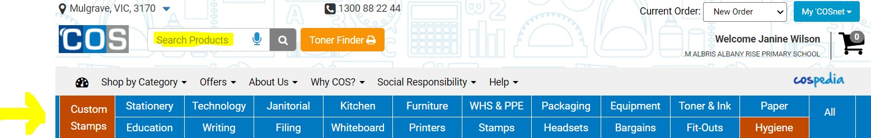

MAJOR CATEGORY

Click on any of the Major Categories (e.g Janitorial) and you will be presented with the list of minor- categories.
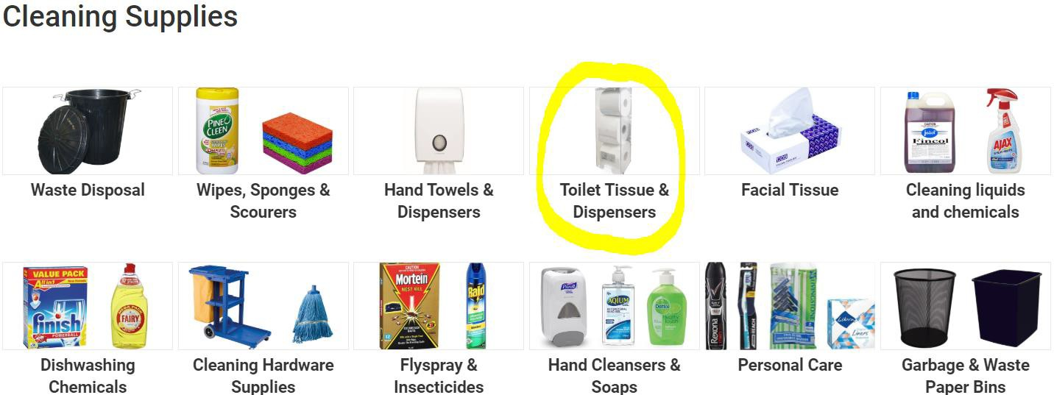

Sub-Category
Click on any of the minor-categories (e.g Toilet Tissue & Dispensers) to display all the applicable products.

You can filter this list to specific product types by clicking Filter Search on the left-hand side.
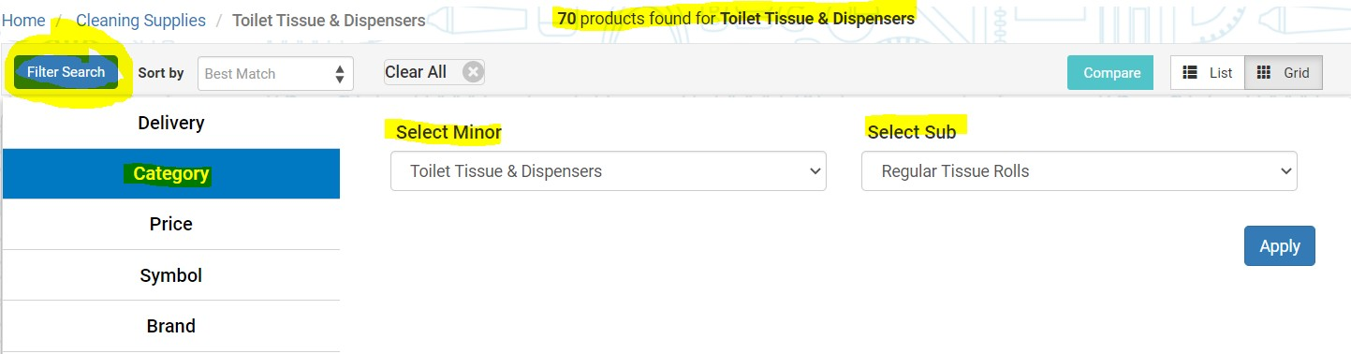

Filter to specific product type

After clicking Filter Search select type of filter (e.g Category) on left-hand side, then select Minor (e.g Toilet Tissue & Dispensers) and Sub (e.g Regular Toilet Rolls) categories from dropdown menus to filter your search results further.
Your results filter down from 70 to 23 .. now displaying only Regular Tissue Rolls
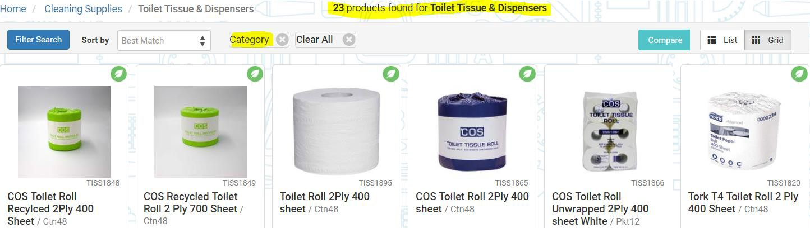

NOTES:
- Individual search results may vary daily as products come in and out of stock
- Some high-demand products may be Temporarily Unavailable as we wait for stock to arrive from our suppliers … please keep checking back on a regular basis

SEARCH PRODUCTS

Search Products field at top of screen can be used to search by keyword(s) or product code. Once your initial search results are presented, you can further refine the lists by using the Filter Search button on the left-hand-side as discussed above.

Handy links to major high-demand product types

After logging into COSnet you can click on the below shortcut links to search for products that are currently in high-demand
Hand Sanitisers – all

Hand Sanitisers – available for immediate delivery

Toilet Paper & Dispensers – all

Toilet Paper & Dispensers – available for immediate delivery

Toilet Paper – Interleaved – all

Toilet Paper – Interleaved - available for immediate delivery

Toilet Paper – Jumbo Roll - all

Toilet Paper – Jumbo Roll - available for immediate delivery

Hand Towels & Dispensers – all

Hand Towels & Dispensers – available for immediate delivery

Facial Tissue – all

Facial Tissue – available for immediate delivery

Liquid Hand Soap – all

Liquid Hand Soap – available for immediate delivery

Multipurpose Cleaning Spray/Product – all

Multipurpose Cleaning Spray/Product – available for immediate delivery

Wipes, Sponges & Scourers – all

Wipes, Sponges & Scourers – available for immediate delivery

Air Freshener (including antibacterial) – all

Air Freshener (including antibacterial) – available for immediate delivery

Gloves – all

Gloves – available for immediate delivery

Thermometers – all

Thermometers – available for immediate delivery

Masks – all

Masks – available for immediate delivery

NOTES:
- Individual search results may vary daily as products come in and out of stock
- Some high-demand products may be Temporarily Unavailable as we wait for stock to arrive from our suppliers
… please keep checking back on a regular basis

FORWARD ORDERS

To assist you and COS in the forward planning of supplies we recommend that you place orders with a future date set for delivery. This can be specified during the Checkout process as below:
Click on the Shopping Cart icon and View or Checkout your order
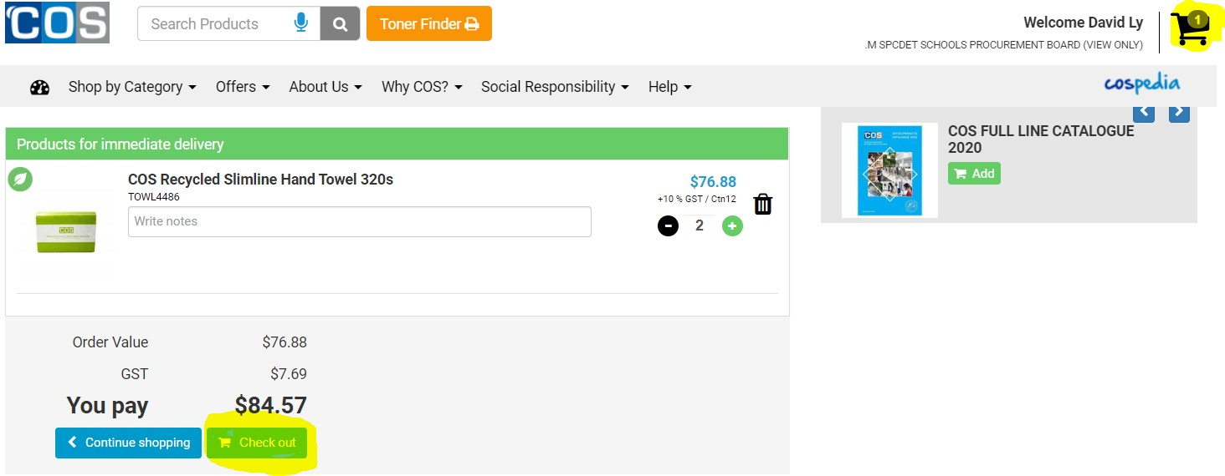

Specify delivery address, delivery instructions and click the NEXT > button

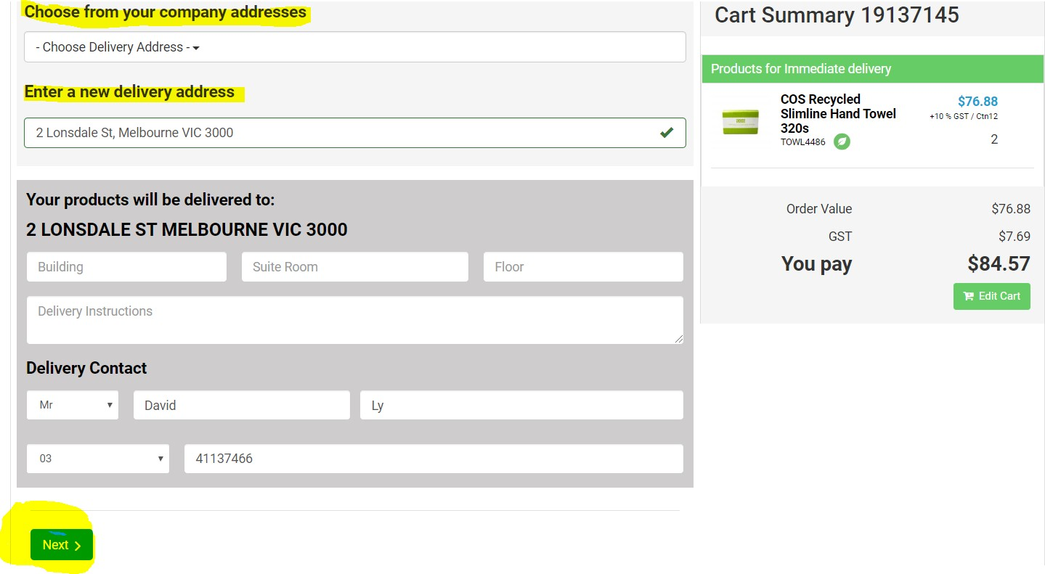

Click “Choose your own date” and pick a future date from the drop-down calendar, then click “Pay securely now >”
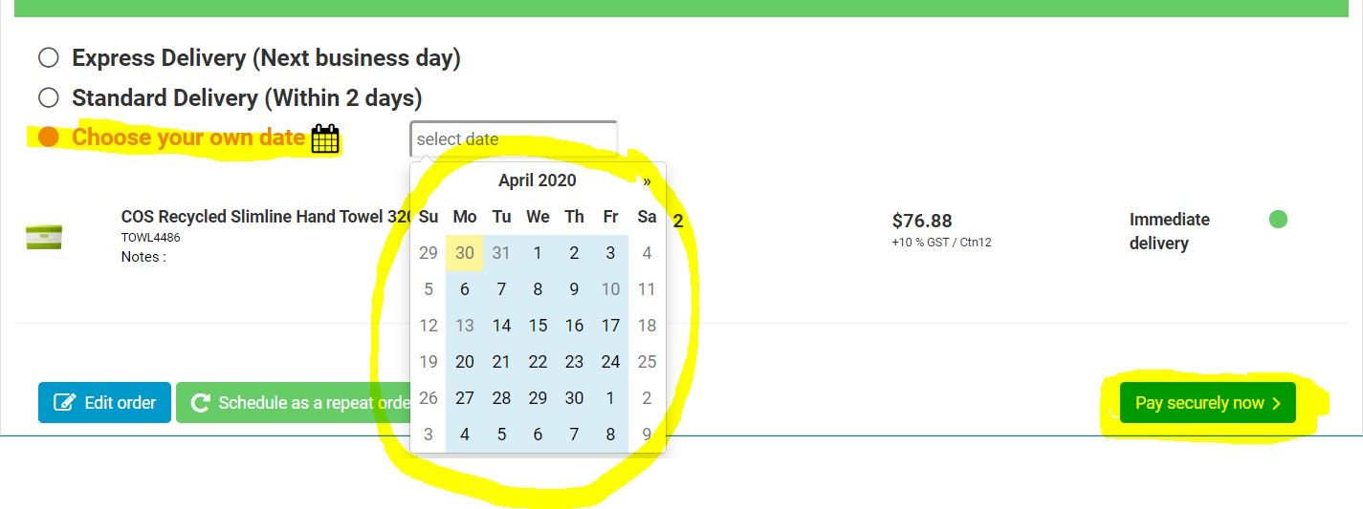

NOTE: We will endeavour to deliver your order on the selected date, depending on stock availability

Populate the mandatory “Order reference” field with your Purchase Number.
NOTE: This MUST be 10 alpha/numeric characters (no spaces). Use zeros to pad your PO number so it is 10 characters e.g 0000PO4567
Click the “Charge Account” button and your order will be processed.

For assistance please contact
COS Account Manager
Paul Loxley
0407 076 543 or paull@cos.net.au

