EQUIPMENT BOOST FOR SCHOOLS

PROFESSIONAL PRACTICE GUIDE:

PORTABLE SOUNDFIELD SYSTEMS

Contents
EQUIPMENT BOOST FOR SCHOOLS 1
PORTABLE SOUNDFIELD SYSTEMS 1
INCLUSIVE EDUCATION POLICY AND PRACTICE 4
EQUIPMENT BOOST FOR SCHOOLS 4
INCLUSIVE EQUIPMENT AND ASSISTIVE TECHNOLOGY 5
PROFESSIONAL PRACTICE GUIDES 6
INTRODUCTION 7
WHAT IS A SOUNDFIELD SYSTEM? 7
WHAT IS A REMOTE MICROPHONE? 7
BACKGROUND INFORMATION 7
CLASSROOM ACOUSTICS AND NOISE LEVELS 7
WHO BENEFITS FROM SOUNDFIELD SYSTEMS? 8
Students who are deaf or hard of hearing 9
Students who have been fitted with a personal wireless communication device 10
Benefits for teachers 10
Benefits for schools 10
COMPONENTS AND FEATURES OF A SOUNDFIELD SYSTEM 11
RECEIVER / AMPLIFIER / LOUDSPEAKER UNIT 11
TEACHER TRANSMITTER 11
STUDENT MICROPHONE 12
TRANSMISSION TYPE 12
Digitally Enhanced Cordless Telecommunications 13
Infra-red 13
Digital adaptive wireless technology (RogerTM) 13
VOLUME SETTING 14
REMOTE MICROPHONES 14
Teacher transmitter 14
Student transmitter 15
Table microphone 15
FACTORS TO CONSIDER IN SELECTING A SOUNDFIELD SYSTEM OR REMOTE MICROPHONE 16
COMPATIBILITY WITH PERSONAL WIRELESS COMMUNICATION DEVICE EQUIPMENT USED BY STUDENTS 16
ROOM SIZE AND TRANSMISSION TYPE 17
ROOM LAYOUT 17
COMPATIBILITY WITH EXISTING SOUNDFIELD SYSTEMS AND OTHER CLASSROOM TECHNOLOGY 17
NUMBER OF MICROPHONES OR TRANSMITTERS 18
POSITION OF LOUDSPEAKERS 18
TEACHER AND STUDENT COMMITMENT 19
DAILY MANAGEMENT 19
COST 19
RECOMMENDED PROCESS FOR SCHOOLS 20
IDENTIFY INCLUSION NEEDS 20
CHOOSE EQUIPMENT 21
INTRODUCE THE EQUIPMENT 21
EVALUATE THE EQUIPMENT 22
GLOSSARY OF TERMS 23
ABBREVIATIONS 24
REFERENCES 25
APPENDIX A 28
Share diagram (Text Alternative) 28
APPENDIX B: RECOMMENDED ACOUSTIC CONDITIONS FOR PRIMARY CLASSROOMS (MEALINGS, 2016). 29
APPENDIX C: SUMMARIES OF SELECTED RESEARCH 30
Mealings et al (2015b) 30
Anderson and Goldstein (2004) 30
Zanin and Rance (2016) 30
Massie and Dillon (2006a) 31
APPENDIX D: TRANSMISSION TYPES 32
APPENDIX E: CLASSROOM ACOUSTICS EVALUATION TOOL 34
APPENDIX F: TEACHER EVALUATION TOOL 35
APPENDIX G: STUDENT EVALUATION TOOL 37

INCLUSIVE EDUCATION POLICY AND PRACTICE
Inclusive education means that all members of every school community are valued and supported to participate, learn, develop and succeed within an inclusive school culture. This includes making reasonable adjustments for students with disabilities and additional learning needs.
Data shows that Victorian schools make adjustments for 19% of students because of a disability or an additional learning need. This equates to approximately 115,000 students in Victorian government schools, which suggests that every government school may receive benefit from equipment and assistive technology that supports their capacity to deliver inclusive education.

EQUIPMENT BOOST FOR SCHOOLS
The Equipment Boost for Schools initiative responds to calls to strengthen inclusive education practice to provide better supports for students with disabilities and additional needs by providing all Victorian government schools with:
- access to funding to purchase new equipment and assistive technology to support students with disabilities or additional learning needs to participate, experience, learn and achieve on the same basis as their peers
- support to identify their needs and utilise equipment and assistive technology to implement effective, evidence-based interventions (including through the provision of training).
The Equipment Boost for Schools funding model aligns with the SHARE Principles of Inclusive Education (Figure 1). The model provides schools with flexibility to collaborate with students, parents, carers, teachers and support staff to tailor equipment and technology needs to the unique requirements of their school and students in line within these principles.

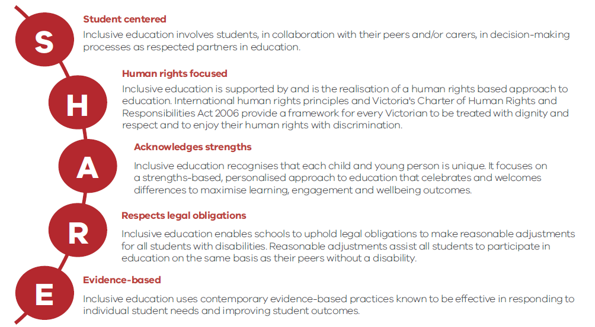

Figure 1. SHARE Principles of Inclusive Education (developed based on feedback captured in 2017 during public consultations on the Department’s Education for All inclusive education policy)
Appendix A includes an accessible text-alternative version of this image.

INCLUSIVE EQUIPMENT AND ASSISTIVE TECHNOLOGY
Inclusive equipment and assistive technology includes any item that supports students, including those with disabilities or additional learning needs, to participate, learn, develop and succeed in school and school-related activities. Examples of equipment and assistive technology include:
- customised or adjustable furniture
- mobility equipment and resources
- ability switches and switch-adapted toys
- portable amplification equipment
- literacy aids
- communication software
- inclusive recreation equipment and resources.

Equipment and assistive technology support inclusive education practice by:
- removing barriers to accessing curriculum content
- supporting students to participate fully in learning activities
- supporting students to demonstrate their knowledge and strengths
- enabling all students, including those with disabilities or additional learning needs, to participate and learn together in the learning environment.

Equipment and assistive technology can be used in schools to support students at a functional level (to access curriculum content), a participatory level (to interact and engage with other students and teaching practices) or a pedagogical level (to grow as self-directed learners). To determine the appropriate equipment or technology to support inclusive education, schools should consider factors such as:
- the student(s) who will benefit most from the use of equipment
- the outcomes expected from equipment use and whether these outcomes align with the school’s priorities and goals
- the practicality of using, maintaining and storing the equipment
- any training required to use the equipment appropriately and effectively
- how the school will evaluate the effectiveness of purchased items.

Adjustments, interventions and other supports should be personalised and individualised to address the strengths and learning needs of individual students. They should reflect collaboration between students, families, teachers, education support staff, school leaders and suitably qualified professionals (for example, allied health professionals) to support students' needs.

PROFESSIONAL PRACTICE GUIDES
The purpose of Professional Practice Guides, including this document, is to guide schools’ decision-making in relation to identifying, purchasing and implementing inclusive equipment and assistive technology.
The purpose of this Professional Practice Guide is to provide specific guidance to schools that are considering a Soundfield system or remote microphone to enhance their inclusive education practices, as well as any Visiting Teacher or other Health and Wellbeing Inclusion staff who may be assisting schools to implement this equipment.
Please note that:
- equipment specifications given in this document were provided by the relevant manufacturers/suppliers, and have not been tested by the Department of Education and Training (the Department) or Hearing Australia
- this guide provides general information only; the Department and Hearing Australia do not endorse one system or brand over another, and recommend that schools select the equipment that best meets the needs of their students and circumstances.

INTRODUCTION

WHAT IS A SOUNDFIELD SYSTEM?
A Soundfield system is a mini public address system that can be used in classrooms to benefit all students, including students who are deaf or hard of hearing. Soundfield systems support students to hear what their teachers and peers are saying, regardless of the noise levels in the classroom or where they are sitting.
A Soundfield system typically consists of a microphone and loudspeaker, which deliver the teacher’s voice at a consistent level across the entire classroom or learning space, and may include additional microphones for students.
Please note that ‘Soundfield system’ is used throughout this document because it is the most commonly used term for this type of equipment in Victoria. This type of equipment is sometimes referred to as portable amplification equipment or classroom audio distribution systems (CADS).

WHAT IS A REMOTE MICROPHONE?
A remote microphone is a microphone that delivers a teacher’s (or student’s) voice directly to the hearing aid or cochlear implant of a student who is deaf or hard of hearing. By using a remote microphone, a student who is deaf or hard of hearing can hear the teacher’s voice even in conditions that are not well suited to hearing aids or cochlear implants (for example, over greater distances and/or in background noise).

BACKGROUND INFORMATION

CLASSROOM ACOUSTICS AND NOISE LEVELS
Classrooms can be noisy, creating a challenging listening and learning environment for students. The level of noise in a classroom will vary during the day, with higher levels of noise occurring during interactive learning activities, or when there is noise from adjacent classrooms or from other classes in an open-plan setting. Additionally, classrooms with hard floors and wall surfaces will have longer reverberation times than rooms with carpet and acoustic panels, because sound bounces off the hard surfaces rather than being absorbed by the soft surfaces. Appendix B includes more details about the recommended acoustic conditions for classrooms.
The noise levels in a classroom can be measured to objectively determine the acoustic conditions of a classroom. As adults, we cannot rely on our subjective evaluation of the acoustic conditions in a classroom; research shows that children up to the age of 15 years are more affected by noise than adults, and that younger children require a greater signal-to-noise ratio than older children. Students who are deaf or hard of hearing, or have a language impairment, require a greater signal-to-noise ratio than students with normal hearing.
In typical classroom conditions, schools should reduce the noise levels as much as possible before introducing a Soundfield system. This can be done by:
- modifying sources of direct noise (for example, from air-conditioners, heaters and other sound sources in the room)
- closing doors and windows to reduce sounds coming from outside the room
- using acoustic treatments to reduce the reverberant noise generated by hard surfaces in the room. Carpet with foam underlay, acoustic tiles on the walls or ceiling and absorptive panels provide the largest reductions in reverberant noise. Examples of lower-cost options to reduce classroom noise levels include self-adhesive acoustic tiles, hanging displays and non-slip drawer lining on tables for group activities.
Even in a classroom with good acoustics, a Soundfield system can provide benefits by distributing the teacher’s voice at a consistent level across the classroom. The signal-to-noise ratio will vary depending on how far the student is sitting from the teacher. Research has found significantly poorer speech perception for students sitting at the back of a classroom than those sitting at the front.
Soundfield systems may also be effective in reverberant classrooms. However, schools should be cautious when using a Soundfield system in a highly reverberant classroom (i.e. with a reverberation time greater than one second) because the speech may need to be amplified to a level at which it becomes distorted. Noise above normal conversational level (above 65dBA) may disadvantage some students,. It should not be obvious that the teacher’s voice is being amplified through the Soundfield system loudspeaker.

WHO BENEFITS FROM SOUNDFIELD SYSTEMS?
Research has shown that all students can benefit from the use of a Soundfield system in the classroom, not just those who are deaf or hard of hearing. This includes students with normal hearing as well as students with fluctuating conductive hearing loss, auditory processing disorder, learning difficulties, developmental disabilities, attention disorders, and students who speak English as an additional language (EAL),,. The use of Soundfield systems has been associated with improvements in academic achievement, speech recognition, attention, class participation, and learning behaviours.
Soundfield systems also have the capacity to distribute students’ voices consistently throughout the room through the use of student microphones. Teachers have reported that students benefit from using a microphone during presentations to the class, and students have provided positive feedback about microphones,. Students who are deaf or hard of hearing can also receive the signal from the microphone if their personal wireless communication devices (PWCDs) are being used in conjunction with a Soundfield system.

Students who are deaf or hard of hearing
Students who are deaf or hard of hearing will have been fitted with funded primary amplification devices (including air conduction and bone conduction hearing aids, implantable bone conduction devices and cochlear implants) and PWCDs.
Hearing aids and cochlear implants have a microphone that picks up all sounds, background noise as well as speech, which are then processed and delivered to the ear. However, the greatest improvement in the signal-to-noise ratio is achieved when a hearing aid or cochlear implant is used in conjunction with a PWCD. A PWCD provides the best signal-to-noise ratio because the signal is delivered directly to the student’s hearing aids, preventing any degradation of speech from a distance or due to reverberation or noise. Without using a PWCD, it is more difficult for the student to hear the teacher’s voice.
Students who are deaf or hard of hearing require other supports to access the curriculum in addition to amplification devices. Optimally fitted hearing aids may not be able to provide the student with access to all speech sounds. These students will benefit from the use of contextual information, and visual cues such as lip-reading and captioning of videos, to supplement the auditory information. In addition, many students who are deaf or hard of hearing will have a language delay compared to their peers when they start school.
Classroom noise, rapid changes of topic, and large numbers of people engaged in conversation all present barriers for students who are deaf or hard of hearing to participate in teacher–student and student–student communication. Some PWCDs can be used with a student microphone so that students who are deaf or hard of hearing can hear their classmates’ contributions to class discussions in addition to hearing the teacher. However, because of the fragmentation of auditory signals, visual cues remain important for students who are deaf or hard of hearing, even in good listening conditions. Other adjustments that can benefit these students include being in the front third of classroom and near the side so they can see other students as well as the teacher, facing the student, calling the student by name, confirming the student’s understanding, buddying with another student and alternating activities that require critical listening.

Students who have been fitted with a personal wireless communication device
Some students who have difficulty listening in noise may have been fitted with a PWCD (also called a personal frequency-modulated (FM) system). This can include students who have normal hearing or have an auditory processing disorder, as well as those who are deaf or hard of hearing. A PWCD can be used in conjunction with hearing aids or cochlear implant for students who are deaf or hard of hearing, or can be a personal ear-level wireless receiver for students with normal hearing or a unilateral hearing loss (fitted to the ear with normal hearing).

Benefits for teachers
Classroom noise can also have an adverse effect on teachers. Research has found that teachers can spend half their time in the classroom speaking at a volume up to 20db above normal conversational level, which can lead to vocal fatigue and poor voice quality and clarity. A Soundfield system reduces the need for teachers to project their voice across the room, increases the ease of speaking and minimises vocal strain and fatigue. Teachers have also reported that they needed less time to direct and maintain the students’ attention, and spent less time on organising the class and transitioning between class activities, thereby increasing productivity.

Benefits for schools
Victorian government schools have reported a range of additional benefits associated with Soundfield systems, although it should be noted that these benefits have not yet been formally validated in the academic literature. These benefits include:
- a reduction in sick leave taken by teachers when a Soundfield system is used in the classroom due to a reduced incidence of vocal fatigue
- more effective staff meetings when a Soundfield system is used to support staff participation (especially in large schools)
- more inclusive school events when a Soundfield system is used to support families and community members who are deaf or hard of hearing.

COMPONENTS AND FEATURES OF A SOUNDFIELD SYSTEM

The main components of a portable Soundfield system are:
- a receiver/amplifier/loudspeaker unit
- a teacher transmitter
- a student microphone.
These components work as a system by sending and receiving wireless signals.

RECEIVER / AMPLIFIER / LOUDSPEAKER UNIT
In a portable Soundfield system, the receiver, amplifier and loudspeaker are combined into a single unit. This unit is generally positioned in the classroom according to supplier recommendations, but can be moved around if needed.
The receiver picks up the speech from the teacher transmitter and student microphones, the amplifier increases the volume of speech and the loudspeaker distributes the speech evenly across the classroom. The amplifier can be adjusted to ensure that the volume is appropriate for the room.
If the Soundfield system includes multiple microphones (for example, a teacher microphone and student microphone), the volume of each microphone can be adjusted independently. Depending on the Soundfield system, the volume of each microphone is adjusted either on the amplifier or on the individual microphones.
Portable Soundfield systems are supplied with one or two loudspeakers that can be free standing or wall mounted. If used as a free-standing device, the loudspeaker should be at chest height and either attached to a stand or placed on a shelf (depending on the system). In some cases, additional speakers can be added.

TEACHER TRANSMITTER
The teacher transmitter is a device worn on a lanyard around the teacher’s neck that picks up the voice and transmits it to the receiver unit. The transmitter has a built-in microphone, which should be positioned approximately 20cm from the mouth by adjusting the lanyard to ensure a consistent signal. The transmitter has a directional microphone which picks up the teacher’s voice and minimises background noise. Care should also be taken that jewellery and clothing near the transmitter do not create unwanted noise. Figure 2 shows a visual representation of a directional microphone for a teacher wearing a transmitter.
Figure 2: A visual representation of a directional microphone for a teacher wearing a transmitter. The blue shaded area shows the direction the microphone will be picking up sound.
Soundfield systems can be linked to multiple teacher transmitters for team teaching situations. With some Soundfield systems, it is possible to prioritise a teacher transmitter over other microphones linked to the system. This will mean that the Soundfield system is not transmitting more than one voice at any given time.

STUDENT MICROPHONE
A student microphone is a hand-held device that can be passed around between students in the classroom. It picks up a student’s voice and transmits this to the receiver unit. These microphones should be held 5–10 cm from a student’s mouth to ensure consistent voice transmission.
A Soundfield system should include at least one student microphone, for example, for use during student presentations and whole-class discussions. This ensures that all students will be able to hear student presentations and answers, even if the student speaking has a quiet voice. Some Soundfield systems allow more than one student microphone to be linked to the system at the same time, although in some cases the Soundfield system will only transmit the signal from one student microphone at any given time.
The number of student microphones per classroom will depend on needs and preferences. For example, extra student microphones can be added to the system to reduce the time required to pass the microphone around the class. In this scenario, it is recommended that schools introduce a system to monitor and manage the use of microphones, for example, by nominating students to be microphone monitors.

TRANSMISSION TYPE
Different manufacturers use different transmission types for their Soundfield systems. Three types of transmission are used to link the transmitter/microphone with the receiver unit. The quality of the signal is not determined by the type of transmission, but there are benefits and limitations associated with each that need to be taken into account. For example, the transmission type can affect the Soundfield system’s operating range. This is the maximum distance between the receiver unit and the teacher transmitter or student microphone that allows the speech signal to be successfully transmitted to the loudspeaker.

Digitally Enhanced Cordless Telecommunications
Digitally Enhanced Cordless Telecommunications (DECT) uses radio waves to transmit and receive a signal. Radio waves can pass through walls or partitions, so a radio frequency system is suited to irregularly-shaped rooms. However, the signal can be affected by electrical interference from computers and steel beams in classrooms, which can cause ‘dead spots’. DECT does not rely on line of sight, so there is no signal drop-out. DECT will continue transmission even if the teacher moves outside the classroom, so teachers need to remember to mute the transmitter when leaving the classroom. DECT technology allows the system to automatically change radio frequency to maintain interference-free transmission. The operating range for this type of transmission is forty metres between the transmitter/ microphone and the receiver unit.

Infra-red
Infra-red (IR) technology uses light waves to transmit and receive a signal. It relies on line of sight between the transmitter and receiver for transmission, so the signal is contained within the classroom (unless doors across corridors are open, or if windows allow line-of-sight transmission of the signal). In most cases, as soon as the teacher leaves the room, transmission of the signal stops. Transmission is automatically restored when the teacher re-enters the classroom. IR light cannot penetrate solid walls, so there is no interference from adjacent classrooms.
Bright sunlight, fluorescent light and other IR light sources may interfere with transmission. The IR loudspeaker unit should not be placed outside, in direct sunlight or near a window. A sensor can receive the IR signal directly via line of sight, but also through a different path when the light waves are reflected from the walls, the floor or the ceiling. Multiple emitters may be required in an irregularly shaped room. The operating range for this type of transmission is twenty metres between the transmitter/microphone and the receiver unit/emitter.

Digital adaptive wireless technology (RogerTM)
RogerTM technology uses packaged digitised audio signals to transmit and receive a signal. This technology allows the system to automatically change frequency to avoid channel interference, and for dynamic maintenance of desirable signal-to-noise ratios. A receiver can receive the digital audio signal directly via line of sight, but also through a different path when the signal is reflected from the walls, the floor or the ceiling. This technology uses an automatic noise suppression algorithm in high-noise surroundings to maintain a favourable signal-to-noise ratio even when the noise level in the classroom varies. The operating range for this type of transmission is twenty metres between the transmitter/microphone and the receiver unit.

VOLUME SETTING
The Soundfield system loudspeaker distributes the teacher’s voice evenly throughout the classroom. The speaker should provide enough volume to ensure that all students hear the teacher’s voice at the same volume as the student sitting immediately in front of the teacher. When set up properly, the teacher’s voice should be at a normal, natural level and the teacher and students should be only mildly aware that the system is operating. It should not be obvious that the teacher’s voice is being amplified.
For the teacher’s voice to sound natural, the speaker must have a uniform response throughout the entire range of speech frequencies. In other words, the speaker must not exaggerate or diminish any speech sounds.

REMOTE MICROPHONES
Remote microphones are recommended for students who are deaf or hard of hearing when the class is doing group work, rather than whole-class activities, for which Soundfield systems may be more appropriate. In this situation, students who are deaf or hard of hearing can use a remote microphone placed in the centre of the table to hear the other students in their group. Students should be in close proximity to the microphone for their voice to be picked up.
There is limited research on the use of table microphones in the classroom. However, as these devices deliver speech directly to a student’s hearing aid or cochlear implant, the benefit is likely to be similar to when the teacher is wearing the transmitter, as long as everyone in the group is within range of the microphone for their voice to be picked up. Several kinds of remote microphones may be suitable, depending on the particular equipment being used.

Teacher transmitter
Some Soundfield systems have a teacher transmitter that can be worn around the neck on a lanyard for whole-class teaching or placed on a table for small group work. Some transmitters will automatically mute the Soundfield loudspeaker and put the transmitter microphone in omni-directional mode when placed on a table, in order to pick up the voices of students around the table. Figure 3 shows a visual representation of the omni-directional microphone for a teacher transmitter placed on a table for group work. Students in the group should remain in close proximity to the transmitter so their voices will be picked up by the microphone.
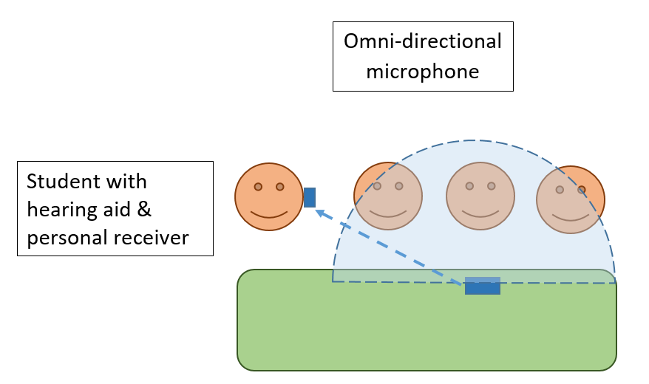
Figure 3. A visual representation of the omni-directional microphone for a teacher transmitter placed on a table for small group work. The blue shaded area shows the direction the microphone will be picking up sound.

Student transmitter
Students who are deaf or hard of hearing may have a personal transmitter/remote microphone that can also be used as a table microphone. Some devices automatically go into omni-directional mode when placed on the table. Other devices have a directional microphone that automatically directs the focus of the microphone to the student who is talking, or can be manually adjusted (Figure 4 shows a visual representation of the directional microphone for a remote microphone placed on a table for small-group work). Students in the group should remain in close proximity to the transmitter so their voices will be picked up by the microphone.
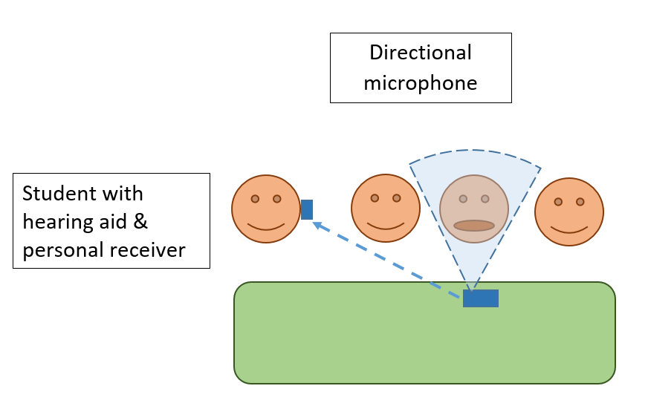
Figure 4. A visual representation of the directional microphone for a remote microphone placed on a table for small group work. The blue shaded area shows the direction the microphone will be picking up sound. This area will move depending on which student is talking.

Table microphone
There exists a remote microphone option specifically designed to be used as a table microphone only. This device was designed for use by adults who are deaf or hard of hearing in the workplace, but is suitable for secondary school-aged students in the classroom. This device also has a directional microphone that is adaptive or can be manually adjusted. In addition, multiple microphones can be wirelessly connected and placed strategically around the group to increase the number of students in close proximity to a microphone.

FACTORS TO CONSIDER IN SELECTING A SOUNDFIELD SYSTEM OR REMOTE MICROPHONE
No single Soundfield system can be a solution for all classrooms. The choice of system should be based on the needs of the students, the size and layout of the room and the equipment already in use. Schools that are interested in purchasing a Soundfield system should consider which system will best meet their current requirements and possible future needs.
It is strongly recommended that schools consult a Teacher of the Deaf when selecting a Soundfield system. For many schools, this will be their Visiting Teacher of the Deaf, but in some cases a school-based Teacher of the Deaf will be available.

COMPATIBILITY WITH PERSONAL WIRELESS COMMUNICATION DEVICE EQUIPMENT USED BY STUDENTS
The first factor to be considered should be whether any students in the school use a PWCD, such as a hearing aid or cochlear implant. All Soundfield systems have the ability to be used in conjunction with students’ PWCDs. This means the signal from the teacher’s microphone will be transmitted directly to these students, in addition to being distributed around the classroom via the loudspeaker.
A PWCD is the recommended system of choice for students who are deaf or hard of hearing or who have an auditory processing disorder. The terms ‘parallel signal transmission’ and ‘sequential signal transmission’ describe the ways in which a Soundfield system and a student’s personal equipment can be used together (see Appendix D). A Soundfield system that allows for parallel signal transmission is generally recommended, and can only be achieved if the PWCD and the Soundfield system are from the same manufacturer and use the same transmission type.
For students who are deaf or hard of hearing, the student’s Visiting Teacher of the Deaf (or school-based Teacher of the Deaf) and audiologist should be consulted to determine whether parallel signal transmission is compatible with that student’s personal devices. If it is not, the most appropriate sequential signal transmission option should be identified.
When students who are deaf or hard of hearing are moving between rooms (for example, as would typically be the case in a secondary school), some Soundfield systems enable the automatic connection of students’ personal equipment to the Soundfield system as they enter a room. This means that the student and teacher do not need to manually connect the equipment each time the student moves to a different classroom during the day.

ROOM SIZE AND TRANSMISSION TYPE
The size of the room will determine whether a Soundfield system with one loudspeaker will be suitable. For classrooms of up to one hundred square metres, a Soundfield system with one loudspeaker should be adequate to provide a consistent sound level across the entire space. For larger rooms, multiple loudspeakers may be required. Some portable Soundfield systems allow extra loudspeakers or supplementary components (such as sensors or range extenders) to extend the transmission range.

ROOM LAYOUT
The shape of the room needs to be considered, because some Soundfield systems rely on line of sight for effective transmission. Any partitions in the room will also interfere with line-of-sight transmission. If this equipment is used in an irregularly shaped classroom, extra loudspeakers, or supplementary components to extend the coverage of the transmission throughout the entire space, may be needed. Depending on the shape of the classroom, this may include extra loudspeakers, sensors or range extenders.
In open-plan classrooms (larger spaces with more than one class group with no solid walls between classes), a single-loudspeaker Soundfield system can provide a consistent signal for one class group (not the entire larger space) without interfering with other classes operating in the same space.

COMPATIBILITY WITH EXISTING SOUNDFIELD SYSTEMS AND OTHER CLASSROOM TECHNOLOGY
Schools that already have Soundfield systems in use and are considering additional systems should purchase the same type of system. This will make use of existing knowledge in the school, and maintenance and repairs can be arranged through the one supplier. However, compatibility with students’ personal equipment should take priority, even if this means purchasing a different type of Soundfield system.
Soundfield systems can be used with existing classroom audiovisual (AV) equipment such as interactive whiteboards, laptops, iPads and other multimedia devices. This may be needed when the built-in speakers in these items do not distribute an even sound level across the entire classroom. The Soundfield system will distribute the audio signal from these devices via the loudspeaker.
In some cases, additional devices or software may be required to interface between the Soundfield system and other multimedia devices. Soundfield systems can allow for multiple audio sources and students’ personal devices to be connected at the one time, so all students will be able to hear via the teacher transmitter, the audio signal from a multimedia device and other students using microphones, with only one audio signal being transmitted at any one time. It is also possible to record lessons for students to access at a later time.
Students who are deaf or hard of hearing will also be able to hear the sound from the multimedia devices via their PWCD if this is being used in conjunction with the Soundfield system.

NUMBER OF MICROPHONES OR TRANSMITTERS
Schools should consider the number of teacher transmitters and student microphones that will best suit their teaching activities. All Soundfield systems allow for two teacher transmitters for team teaching situations. Some Soundfield systems allow for one or more student microphones in addition to a teacher transmitter. The optimum number of student microphones will depend on the situation and the school’s preferences; for example, multiple microphones can be used to reduce the time spent passing the microphone(s) between students.

POSITION OF LOUDSPEAKERS
Recommendations for positioning the loudspeaker vary depending on the system being used. These include:
- at the back of the classroom/teaching space (facing the teacher) to compensate for the natural decrease in the level of the teacher’s unamplified voice with increasing distance
- at the front of the room (behind the teacher) so the amplified sound is coming from the same general direction as the teacher to make it sound more natural
- in the middle of the longest wall to provide good coverage and minimise feedback
- near power points and other AV equipment to be connected to it to reduce hazard from cables (Bluetooth connection for AV equipment is available in some Soundfield systems).

The ability to move the loudspeaker position with a portable Soundfield system provides flexibility in how the classroom is set up. If desired, a teacher can rearrange the position of the students’ desks or tables and move the loudspeaker to accommodate these changes.

TEACHER AND STUDENT COMMITMENT
Teachers and students should be consulted before a Soundfield system is purchased for the classroom. Without this prior consultation and the commitment of students and teachers, uptake and use of the Soundfield system may not be optimal.
Primary school-aged students are generally positive about the use of a Soundfield system in their classroom and are keen to use the pass-around microphone³⁴. Secondary school-aged students can be reluctant to use equipment that singles them out, so a Soundfield system is an attractive option because it does not single out any one student or group of students. Psychosocial factors such as social stigma and low self-esteem, logistics when moving between classrooms and cosmetic appearance can reduce the acceptance of the use of personal equipment for secondary school-aged students who are deaf or hard of hearing. They may prefer using some types of technology over others, especially if social factors—as well as speech perception performance—affect their choices. However, their preferred equipment may not give the signal-to-noise ratio they require.

DAILY MANAGEMENT
Schools should nominate one person to be responsible for the day-to-day checking, maintaining and charging of the school’s Soundfield systems. A daily maintenance check of each Soundfield system is recommended. Transmitters and microphones have rechargeable batteries, and these should have enough charge to operate for the whole school day. They need to be put in the charger at the end of each day to be charged overnight. Some charging units allow for multiple transmitters or microphones to be charged without the inconvenience of multiple individual chargers and cables.

COST
The cost of a Soundfield system with a teacher transmitter, one student microphone and receiver/amplifier/loudspeaker unit is reasonably similar across suppliers, so cost is not likely to be a significant factor in the choice of system.

RECOMMENDED PROCESS FOR SCHOOLS
The recommended process for schools applying to purchase a portable Soundfield system is set out below.

IDENTIFY INCLUSION NEEDS
Identify barriers to inclusion, such as noise in the classroom or distance from the teacher, and describe how the Soundfield system will address these using the following steps:
- Measure the acoustic conditions in the classroom. This can be done at no cost, for example using the SoundOutTM iPad app, which has been designed specifically for classrooms. The app can be used to measure ambient and background noise levels and reverberation time, and will give an estimate of the speech transmission index for the classroom/learning space.
- Once noise measurements have been carried out, the room should be acoustically optimised before introducing a Soundfield system. If the measurements are above the recommended levels for classrooms (see Appendix B), consider the current equipment and surfaces in the classroom and what action can be taken to improve the acoustic environment. A plan of the classroom, including measurement of the size of the room (length x width in square metres), locations where noise measurements were taken, and the placement of teacher and students will assist with decisions about acoustic treatments. A classroom acoustics evaluation tool that can be used to record these measurements is included in Appendix E.
- Consult with your Visiting Teacher of the Deaf or school-based Teacher of the Deaf on what acoustic accommodations can be made before a Soundfield system is used.
- For very large spaces such as gymnasiums and halls, the recommended background noise level is 45 dBA. In such spaces, advice from an acoustical engineer should be obtained on managing background noise level and reverberation requirements.
- If the class includes students who are deaf or hard of hearing, consult with the student’s Visiting Teacher of the Deaf or school-based Teacher of the Deaf and/or audiologist. These professionals can support schools to identify a student’s needs, including details of the student’s personal devices.
- For students who have normal hearing and use a PWCD because of difficulties listening in noise (for example, students with an auditory processing disorder), the student’s audiologist will be able to help the school to identify the students’ needs.
- Engage with any teachers, education support staff and any other school staff who are likely to use the equipment, as well as any specific students whom the equipment is intended to support.

CHOOSE EQUIPMENT
If a student is deaf or hard of hearing, schools should consult the student’s Visiting Teacher of the Deaf or school-based Teacher of the Deaf and audiologist when selecting a Soundfield system.
The parallel transmission type is generally recommended, but this will depend on the student’s personal devices. If this is not possible, sequential transmission may be suitable. Schools should arrange with the supplier to trial the equipment and check for interference between the two types of technology. Suppliers will generally provide schools with a system for a free evaluation period so that the technology can be trialled before purchase.
Once a decision has been made, obtain a quote for the equipment, including the required number of loudspeakers, transmitters and microphones.

INTRODUCE THE EQUIPMENT
Once the Soundfield system is purchased, the supplier will set up the equipment in the classroom and provide training in its use. This should include optimising the position of the loudspeaker and adjusting the volume to be appropriate for the room or learning space.
In-service training should cover direct operation and maintenance of the equipment, including daily maintenance, instructions for charging batteries, and who to contact for repairs. More than one staff member (teachers, education support staff, allied health professionals and/or school leaders) should attend the training to ensure that the effective use of the Soundfield system is not dependent on a single staff member. Training should also include support documents and hands-on practice with using the Soundfield system to ensure consolidation of the training. In addition, ongoing support should be available until teachers feel confident in the effective use of the Soundfield system.
If the school includes students with PWCDs, set up and in-service training should include guidance regarding the interaction of personal technology and the Soundfield system.
The research literature recommends that teachers receive training on how to incorporate the Soundfield system into their teaching. A Visiting Teacher of the Deaf or school-based Teacher of the Deaf can provide guidance on how to best incorporate the use of the Soundfield system in a busy classroom depending on the layout of the room, classroom management style and the learning style of the student. This may include:
- the advantages and disadvantages of using a Soundfield system
- techniques and strategies for using the teacher transmitter and the student microphones,
- teaching strategies that make best use of a Soundfield system
- situations in which the Soundfield system should be used. For example:
  - whole-class teaching (teacher transmitter only)
  - class discussions (teacher transmitter and student microphone/s)
  - multimedia presentations
  - listening in to other conversations to develop social competence
- situations in which the Soundfield system is not needed, for example:
  - in a quiet room one-to-one sitting close to the talker (for example, individual sessions with a specialist)
  - when the teacher is not addressing the whole class
  - when the teacher is working with individual students so that the conversation is not amplified for other students
  - independent study
- situations in which students who are deaf or hard of hearing should use a remote microphone placed on the table (for example, group work).

EVALUATE THE EQUIPMENT
The use of the Soundfield system should be evaluated in two stages:
- approximately two weeks after the system is set up in the classroom to review use in the short term, and identify the need for further training or support as required to embed effective use of the Soundfield system
- approximately six months after the system is set up, to review the regular use of the Soundfield system and its effectiveness in improving access to the curriculum for the students and its benefits for the teacher. The results of the evaluation should be used to modify the use of the Soundfield system or prompt the seeking of advice from a professional.
A teacher evaluation tool and a student evaluation tool are included in Appendices F and G respectively.

GLOSSARY OF TERMS
Ambient noise level (ANL)
The noise level (in dBA) measured using a sound level meter when a room is unoccupied.
Background noise level (BNL)
The noise level (in dBA) measured using a sound level meter when a room is occupied.
Decibel (dB)
A unit used to measure the intensity of sound.
Decibel A-weighted (dBA)
The decibel level of a sound with reference to how the human ear responds to sound (low frequencies are reduced).
Decibel sound pressure level (dB SPL)
The decibel level of a sound with reference to a standard level (un-weighted) defined for the purpose of sound measurement.
Digital adaptive wireless technology (RogerTM)
A type of wireless transmission technology used in Soundfield systems and remote microphones.
Digitally enhanced cordless telecommunications (DECT)
A type of wireless transmission technology used in Soundfield systems.
Deaf and hard of hearing (DHH)
This terminology is used to refer to individuals who have a degree of hearing loss or identify as deaf or hard of hearing. An individual would be either deaf or hard of hearing.
FM system
This type of personal system is now called a wireless communication device (see below). It is a personal system with a transmitter and receiver that operates using frequency-modulated (FM) radio waves to send and receive the speech signal. FM means that the auditory signal is coded into changes in the frequency of the radio wave. Now that personal devices use a range of wireless transmission options, this terminology is no longer accurate.
Infra-red (IR)
A type of wireless transmission technology used in Soundfield systems.
Operating range
The maximum distance that can occur between the receiver unit and the teacher transmitter or student microphone for the speech signal to be successfully transmitted to the loudspeaker. The operating range differs depending on the transmission type.
Remote microphone
A device that delivers speech directly to a hearing aid or cochlear implant from a distance.
Reverberation time (RT)
The time a sound takes (in seconds) to drop by 60 dB.
Signal-to-noise ratio (SNR)
The difference in decibels between the speech level and the background noise level measured using dBA or dBSPL.
Soundfield system
A Soundfield system consists of an amplifier/receiver/loudspeaker unit, a teacher transmitter and a student microphone. It may also be referred to as a classroom audio distribution system (CADS) or portable amplification equipment.
Speech transmission index (STI)
The speech transmission index (STI) is a calculation of the amount of speech information available based on noise and reverberation measurements in a room.
Personal wireless communication device (PWCD)
A personal system with a transmitter and receiver. A student who is deaf or hard of hearing can use a PWCD in conjunction with a hearing aid or cochlear implant to hear despite distance or background noise. Some PWCDs are used by students with normal hearing or unilateral hearing loss without a hearing aid or cochlear implant. These systems were previously called personal FM systems (see above).

ABBREVIATIONS

AV audiovisual
CADS classroom audio distribution systems
DECT digitally enhanced cordless telecommunications
EAL English as an additional language
FM frequency-modulated
IR infra-red
PWCD personal wireless communication device

REFERENCES

Anderson, K. 2001. Kids in noisy classrooms: what does the research really say? Journal of Educational Audiology, 9, 21-33.
Anderson, K. 2012. Approaches to functional verification of classroom accessibility. In J.J. Smaldino & C. Flexer (Eds.) Handbook of Acoustic Accessibility: Best Practices for Listening, Learning and Literacy in the Classroom. Thieme Medical Publishers Inc. New York, pp. 105-127.
Anderson, K.L. & Goldstein, H. (2004). Speech perception benefits of FM and infrared devices to children with hearing aids in a typical classroom. Language, Speech and Hearing Services in Schools, 35, 169-184.
Australian Association of Acoustical Consultants. (2018). Association of Australasian Acoustical Consultants Guideline for Educational Facilities Version 2.0. www.aaac.org.au/Guidelines-&-Downloads, accessed 6/8/2019.
Cameron, S., Glyde, H., Dillon, H., King, A. & Gillies, K. 2015. Results from a National Central Auditory Processing Disorder Service: A real-world assessment of diagnostic practices and remediation for central auditory processing disorder. Seminars in Hearing, 36(4), 216-236.

Cupples, L., Ching, T.Y.C., Button, L., Seeto, M., Zhang, V., Whitfield, J., Gunnourie, M., Martin, L. & Marnane, V. 2018. Spoken language and everyday functioning in 5-year-old children using hearing aids or cochlear implants, International Journal of Audiology, 57 (sup2), S55-S69, DOI: 10.1080/14992027.2017.1370140.
De Conde Johnson, C. 2012. Best practices: AAA Clinical Practice guidelines for Hearing Assistance Technology. In J.J. Smaldino & C. Flexer (Eds.) Handbook of Acoustic Accessibility: Best Practices for Listening, Learning and Literacy in the Classroom. Thieme Medical Publishers Inc. New York, pp. 89-104.
Dockrell, J. E. & Shield, B. 2012. The Impact of sound-field systems on learning and attention in elementary school classrooms. Journal of Speech, Language and Hearing Research, 55, 1163-1176.
Finitzo-Hieber, T. & Hillman, T.W. 1978. Room acoustics effects on monosyllabic word discrimination ability for normal and hearing-impaired children. Journal of Speech and Hearing Research, 21, 440-458.
Iglehart, F. 2004. Speech perception by students with cochlear implants using sound-field systems in classrooms. American Journal of Audiology, 13, 62–72.
Jamieson, D.G., Kranjc, G., Yu, K., & Hodgetts, W.E. (2004). Speech intelligibility of young school-aged children in the presence of real-life classroom noise. Journal of the American Academy of Audiology, 15(7), 508-517.
John, A.B. & Kriesman, B.M. 2012. Classroom Audio Distribution Systems: Literature Review 2003-2011. In J.J. Smaldino & C. Flexer (Eds.) Handbook of Acoustic Accessibility: Best Practices for Listening, Learning and Literacy in the Classroom. Thieme Medical Publishers Inc. New York, pp. 55-71.
John, A.B., Kriesman, B.M. & Smaldino, J.J. 2012. An overview of current CADS Technologies. In J.J. Smaldino & C. Flexer (Eds.) Handbook of Acoustic Accessibility: Best Practices for Listening, Learning and Literacy in the Classroom. Thieme Medical Publishers Inc. New York, pp. 72-88.
Madell, J.R. 2012. Acoustic accessibility: The. In J.J. Smaldino & C. Flexer (Eds.) Handbook of Acoustic Accessibility: Best Practices for Listening, Learning and Literacy in the Classroom. Thieme Medical Publishers Inc. New York, pp. 128-142.
Massie, R. & Dillon, H. 2006a. The impact of sound-field amplification in mainstream cross-cultural classrooms: Part 1 Educational outcomes. Australian Journal of Education, 50 (1), 62–77.
Massie, R. & Dillon, H. 2006b. The impact of sound-field amplification in mainstream cross-cultural classrooms: Part 2 Teacher and child opinions. Australian Journal of Education, 50 (1), 78–94.
Massie, R., Theodoros, D., McPherson, B. & Smaldino, J. 2004. Sound-field amplification: Enhancing the classroom listening environment for Aboriginal and Torres Strait Islander children. The Australian Journal of Indigenous Education, 33, 47-53. DOI: 10.1017/S1326011100600868.
McSporran, E. 1997. Towards better listening and learning in the classroom. Educational Review, 49(1), 13-20.
McSporran, E. & Butterworth, Y. 1997. Sound field amplification and listening behaviour in the classroom. British Educational Research Journal, 23(1), 81-96. DOI: 10.1080/0141192970230107.
Mealings, K., Demuth, K., Buchholz, J.M. & Dillon, H. 2015a. The development of the Mealings, Demuth, Dillon, and Buchholz Classroom Speech Perception Test. Journal of Speech, Language, and Hearing Research, 58, 1350–1362.
Mealings, K., Demuth, K., Buchholz, J.M. & Dillon, H. 2015b. The effect of different open plan and enclosed classroom acoustic conditions on speech perception in Kindergarten children. The Journal of the Acoustical Society of America, 138 (4), 2458-2469. DOI: 10.1121/1.4931903.
Mealings, K. 2016. Classroom acoustic conditions: Understanding what is suitable through a review of national and international standards, recommendations, and live classroom measurements. Proceedings of ACOUSTICS 2016, 9-11 November 2016, Brisbane, Australia.
Phonak. 2013a. Phonak Insight. Roger - The new wireless technology standard. www.phonakpro.com/au/en/products/wireless-accessories/roger-dynamic-soundfield/evidence-roger-dynamic-soundfield.html, accessed 14/11/19.
Phonak. 2013b. Digimaster X Installation instructions. www.phonakpro.com/content/dam/phonakpro/gc_hq/en/products_solutions/wireless_accessories/dynamic_soundfield/documents/phon_digimaster_x_installation.pdf, accessed 14/11/19.
Rance, G., Saunders, K., Carew, P., Johansson, M. & Tan, J. 2014. The use of listening devices to ameliorate auditory deficit in children with autism. The Journal of Pediatrics, 164(2), 352-357.
Rekkedal, A.M. 2012. Assistive hearing technologies among students with hearing-impairment: Factors that promote satisfaction. Journal of Deaf Studies and Deaf Education, 17(4), 499-517.
Smaldino, J.J. and Ostergren, D. 2012. Classroom acoustic measurements. In J.J. Smaldino & C. Flexer (Eds.) Handbook of Acoustic Accessibility: Best Practices for Listening, Learning and Literacy in the Classroom. Thieme Medical Publishers Inc. New York, pp. 34-54.
Wilson, W.J., Marinac, J., Pitty, K., and Burrows, C. 2011. The use of soundfield amplification devices in different types of classrooms. Language, Speech and Hearing Services in Schools, 42, 395-407. DOI:10.1044/0161-1461(2011/09-0080).
Zanin, J. and Rance, G. 2016. Functional hearing in the classroom: assistive listening devices for students with hearing impairment in a mainstream school setting. International Journal of Audiology, 55(12), 723-729. DOI: 10.1080/14992027.2016.1225991.

APPENDIX A: SHARE DIAGRAM (TEXT ALTERNATIVE)

S: Student centred
Inclusive education involves students, in collaboration with their peers and/or carers, in decision-making processes as respected partners in education.
H: Human rights focused
Inclusive education is supported by and is the realisation of a human rights-based approach to education. International human rights principles and Victoria's Charter of Human Rights and Responsibilities Act 2006 provide a framework for every Victorian to be treated with dignity and respect and to enjoy their human rights without discrimination.
A: Acknowledges strengths
Inclusive education recognises that each child and young person is unique. It focuses on a strengths-based, personalised approach to education that celebrates and welcomes differences to maximise learning, engagement and wellbeing outcomes.
R: Respects legal obligations
Inclusive education enables schools to uphold legal obligations to make reasonable adjustments for all students with disabilities. Reasonable adjustments assist all students to participate in education on the same basis as their peers without a disability.
E: Evidence based
Inclusive education uses contemporary evidence-based practices known to be effective in responding to individual student needs and improving student outcomes.
Return to SHARE Diagram (page 5)

APPENDIX B: RECOMMENDED ACOUSTIC CONDITIONS FOR PRIMARY CLASSROOMS (MEALINGS, 2016)

Measure | Description | Recommendations for:
 |  | students with normal hearing | students who are deaf or hard of hearing
Ambient noise level (ANL) | Measurement in dBA of the noise level in an unoccupied room | 30-40 dBA | 20-30 dBA
Background noise level (BNL) | Measurement in dBA of the noise level in an occupied room | 50-55 dBA | 40-45 dBA
Reverberation time (RT) | Time in seconds that it takes for a noise to drop by 60 dB | 0.4-0.6s | 0.3-0.5s
Signal-to-noise ratio (SNR) | The difference between the level of the signal and the level of the background noise | +10 to +15 dB | +15 to +20 dB
Speech transmission index (STI) | Calculation of the amount of speech information available based on other measurements | 0.6-0.75 | 0.6-0.75

APPENDIX C: SUMMARIES OF SELECTED RESEARCH

Mealings et al (2015b)
In this study, a closed-set speech test specifically developed to be administered in a classroom to the whole class of students at the same time was used. Recorded sentences were presented via a speaker at the front of the room at a normal conversational level (60 dBA measured at two metres). Four pictures were displayed on a screen at the front of the room and students were instructed to press a button on a personal response device to select the picture that corresponded to the target word in the sentence. Students sitting at the front of the room scored 79–83% correct while students at the back of the room scored just 52–56% correct.
With higher noise levels in the triple classroom (background noise level of approximately 67 dBA), the scores were as low as to 72% at the front of the room and as low as 25% at the back of the room.
The authors recommended a background noise level of less than 50 dBA, a reverberation time of less than 0.5 s and spatial separation between class groups in open plan spaces.

Anderson and Goldstein (2004)
This study looked at the performance of a group of students aged 9–12 years with mild to severe hearing loss on a sentence test in classroom conditions. All of these students used hearing aids. The test used recorded sentences presented via a speaker in front with competing noise via a speaker behind to give a signal-to-noise ratio of +10 dB. They found that there was a significant improvement in speech recognition scores when using hearing aids plus a PWCD (94.4%) compared to hearing aids only (82.4%). However, there was no significant improvement in speech recognition scores when a hearing aid plus a Soundfield system was used (83.1%).

Zanin and Rance (2016)
This study involved students aged 12–18 years with mild to profound hearing loss. Students in this group used hearing aids, cochlear implants, a hearing aid on one side and cochlear implant on the other, or a wireless receiver. The test used recorded words presented via a speaker at the front of the classroom with competing noise presented via a speaker at the back of the classroom with a signal-to-noise ratio of 0 dB. They found that there was a significant improvement in performance on the speech test when a PWCD was used: the average score for the group was 65.8% correct on the word test when using a PWCD, compared to 24.3% when using only their hearing aids/cochlear implants. There was only a small improvement when a Soundfield system was used in conjunction with their hearing aids/cochlear implants (35.9% words correct). A group of normally hearing students scored 80.1% on the same test under the same conditions. This supports the need for students who are deaf or hard of hearing to be provided with additional assistance to access the curriculum even with optimally fitted devices.
Half of the students in the Zanin and Rance (2016) study also completed a two-week classroom trial of a Soundfield system and a PWCD, evaluated using student and teacher questionnaires. The questionnaire responses agreed with the speech perception results, showing that the most benefit was obtained by using a PWCD in conjunction with the hearing aid/cochlear implant, and that there was no difference when a Soundfield system was used in conjunction with the hearing aid/cochlear implant. Even though speech perception ability and questionnaire responses showed that a PWCD gave the greatest benefit, device acceptance for students of this age was affected by psychosocial factors such as social stigma, low self-esteem and cosmetic appearance.

Massie and Dillon (2006a)
This study found that grade 2 students with normal hearing or a mild hearing loss had significantly better literacy and numeracy skills after a semester using a Soundfield system than a semester without using a Soundfield system.
Also, Massie, Theodorus, McPherson and Smaldino (2004) found students in grade 2, 3 and 5 (6–10-year-olds), some with mild–moderate hearing loss, communicated more with the teacher and with their peers, were more attentive and participated more in class when a Soundfield system was used. In another study, Dockrell and Shield (2012) found students aged 8–10 years benefited in listening comprehension and speed of information processing when a Soundfield system was used. In this study, some of the classrooms had poor acoustics (reverberation times up to 0.83 s) and some of the students had special needs or EAL. Of the 16 teachers in the study, 11 were still using the Soundfield system six months after it was installed, and all of these used it for part of every day for whole-class teaching (40% of the day). Five teachers stopped using it because it was uncomfortable or because they had technical problems. Teachers reported improvement in students’ attention spans, as well as ability to respond appropriately to questions and understand spoken instructions.

APPENDIX D: TRANSMISSION TYPES

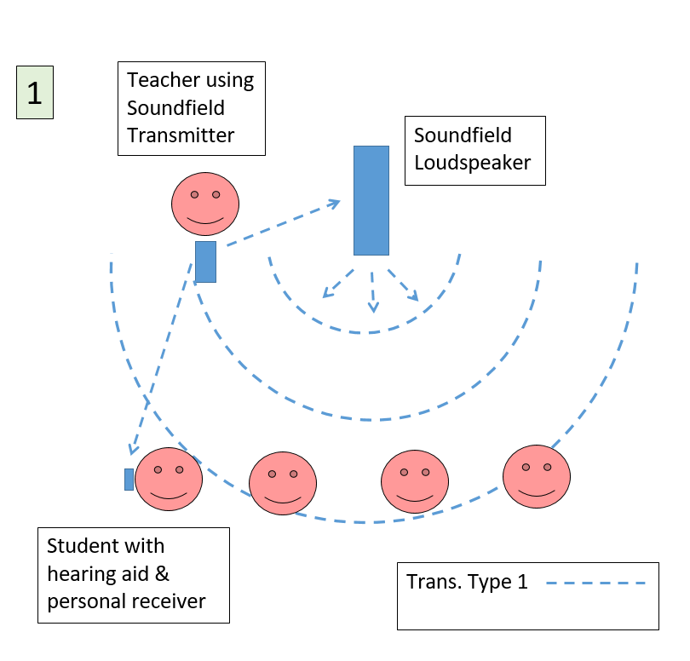
Parallel signal transmission
This is the preferred option when students in the class use PWCDs with a compatible transmission type.
The PWCD and the Soundfield system must be from the same manufacturer and use the same transmission type. The Soundfield system transmitter can transmit the signal to the student’s personal receiver (connected to the hearing aid/cochlear implant) as well as to the Soundfield system loudspeaker.

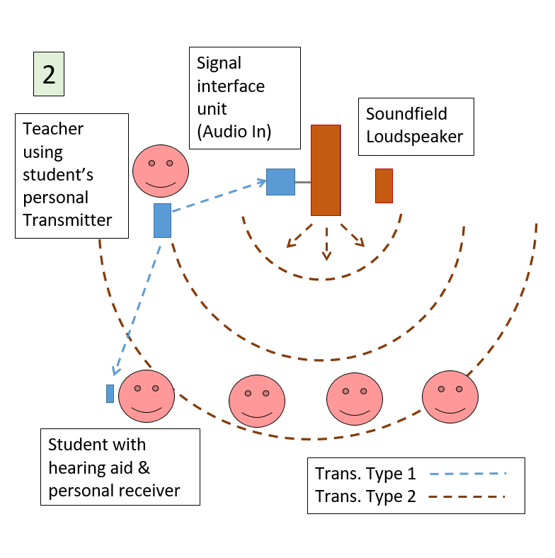
Sequential signal transmission (type 1)
This is the second preference, because the automatic noise suppression algorithm in the PWCD will remain active for the student.
A signal interface unit (Digimaster XTM) is connected to the audio in socket of the existing Soundfield system amplifier unit, and the teacher uses the student’s personal transmitter. The signal is transmitted to the students’ personal receiver, and to the Soundfield system loudspeaker for distribution to the whole class (using the different transmission type of the Soundfield system). The signal interface unit upgrades the Soundfield system to dynamic behaviour.
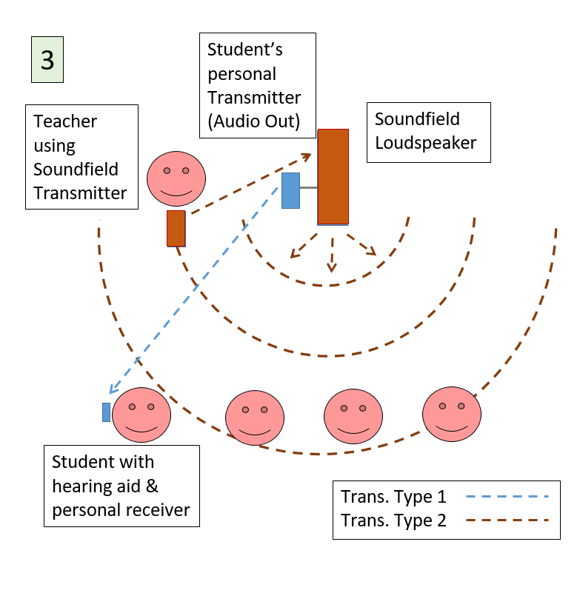
Sequential signal transmission (type 2)
This is the third preference because, if the student’s PWCD has the automatic noise suppression algorithm, it will be deactivated when the personal transmitter is connected to the amplifier unit.
The transmitter of the student’s PWCD is connected via a cable to the audio out socket of the Soundfield system amplifier unit and the teacher uses the Soundfield system teacher transmitter.

APPENDIX E: CLASSROOM ACOUSTICS EVALUATION TOOL
This evaluation tool is intended to be used in conjunction with the Professional Practice Guide: Portable Soundfield Systems. This tool is used to record measurements of the noise levels and room acoustic conditions prior to consideration or installation of a Soundfield system in the classroom.
Classroom acoustics evaluation
School: |  |  |  | Date:
Teacher: |  |  |  | Year level:
Room details
Length (in metres): |  |  | Width (in metres):
Length x width (in m²)
Ambient noise level: |  |  | Recommended level* is: |  | 40 dBA
Background noise level: |  |  | Recommended level* is: |  | 55 dBA
Reverberation time: |  |  | Recommended level* is: |  | 0.6 secs.
Are acoustic modifications needed: yes/no
Details of modifications to be undertaken:

*Refer to the table in Appendix B of the Professional Practice Guide: Portable Soundfield Systems. These levels apply if there are no students who are deaf or hard of hearing in the class.

APPENDIX F: TEACHER EVALUATION TOOL
This evaluation tool is intended to be used in conjunction with the Professional Practice Guide: Portable Soundfield Systems. This tool is used to record the teacher’s responses to use of a Soundfield system two weeks and six months after installation in the classroom.
Teacher evaluation of Soundfield system
School: |  |  |  |  |  | Date of evaluation:
Teacher: |  |  |  |  |  | Date of installation:
Year level: |  |  |  |  |  | No. of students:
Equipment details
Brand: |  |  |  |  |  | No. of loudspeakers:
No. of teacher transmitters: |  |  |  |  |  | No. of student microphones:
Equipment use
How many days a week do you use the equipment? |  |  |  |  | How many hours a day do you use the equipment?
For what subjects/activities do you use the Soundfield system with the teacher transmitter?
For what subjects/activities do you use the Soundfield system with the student microphone?
Do you find the Soundfield equipment easy to use?
Please add comments.
Who is responsible for the daily check of the equipment?
Has there been a need for repair of the equipment?
Other comments:

Benefit for students
Have you observed a change in the following areas when you have used the Soundfield system? Please provide comments:
Following verbal instructions to the whole class
Hearing what other students are saying
Understanding of AV, media presentations to the class
Ability to stay on task
Time spent on getting organised, getting ready for the next subject/activity
Benefit for teachers
Have you had to change your teaching practices to accommodate using the equipment?
Has your attitude to using the equipment changed since you started using it?
Have you noticed a change in the vocal effort you need to use to address the class? Please comment:
Other comments (for example, additional training required, modifications needed):

APPENDIX G: STUDENT EVALUATION TOOL
This evaluation tool is intended to be used in conjunction with the Professional Practice Guide: Portable Soundfield Systems. This tool is used to record the students’ responses to the use of a Soundfield system two weeks and six months after installation in the classroom.
Student evaluation of Soundfield system
School: |  |  | Date of evaluation:
Teacher: |  |  | Date of installation:
Year level: |  |  | No. of students:
Room details:
Equipment details
Brand: |  |  | No. of loudspeakers:
No. of teacher transmitters: |  |  | No. of student microphones:
Student observations
Do you think the Soundfield system helps you to hear your teacher’s voice? In what way?

Do you think the Soundfield system helps you to hear other students in the class? In what way?

Do you think the Soundfield system has helped you in your schoolwork? In what way?

Is there anything that would make the Soundfield system better?

Anderson (2001)
John and Kriesman (2012)
Anderson (2001)
Finitzo-Hieber & Tillman (1978)
De Conde Johnson (2012)
Smaldino and Ostergren (2012)
Mealings et al (2015b)
Dockrell and Shield (2012)
Anderson and Goldstein (2004)
Iglehart (2004)
Massie, Theodoros, McPherson and Smaldino (2004)
John, Kriesman and Smaldino (2012)
McSporran and Butterworth (1997)
John and Kriesman (2012)
Massie and Dillon (2006b)
McSporran and Butterworth (1997)
Massie and Dillon (2006b)
McSporran and Butterworth (1997)
John and Kriesman (2012)
Anderson and Goldstein (2004)
Anderson (2012)
Cupples et al. (2018)
Rekkedal (2012)
Madell (2012)
Cameron, Glyde, Dillon, King and Gillies (2015)
John and Kriesman (2012)
John, Kriesman and Smaldino (2012)
Phonak (2013a)
John, Kriesman and Smaldino (2012)
John and Kriesman (2012)
John, Kriesman and Smaldino (2012)
Madell (2012)
De Conde Johnson (2012)
Massie & Dillon (2006b)
Massie and Dillon (2012b)
De Conde Johnson (2012)
Anderson and Goldstein (2004)
Zanin and Rance (2016)
John and Kriesman (2012)
Australian Association of Acoustical Consultants (2018)
Wilson et al. (2011)
John and Kriesman (2012)
Massie and Dillon (2006b)
Anderson (2012)
Mealings et al. (2015a)
Phonak (2013a)

