EQUIPMENT BOOST FOR SCHOOLS

PROFESSIONAL PRACTICE GUIDE:

INCLUSIVE SOFTWARE

CONTENTS

Professional Practice Guides 3
INCLUSIVE EDUCATION POLICY AND PRACTICE 4
Identify inclusion needs within your school 6
Identify functional needs 9
Consider functional need 9
Applying the Technological Pedagogical Content Knowledge (TPaCK) Framework to your decision making 11
Determine the category of software 12
Choosing and testing software 13
Implementation 15
Evaluate the software 16
Process Overview 17
18
Appendix A: Share diagram (Text Alternative) 19
Appendix B: Categories of software 20
Appendix c: ABBREVIATIONS 25

Professional Practice Guides
The purpose of Professional Practice Guides, including this document, is to guide schools’ decision-making in relation to identifying, purchasing and implementing inclusive equipment and assistive technology. This document includes:
- a recommended process to support schools’ decision-making
- an evidence-based framework for evaluating inclusive software.
This Professional Practice Guide is to be read together with the Inclusive Software Catalogue, available at the Department's FUSE website.The catalogue provides a teacher-curated list of inclusive software used in Victorian government schools to:
- support students to participate in all aspects of school life
- improve students’ access to learning
- enhance communication between students, families, teachers and school staff
- enhance student engagement, independence and agency
- build inclusive school environments in which all students are supported to learn together.

INCLUSIVE EDUCATION POLICY AND PRACTICE
Inclusive education means that all members of every school community are valued and supported to fully participate, learn, develop and succeed within an inclusive school culture. This includes making reasonable adjustments for students with disabilities and additional learning needs.
Data shows that Victorian schools make adjustments for 19% of students because of a disability or an additional learning need. This is approximately 115,000 students in Victorian government schools, which suggests that every government school may receive benefit from equipment and assistive technology that supports their capacity to deliver inclusive education.
This Inclusive Software Catalogue aligns with the SHARE Principles of Inclusive Education (Figure 1).

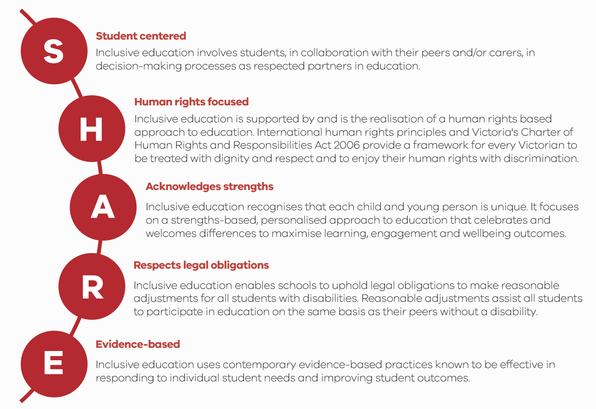
Figure 1. SHARE Principles of Inclusive Education (developed based on feedback captured in 2017 during public consultations on the Department’s Education for All inclusive education policy)
Text alternative for ‘SHARE’ Diagram
Appendix A includes an accessible text-alternative version of this image.
inclusive software catalogue
The Inclusive Software Catalogue responds to calls to strengthen inclusive education practice to provide better supports for students with disabilities and additional learning needs by providing all Victorian government schools with:
- support to identify their needs and utilise assistive technology to implement effective, evidence-based interventions
- information on existing software applications that may assist in meeting the identified needs
- decision-making and effective implementation guidance
- implementation and evaluation resources.

Inclusive software supports inclusive education practice by:
- removing barriers to accessing curriculum content
- supporting students to participate fully in learning activities
- supporting students to demonstrate their knowledge and strengths
- enabling all students, including those with disabilities or additional learning needs, to participate and learn together in an inclusive environment.

Inclusive software can be used in schools to support students at a functional level (to access curriculum content), a participatory level (to interact and engage with other students and teaching practices) or a pedagogical level (to grow as self-directed learners). To determine the appropriate inclusive software, schools should consider factors such as:
- the student(s) who will benefit most from the use of the inclusive software
- the outcomes expected from inclusive software use and whether these outcomes align with the school’s priorities and goals
- the practicality of using the inclusive software within the school setting
- any training required to use the inclusive software appropriately and effectively
- how the school will evaluate the effectiveness of the inclusive software.

Adjustments, interventions and other supports should be personalised and individualised to address the strengths and learning needs of individual students, and reflect collaboration between students, families, teachers, education support staff, school leaders and suitably qualified professionals (for example, allied health professionals) to support students' needs.
The Inclusive Software Catalogue includes any electronic and/or digital software, program, or application that supports students of all abilities to access the curriculum. Categories of inclusive software include:
- literacy aids
- mathematical software
- captioning software
- Optical character recognition (OCR) technology
- mouse/keyboard training software
- screen magnification software
- screen reader software
- picture symbol software and resources
- communication software
- personal organisation tools
- sensory software.

what to consider when deciding on inclusive software to implement
To select the most appropriate software and applications for your school, it is recommended that you take the following steps.

Identify inclusion needs within your school
In consultation with students, families, teachers and other school staff, determine whether any students are not being supported to fully participate, learn, develop and succeed in school. The reasons may relate to individual students, groups of students or the school as a whole.
It is recommended that you identify a key staff member to lead this process. This role will involve liaising with students, teachers, families, school staff and relevant professionals. To identify an appropriate staff member to fulfil this role, you may consider teachers and other school staff who:
- are currently working in special education
- have qualifications in special and/or inclusive education
- are responsible for completing your school’s Inclusive Schools Index
- are currently studying a Masters in Special and/or Inclusive Education through the Department of Education and Training (the Department) Inclusive Education Scholarships initiative
- have completed online training through the Inclusive Classrooms initiative
- have relevant expertise, knowledge or experience.

Inclusion in the classroom
Within the classroom, students may benefit from software that supports them to participate and learn across one or more curricular learning areas.
Software may also support teachers to implement specific teaching strategies and approaches that previously presented barriers to participation for some students. For example, students may benefit from inclusive software that removes barriers to participation in classroom activities such as:
- interacting with teachers and peers
- group work
- independent study
- accessing digital resources.

Suitable inclusive software may include:
- text-to-speech software
- assisted communication software
- mouse/keyboard training software
- task organisation tools.

Inclusion in school life
Outside of the classroom, students may benefit from software that supports access, inclusion and participation in a range of activities, including:
- recreational activities
- camps and excursions
- Outside School Hours Care.
Such software may include:
- visual organisers
- sensory software
- communication devices.

Consultation
To effectively identify inclusion needs across your school, the responsible staff member should consult a wide variety of stakeholders, particularly when an identified need relates to an individual student. Applicable stakeholders may be:
- students
- families
- teachers (including teachers who do not work directly with the individual student but interact with the student outside the classroom)
- other school staff, such as education support staff, health and wellbeing coordinators and welfare support coordinators
- other individuals who interact with students during the school day (for example, building and grounds maintenance personnel, bus drivers)
- Student Support Groups
- Professional Learning Communities and other relevant networks
- DET regional staff, including allied health professionals, who have knowledge of students at your school
- suitably qualified professionals (for example, a medical practitioner, occupational therapist, speech pathologist, psychologist, social worker, counsellor, guidance officer or audiologist)
- Outside School Hours Care staff.

Existing evidence of need
If applicable, consider any existing evidence that demonstrates the need for adjustment(s). For example:
- adjustments currently being provided to students
- results of formative and/or summative assessments
- students’ individual learning plans
- students’ responses to previous adjustments
- documented observations and/or discussions by teachers and/or other school staff
- family concerns
- reports from suitably qualified professionals (for example, a medical practitioner, occupational therapist, speech pathologist, psychologist, social worker, counsellor, guidance officer or audiologist)
- evidence that has been used to support a student’s inclusion in the Nationally Consistent Collection of Data for Students with Disabilities (NCCD)
- previous applications for the Program for Students with Disabilities (PSD) (this may demonstrate a need regardless of whether the application was successful)
- your school’s Annual Implementation Plan (AIP)
- other available data and evidence.

Identify functional needs
Part of determining the software needed to remove barriers and/or improve a skill for a student is to identify the functional need(s) that are not currently being met. This will help you decide what type(s) of software can address the need(s) and promote the student’s access to curriculum and education.
The table below lists functional needs and inclusive education software that may meet them.

Consider functional need
FUNCTIONAL NEED | DESCRIPTION | CATEGORIES OF SOFTWARE
Physical–Fine Motor | - All students have fine motor needs. Strategically introducing software can support individuals in developing their fine motor skills. Examples of software include touch typing/keyboard tutorials and fine motor training applications. Software can also be used to reduce fatigue associated with writing and typing  - Think about: Have you consulted an Occupational Therapist? | - Mouse/keyboard training software  - Speech-to-text software
Sensory–Vision | - Technology can assist students who require visual adjustments in the classroom. Software adjustments might include operating systems, word processors, and mobile applications with accessibility features to maximise ease of viewing, such as zoom and high contrast. A range of artificial intelligence software is designed to support reading real-life objects like signs and documents as well as text on screens | - Screen reader software
Sensory–Deaf/Hard of Hearing | - Educators can use technology to support learners who require auditory supports and adjustments. Software, such as text-to-speech readers and captioning software, can support student’s understanding of spoken language | - Communication software
Cognitive–Learning and Organisation | - Students require varying degrees of support to develop the skills for independent learning and organisation. Software can be used to support skills development. For example, some apps allow the creation of lists, schedules and reminders. Academic training software includes literacy learning software and mathematical software. Organisation software includes visual schedulers, note-taking and to-do list software, and word processing software with spelling and word prediction features | - Literacy aids  - Mathematical software  - Communication software  - Personal organisation tools
Socio-Emotional–Speech/Communication | - A range of available software supports students’ communication. Augmentative and Alternative Communication (AAC) apps include visual communication systems, pictographs, and articulation software. Other software focuses on social skill development or helping with articulation and speech  - Think about: Have you consulted a Speech and Language Pathologist? | - Picture symbol software and resources  - Communication software  - Sensory software

Applying the Technological Pedagogical Content Knowledge (TPaCK) Framework to your decision making
Schools are encouraged to choose software for its ability to make content more accessible to students while supporting the teacher’s chosen pedagogical strategy (how they are going to teach). According to Koehler and Mishra’s TPaCK Framework (2009), the teacher needs to first consider the learning outcomes and expectations of the student (the content), then choose a way to teach the skills and knowledge necessary to achieve the outcomes (the pedagogy), and only then consider incorporating appropriate technology to support the teaching of the content.
When choosing appropriate inclusive software, schools should consider:
- each of the three knowledge areas (content knowledge [CK], pedagogical knowledge [PK], and technological knowledge [TK]) individually
- how these three knowledge areas work together (TPaCK)
- how each knowledge area relates to one of the other knowledge areas:
  - pedagogical content knowledge (PCK), which is teachers knowing what to teach and the best methods for teaching the content
  - technological pedagogical knowledge (TPK), which is how specific technology can change the way the teacher teaches
  - technological content knowledge (TCK), which is how specific technology can communicate and represent the content and what the teacher teaches.
Use the diagram below to evaluate the suitability of your chosen software before implementation.

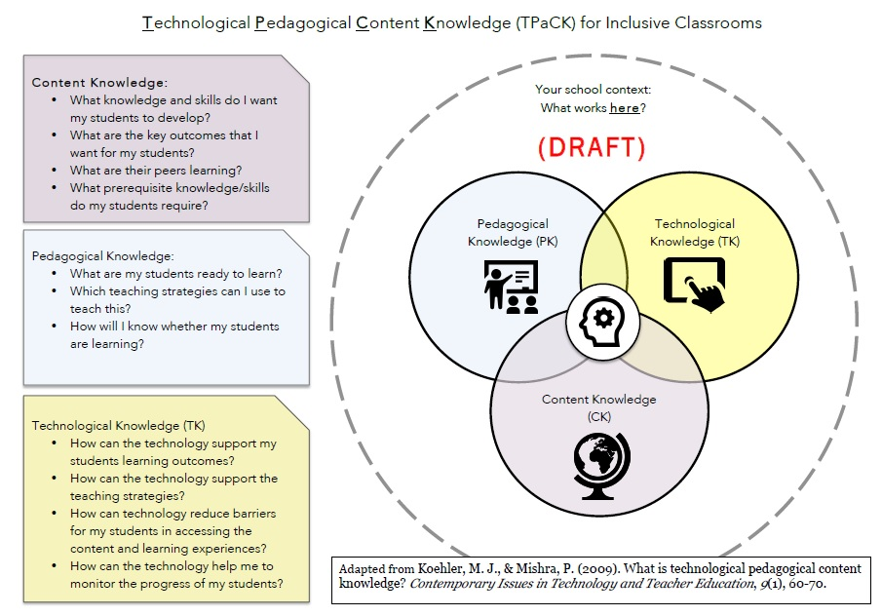

Determine the category of software
Once you have identified the functional needs of the student(s), the next step is to consider whether they can be met through the provision of age-appropriate software. If so, you will need to determine the most appropriate uses and types of software. Software may be used:
- to enhance current practices, or
- to develop new practices that are more inclusive for all students.
Appendix B lists categories of software with detailed descriptions and examples of some common types of inclusive education software.
After you have determined the appropriate category or categories of software to meet the functional need(s), read the category description in Appendix B to determine the most appropriate type of software to meet the goals and outcomes for the student(s).
Further research, including consultation with suitably qualified professionals and the student’s health professionals and parents, will also assist you to determine the most appropriate software types or products to meet students’ needs. For example, if the student requires support in communication, consult with speech and language pathologists and/or other suitably qualified professionals to learn about existing interventions, such as AAC and Picture Communication Symbols (PCS), that the student may already be using and familiar with.

Choosing and testing software
Now that you have determined the category of software that may support the inclusive needs of the student, compile a list of specific software applications to be evaluated for formal implementation. To do this:

Explore existing and available school software
Once you have identified specific needs, investigate whether the need(s) can be met using the school’s existing software (for example, accessibility features built into operating systems). To ensure that you do not purchase software that performs functions similar to what is already available within your school, consider whether your school already has the software, or similar software, that may address the identified need.

Understand existing school hardware and technical requirements as well as Information and Communications Technology (ICT) use
Every school is different when it comes to using technology for teaching and learning. Differences include the types of hardware (for example, Windows vs Mac), software (for example, Microsoft Office vs Google G Suite), and their availability (for example, 1:1 laptop programs vs sharing a set of laptops among multiple students/classes).
Further, it is important to consider how technology is used in everyday teaching and learning (for example, highly integrated vs only for certain uses). Certain software may be better suited for whole-group or small-group instruction (for example, an interactive whiteboard) than individual or peer learning (for example, a tablet). How the software will be used and how its use will fit with existing norms and expectations of teachers and students must be considered.
Also, it is important to understand the school’s security and network restrictions and whether the software needs to be installed by a network administrator, needs special access rights to run, and whether it poses a security risk. Some software requires initial or constant internet access, which may be blocked by the school’s network firewall. Be sure to discuss potential software applications with relevant technicians.

Investigate existing software used outside of school
Students, families and students’ specialists should be consulted during the investigative process to determine if the student is already using specific software programs outside of school. This is particularly important for more specialised software, such as AAC programs. Consider the software’s compatibility and alignment with interventions already in place. Introducing a new or different program can hinder the student’s progress, particularly if several programs are run concurrently. For example, AAC programs use different symbols and images (for example, PCS© and Symbolstix®), and if a student is already using one system, the school should use software that supports it rather than introducing a new system.

Investigate alternative software
If your school has no appropriate inclusive software, or you want to consider alternatives, investigate software available through the Department's website, such as FUSE. Consider the cost (including time required) of purchasing, installing and maintaining the software.
Price alone, however, may not reflect quality or the strength of a software application’s ability to meet the functional need. While price should be considered in the decision process, it should not be the determining factor. Also note that many high-quality software products and applications are available to schools at little or no cost. For example, most programs include built-in accessibility features and may already be available within the school.

Staff capability and commitment
Common barriers to the effective implementation of assistive technology in education settings are inadequate staff training and support and negative staff attitudes. Particularly with regard to more specialised digital technologies, there is a high risk that the software will be abandoned if those using it do not understand how to integrate it into the curriculum effectively. When choosing your inclusive software, consider whether students, teachers and other school staff have the technological capability to manage it.
For software which will be used to support large numbers of students, consider identifying a teacher or staff member to act as a ‘champion’ for the software and take responsibility for:
- promoting the availability of the software
- on-training other staff members in its use.
Students, teachers, education support staff and other school staff could be trained to use the software. To ensure the effective use of the chosen software is not dependent on a single staff member, more than one staff member should undertake training. Investments in inclusive education assistive technology are unlikely to be effective unless they are accompanied by adequate and appropriate staff training. Training may consist of two distinct components:
- training on how to use the software
- training on how to integrate the software into pedagogy and the curriculum.

Training may be provided in a variety of ways. For example:
- teachers, other school staff and the Department’s regional staff who are already familiar with the software may be able to on-train their colleagues
- software manufacturers and/or suppliers may offer complimentary training (including online training)
- suitably qualified professionals with relevant expertise may be able to provide training and/or advice.

Software for formal examinations
If you are considering purchasing software that will support students to achieve the Victorian Certificate of Education (VCE) or Victorian Certificate of Applied Learning (VCAL), confirm with the Victorian Curriculum and Assessment Authority (VCAA) that the equipment meets the eligibility requirements for Special Provision.

Privacy
Before using any online service/app or introducing it to students, schools must ensure that they identify and address any privacy concerns. The following checklist gives guidance:
1. Does the student require an account/log in to access this service/app?
2. What personal identifiable information is the application collecting? (This can include names, emails, phone numbers, photographs, age, address/location, gender, fingerprint or facial recognition etc.)
3. Does the application have an unmoderated or unsupervised chat/communication function?
4. Does the application have video or teleconferencing functions?
5. Can users share content (for example, copyrighted works or student works) via the application, including publicly on the internet?
6. Can students or staff sign in using their personal accounts on social networking services (for example, Google, Facebook)?
7. Are there any other risk(s)?
If the answer to any of these questions is yes, or if any other concerns are raised, the Privacy Unit at privacy@edumail.vic.gov.au can provide advice. A privacy impact assessment or other review may be needed.

Implementation
Once you have decided on a piece of software to address identified functional needs, work with stakeholders to ensure the software is used correctly and as designed.
Once your school has purchased the software, additional steps may be required before the software can be used. For example:
- software may need to be installed on computers, servers, and/or tablets
- software may need to be configured/modified based on students’ individual needs
- teachers and other staff may require training to set observable and objective goals to determine the effectiveness of the software.

what to CONSIDER WHEN DETERMINING EFFECTIVENESS

Evaluate the software
Once the software has been implemented and is being used to support inclusion in your school, you should evaluate whether it is achieving the intended outcome(s). The evaluation process should involve consultation with all stakeholders, including students, families, teachers, school staff and suitably qualified professionals as applicable.
You can use the TPaCK framework to assess how well the chosen software is supporting the way content is communicated and presented to the student(s) (TCK) and how well the chosen software is affecting the teaching and learning experience and how the content is delivered to the student(s) (TPK).
If the evaluation indicates that the software is not achieving its intended outcomes, review and modify its use, consider alternative software, and/or seek professional advice.
To remain effective, most software requires occasional updates. This may involve consultation with suitably qualified professionals. Your school is responsible for ensuring that the software is updated as required.

Process Overview
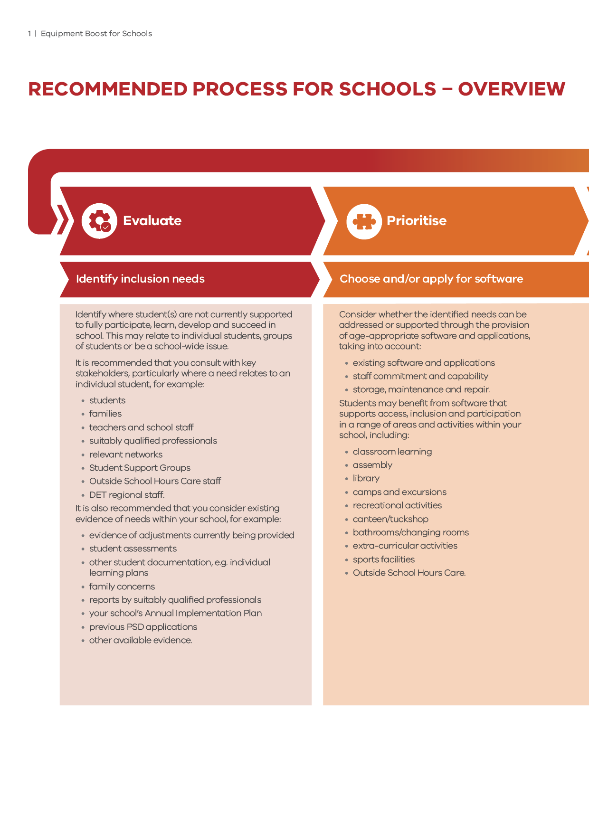

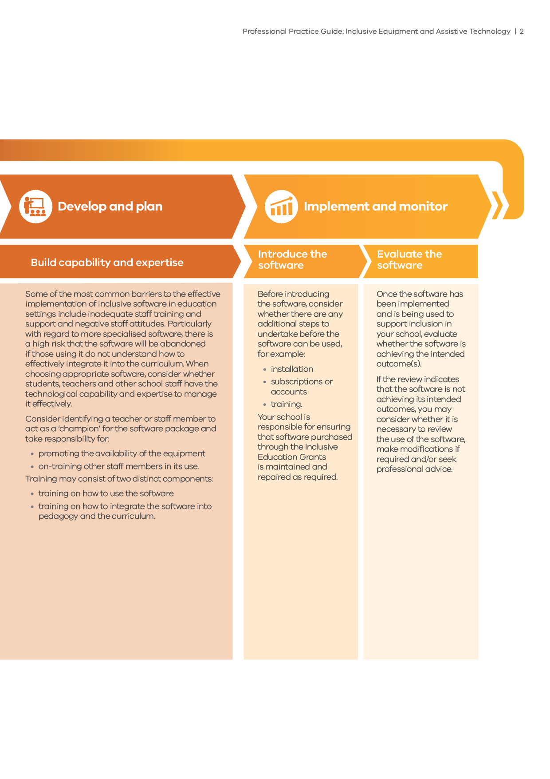

Appendix A: Share diagram (Text Alternative)
S: Student centred
Inclusive education involves students, in collaboration with their peers and/or carers, in decision-making processes as respected partners in education.
H: Human rights focused
Inclusive education is supported by and is the realisation of a human rights-based approach to education. International human rights principles and Victoria's Charter of Human Rights and Responsibilities Act 2006 provide a framework for every Victorian to be treated with dignity and respect and to enjoy their human rights without discrimination.
A: Acknowledges strengths
Inclusive education recognises that each child and young person is unique. It focuses on a strengths-based, personalised approach to education that celebrates and welcomes differences to maximise learning, engagement and wellbeing outcomes.
R: Respects legal obligations
Inclusive education enables schools to uphold legal obligations to make reasonable adjustments for all students with disabilities. Reasonable adjustments assist all students to participate in education on the same basis as their peers without a disability.
E: Evidence based
Inclusive education uses contemporary evidence-based practices known to be effective in responding to individual student needs and improving student outcomes.
Return to SHARE Diagram (page 5)

Appendix B: Categories of software
After you have determined the appropriate category or categories of software to meet the functional need(s), read the category description below to determine the most appropriate type of software to meet the goals and outcomes for the student.
Further research, including consultation with suitably qualified professionals, will assist you to determine the most appropriate software types or products to meet students’ needs. For example, if the student requires support in communication, consult speech and language pathologists and/or other suitably qualified professionals to learn about existing interventions, such as AAC and PCS©, that the student may be using and familiar with.

 | Category | DESCRIPTION | EXAMPLE ITEMS
 | Literacy aids | Literacy aids aim to support students’ engagement with reading and writing by removing barriers to learning associated with a disability or additional learning needs.  Some literacy aids are designed to support a range of needs, while others are targeted at learning difficulties and specific needs such as those with Cognitive–Learning and Organisation functional needs. When considering this type of equipment for an individual student, consider whether the equipment supports that student’s specific needs.  Anticipated student outcomes:  - increased ability to access literacy activities independently  - increased participation, engagement and success in literacy. | - Literacy development software/apps with a focus on inclusion  - Assistive writing software/apps  - Portable word processors  - Word prediction software
 | Mathematical software | Mathematical writing software can be used to write mathematical formulae and equations using digital technology. While the software can be used by all students and may suit individual students’ learning preferences, it may be particularly beneficial for students who have difficulty writing legibly due to a Physical–Fine Motor functional need, Cognitive–Learning and Organisation functional need, or additional learning need.  Anticipated student outcomes:  - increased participation, engagement and success in mathematics. | - Mathematical visual aids
 | Mouse/keyboard training software | Mouse/keyboard training software helps students improve their proficiency in using standard computer hardware. It may also enable students who have difficulty using standard computer hardware to access a broader range of computer software and more successfully engage in computer-based activities and tasks. It may also suit students who have a Physical–Fine Motor functional need.  Anticipated student outcomes:  - increased access to curriculum content and computer-based tasks  - increased independence and engagement in computer-based tasks. | - Typing software  - Mouse/keyboard training games
 | Screen reader software | Screen reader software converts text on a screen to speech and may be a suitable alternative to screen magnification software when a student is required to read large amounts of on-screen text.  This software may assist students who have a Sensory–Vision functional need or who do not benefit from using screen magnification software, as well as students who are learning English as an additional language. Screen reader software can also support students with a Cognitive–Learning and Organisation or a Socio-Emotional–Speech/Communication functional need by providing another way to receive information.  When considering this type of equipment, note that many operating systems have built-in accessibility features, including screen reader software. Some screen reader software is available for free.  Anticipated student outcomes:  - increased access to, and engagement with, digital electronic devices. | - Text-to-speech
 | Picture symbol software and resources | Picture symbol software and resources support students to communicate and understand ideas and concepts. For example, students who are non-verbal and/or have Socio-Emotional–Speech/Communication functional needs can use pictures and symbols provided in these programs. This software enables teachers and students to make visual resources such as checklists, timetables, schedules and social stories/social scripts.  Picture symbols can be used to assist students’ understanding of social/emotional concepts. For example, social stories/scripts describe a situation, skill, or concept in terms of relevant social cues, perspectives, and common responses, and aim to increase students’ understanding of social situations and the appropriate behaviours.  Where picture symbol software and resources are intended to be used by an individual student, consult a suitably qualified professional to determine the types of equipment that will most appropriately and effectively meet that student’s needs. Also, consider whether teachers and other school staff who work with the student will require training to use the equipment effectively.  Anticipated student outcomes:  - increased opportunities for effective communication between students, teachers and other school staff. | - Picture symbol boards  - Picture symbol software/apps  - Picture symbol ‘wearables’
 | Communication software | Communication software can be used to:  - support students’ verbal and written communication  - promote time-efficient communication  - enable students to communicate with their teachers and peers using digital technology.  For example, speech-to-text software may support students to present more accurate and legible written work, and may be particularly beneficial for students who have additional learning needs as a result of dyslexia or dysgraphia.  Communication software supports multiple functional needs, including Sensory–Deaf/Hard of Hearing needs, Socio-Emotional–Speech/Communication needs, and Cognitive–Learning and Organisation needs.  Anticipated student outcomes:  - increased access to digital technologies  - increased independence and engagement in classroom activities  - more effective communication between students, teachers and other school staff. | - Speech-to-text software  - Accessible word processor technology  - Articulation skill development
 | Personal organisation tools | Personal organisation tools may support students to develop their organisational skills and may be particularly beneficial for students who have Cognitive–Learning and Organisation function challenges, for example, by providing visual schedules, cues and reminders.  Anticipated student outcomes:  - increased independence in organising and completing school work. | - Graphic organisers  - Task sequencing devices/software  - Cueing devices/software  - Visual timers (for example, sand timers)  - Timer software  - Scheduling software/apps
Sensory software |  | Sensory software and resources may support students’ sensory processing needs such as a Sensory–Vision, a Sensory–Deaf/Hard of Hearing, and a Socio-Emotional–Speech/Communication functional need. When used appropriately and in collaboration with individual goals, sensory resources can support students to understand, engage and interact in their environment.  If sensory software is intended to be used by an individual student, consult a suitably qualified professional to determine the types of software and resources that will most appropriately and effectively meet that student’s needs. No single resource will provide feedback suitable for all students’ needs. Used inappropriately, sensory resources may create barriers to learning for the student.  Anticipated student outcomes:  - increased independence and engagement in school activities. | - Augmented reality software  - Global Positioning System (GPS)

Appendix c: ABBREVIATIONS

Practice Guide
AAC augmentative and alternative communication
CK content knowledge
GPS global positioning system
NCCD Nationally Consistent Collection of Data for Students with Disabilities
OCR optical character recognition
PCK pedagogical content knowledge
PK pedagogical knowledge
PSD Program for Students with Disabilities
TCK technological content knowledge
TK technological knowledge
TPaCK technological pedagogical content knowledge
TPK technological pedagogical knowledge
VCAA Victorian Curriculum and Assessment Authority
VCE Victorian Certificate of Education
VCAL Victorian Certificate of Applied Learning

Copley & Ziviani, 2007
Schoonover & Argabrite, 2015
Assistive Technologies for Students with Disabilities: Final Report to the Department of Education and Training (Nous Group, 2018)

