INCLUSIVE EDUCATION EQUIPMENT BOOST FOR SCHOOLS (2018)
GUIDANCE
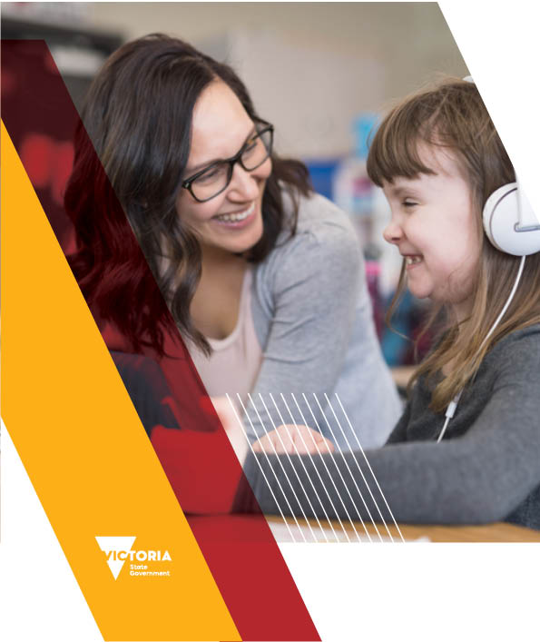

If you would like to receive this publication in an accessible format, such as large print or audio, please telephone (03) 9637 2000 (TTY), or email literacy.and.numeracy@edumail.vic.gov.au.
This document is also available in PDF and Word formats on the internet at the Victoria State Government Education and Training website.
The Department of Education and Training acknowledges and pays respect to Elders and all Victorian Aboriginal communities. We honour and respect Traditional Owners, past and present, and value the rich culture and history of the First Peoples of this land. Throughout this document the term Koorie is used to refer to both Aboriginal and Torres Strait Islander people. Use of the terms Aboriginal, Aboriginal and Torres Strait Islander and Indigenous are retained in the names of programs and initiatives and unless noted otherwise are inclusive of all Aboriginal and Torres Strait Islander peoples.
Published by the Department of Education and Training
Melbourne June 2018
© State of Victoria (Department of Education and Training) 2018
The copyright in this document is owned by the State of Victoria (Department of Education and Training), or in the case of some materials, by third parties (third party materials). No part may be reproduced by any process except in accordance with the provisions of the Copyright Act 1968, the National Education Access Licence for Schools (NEALS) (see below), or with permission.
An educational institution situated in Australia which is not conducted for profit, or a body responsible for administering such an institution may copy and communicate the materials, other than third party materials, for the educational purposes of the institution.
Authorised by the Department of Education and Training, 2 Treasury Place, East Melbourne, Victoria, 3002.
ISBN: 978-0-7594-0837-1 (Print)

CONTENTS

Overview 5
Inclusive Education Reform Agenda 7
Inclusive education policy and practice 8
Figure 1. SHARE Principles of Inclusive Education 9
fUNDING STREAMS 10
Figure 2:Equipment Boost for Schools three-stream funding in 2018. 11
Specialised Equipment and assistive technology 12
Implementation resources 13
Principles and scope 14
Flexible Funding 16
specialised stream 17
Eligibility 17
How to apply 17
Applications 18
Support for applications (encouraged) 18
Funding priorities 18
Ongoing management of equipment 19
Blind and low vision stream 20
Other related funding 21
Policies, Programs and Resources 21
Related workforce capacity initiatives 23
Legal obligations 23
Education for All policy 23
Inclusion Boost 23
Inclusive Education Scholarships 24
Inclusion Online 24
Further support and guidance 25
Appendix A 26
Share diagram (Text Alternative) 26
Equipment boost for schools diagram (Text Alternative) 27

In Term 3, 2018, all Victorian government schools will receive $5,000 in their SRP to invest in specialised equipment and assistive technologies.
On top of this, schools can apply to access more highly specialized equipment and technology through the
targeted streams of the Equipment Boost for Schools.

Overview
In 2018, the Victorian Government is giving schools extra resources, guidance, access to specialist expertise and support to embed inclusive education in all aspects of school life for students with disabilities and additional learning needs.
As part of the Department’s Inclusive Education Reform Agenda – Additional Supports Program, schools will receive funding to purchase new specialised equipment and assistive technologies to strengthen whole-of-school inclusive education practice.
The $12 million Equipment Boost for Schools initiative supports inclusive education practices in Victorian government schools through three discrete funding streams:
1. Flexible
Dedicated funding of $5,000 provided to all schools though the Student Resource Package (SRP) for specialised equipment and assistive technologies to support a review and refresh of school-level inclusive education practice during Term 3, 2018.
2. Specialised
An opportunity for schools to apply for high-value and/or highly specialised equipment and assistive technologies to meet the needs of individual student(s) or support improvements in whole-of-school inclusive education practice.
3. Blind and Low Vision
Targeted supports for students who are blind or have low vision through the Statewide Vision Resource Centre (SVRC) Technology Library.
The Equipment Boost for Schools complements and supports the Inclusion Boost funding of $4,800 provided to schools in Term 3, 2018, to support schools to review and refresh inclusive education policies, and identify opportunities for practice improvements.
Schools’ increased awareness of, and reflection on, legislative and policy responsibilities provides an opportunity for impactful decision-making to embed equipment and technologies within high-quality inclusive education practice.

This guidance:
- Outlines the funding arrangements for the three streams
- Provides a recommended process to identify and implement equipment and technologies
- Provides schools with a list of specialised equipment and assistive technologies
- Refers schools to alternative funding programs and related workforce capacity initiatives.

Inclusive education reform agenda
The Inclusive Education Reform Agenda – Additional Supports Program aims to:
- maximise access, participation, achievement and wellbeing in school and early childhood education
- support children and young people with disabilities by providing learning environments that are safe, positive, supportive and suited to their needs
- ensure adequate support for families, education professionals and communities to enable inclusive education.
To read the Education for all policy, see:
- School Policy and Advisory Guide – Students with a Disability
For more information about other inclusive education reforms, see:
- Inclusive Education for Students with Disabilities
- Supporting Students with Additional Learning Needs

Inclusive education policy
and practice
Inclusive education means that all members of every school community are valued and supported to fully participate, learn, develop and succeed within an inclusive school culture. This includes making reasonable adjustments for students with disabilities and additional learning needs.
Data shows that Victorian schools make adjustments for 19 per cent of students because of a disability or an additional learning need. This would be approximately 115,000 students in Victorian government schools, and this suggests that every government school may receive benefit from specialised equipment and assistive technologies that supports their capacity to deliver inclusive education.
The Equipment Boost for Schools supports Victorian government schools with dedicated funding for specialised equipment and assistive technologies. This comes at a time when schools are being asked to review and refresh inclusive education policies and practices via the Inclusion Boost.
Specialised equipment and assistive technology supports inclusive education practice by:
- removing barriers to access to curriculum content
- supporting full participation of students in learning activities
- supporting students to demonstrate knowledge and strengths at assessment
- allowing students with and without disabilities and additional learning needs to participate and learn together in the same classes/environment.
The Equipment Boost for Schools initiative aligns with the SHARE Principles of Inclusive Education. The initiative provides schools with flexibility to collaborate with students, parents, carers, teachers and support staff to tailor equipment and technology needs to the unique requirements of their school and students in line within these principles.

Figure 1. SHARE Principles of Inclusive Education
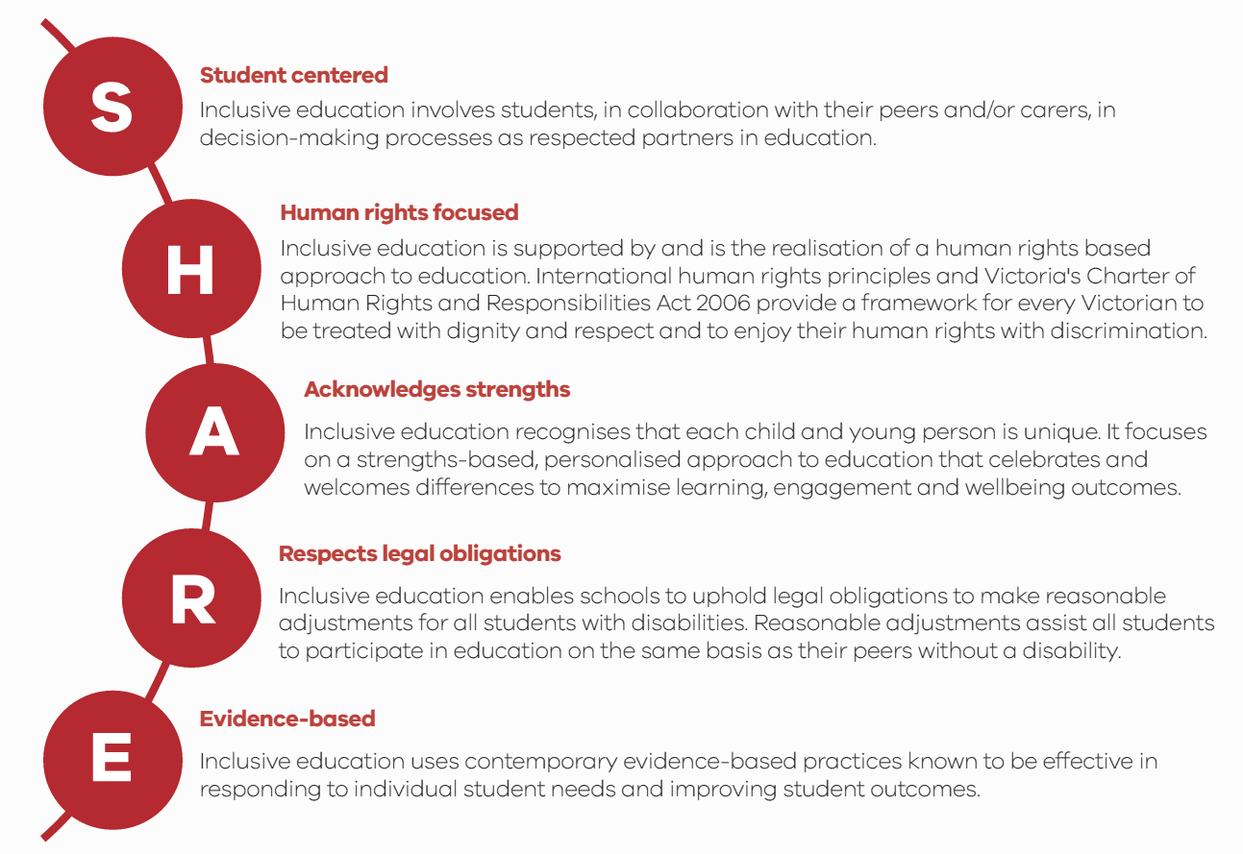
Developed based on feedback captured in 2017 during public consultations on the Department’s Education for All inclusive education policy
Text alternative for ‘SHARE’ Diagram

Funding streams
Schools can purchase, or apply to purchase, specialised equipment and assistive technology to support students with a disability or an additional learning need to participate in any aspect of school life.
Funding is not linked to students’ eligibility for other types of disability funding or the Program for Students with Disabilities, which provides schools with supplementary resources for a defined group of students who have disabilities with high needs.
Equipment and technologies can be highly individualised for a particular student or students, or support areas for improvement identified in the review of whole-of-school inclusive school practice.
To determine the appropriate equipment or technologies to support inclusive education, schools should consider factors such as:
- student(s)/student groups who will most benefit from the use of equipment
- outcomes expected from equipment use and whether this is consistent with the school’s goals
- practicality of using and storing within the school setting
- training required to use the equipment appropriately and any additional resources required
- ways in which the school will evaluate the outcome and effectiveness of the equipment enabling students to better meet educational goals and/or in promoting whole-of-school inclusive education.
Purchases under this initiative should reflect collaboration between the school leaders and teachers, parent/guardian/carer(s), students, and specialist education or allied health staff to support agreed understandings and responses to students' needs.

Figure 2: Equipment Boost for Schools three-stream funding in 2018
Text alternative for ‘equipment boost for schools’ Diagram

Specialised equipment and assistive technology
Specialised equipment is any item that supports students, including those with disabilities or additional learning needs, to fully participate, learn, develop and succeed in school and school-related activities. This may include items such as adjustable furniture, mobility resources, portable wheelchair ramps, literacy aids or customised sporting equipment.
Assistive technology is any device or system that allows individuals to perform tasks they would otherwise be unable to do or increases the ease and safety with which tasks can be performed.
The specialised equipment and assistive technology funded under all streams of this initiative must be used primarily within the school, or in school-related activities, to promote inclusive learning environments. The Equipment Boost for Schools provides schools with flexibility to purchase from a range of inclusive education equipment and assistive technologies which will:
- support students to participate in all aspects of school life including co-curricular activities, recreational opportunities and Outside School Hours Care
- improve students’ access to learning and enhanced communication between students and their teachers and peers
- enhance student engagement, independence and agency
- build inclusive school environments where all students are supported to learn together.
All adjustments, interventions and other supports provided to students with disabilities and additional learning needs should be personalised and individualised to address the student’s identified learning needs and build on their strengths. Flexibility is provided to support localised and individualised decision-making for schools’ unique needs considering the resources within the school, staff capability, need for additional training, allocation of resources and developing new programs or systems.
Equipment and technology can be used in schools to support students at a functional level (to access content), a participatory level (to interact and engage with other students and teaching approaches) or a pedagogical level (to grow as self-directed learners).
It is important that schools consider where purchased items can be incorporated within usual practices, or where usual practices can be adapted using equipment and technologies, to develop new ‘norms’ that are more inclusive for all students.

Implementation resources
The Department has developed comprehensive resources to support schools to implement the Equipment Boost for Schools. This includes:
- a recommended process to identify and implement equipment and technologies provided to support school-level decision-making
- a list of specialised equipment and assistive technologies used to support Victorian government school students as collated with the support of allied health professional peak bodies and regional, area and school based support staff.
Implementation resources are not intended to be exhaustive. The resources provided aid schools to maximise their investments, implement equipment and technologies effectively and to identify examples of purchases within scope of the initiative.
Refer to the Equipment Boost for Schools Implementation Resources webpage.

Principles and scope
While schools have the flexibility to make purchases that best suit the needs of their student(s), the following principles must apply:
- Funding is only for new specialised equipment and assistive technologies
- Purchases must be:
- directly supporting inclusive education practice within the school or in school-related activities
- expended in terms 3 and 4, 2018
- consistent with the Victorian SHARE Principles for Inclusive Education
(Student centred, Human rights focused, Acknowledges strengths, Respects legal obligations and Evidence-based)
- within the scope of the initiative as described within this guidance.

In scope | Out of scope
- New specialised equipment  - New assistive technologies  - Staff training to effectively integrate new equipment and technologies purchased under the initiative into the school’s programs and practices  - Extended maintenance plans for new purchases of equipment. | - Equipment that can present a risk of physical harm or danger within the school environment if not appropriately used or individually prescribed  - Equipment that can be used to restrain or seclude students  - Equipment that is essential to meeting students’ essential medical and/or safety needs and required by an individual regardless of the activity they are undertaking (for example, additional to the reasonable adjustment obligations of schools)  - Equipment readily funded elsewhere (for example, equipment funded under other departmental programs, or reasonable and necessary supports funded through the National Disability Insurance Scheme (NDIS))  - Specialised equipment and technology for students in non-government schools  - General equipment that is not primarily intended to support inclusion  - Equipment or technologies already purchased  - Rented or leased equipment  - Updates, upgrades or repair of existing equipment  - Permanent infrastructural improvements and modifications to school buildings or grounds  - Consumables such as braille tape, tactile stickers, spur wheels  - Staffing costs  - Student support hours or program costs  - Staff training (other than training that is necessary to integrate the requested equipment into the school’s programs and practice).

Flexible funding
In Term 3, 2018, all Victorian government schools will receive a one-off $5,000 cash allocation identified through the SRP Targeted Initiative line ‘Inclusive Education Equipment Boost’. Schools can view this funding in the Budget Details Report and Budget Management Report.
School business managers are advised to use the new ‘Inclusive Education’ Sub Program code 5220 in the Chart of Accounts to acquit their Inclusive Education Equipment Boost financial transactions in CASES21 during 2018.
All expenditure of Equipment Boost for Schools funding must be in line with the guidance in this document.
As part of the Department’s evaluation, a selection of schools will be asked to demonstrate implementation of the equipment and technologies under the initiative. These schools will provide information on their school’s approach to using Equipment Boost for Schools funding. The Department’s Inclusive Education Grants team will be in contact with selected schools directly in terms 3 and 4.

Specialised stream
Schools that identify a higher level of need that cannot be serviced via the SRP can submit an application for funding to purchase high-value and/or highly specialised equipment and assistive technologies which will have a profound impact on students’ participation, learning and success at school.
Teachers and other support staff may recommend assistive technology as a reasonable adjustment for students with a disability to access and participate in the curriculum, classroom learning activities, school-related activities and the educational environment. Specialist staff, including occupational therapists, physiotherapists, speech-language pathologists, psychologists, social workers and visiting teachers, may assist with assessing students' needs and recommending appropriate items. Consultation with families is an important part of this process.
All applications must include endorsement of the school’s principal prior to lodgement.

Eligibility
All Victorian government schools are eligible to apply for:
- highly specialised equipment or assistive technologies to support individual student(s)
- high-value specialised equipment or assistive technologies to be embedded in whole-of-school approaches to inclusive education.

How to apply
- Applications open 17 July 2018 and close 7 September 2018
- Applications must be submitted online at the Department of Education and Training online portal.
- Incomplete or late applications will not be considered
- Applications must be accompanied by an itemised quote(s)
- Applications must include school principal endorsement
- Changes to applications can occur until applications are submitted
- Additional supporting documentation can be uploaded with the online application.
Following an assessment process, the Department will notify schools of their application outcome by early Term 4, 2018. This will allow schools that are successful in their application sufficient time to purchase equipment and apply for reimbursement via the Schools Targeted Funding Portal during Term 4, 2018. Schools with successful applications will be supported to make reimbursements through the portal and guided through this process as needed.

Applications
Applications must state:
- the need or improvement the specialised equipment or assistive technology is intended to address
- how this need or improvement was identified
- how the requested equipment was identified as the most suitable solution to address the identified need, including details of any alternative options that were considered and why they were not deemed to be suitable
- the expected impact/benefit of integrating the requested equipment into the school’s teaching and learning process, including the expected benefit to student(s) who have a disability or an additional learning need
- other funding sources that have been considered
- the alternative should funding not be approved
- any staff training that is necessary for the equipment to be effectively integrated into the school’s teaching and learning programs.

Support for applications (encouraged)
To strengthen applications, schools are strongly encouraged to provide supporting documentation where possible. For example, this may include:
- professional advice or assessments by a clinician or allied health professionals
(for example, clinical assessments/recommendations in relation to the student’s needs)
- supporting advice or recommendations from specialist staff
(for example, occupational therapists, physiotherapists, speech-language pathologists, psychologists, social workers and visiting teachers assisting with identifying and assessing students' needs and recommending appropriate items)
- evidence that the requested equipment has had a positive impact in other schools
- results of pilot programs or trials of the requested equipment in similar contexts
- academic research.

Funding priorities
Priority is given to applications:
- that best demonstrate that the requested equipment or technology addresses an identified need within the school and will have a profound impact on students’ participation and learning at school
- where the requested equipment or technology provides a substantial or extensive adjustment to students’ access and participation in education on the same basis as students without disability
- that best demonstrate the expected impact of the requested equipment or technology
- that represent value for money and add value to existing supports.

Ongoing management of equipment
Schools should note that:
- purchasing must follow schools’ purchasing, insurance and taxation policies
- equipment and technologies will be the property of the school and must be managed in compliance with relevant asset recording and control policies
- all repairs, maintenance, transfer, storage and disposal of equipment are to be maintained by the school within existing resources, policies and practices noting specialised stream funding applications can include extended warranty and maintenance costs for new equipment and technologies
- ongoing management of all equipment and technologies must be in compliance with relevant Department policies.

Blind and low vision stream
The Department’s Statewide Vision Resource Centre (SVRC) provides supports, including the provision of a range of technology options, for students who are blind or have low vision through its Technology Library. SVRC procures items to be part of this lending library, based on the identified demand from schools.
Through the Equipment Boost for Schools, the SVRC will receive additional funding to continue, and expand, support for students who are blind or have low vision in Victorian government schools. This replaces the annual Equipment Grants previously provided to schools to purchase essential equipment for students with vision impairments not supported through any category of the Program for Students with Disabilities.
Eligibility for SVRC additional supports is established through the Educational Vision Assessment Clinic (EVAC), run jointly by the Department and the Royal Victorian Eye and Ear Hospital.
Separate guidance is provided to access equipment and technology through the Blind and Low Vision Technology Library.
Applications open 17 July 2018 and close 17 August 2018.

Other related funding
There are a range of policies, programs and resources for schools to support the delivery of high-quality schooling for all students, inclusive of students with disabilities and additional learning needs. These resources are provided by the Department in the SRP, through student support services, or through early identification and intervention programs. There are also other state and commonwealth programs that provide funding for specialised equipment and assistive technologies.

Policies, programs and resources
- Australian Hearing provides services under the Australian Government Hearing Services Program for children and young Australians with permanent or long-term hearing loss. This support includes selecting and fitting hearing devices as well as additional assistance to clients with complex communication needs (access to higher level technology and devices in addition to hearing aids).
- Accessible Buildings Program covers the costs of infrastructure upgrades to provide access to education facilities for students, parents and staff members with a disability.
- Employment Assistance Fund gives financial help to eligible people with a disability or mental health condition and employers to buy work-related modifications and services. The commonwealth funding is available for staff that require modifications to access their school. Schools can also apply for funding directly to provide teachers and staff with disabilities with support, equipment and technologies.
- Inclusive Schools Fund provides Victorian government schools with quality new spaces and more inclusive facilities, based on best practice research and design. Schools are able to apply to the fund for innovative building projects that improve participation and learning outcomes for students with disabilities.
- Language and Learning Disabilities Support Program provides schools with resources to support the delivery of teaching and learning programs for students with autism, dyslexia, language or other learning disabilities and can be used for specialist equipment or materials.
- National Disability Insurance Scheme (NDIS) provides all Australians under the age of 65 who have a permanent and significant disability with the reasonable and necessary supports they need to enjoy an ordinary life. The NDIS funds supports that are associated with the functional impact of the student’s disability on their daily living activities (those not primarily relating to education attainment) including personal care and support, transport to and from school, and specialist transition supports to and from school to further education, training or employment.
- Program for Students with Disabilities provides a range of supports and initiatives to assist government school students with disabilities including resourcing for eligible students which assists schools to meet their obligations under the Disability Discrimination Act. Supports can include funding for the provision of specialist staff (for example, special needs coordinator, occupational therapists, and speech pathologists); teacher professional learning; specialist equipment/materials; and education support staff.
- State-wide Equipment Program (SWEP) is a subdivision of Ballarat Health Services which oversees a number of different 'assistive technology' programs. SWEP provides Victorian people who either have a permanent or long-term disability or are frail aged with subsidised aids, equipment, and home and vehicle modifications to enhance their independence and facilitate community participation.

Related workforce capacity initiatives
There is a range of existing workforce capacity strategies and supports to help schools understand their obligations and responsibilities to provide inclusive learning environments.

Legal obligations
Education and training providers must be aware of their obligations under disability discrimination legislation. In broad terms, the Equal Opportunity Act 2010 (Vic) and the Disability Discrimination Act 1992 (Cth) and the Disability Standards for Education 2005 (Cth) state that it is unlawful to discriminate against a student on the basis of their disability. This legislation also states that schools are required to provide students with disabilities with reasonable adjustments, so that they can participate in their education on the same basis as other students.
Schools have Legal Obligations and must comply with Disability Standards for all students with disabilities, not just those who are eligible for support under targeted funding programs. Additional resources provided to schools, including the Equipment Boost for Schools, do not define or limit the support to be provided for students with disabilities or additional needs.
The Disability Standards for Education eLearning modules can help schools and education providers to understand their obligations.

Education for All policy
The Department’s Education for All policy, which was released in December 2017, articulates the Department’s expectations and vision for inclusive education for students with disabilities and additional needs. The Education for All policy and related Additional Supports reform agenda initiatives address recommendations from the Review of the Program for Students with Disabilities.

Inclusion Boost
During Term 3, 2018, all Victorian government schools will undertake a refresh of school-level inclusive education policies and practices under the Inclusion Boost initiative. The Equipment Boost for Schools funding has a direct relationship with this review, in particular by increasing the awareness, understanding and focus on commonwealth and state legal obligations to all students with disabilities and additional learning needs, not just those eligible for targeted funding.

Inclusive education scholarships
From 2018 to 2022, Inclusive Education scholarships are available to strengthen the capacity of teachers, schools, and regions to provide high-quality inclusive education. Victorian government teachers and regional allied health professionals can apply to undertake postgraduate studies in Special Education and Applied Behaviour Analysis.

Inclusion Online
The Inclusion Online learning portal offers teachers, principals and allied health staff in Victorian government schools a suite of free online blended professional learning courses.
There are four Inclusion Online courses available in 2018 including: Understanding Autism Spectrum Disorder; Understanding Dyslexia and Significant Difficulties in Reading; Inclusion of Students with Speech, Language and Communication Needs; and Understanding Hearing Loss.
Each of the online courses provides up to 20 hours professional learning, including three face-to-face sessions or web-conferenced sessions, spread across 10 weeks. These hours may contribute to teacher registration renewal requirements with the Victorian Institute of Teaching.

Further support and guidance
Equipment Boost for Schools guidance and implementation resources are provided on the Department’s website.
For questions on the Equipment Boost for Schools initiative, contact the Department at:
Inclusive Education Grants
Email: inclusive.ed.grants@edumail.vic.gov.au
Inclusive Education Professional Practice Branch, Regional Services Group
For information on the Equipment Boost for Schools Blind and Low Vision stream only, contact:
Statewide Vision Resource Centre
Web: SVRC webpage
Email: vision.tech.library@edumail.vic.gov.au
For assistance with the online application process through SmartyGrants, contact:
SmartyGrants Service Team
Email: service@smartygrants.com.au
Phone: 03 9320 6888

Appendix A

Share diagram (Text Alternative)
S: Student centered
Inclusive education involves students, in collaboration with their peers and/or carers, in decision-making processes as respected partners in education.
H: Human rights focused
Inclusive education is supported by and is the realisation of a human rights based approach to education. International human rights principles and Victoria's Charter of Human Rights and Responsibilities Act 2006 provide a framework for every Victorian to be treated with dignity and respect and to enjoy their human rights with discrimination.
A: Acknowledges strengths
Inclusive education recognises that each child and young person is unique. It focuses on a strengths-based, personalised approach to education that celebrates and welcomes differences to maximise learning, engagement and wellbeing outcomes.
R: Respects legal obligations
Inclusive education enables schools to uphold legal obligations to make reasonable adjustments for all students with disabilities. Reasonable adjustments assist all students to participate in education on the same basis as their peers without a disability.
E: Evidence-based
Inclusive education uses contemporary evidence-based practices known to be effective in responding to individual student needs and improving student outcomes.
Return to SHARE Diagram (page 7)

Equipment Boost for Schools diagram (Text Alternative)

Equipment Boost for Schools

Flexible Funding $5,000 per School (provided to all schools)
- Flexible to accommodate unique needs
- $5,000 to all Victorian government schools
- Allocation in Term 3, 2018 through the Student Resource Package Targeted Initiative
- Acquitted through CASES21

Specialised Stream by Application (by application)
- For Victorian government schools identifying a higher level of student or school needs
- By online application from schools with principal endorsement
- Funding of approved purchases via Schools Targeted Funding Portal
- Funding by reimbursement

Blind and Low Vision Technology Library (by application)
- For Victorian government students with vision-related needs
- Eligibility determined via Educational Vision Assessment Clinic
- Blind and Low Vision Technology Library through the Statewide Vision Resource Centre
- Equipment is lent and returned
Return to Equipment Boost for Schools Diagram (page 9)

Nationally Consistent Collection of Data for Students with Disabilities (NCCD), 2017 & Department of Education and Training February School Census, 2017

